It’s OK to not be OK - a student voice inspired communications campaign

Luke Martin & Vanna Garrick
Student Mental Wellbeing Initiatives, RMIT University

One in four tertiary education students experiences a mental health condition each year (Orygen, 2017). Despite being common, these conditions remain a hidden adversity for many students. The stigma of mental health conditions on campus can contribute to students staying silent about their difficulties and prevent them from accessing the formal and informal support they need to stay engaged in their studies (Martin, 2009).

Orygen’s Under the Radar (2017) report on university student mental health outlines that many students are afraid, anxious, embarrassed or ashamed to talk about their mental health for fear of being perceived as less capable than others or potentially jeopardising their future academic and career outcomes.

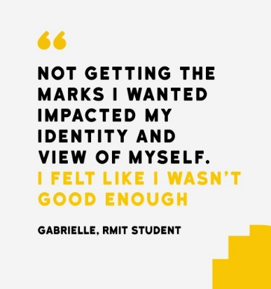
For these reasons, RMIT seeks to create a culture which holds positive attitudes towards students experiencing mental health conditions, assists these students to feel less alone, and promotes belief in their academic success.

Driving this work is RMIT’s endorsement of, and commitment to implementing, the Framework for Promoting Student Mental Wellbeing in Universities. The Strengthening Community Awareness action area of the Framework recommends conducting engagement campaigns which raise awareness of mental health and reduce stigma. Research shows that communication campaigns which educate about mental health conditions and showcase personal stories of hope and resilience can help to challenge negative attitudes in the community (beyondblue, 2015).

Campaign co-design with students
The RMIT Student Mental Wellbeing Initiatives team partnered with the RMIT Student Union (RUSU) to lead the development of a stigma reduction campaign. The primary objective was to assist students studying with mental health conditions to feel less alone by showcasing a community of understanding and support at RMIT.

A series of workshops and engagement surveys were conducted with students to determine the strategic and creative approach to the campaign. Several common themes emerged that were influential in shaping the campaign directions:
- The key message students wanted conveyed to other students was the idea that it’s OK to not be OK. If you’re studying with a mental health condition, you’re not the only one. It doesn’t make you different. And it’s okay to talk about it.
- Students spoke about the ‘mask of coping’ during times of distress, and believed a campaign which revealed the inner thoughts that are rarely shared would assist students to feel less ‘different’ for having similar thoughts.
- Content authenticity was considered key, rather than a slick marketing approach. The importance of conveying genuine student experiences in their own words was deemed critical to engaging students.

The It’s OK to not be OK campaign was the result.

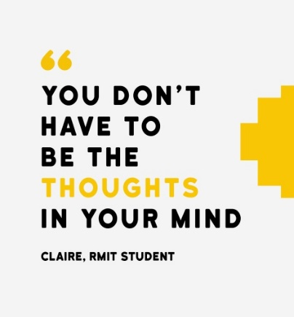
The campaign was a platform from which to share authentic student experiences of insight, understanding and support about managing mental health while studying. Care was taken to avoid clinical/diagnostic terminology, and hold an inclusive conversation about ups and downs in mental health that all students could relate to.

Campaign materials were designed to honour the voice of students through the respectful curation of quotes. Two types of quotes were gathered from students to include in campaign materials: 1) ‘insight’ messages about the experience of managing mental health while studying , and 2) ‘support’ messages offering words of understanding and hope to other students.

Example ‘Insight’ messages | Example ‘Support’ messages
“Towards exams, I was so stressed and worried I could barely sleep or eat. I felt anxious, nervous and depressed. I felt hopeless like I couldn't do anything”  - Has, RMIT Student | “You are human. You always have emotions. You are sometimes vulnerable. It is ok, to not always be ok”  - Benjamin, RMIT Student
"Not getting the marks I wanted impacted my identity and view of myself. I felt like I wasn't good enough"  - Gabrielle, RMIT Student | “You may experience issues but you still have the potential to reach your goals. It just may take time and a different approach”  - Deniz, RMIT Student.
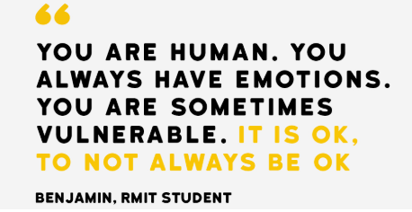

Campaign assets were promoted across the full range of RMIT owned communication channels for two weeks in October 2018, including social media, computer lock screen and desktop images, student email, website, and digital screens around campus.

The call to action was to ‘voice your support’ by submitting a message on the campaign website (rmit.edu.au/itsok). The campaign website:
- Showcased a wall of messages of support from RMIT students (reviewed by the project team prior to uploading)
- Hosted an RMIT Alumni personal story about managing experiences of depression and anxiety while studying, and offered words of encouragement from the other side of graduation
- Linked to further mental health information and support for students and staff, including urgent support options.
- Encouraged students to sign up to stay involved with mental wellbeing initiatives at RMIT.

Results

Preliminary campaign evaluation shows it was positively received by RMIT students and staff. The campaign webpage received over 5,000 unique visitors, and over 250 considered and caring messages of support were submitted from students. Feedback received from staff and students was overwhelmingly positive:

"What an AMAZING campaign! You should all be IMMENSELY proud of what you are doing here. This work saves lives" - staff.
"This work is so important - and the campaign is brilliant- it’s getting a great response on social media - stellar work!" - staff
“Well done, this is a brilliant idea, such a clever yet gentle way to raise awareness about mental health that RMIT community cannot shy away from!” - student
“What a fantastic initiative. I love it! Praise to all involved!” - student
Conclusion

While stigma reduction is complex and requires an ongoing and multi-faceted approach, this campaign has engaged the RMIT community in an important mental health conversation. In a small way, we hope it has further chipped away at the barriers students face in seeking support and staying engaged in their education.

References

beyondblue (2015) Position Statement: Stigma and Discrimination. Retrieved from: https://www.beyondblue.org.au/docs/default-source/about-beyond-blue/beyondblue-position-statement_stigma-and-discrimination_final.pdf?sfvrsn=7fbe40ea_4

Martin, J. (2009). Higher Education Research & Development, Stigma and student mental health in higher education, Higher Education Research & Development, 29(3),259–274

Orygen. (2017). Under the radar: The mental health of Australian university students. Melbourne: Orygen, The National Centre of Excellence in Youth Mental Health.

