Who are graduates with disability?

There are 63,717 (6.03%) students with disability in HE and enrolment numbers are increasing.
22,569 students with disability commenced in 2016, up 6.9% on 2015.

Some student profiles
Student with dyslexia graduated and now working in the biosciences field – still self advocating | Student with PTSD studying Business
Student with a language processing condition graduating from Aviation | Student with Fibromyalgia studying law, doing additional placement at a very good law firm to catch up on lack of experience
Student with dwarfism studying Nursing | Student with Asperger's studying IT
Student with agoraphobia studying HR | Student with anxiety studying and working in human services

Descriptive sample of students who have met with USEP consultants across 3 universities.

How’s the job search going

2017 QILT – Undergraduate equity/demographic breakdown: Overall employment only

 | 2016 |  | 2017
Indigenous students | 86.0% |  | 88.8%
National Average | 86.4% |  | 86.5%
Over 30 Years | 86.1% |  | 86.3%
LSES | 84.7% |  | 85.0%
Students with disability | 79.5% |  | 78.7%
NESB | 73.6% |  | 71.6%

From all angles

- Undergraduates with a reported disability were more likely to report that they were not fully using their skills or education: 44.5 per cent of these undergraduates in overall employment, in comparison with 40.9 per cent of undergraduates who reported no disability.”*

- … “those who reported a disability were more likely to engage in further full-time study than their counterparts.”*

- “Postgraduate coursework graduates with a reported disability had a full-time employment rate of 72.5 per cent, which is higher than undergraduates reporting a disability with 61.5 per cent, but was
14 percentage points lower than the 86.6 per cent for postgraduate coursework graduates who reported no disability.”*

- “Graduates with disability’s median full time salaries are $5,800 less than graduates without disability.”*

- Quotes from: 2017 Graduate Outcome Survey, QILT.

Student Openness Research: MyPlus, UK

  - “81% of respondents said they would be more likely to inform an employer about their disability if they had been told that the employer was disability confident by their careers adviser/service”

  - “70% the most important factor that would encourage openness is knowing what the benefits are”

  - “77% the greatest concern about being open with employers during the recruitment process was ‘being discriminated against’”

  - Disclosing Disability on a resume: Research indicates this reduces chances of an interview, and interviewers ‘ranked’ disabilities, with people living with a mental health condition the least likely to secure an interview. **

*Direct quotes from ”Openness: Understanding why students are reluctant to be open with employers about their disability.” By Helen Cooke, My Plus Consulting: www.myplusconsulting.com. 1041 students with disability surveyed.

** Pearson et al. (2003). To tell or not to tell; disability disclosure
and job application outcomes. Journal of Rehabilitation, 69(4), 35-38.

Introduction to Panellists

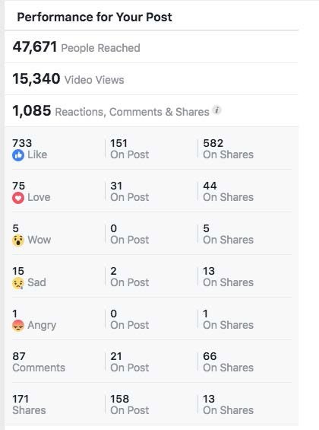Sam Flood (Graduate)
- participated in a social media campaign called 'Let's find Sam an internship' and is now working as a Pharmacist in Melbourne,
- 15,340 Views, 1,085 engaged, 171 Shared, 3 offers, 1 Job

Jeremy Muir (Griffith)

- working on a project to improve the internal employment of PwD,

Natalie Searson (Mylestones Employment)

- Has spent the last 12 months supporting graduated and graduating students with disabilities in their career search,

Kate Carroll (UOW)

- Specialises in providing career services to students from equity groups, including students with disability.

Audience Poll: What do you think?

Q: Why are graduates with disability not getting work at the same rate as peers without disability?

  - Employer attitudes

  - Students aren’t confident to disclose disability

  - Pervasive low expectations of PwD

  - Lack of experience in the workplace comparative to peers without disability

  - Other

Discussion Themes/Questions

- What can practitioners do to support the career success of graduates with disability?
- What kind of advice would you give to students to support successful disclosure?
- What needs to change to make a difference?

