A Pre-planning Toolkit
for people with an Intellectual Disability
interested in further study
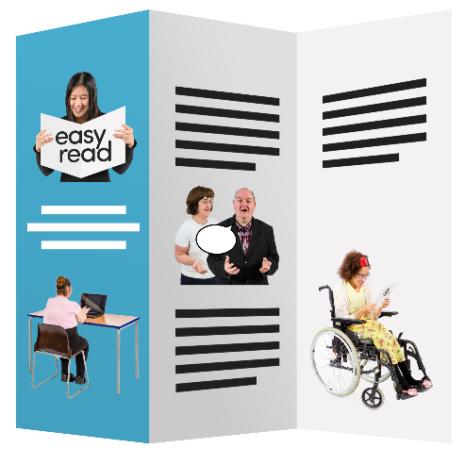

Getting the
Right Support
at the
Right time
from the
Right people

What is in this toolkit

About this toolkit 3
When you study after high school 4
You can get help to study 5
National Disability Insurance Scheme (NDIS) help 6
Help from where you study 8
You will need to pay for 10
What you need to do 11
Think about what you might need 12
A story about Rebecca 13
Off campus and distance students 15
Write notes here to help you talk to the NDIS or the place where you are going to study 16
Useful Links 17

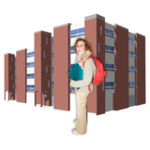
About this toolkit
This is a toolkit to help people with an intellectual disability who are going to study after finishing high school.
It talks about support that is available to help you study.

We have written this toolkit in easy English.
It is okay to get someone to help you read it.

There is a bigger toolkit with lots more information.

You can get the bigger toolkit at:
bit.ly/2m3JELk

This toolkit was made by the National Disability Coordination Officer Program.
We call it NDCO for short.

When you study after high school
You can -

Learn new skills

Feel good about yourself

- Make new friends

- Find a job easier

You can get help to study
Sometimes because of your disability you might need some extra help.
You have a right to extra support if you need it.

You can get help to study from –
The National Disability Insurance Scheme.
We call this the NDIS for short.

You can also get help from the place where you study like TAFE.

The help needs to be reasonable.
That means it must be fair.

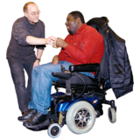
The help needs to be necessary.
Necessary means something you must have to help you do everyday things or study.

National Disability Insurance Scheme (NDIS) help
The NDIS can help you to be more independent.
Being independent means doing some things for yourself.

Things like:
Looking after yourself – like showering

Doing everyday things – like cooking

Getting to and from your course
The NDIS can help you learn how to catch the bus and be more independent.

Finding your classrooms

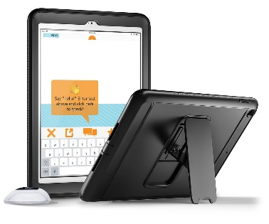
Things to help you communicate with others

Joining in to do things with other students

Talking to your teachers

Help from where you study
Where you study can help with –
Making sure the buildings are accessible

Giving you aides and equipment you need for your study

Reading and writing

Communicating with others if this is part of your study

Going places with other students if this is needed as part of your study

Using computers

Learning skills for work

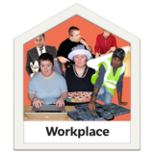
Try out workplaces

You will need to pay for
Your computer at home

Your books

The cost of the course.
Some courses are free.
You will need to check.

Your food and drink

What you need to do
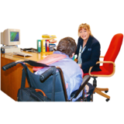
Most places where you might study have a person whose job it is to help students with disability.
They are called different names, they could be called
- Disability Liaison Officer
- Disability Advisor
- Disability Practitioner

You should meet with this person at least 4 weeks before you start.
You can take someone with you when you meet with them – this is a good idea.

A plan will be made to help you study.

You need to give a copy of this to the NDIA.

Think about what you might need
What helps you learn new things?

It is a good idea to talk to someone who has done this type of course before.
You could ask them:
- What did they do?
- What help did they get?
- Do they have any tips they can give you?
Talk to other people like your family and teachers.
Write a list of the things that help you learn best.
________________________________________________________________________________________________________________________________________________________________________________________________________________________________________________________________________________________

A story about Rebecca
Rebecca wanted to learn how to make soft toys to sell at a market.

So, Rebecca went to TAFE to do a Certificate II Course in Fashion Design and Technology.

Both NDIS and TAFE helped Rebecca do the course.
They helped her with her plans.

Rebecca’s NDIS plan paid for someone to
- help her get out of bed on time
- have a shower
- have breakfast
- take her medicine
- learn how to catch the bus to and from TAFE

TAFE paid for someone to
- help her in her classroom
- tell her what some words mean
- put things in Easy English
- tell her the small steps in her tasks

Off campus and distance students
Some students live a long way from places where they can study.
They may live in a rural area on a farm.
They can choose to study from home.
This is called distance education.

Distance education students can still get help from both NDIS and the place where they are doing their course.

If this might be what you want to do, talk to the Disability Liaison Officer and your NDIS planner.
They can give you more information.

Write notes here to help you talk to the NDIS or the place where you are going to study.

Questions I can ask the NDIS Planner
________________________________________________________________________________________________________________________________________________________________________________________________________________________________________________________________________________________________________________________________________________________________________________________________________________________________________________________________________________________________________________________

Questions I can ask the Disability Liaison Officer
________________________________________________________________________________________________________________________________________________________________________________________________________________________________________________________________________________________________________________________________________________________________________________________________________________________________________________________________________

Useful Links

This toolkit was made by the NDCO Program

You can find out more about us at:
www.adcet.edu.au/resource/9243/ndco-details

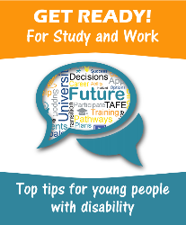
Getting ready for study and work – top 10 tips www.westernsydney.edu.au/getreadyforstudyandwork/resources/get_ready_top_tip_workbooks

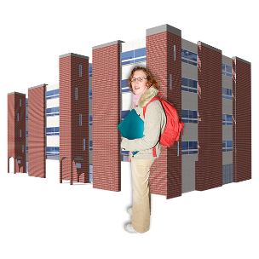
For more tips to help with your study
www.adcet.edu.au/students-with-disability/

© NDCO 2018. Checked and updated June 2021.
Easy English Translation by Speak Out Tasmania
and custom images, these images are not to be reproduced.

