New and under-used strategies for accessible graphics in higher education
Leona Holloway
leona.holloway@monash.edu
[slide 2]

Outline
- Background: OLT Project "Improving vision impaired students' access to graphics in higher education"
- Practical strategies for accessible graphics:
  - identifying which graphics need to be made accessible
  - choosing the most suitable technique for access
  - sharing expertise – groups and resources
[slide 3]

Our team
- Led by Monash and Deakin Universities
- Team members: Kim Marriot, Matt Butler, Leona Holloway & Cagatay Goncu (Monash IT), Merrin McCracken (Deakin Disability Services) & Tom Perry (Monash Disability Services)
- Expert reference group: University of Adelaide, Vision Australia, Department of Education (Vic), DIAGRAM Center (USA), consumer representative
- External evaluator: Matt Brett
[slide 4]

Accessible graphics in HE
- OLT Project: "Improving vision impaired students' access to graphics in higher education"
- Stage 1: Information gathering
  - National survey of 71 VI students
  - Interviews with 42 Students, academics, disability services staff and accessible format providers
[slide 5]

Findings – level of access
Vision impaired students lack access to graphics:
- 84% skip graphic materials of potential value because it is inaccessible
- 94% could benefit from improved graphics
- 50% avoided a potential area of study or career due to concerns about access
- Higher participation in Society and Culture (43% vs 24%)
- Lower participation in STEM (11% vs 24%)
[slide 6]

Accessible graphics project continued
Stage 2: Pilot studies
- Working with 8 students and their disability advisors, lecturers, tutors and accessible formats providers
Stage 3: Recommendations
- Workshop with participants and contributors to the project
[slide 7]

Principles for improving vision impaired students' access to graphics in higher education
http://accessiblegraphics.org/research/principles/
[slide 8]

1. Communication & shared responsibilities
1. Support for the learning requirements of vision impaired students requires communication and shared responsibilities between students, academics, support staff and specialist services.
- Roles and responsibilities must be understood and agreed to by all stakeholders.
- Foster effective and timely formal (and informal) communication processes between all stakeholders
- Formal mechanisms are required to capture and distribute feedback regarding disability services
[slide 9]

2. Inclusive teaching strategies
2. Many of the learning requirements of vision impaired students can be addressed through inclusive teaching strategies.
- Improve disability awareness among academics.
- Encourage use of teaching strategies that improve accessibility and learning outcomes for all students.
[slide 10]

3. Specific learning requirements
3. Vision impaired students have specific learning requirements for which higher education institutions are obligated to provide appropriate services and support.
- Students with disabilities require specialised support for transition to higher education.
- Vision impaired students require resources and skills to access materials independently. Universities should assist students in acquiring these.
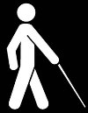
[slide 11]

4. Strategies for accessible graphics
4. Vision impaired students require further specialized support, including the use of appropriate strategies for accessible graphics.
- Consideration is given to the multiple roles that graphics play in the overall learning experience.
- Application of appropriate technologies and practices to make graphics accessible, as best suited to the individual student, content and context.
- Use national networks and partnerships to share expertise, best practice and resources and keep up-to-date with changes in technology and the teaching environment.
[slide 12]

Applying the principles
- Suggested strategies accompany the principles
- http://accessiblegraphics.org/research/he/principles/
- Workshops available to explore how to apply the strategies at your institution
[slide 13]

Identifying which diagrams need to be made accessible
[slide 14]

Identifying which diagrams need to be made accessible – the problem
- Everything?
- Student request?
"I don't know what to ask for"
"It takes a lot to be able to stand up and say 'I've got this condition and I can't do it'"
- Lecturer?
"I wouldn’t want to go through and identify which graphics I think are needed ahead of time because … I could spend a lot of time worrying about something that [the blind student is] perfectly able to access already."
- Tutor?
[slide 15]

Identifying which diagrams need to be made accessible – some ideas
- Recognise the importance of ALL graphics
- Student needs minimum level of information about diagrams so they can make a decision about which they need to access more fully
- Lecturer can identify which diagrams will be needed for assessment. These should provided in same format that will be used for the exam.
[slide 16]

Choosing a format
http://accessiblegraphics.org/formats/choosing
[slide 17]

Enlargement
- Most common method for accessing graphics for students with low vision in HE
- Disadvantages:
  - Original needs to be good quality (high resolution and high contrast)
  - Difficult to get an overview
  - Can cause headaches and fatigue
screen magnification
[slide 18]

Verbal descriptions
- Most common method for accessing graphics for blind students in HE
  - Least preferred method for accessing graphics
  - Lecturers don't have time to give full descriptions
  - Students, family and friends are unable to give adequate descriptions
  - Does not foster or allow for independence
Enlargement and verbal descriptions are good starting points, but may need to be supplemented with other methods.
[slide 19]

Written descriptions
Advantages:
- allows for more independent study
- useful as accompaniment to other formats (enlargement or tactile graphics) to provide overview and assist with navigation
- can also be helpful for other students in the class
Overcoming difficulties:
- Subject matter knowledge needed – ask a tutor or follow an example written by the lecturer
- Links to training resources given at http://accessiblegraphics.org/formats/descriptions/
[slide 20]

Image description apps
- Take a photograph and receive a brief description
- Advantages:
  - Instant and independent access
  - Gives an indication of type of diagram and whether further access is required
- Examples
  - TapTapSee http://taptapseeapp.com/
  - IRIS for maths and science content. Call for beta testers at www.grapheel.com
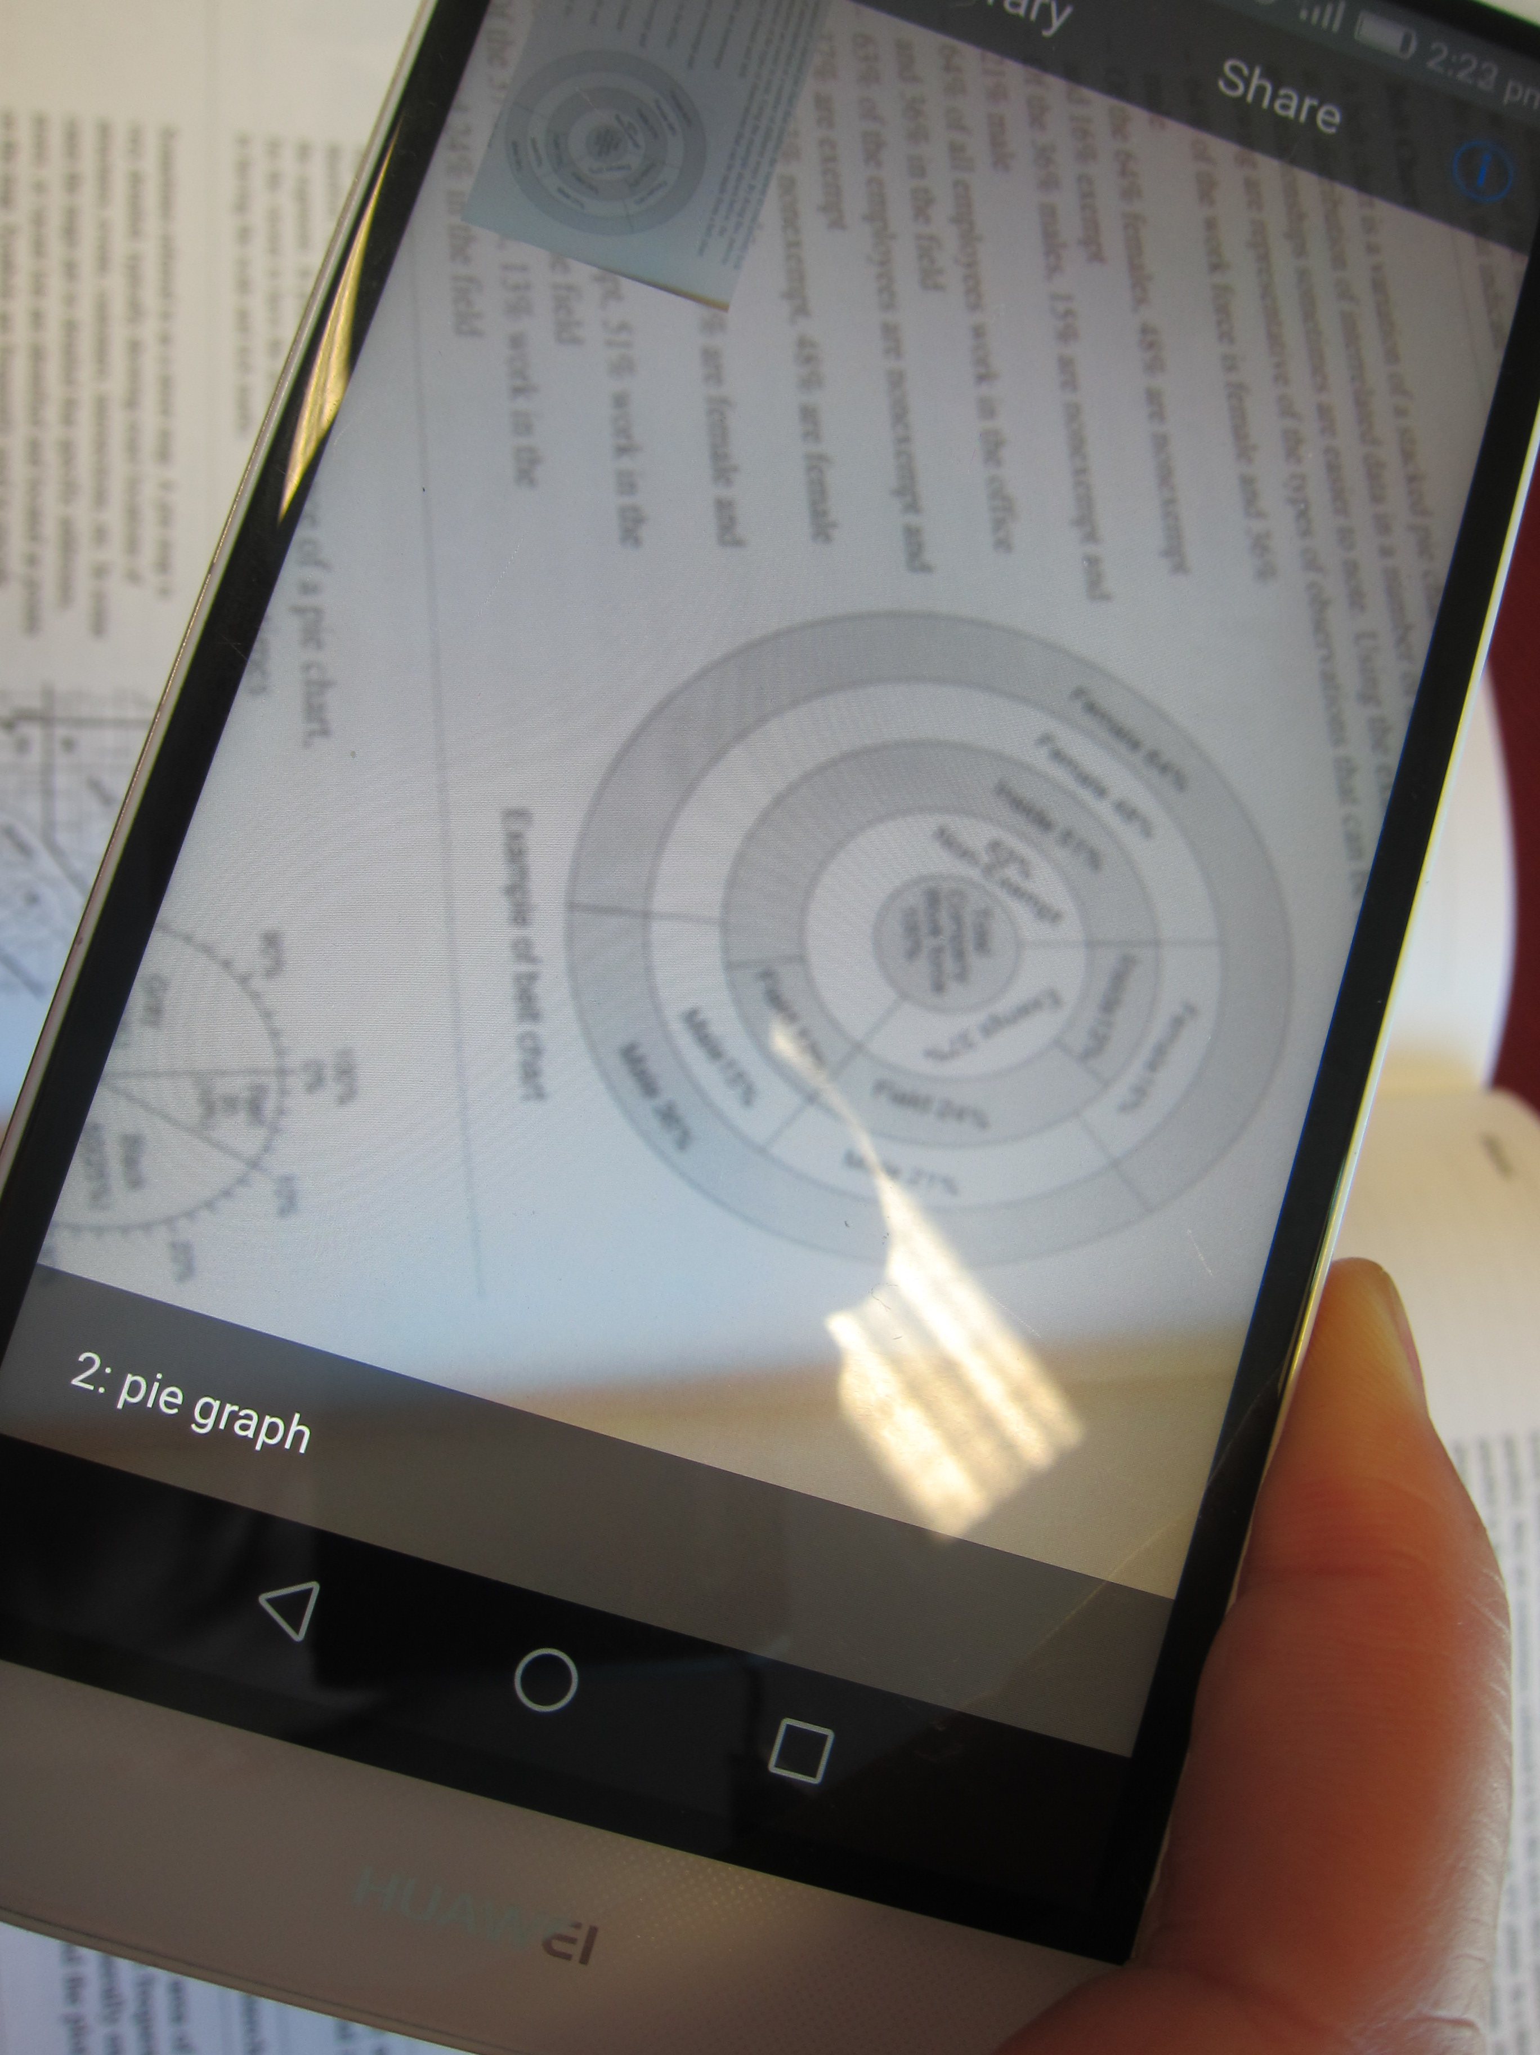
"pie graph" identified using TapTapSee
[slide 21]

Sonification
Data or equation converted to audio tones. Works best for line graphs.
Advantages:
- Independent and instant access
- Does not require tactile literacy
e.g. MathTrax by NASA
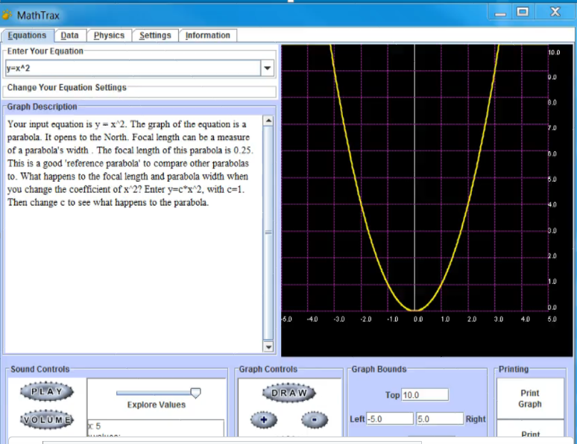
MathTrax
[slide 22]

Statistics
- R
  - The most accessible statistics package for navigation and use
  - BrailleR package provides descriptions of graphs and ability to automatically output graphics as tactile graphics
  - Information and Blind R Users Group (BlindRUG) email listserv available at https://www.nfbnet.org/mailman/listinfo/blindrug_nfbnet.org
- SAS Graphics Accelerator
  - Free add-in for SAS University Edition
  - Gives description, sonification and data
  - Works for all graphs created using SAS
[slide 23]

GraVVITAS
- Author tool to create simple graphics with associated audio tones and labels http://www.raisedpixels.com/graauthor/#
- Reader app by Raised Pixels from the app store
- Best suited to:
  - diagrams with spatial component
  - diagrams with lengthy labels
  - quick in-house production
  - students who do not want to use tactile graphics
- Available for (free) use but still in development. Please contact cagatay.goncu@monash.edu
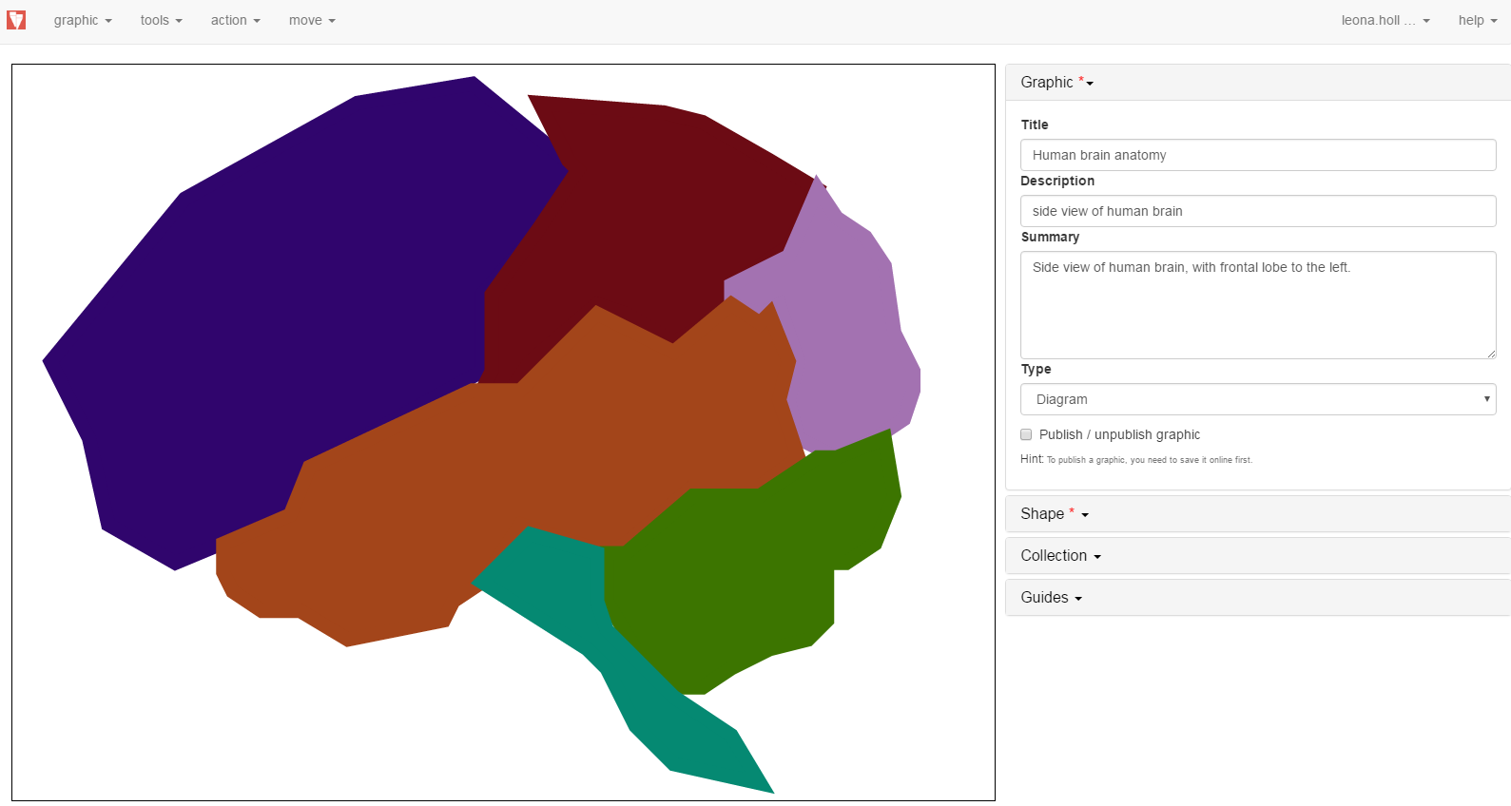
GraVVITAS Author tool
[slide 24]

Tactile graphics
- Widely recognised as the ideal format for graphics with spatial information
  - Only required for around 5-10% of graphics
- Under-used
  - only 30% of tactile literate students receive tactile graphics at university
  - concern regarding tactual literacy
  - concern regarding cost and time for production
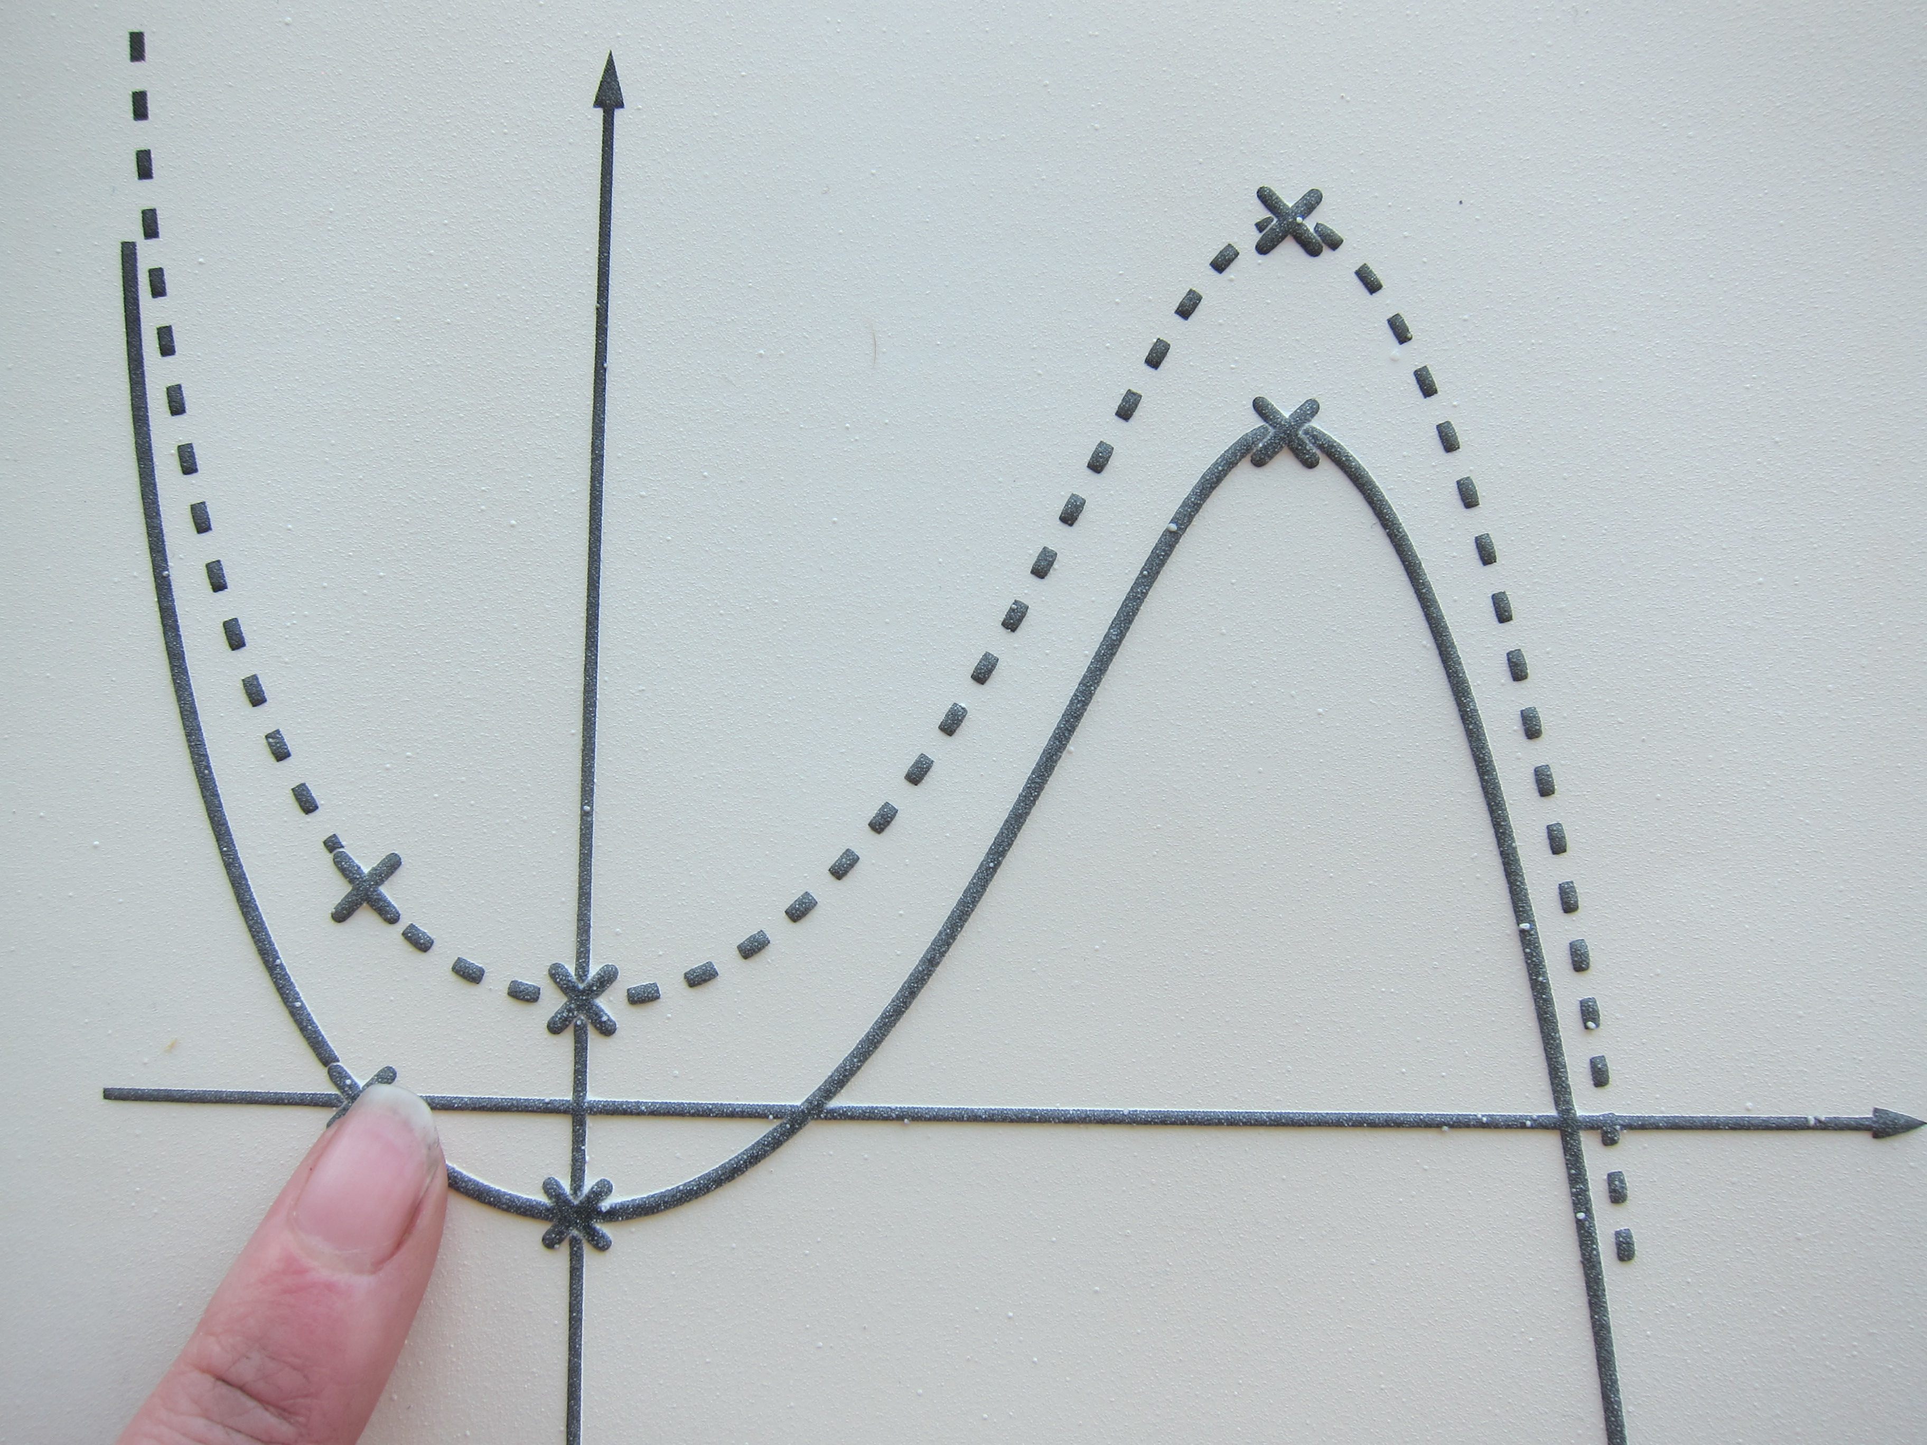
tactile graphic
[slide 25]

Tactile graphics – overcoming barriers
- If a tactile graphic will be used in the exam, give exposure to similar tactile graphics during semester
- Accompany with written or verbal description giving type of diagram and direction for reading to aid with navigation; and with labels for non-braille readers
- Quick handmade tactile graphics
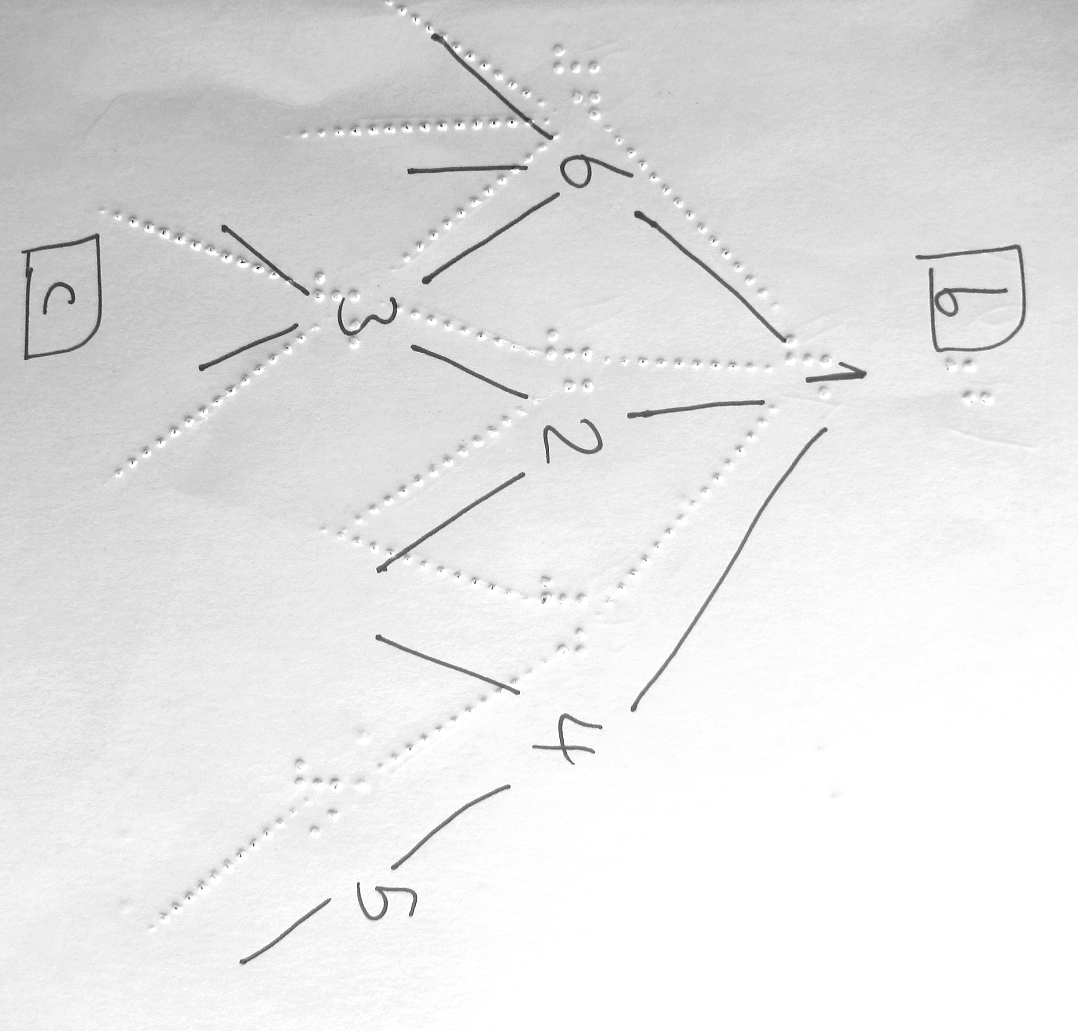
handmade tactile graphic
[slide 26]

3D models
- Advantages:
  - more intuitive for blind students
  - appealing and inclusive for all students
  - becoming more readily available as pre-existing objects, open source models for 3D printing, or custom-designed for 3D printing
- Resources:
  - http://accessiblegraphics.org/formats/3d/
  - Upcoming workshop at 2017 Round Table Conference in Perth (May)
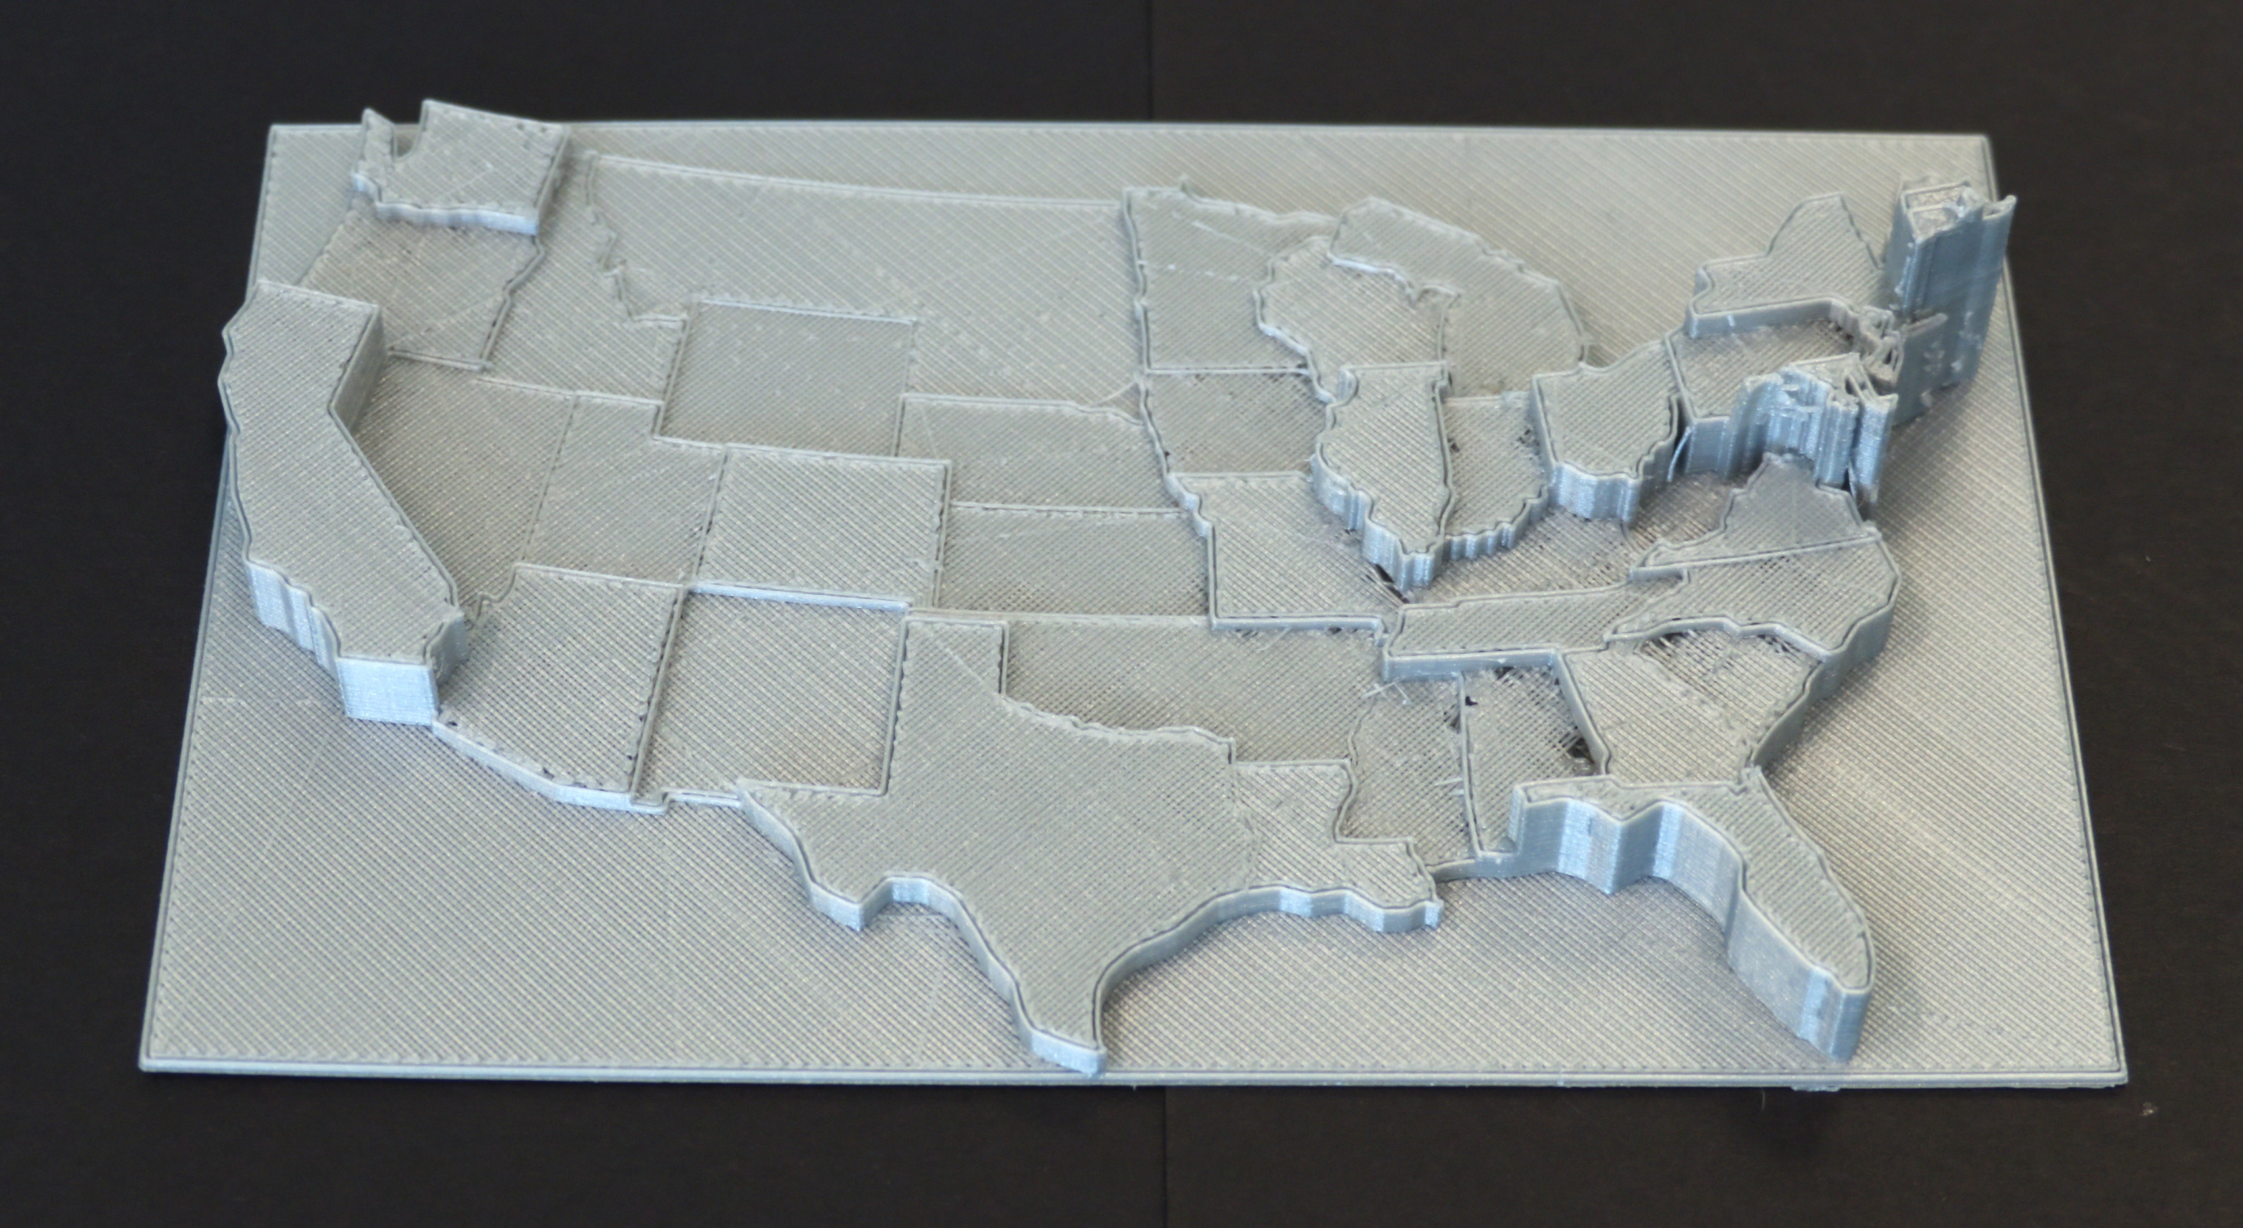
Population density of USA, represented in 3D
[slide 27]

Summing up
- Diagrams and graphics are an important component of access to learning and environment in higher education
- Provision of access to graphics does not need to be difficult
  - Match the strategy to the student and situation
  - Join communities and communicate to share expertise
  - Best practice is within reach
- Help students reach their true potential
"Statistics was a very challenging unit for me and there were several hurdles along the way. I couldn't have achieved such a high result without the help from each of you" – blind student to disability advisors, academics, accessible formats providers and the project team
[slide 28]

For more information
- Butler, M., Holloway, L. M., Marriott, K. & Goncu, C. (2016). Understanding the graphical challenges faced by vision-impaired students in Australian universities, Higher Education Research & Development
- http://accessiblegraphics.org/he
- Contact us:
  - at Leona.Holloway@monash.edu, Kim.Marriott@monash.edu and Matthew.Butler@monash.edu
  - Available for local workshops, e.g. how to apply the principles for your circumstances
  - Interactive 3D campus models
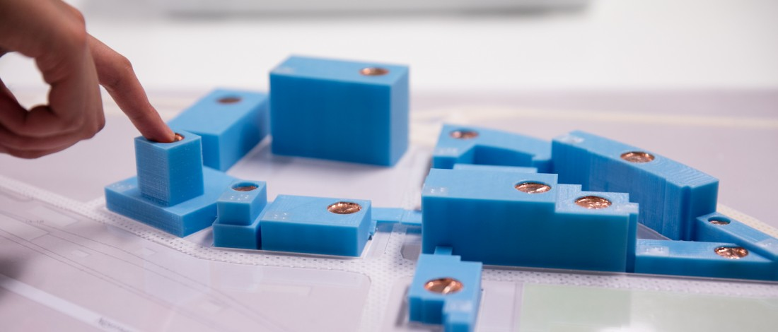
3D map of Monash Caulfield with audio touch points

