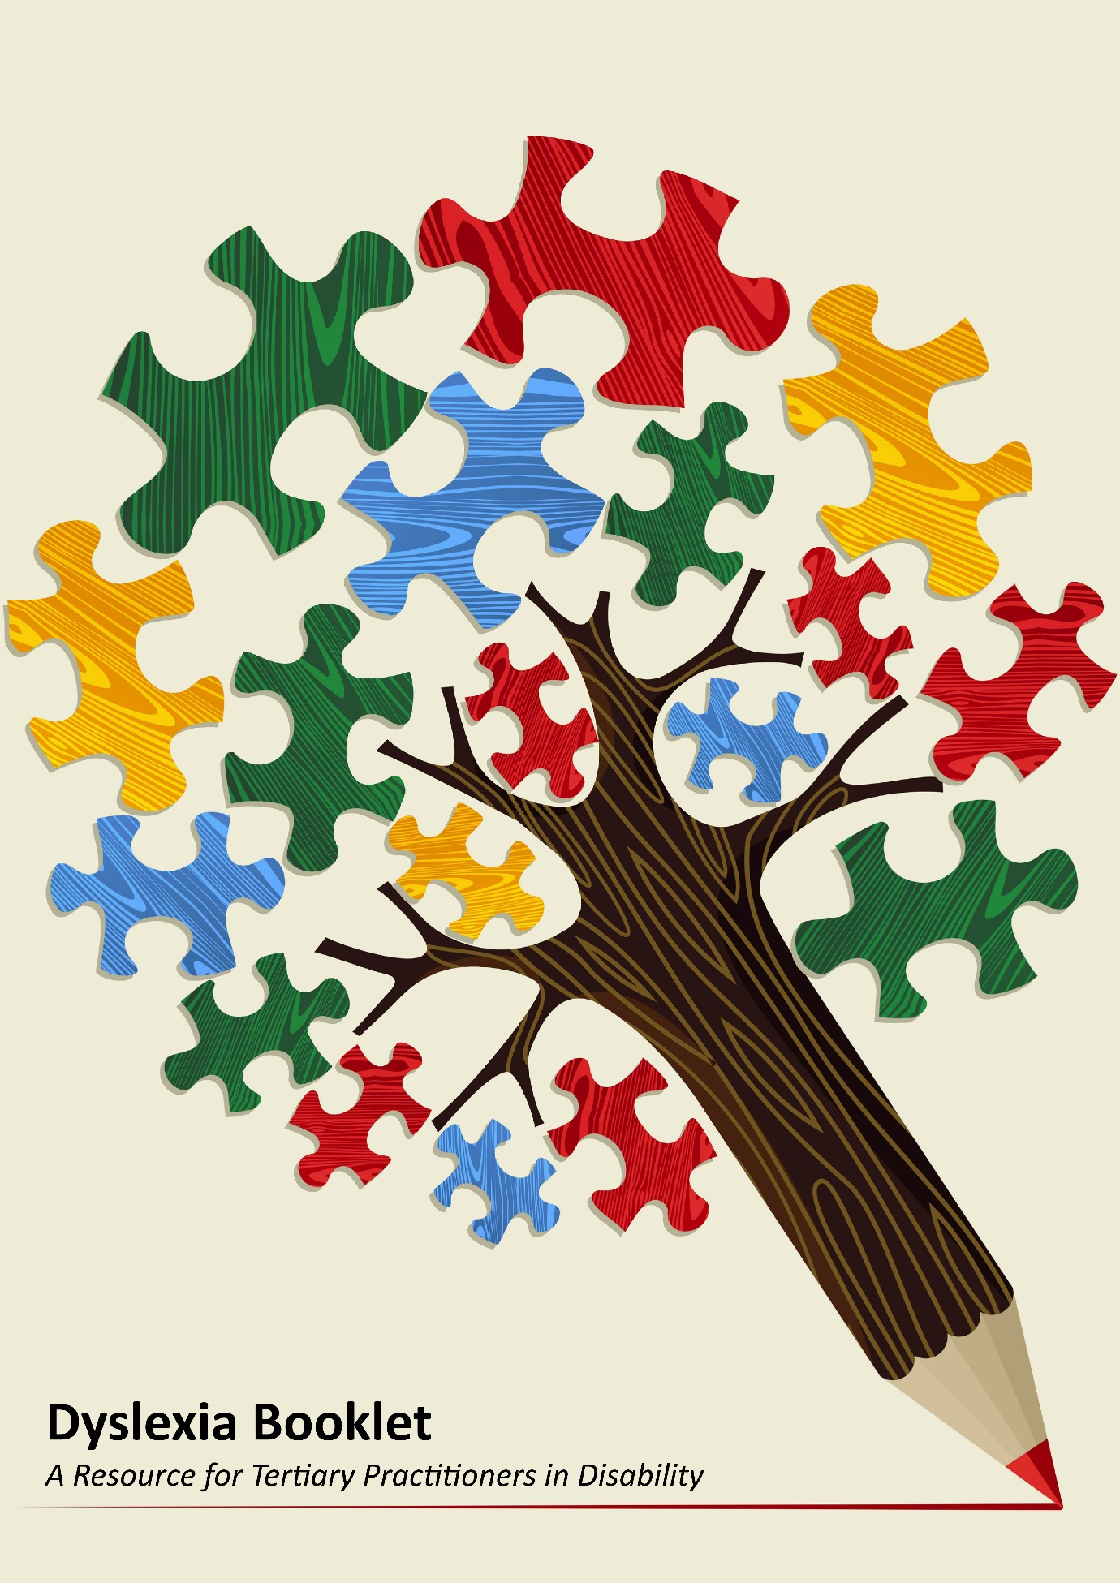

Dyslexia Booklet:
A Resource for Tertiary Practitioners in Disability Services
Acknowledgment of Country
We acknowledge the traditional custodians of this country and pay respect to Aboriginal Sites, Culture and to past, present and future Elders.
Acknowledgements
This resource was developed by Tania Perez from the Inner Melbourne VET Cluster (IMVC), National Disability Coordination Officer Program and Martin Kelly, Inclusive Technology Consultant.

Martin Kelly
Inclusive Technology Consultant
www.mkellyconsulting.com.au

Purpose

This booklet aims to assist practitioners working in Disability Services within the tertiary sector who are responsible for planning and implementing reasonable adjustments for students with dyslexia, including assistive technology. It provides a legislative framework, information about dyslexia and reasonable adjustments, case studies and further information and resources.

Please contact us if you have any feedback and ideas about this Booklet:
National Disability Coordination Officer Program
Inner Northern Region of Melbourne at IMVC
Level 1, 71 Palmerston Crescent
South Melbourne, Victoria 3205
P 03 9686 2354
W www.imvc.com.au

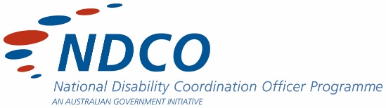
The IMVC is committed to the social inclusion of all, and is passionate about providing opportunities for the wider community to enhance capabilities in applied learning and vocational education and training.

Table of Contents
Section 1: What the Law Says 4
1.1 Overview 4
1.2 What the DDA Does 4
1.3 Definition of Disability 4
Section 2: Dyslexia 7
2.1 Definition of Dyslexia 7
2.2 Characteristics of Dyslexia 7
2.3 Skills Affected by Dyslexia 8
Section 3: Tertiary Disability Services 9
3.1 Registration Process 9
3.2 Documentation 9
3.2.1 General Requirements 10
3.2.2 Documentation for Students with Dyslexia 10
Section 4: Reasonable Adjustments 11
4.1 General Learning Environment 11
4.1.1 Teaching Strategies 11
4.1.2 Recording of Information 12
4.1.3 Formatting of Text 12
4.1.4 Additional Time 13
4.2 Exams Tests and Quizzes 13
4.2.1 Extra Time 13
4.2.2 Technology and Formatting 13
4.2.3 Other 14
Section 5: Case Studies 16
5.1 Higher Education Case Study – Yasmin 16
5.2 TAFE Case Study - David 17
Section 6: Assistive Technology Resources 18
6.1 Recording and Notetaking 18
6.2 Voice Recognition and Dictation 18
6.3 Text-to-Speech 19
Section 7: Further Information 20
7.1 General Services 20
7.2 Victorian Assessment Providers 21

Section 1: What the Law Says
1.1 Overview
The Federal Disability Discrimination Act 1992 (DDA) provides protection for everyone in Australia against discrimination based on disability.
Disability discrimination happens when people with a disability are treated less fairly than people without a disability. Disability discrimination also occurs when people are treated less fairly because they are relatives, friends, carers, co-workers or associates of a person with a disability.

1.2 What the DDA Does
The DDA implements Australia’s international human rights obligations under the Convention on the Rights of Persons with Disabilities as well as obligations relating to non-discrimination under other treaties, including the International Covenant on Civil and Political Rights.
The DDA protects people with disability against discrimination and harassment in many areas of public life, including education in terms of enrolling or studying in a course at a private or public school, college or university
The DDA provides a mechanism for individuals to make complaints and seek redress for disability discrimination.
Further information on the DDA can be found on the Australian Human Rights Commission’s website at:
https://www.humanrights.gov.au/our-work/disability-rights/guides/brief-guide-disability-discrimination-act

1.3 Definition of Disability
The Definition of Disability in the Disability Discrimination Act is broad and includes:
- Total or partial loss of body function or a body part

- The presence of organisms (such as HIV or Hepatitis C) that may cause disease or disability, malformation or disfigurement of the body

- Mental or psychological diseases or disorders

- Conditions or disorders that may result in a person learning more slowly
Disability can be temporary or permanent and includes:
- Physical
- Intellectual
- Sensory
- Neurological
- Learning
- Psychosocial disabilities
- Diseases or illnesses
- Physical disfigurement
- Medical conditions
- Work-related injuries

It extends to disabilities that people have had in the past and potential future disabilities, as well as disabilities that people are assumed to have

Further Information:
A more detailed explanation of the definition of disability can be found at:
https://www.humanrights.gov.au/dda-guide-who-does-dda-protect

1.4 Disability Standards for Education
The Disability Standards for Education 2005 were formulated under the Disability Discrimination Act 1992.
The Standards clarify the obligations of education and training providers and seek to ensure that students with disability can access and participate in education on the same basis as other students.
Under the Standards, education providers have three main types of obligations. They must:
• Consult
Education providers must consult in order to understand the impact of a student’s disability and to determine whether any adjustments or changes are needed to assist the student.
• Make reasonable adjustments
The Standards set out a process whereby education providers can meet the obligation to meet reasonable adjustments where necessary.
• Eliminate harassment and victimisation
The Standards require that education providers develop and implement strategies to prevent harassment and victimisation of people with disability.

Further information and Fact Sheets can be found at:
https://www.education.gov.au/disability-standards-education
There are fact sheets on the Disability Discrimination Act 1992, the Disability Standards for Education 2005, Parental Engagement, Effective Consultation and Complaints Processes.

Section 2: Dyslexia
2.1 Definition of Dyslexia
Learning Disability is a term for a variety of disorders which affect a person’s ability to develop literacy and numeracy skills.
The word dyslexia comes from the Greek language and means difficulty with words.
No two individuals with dyslexia are alike. Dyslexia occurs on a continuum from mild to severe.
Dyslexia is a type of learning disability that primarily affects an individual’s ability to read and spell despite having the ability to learn.
Dyslexia is neurological in origin and is characterised by difficulties with accurate and/or fluent word recognition and by poor spelling and decoding abilities.
Secondary consequences may include difficulties with reading comprehension and reduced reading experience that can affect the development of vocabulary and background knowledge.

2.2 Characteristics of Dyslexia
Characteristic features of dyslexia are difficulties in phonological awareness, verbal memory and verbal processing speed as outlined:
- Phonological awareness is defined as the ability to identify and manipulate the sounds in words.

For example, phonological awareness would be demonstrated by understanding that if the ‘p’ in ‘pat’ is changed to an ‘s’, the word becomes ‘sat’.

- Verbal (phonological short-term) memory is the ability to retain an ordered sequence of verbal material for a short period of time.

For example, it is used to recall a list of words or numbers or to remember a list of instructions.

- Verbal processing speed is the time taken to process familiar verbal information, such as letters and digits.

Difficulties in these areas can be thought of as reflecting disorders in the systems that are involved in processing information about word sounds (phonology).

Please note: information for ‘Characteristics of Dyslexia’ has been sourced from SPELD Victoria. Further information can be found at:
http://www.speldvic.org.au/information-for-parents/dyslexia-and-ld

2.3 Skills Affected by Dyslexia
In practice people with dyslexia often find it hard to:
- Retain spoken information within their short-term memory systems

- Access spoken information from long-term memory

- Reflect on the units of sound within words.

These difficulties impact on the learning of vital aspects of reading and writing, such as encoding, decoding, segmenting and blending.
Information for ‘Skills Affected by Dyslexia” has been sourced from SPELD Victoria at:
http://www.speldvic.org.au/information-for-parents/dyslexia-and-ld

Section 3: Tertiary Disability Services
3.1 Registration Process
Each disability service provider in the tertiary sector has their own registration process and terminology may also vary. Within the context of the Disability Discrimination Act 1992 and the Disability Standards for Education, there are general steps taken in the registration process across all providers.
The general process is as follows:
- The student is required to meet eligibility criteria to register with Disability Services at the respective tertiary provider. The two main criteria include:

- Be enrolled in a relevant program or course
- Have a disability as per the Disability Discrimination Act definition or be a primary carer

- The student completes a Registration Form which usually includes consent to release information.

- The student provides relevant documentation (refer to documentation section)

- The student organises an appointment with a Disability Advisor, which can be a phone appointment, to discuss and agree on reasonable adjustments.

An assessment is made by the Disability Advisor at this appointment in which reasonable adjustments are considered in the context of the nature of the student’s disability, the documentation provided and the program or course requirements. Further documentation may also be requested if necessary.

- Reasonable adjustments are set out in a plan and distributed to relevant academic staff and student services staff.

3.2 Documentation
Disability Services require suitable documentation to organise reasonable adjustments for students with disability that are eligible to register with the service.

3.2.1 General Requirements
In general students are required to provide original copies of supporting documentation outlining the nature of their disability and its impacts in the academic context.
Documentation can be provided on a Registration or Supporting documentation form provided by the Disability Service which needs to be completed by an appropriate medical practitioner, psychologist or other accredited health or educational specialist.
Alternatively, other documentation from an appropriate practitioner can be provided indicating:
• The nature of the disability
• The impacts of the disability on a student's study
• Any previous adjustments provided in an educational setting
• Recommended academic adjustments
• Whether the disability is short-term, fluctuating or permanent
• How long the documentation is valid for
The specific requirements of documentation may vary depending on the nature of the disability and the adjustments requested.

3.2.2 Documentation for Students with Dyslexia
Students with dyslexia are required to provide a full psychological or educational assessment report.
The assessment is to have been completed by a Psychologist with significant experience in working in education. The report needs to be comprehensive and written by the Psychologist who administered the assessment.
Assessments should be completed after the age of 16 or an update may be required.

An assessment report will:
- Advise whether dyslexia is the underlying reason for a person’s learning problems

- Provide recommendations and strategies to assist the individual, including learning strategies and study accommodations in relation to academic studies

- Provide an overview of the individual’s strengths and weaknesses
Section 4: Reasonable Adjustments
Reasonable adjustments may vary from one individual to another depending on a range of factors including the nature of their dyslexia, inherent requirements of their program of study, recommendations from their learning assessment and preferences of the individual.
As a student is assisted in their transition into adult learning by disability services and other areas of the institution their reasonable adjustments may also change over time. The building of confidence and independence through mentoring programs, assistive technology and study skills development may result in a student approaching learning and assessment tasks with new skills and strategies, a progression from when they first commenced their post-secondary education.
Reasonable adjustments listed below include commonly used recommendations and should not be considered as an exhaustive list.

4.1 General Learning Environment
The general learning environment includes lectures, tutorials and laboratory classes.
4.1.1 Teaching Strategies
These may include:
- Providing PowerPoint slides, handouts and in-class exercises prior to class so the student has extra time to read them

- Verbalising text that is written on white boards

- Providing reading materials early to allow for any necessary alternative formatting to occur prior to classes

- Providing a list of subject area terminology to give the student an opportunity to become familiar with new vocabulary

- Providing opportunity for one-to-one catch up time so the student can seek clarification on course content and expectations

- Providing guidance on selecting readings in reading lists so the student has time to access relevant information within given timeframes

- Referral to learning advisors for the purpose of developing study skills relevant to the area of study
4.1.2 Recording of Information
Information presented in class can be recorded by:
- Lecture capture video and audio recording facilities within teaching venues

This option may require the teacher responsible to ensure that lecture capture is enabled and to upload the recording into the learning management system to make it available to students

- Personal audio recording

Livescribe smartpens allow students to audio record information in class by use of recording technology in a digital pen that allows playback to be synchronized with hand written notes

AudioNote is a similar technology that can be used on tablets and laptops. These options only require the student to write minimal notes or none at all
Sonocent Audio Notetaker is software that audio records and breaks the recording up into managable chunks which can be colour coded and have notes, images and slides added

- Notetaker

A notetaker attends class and writes notes for the student and when appropriate will type notes electronically so the student can use their text-to-speech software to read them

4.1.3 Formatting of Text
Students with dyslexia may be using assistive technology such as text-to-speech software (e.g. Read & Write TextHelp, TextAloud or Claroread). In this case the following recommendations are relevant:
- Books and readings to be in accessible electronic format (e.g. Microsoft Word format, non-image PDF or HTML)

- All in-class materials to be produced in accessible electronic format

- Notes written including those written by the teacher (e.g. feedback on assignments) or by a notetaker should be in accessible electronic format
4.1.4 Additional Time
- Extra time can be given for assignments

The process for organising an extension for an assignment should be as simple as possible and understood by the student and teaching staff

4.2 Exams Tests and Quizzes
Where an exam, test or quiz is online it may be necessary for the teacher to factor in extra time to modify the online platform’s pre-set time limits to provide reasonable adjustments.

4.2.1 Extra Time
- Reading time

For exams that start with reading time extra time should consider the amount of reading required

- Writing time

Extra writing time for each hour of writing time should consider the amount of writing required for the student

- Rest time

This can also be organised for each hour of writing time and reading or writing is typically not allowed during rest breaks

4.2.2 Technology and Formatting
Technology options can be organised in consideration of formatting requirements.
- Computer

The use of a computer allows students to correct mistakes more easily and the standard features of word editing software (e.g. spell check) may also assist students

- Text-to-speech software

Students may use this software to have question papers and their written answers “read” back to them by a life-like electronic voice

- Voice dictation software

For example ‘Dragon NaturallySpeaking’ and other similar software allows the student to dictate their answers with the software converting their spoken words to electronic text

- Mind mapping software

For example ‘iMindMap and Inspiration’ and other similar software can assist students as a visual way of “mapping” ideas to plan the draft of an essay style question

- Format of question paper

An accessible format of the question paper will be required for text-to-speech users

- Electronic format of answers

It should be explained to exam and test administrators that the student’s answers will be in electronic format when this reasonable adjustment has been made

4.2.3 Other
- Reader scribe

A reader scribe may be required for students for whom assistive technology is not appropriate

- Words list

This recommendation allows students to write down a list of words that they would like to take into the exam with them for the purpose of assisting them with spelling

It is recommended that the list is given by the student to the examiner for checking prior to the exam and then the approved list is provided to the student at the start of the exam

- Room on own

If a student is using voice recognition software they will need to be seated in a room on their own for tests and exams so they can speak aloud without being concerned about disrupting others

- Exemption from spelling and grammar

In some circumstances this may be considered when assistive technology or a scribe are not an option

Section 5: Case Studies
Just as reasonable adjustments vary from one individual to another so does the general experience of each student. In the following case studies course content and format, technology resources available with the educational institution and the development of independent study skills are just some of the factors that make each story unique.
Please note that both case studies are fictional.
5.1 Higher Education Case Study – Yasmin

Yasmin is a Bachelor of Arts student. She did not know about assistive technology until she came to university. Yasmin was introduced to text-to-speech software, voice dictation software and a smartpen. Alternative formatting of course books, (that were not commercially available in an accessible format), were also organised for her. Yasmin was successful in applying for a grant for Read & Write Gold and Dragon NaturallySpeaking. Disability Services provided Yasmin with a Livescribe Smartpen and her teachers were asked to use lecture capture to record classes.
Yasmin is enthusiastic about assistive technology and finds that books in an accessible format together with her text-to-speech software means that she can read study materials independently. She also finds that she can write her assignments independently. Yasmin keeps in contact with Disability Services throughout the year to seek advice and if necessary to review her access plan.
For first semester Yasmin decided to use a scribe in exams as she wanted more experience with Dragon NaturallySpeaking prior to using it for exams. By semester two exams however, she had become more confident and started using Dragon for some of her exams.
Yasmin found that she used a variety of means to access information in class. The smartpen was particularly useful for tutorials where lecture capture was not used. For a couple of subjects Yasmin did request a notetaker as lecture capture was not an available option. Furthermore, the lectures had a lot of information that needed notes written so that Yasmin could prepare for weekly tests. Yasmin has also started to use Sonocent Audio Notetaker for these classes and is finding that it allows her to listen to the audio in manageable chunks and add information.
When Yasmin is having difficulty understanding information presented in class she organises for a one-to-one consultation with the lecturer/tutor. She asks questions during these sessions and shows the lecturer/tutor the particular areas she is struggling with. Yasmin also makes sure the lecturers/tutors have a copy of her learning plan so they have strategies on how they can assist her.

5.2 TAFE Case Study - David

David is studying Diploma in Fitness. Most reading materials are accessible PDFs, online articles as well as materials that his teachers produce. They are generally in an accessible format but his teachers forward files they may need formatting to Disability Services for processing.
David uses a number of assistive technologies. As well as using text-to-speech software he has an app called Prizmo on his smartphone that can photograph a page or more of text, convert it into an accessible format and then “read” it aloud to him. He finds this comes in handy in situations when there is a hardcopy of text that he needs to read quickly. This technology is particularly useful for his work placement.
Most of his classes are of a workshop seminar style and are in venues that did not have lecture capture facilities. David found that a smartpen was a suitable way for recording the information he needed to refer back to. If there are discussions in class of a confidential nature he stops recording.
David’s course does not have any exams but there are brief tests at the end of some classes. As the tests consist of questions that require short answers he finds that he does not need to use his voice dictation software and that the extra writing time and use of his text-to-speech software for reviewing his answers is all he requires.
As some of his assignment due dates are close together he uses his assignment extensions to stagger them. His class sizes are relatively small so there is a good rapport between him and his teachers. This has assisted in teachers developing good knowledge of his access plan.

Section 6: Assistive Technology Resources
There is a broad range of assistive technologies available however this section provides further information on technologies that are commonly used to assist students with dyslexia.
6.1 Recording and Notetaking
- Livescribe Smartpen
This digital pen synchronises audio recording to hand written notes.
http://www.livescribe.com/au/smartpen/echo/
- Audionote
Audionote is a similar technology to the smartpen however notes are typed or written using finger stroke on a tablet or laptop.
http://luminantsoftware.com/iphone/audionote.html

6.2 Voice Recognition and Dictation
- Sonocent Audio Notetaker
This product audio records and breaks the recording up into manageable chunks which can be colour coded. Notes, images and slides can be added as well as questions to test their knowledge of the content.
https://www.sonocent.com/en-us/audio-notetaker

- Dragon NaturallySpeaking
Dragon is the leading voice recognition/dictation software. Student licenses are available at discounted costs.
http://australia.nuance.com/dragon/index.htm

6.3 Text-to-Speech
- Read and Write Gold TextHelp & ClaroRead
These products are user friendly text-to-speech software options that also provide other literacy assistance functions. There are a variety of versions available of each product.
https://www.texthelp.com/en-gb
https://www.clarosoftware.com/

- TextAloud
TextAlound is an affordable text-to-speech software, however it has less functions than other similar software.
http://nextup.com/TextAloud/

- ImindMap & Inspiration
Mind mapping software provides users a visual way of representing their ideas.
http://imindmap.com/
http://www.inspiration.com/visual-learning/mind-mapping

- Prizmo
This affordable app scans, performs optical character recognition and reads using text-to-speech. It is available for smartphones and MAC computers.
http://www.creaceed.com/iprizmo

Section 7: Further Information
7.1 General Services
AUSPELD
AUSPELD is the Australian Federation of SPELD Associations that provide information, resources, articles, and useful links with the aim of supporting people with learning disabilities.
http://auspeld.org.au/

State SPELD Associations:
Each state organisation operates differently however they all provide advice, support or services to assist you or someone you know with a specific learning difficulty.
Dyslexia-SPELD Foundation Western Australia Inc.
Email: support@dsf.net.au Web: www.dsf.net.au
SPELD New South Wales
Email: enquiries@speldnsw.org.au Web: www.speldnsw.org.au
SPELD South Australia
Email: info@speld-sa.org.au Web: www.speld-sa.org.au
SPELD Queensland
Email: speld@speld.org.au Web: www.speld.org.au
SPELD Victoria
SPELD Victoria provide information and services to children and adults with Specific Learning Difficulties and for carers and professionals.
http://www.speldvic.org.au/

Australian Dyslexia Association
The Australian Dyslexia Association provide information and resources to identify and assist individuals with dyslexia and they provide a pre-assessment service.
http://www.dyslexiaassociation.org.au/

7.2 Victorian Assessment Providers
The following specialist services provide psychological and/or educational assessments:
Jennifer Finemore Psychologist M.A.P.S.
Jennifer conducts psychological and educational assessments for children and adults who are experiencing learning issues and/or difficulties with reading, writing or spelling. Jennifer also provides counselling and conducts professional development workshops in relation to learning disabilities.
Contact details:
Wattletree Psychology
Address: Suite 1B/ 307 Wattletree Road-Malvern East
Telephone: (03) 9500 0455
Email: jennifer.finemore@psych-assessments.com.au
http://psych-assessments.com.au/psych-assessments.com.au/Assessments.html

SPELD Victoria
Address: 60 High Street Preston, Victoria
Telephone: (03) 9480 4422
http://www.speldvic.org.au/2014-10-28-22-51-19/assessments
For other states:
Please refer to the SPELD in your state as listed in General Services, Section 7.1.

The following tertiary institutions provide psychological and/or educational assessments:
Australian Catholic University
Melbourne Psychology and Counselling Clinic - Fitzroy
Telephone: (03) 9953 3006
Email: melbournepsychologyclinic@acu.edu.au

La Trobe University
Psychology Clinic – Bundoora
Telephone: (03) 9479 2150

Monash University
Monash Psychology Centre - Notting Hill
Telephone: (03) 9905 4393

Swinburne University
Swinburne Psychology Clinic – Hawthorn
Telephone: (03) 9214 8653
Email: psychclinic@swin.edu.au

Victoria University
Psychology Clinic – Footscray
Telephone: (03) 9919 2353

