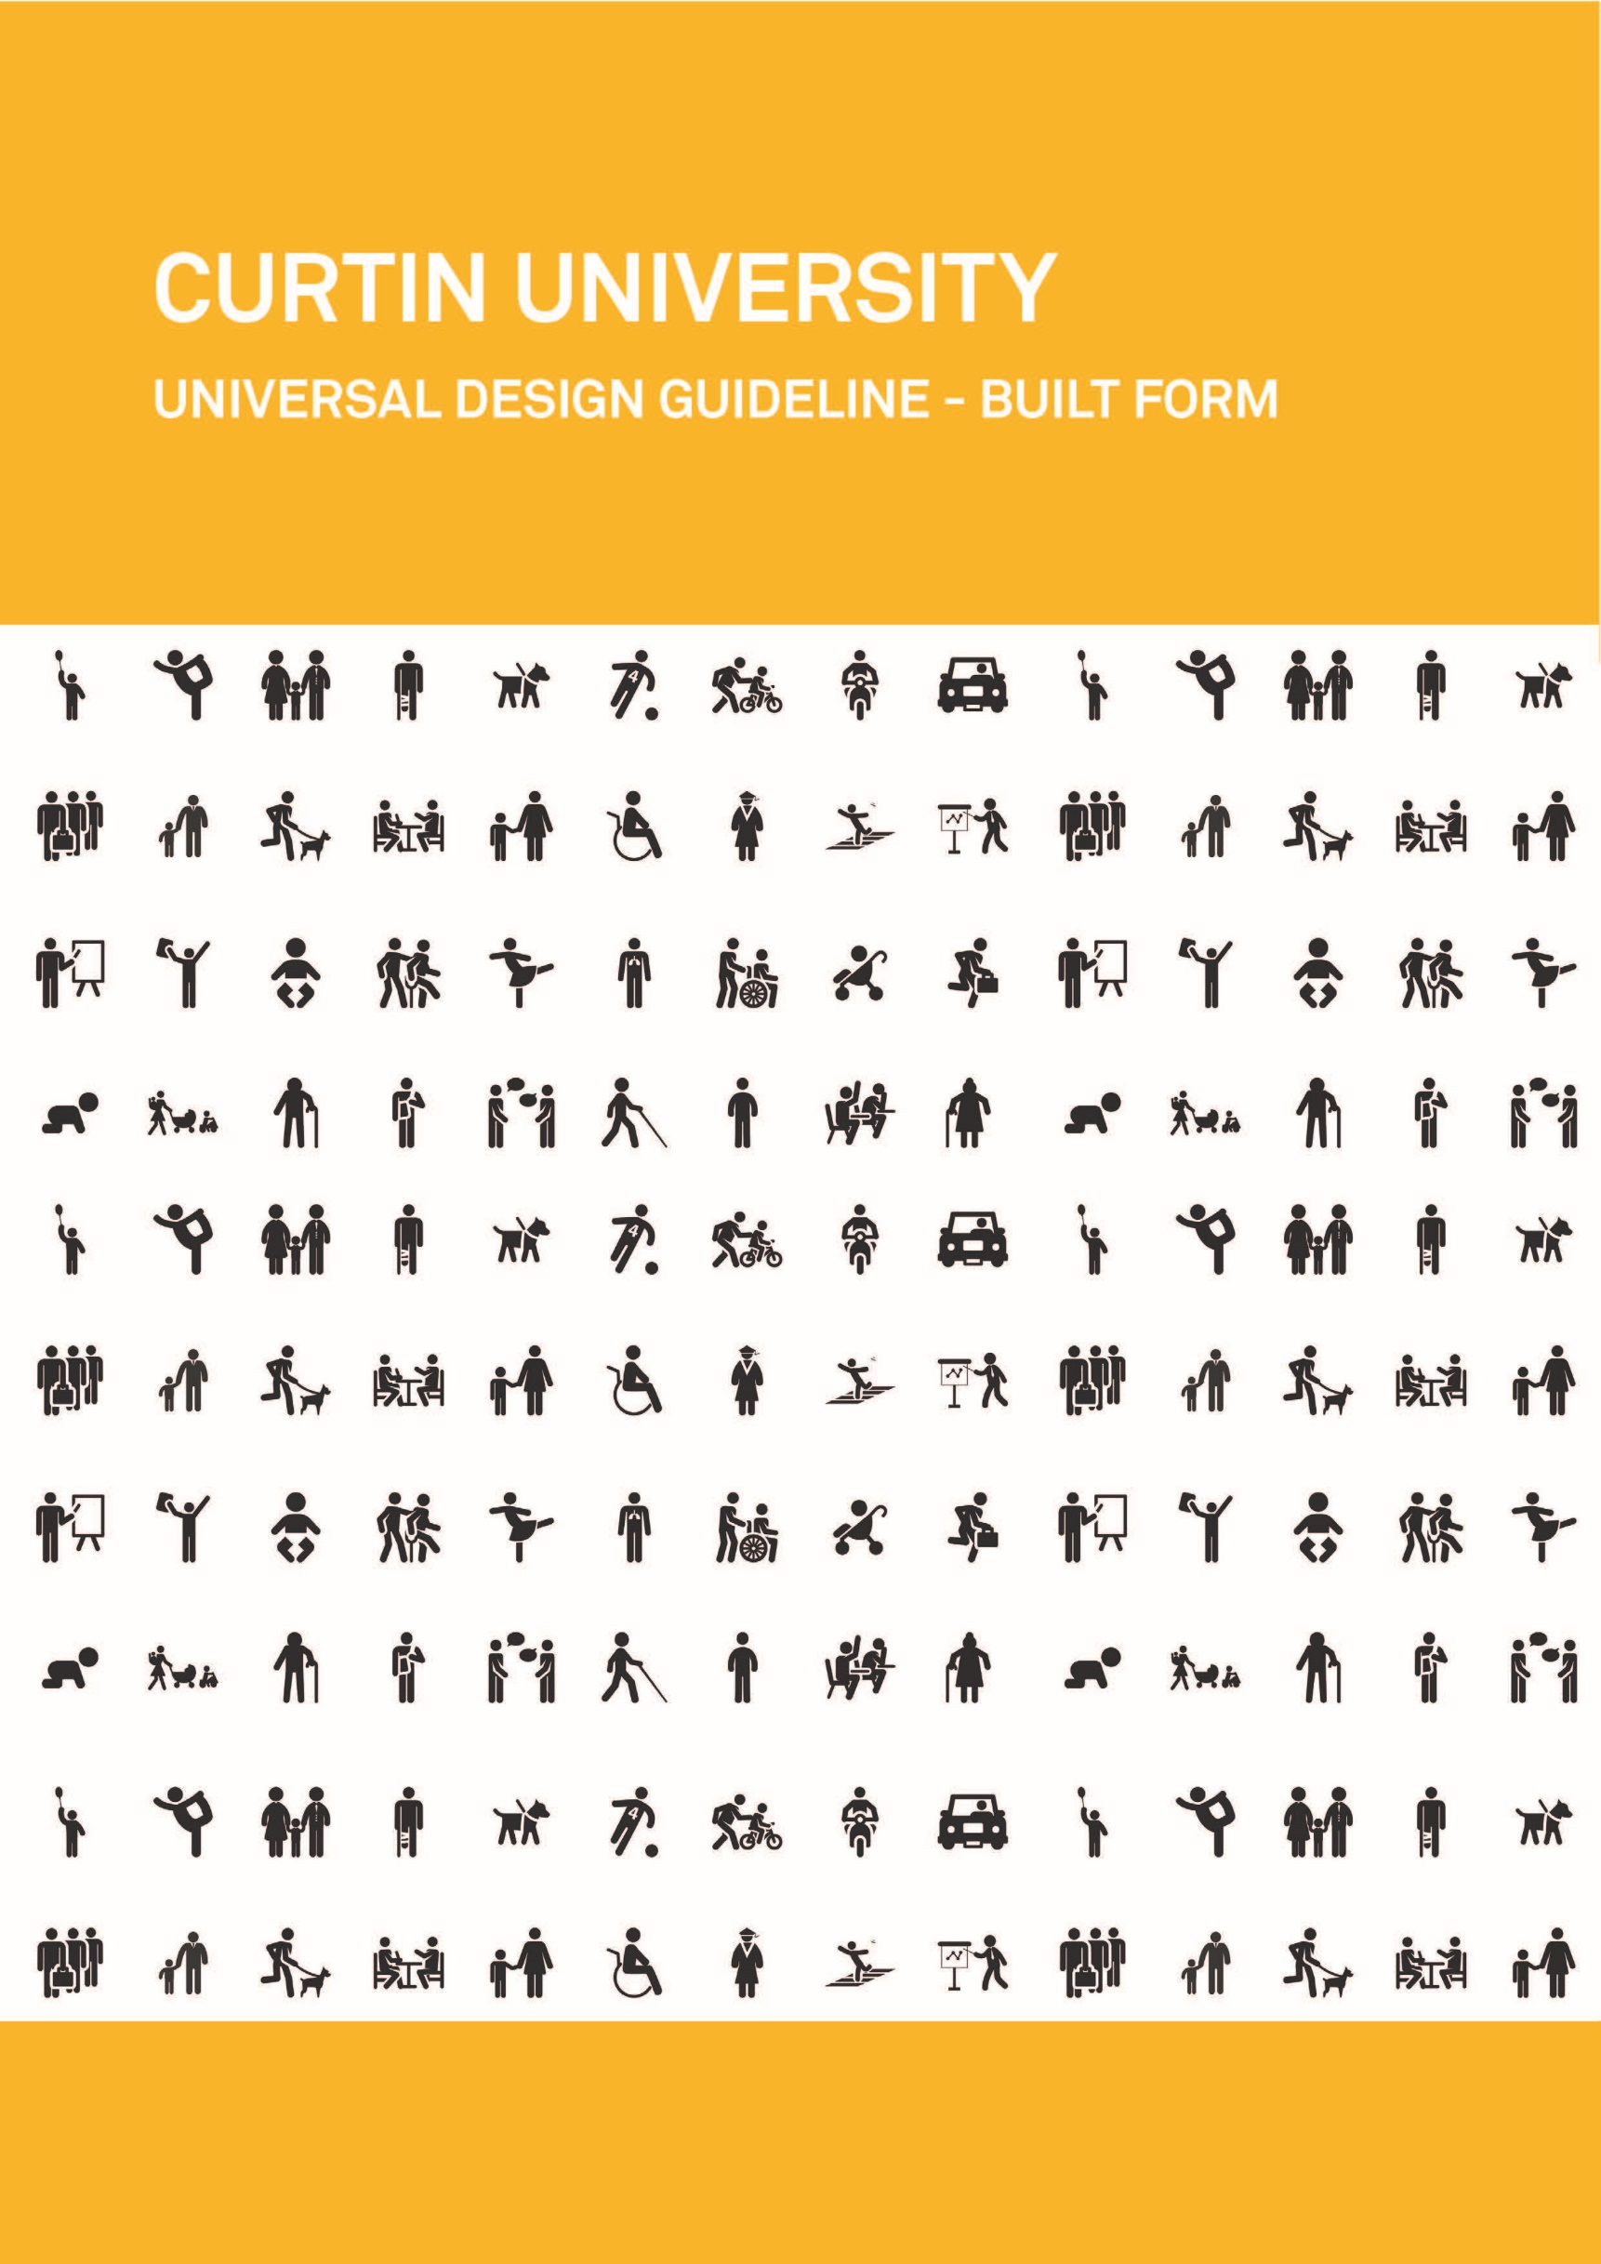
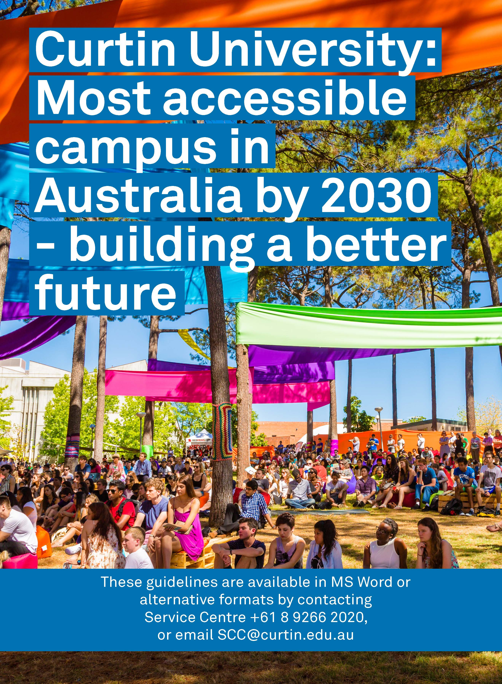
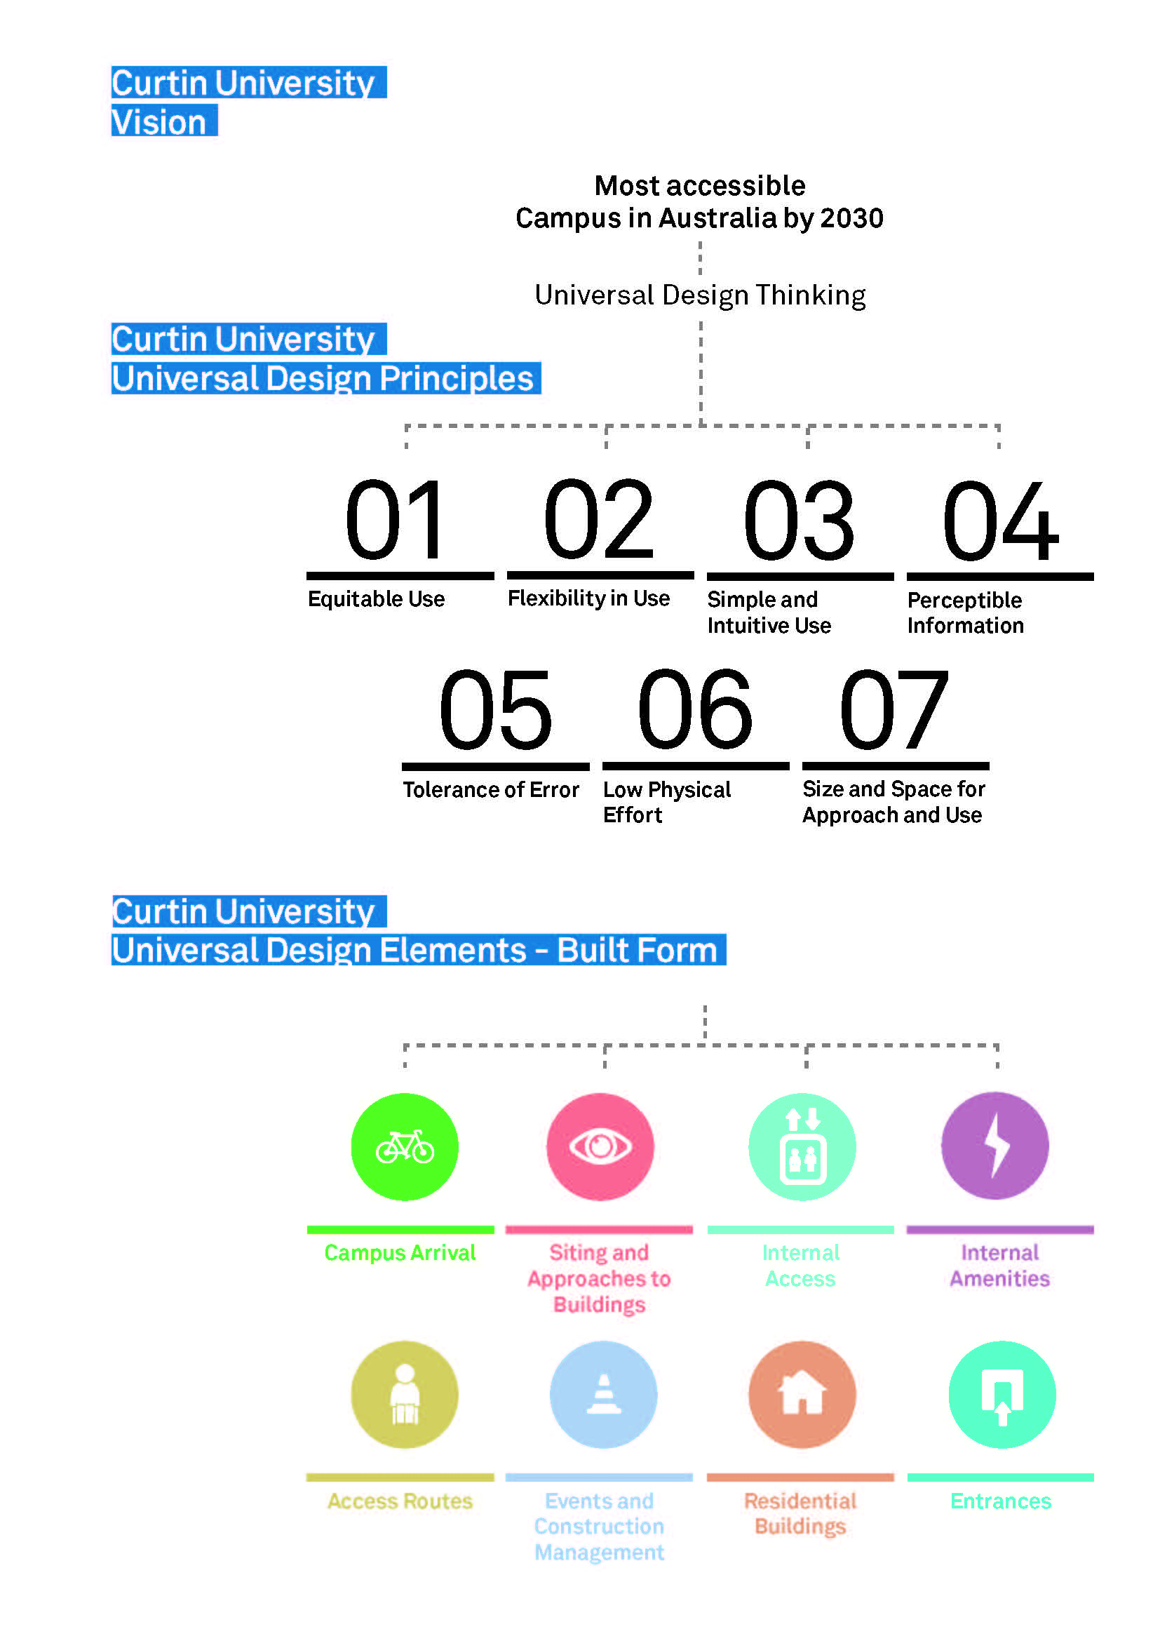
Contents
1. Introduction 7
2. Purpose 7
3. Background 8
4. Universal Design Principles specific to Curtin University 9
4.1. Curtin University’s Seven Universal Design Principles 9
4.1.1. Equitable Use 9
4.1.2. Flexibility in Use 9
4.1.3. Simple and Intuitive Use 9
4.1.4. Perceptible Information 9
4.1.5. Tolerance for Error 10
4.1.6. Low Physical Effort 10
4.1.7. Size and Space for Approach and Use 10
5. How to interpret Elements and their Design Criteria 11
6. Curtin University’s Eight Elements 12
6.1. Campus arrival 12
6.2. Siting and approaches to buildings 12
6.3. Access routes 12
6.4. Entrances 12
6.5. Internal access 12
6.6. Internal amenities 12
6.7. Events and construction management 12
6.7.1. Events 12
6.7.2. Construction management 13
6.8. Residential buildings 13
7. Campus arrival 14
7.1. Universal Design Principles 14
7.2. Drop off points 14
7.2.1. Design Criteria 14
7.3. Accessible parking 15
7.3.1. Design Criteria 15
7.4. Pedestrian crossing 16
7.4.1. Design Criteria 16
7.5. Campus assistance points 16
7.5.1. Design Criteria 16
8. Siting and approaches to buildings 17
8.1. Universal Design Principles 17
8.2. Arrival points 17
8.2.1. Design Criteria 17
8.3. Signage 18
8.3.1. Design Criteria 18
8.4. Artwork, architectural feature or landmark 18
8.4.1. Design Criteria 19
8.5. Bollards and chicanes 19
8.5.1. Design Criteria 19
9. Access routes 20
9.1. Universal Design Principles 20
9.2. All pathways 20
9.2.1. Design criteria 20
9.3. Level changes 20
9.3.1. Design Criteria 20
9.4. Pedestrian ramp 21
9.4.1. Design Criteria 21
9.5. Stairways 21
9.5.1. Design Criteria 21
9.6. Lift 22
9.6.1. Design Criteria 22
9.7. Activity hub 22
9.7.1. Design Criteria 22
9.8. Pause point 23
9.8.1. Design Criteria 23
9.9. Maintenance and product specification 23
9.10. Water bottle refill stations and drinking fountains 23
9.10.1. Design Criteria 23
9.11. Picnic tables 24
9.11.1. Design Criteria 24
9.12. Maintenance and product selection 24
9.13. Seating 24
9.13.1. Design Criteria 24
10. Entrances 25
10.1. Universal Design Principles 25
10.1.1. Design Criteria 25
10.2. Automatic sliding doors, glazed airlocks and entry lobbies 25
10.2.1. Design Criteria 25
10.3. Bridged walkway 26
10.3.1. Design Criteria 26
10.4. Decorative/ privacy film on glazing 27
10.4.1. Design Criteria 27
10.5. Maintenance and specification 27
10.5.1. Design Criteria 27
11. Internal access 28
11.1. Universal Design Principles 28
11.1.1. Design criteria 28
11.2. Doorways 28
11.2.1. Design Criteria 28
11.3. Vertical access 29
11.3.1. Design Criteria 29
11.4. Stairways 29
11.4.1. Design Criteria 29
11.5. Lifts 30
11.5.1. Design Criteria 30
11.6. Emergency Egress 30
11.6.1. Design Criteria 31
12. Internal Amenities 33
12.1. Universal Design Principles 33
12.1.1. Design Criteria 33
12.2. Entry foyer 33
12.2.1. Design Criteria 33
12.3. Reception desks 33
12.3.1. Design Criteria 33
12.4. Wheelchairs and mobility scooters 34
12.4.1. Design Criteria 34
12.5. Power outlets 34
12.5.1. Design Criteria 34
12.6. Seating 34
12.6.1. Design Criteria 34
12.7. Water dispensers 35
12.7.1. Design Criteria 35
12.8. Learning areas 35
12.8.1. Design Criteria 35
12.9. Queuing and temporary barriers 36
12.9.1. Design Criteria 36
12.10. Intercoms, switches and controls 37
12.10.1. Design Criteria 37
12.11. Tea preparation and kitchens 37
12.11.1. Design Criteria 37
12.12. Sanitary facilities 38
12.12.1. All sanitary facilities 38
12.12.2. Design Criteria 38
12.12.3. Unisex accessible sanitary facilities (UAT) 39
12.12.4. Design Criteria 39
12.12.5. Maintenance 40
12.12.6. Changing Places sanitary facility 40
12.12.7. Resting rooms 40
12.12.8. Parenting rooms 40
13. Events and construction management 41
13.1. Events- Universal Design Principles 41
13.1.1. Design Criteria 41
13.2. Construction management- Universal Design Principles 42
13.2.1. Design Criteria 42
14. Residential buildings 43
14.1. Universal Design Principles 43
14.2. Accommodation buildings and common living areas 43
14.2.1. Design Criteria 43
14.3. Accessible bedrooms and ensuites 43
14.3.1. Design Criteria 43
14.4. Kitchens 44
14.5. Laundries 44
14.5.1. Design Criteria 44
14.6. Liveable Housing 44
14.7. Emergency egress 45
15. Governance 46
15.1. Purpose of the Universal Design Guideline 46
15.2. Where the Universal Design Guidelines apply 46
15.3. How to apply the Universal Design Guideline 46
15.4. How stakeholders might use the guideline 48
15.5. Existing buildings 48
16. Definitions 50
17. References 53
18. APPENDIX ONE - Disability awareness 60
18.1. Physical disability 60
18.1.1. Ambulant disability 60
18.1.2. Upper limb disability 60
18.1.3. People who use wheelchairs and scooters 60
18.1.4. People who use a mobility scooter 60
18.2. Sensory disability 61
18.2.1. Blindness 61
18.2.2. Low vision (vision impairment) 61
18.2.3. Deafness 61
18.2.4. Hard of hearing 61
18.3. Cognitive disability 61
18.3.1. Short term, long term and episodic disabilities 62
19. APPENDIX TWO - Universal Design 63
19.1. Universal Design Principles and Guidelines 63

Introduction
Curtin is building a better future.
The Curtin University Universal Design Guideline (the Universal Design Guideline), based on the Universal Design principles, is one of the steps in the process of Curtin University building a better future. It is anticipated that the outcomes resulting from the application of the Curtin Universal Design Guideline will evolve over time, as will this living document.
In the development of the Universal Design Guideline, the University is seeking to provide information to all staff and contractors responsible for the construction of new and the refurbishment of existing buildings, accessways and the landscaped environment. The Universal Design Guideline focuses on information that ensures a whole of campus that is welcoming and inclusive for all people, regardless of age or ability.
As detailed in Curtin’s Disability Access and Inclusion Plan 2012-2017 (DAIP):
“Curtin University believes in creating equitable and inclusive access for people with a disability to our facilities, services, events and academic programs on all our Western Australian campuses.”
The goal of the DAIP is to create the most accessible university campus in Australian by 2030 and the Universal Design Guideline has been developed to reflect a commitment to equity and inclusion for all by “embedding Universal Design principles into project planning, design and delivery guidelines.” Curtin Physical Access Plan (CPAP) 2015-2030.
Specifically, the intent of this Universal Design Guideline will be to focus on access for all people including those with a disability, whether that be sensory, cognitive or physical, temporary, permanent or episodic, to the landscaped and built environment. It should be noted that this document focuses on Universal Design in relation to the physical environment and does not provide information about Universal Design in relation to specific learning environments, information technology and the application of Universal Design in the specialist area of teaching..

Purpose
The purpose of the Curtin Universal Design Guideline is to amass a set of Curtin-specific guidelines that will inform, guide and support the development of a physical environment that is welcoming and inclusive for all people. The intent of this Universal Design Guideline will be to meet the needs of the Curtin community, comprising a diverse mix of ages, abilities, cultures, languages, religions and sexual orientation. The Guideline specifically includes people with a disability, noting that it is generally considered that an environment designed and constructed to meet the varying needs of people with a disability will go a long way to meeting the needs of a diverse community of people. Whilst it is generally not useful to categorise people, having some understanding of the diversity of disability types and the functional implications can be useful. Refer to the Appendix on Disability Awareness for some general disability awareness information.
It is not the intent of the Guidelines to replicate information already detailed in legislative documents, but to build on accessible design principles and mandatory design requirements, so that access is broadened for people with varying and more complex needs, and to create a campus that is inclusive for all people.
The Guidelines have been developed for people involved in the management, maintenance, refurbishment, design and construction of the Curtin University campuses including project managers, architects, interior designers, space planners, landscape architects, engineers and the like.
This Guideline document aims to:
• Clarify expectations for designers, contractors, project managers and staff in applying Universal Design principles to the built environment of Curtin University campuses.
• Provide guidance on methods and prioritisation for the improvement of existing, non-compliant and/ or older built environments.
• Provide a clear governance model and key elements to be addressed in the design and construction of new campus infrastructure.

Background
As the campus has grown organically over time it has met the access requirements for each era in which buildings and their surroundings were created. However, with changing attitudes to social inclusion, advancements in technology and improved knowledge of how people with a range of disabilities are able to access their physical environment, changes to legislation and regulation have been enacted. These changes have resulted in some of Curtin’s older buildings and spaces no longer meeting the expected access needs of its users.
As required by law, all new and affected parts or whole of a refurbished building must meet mandatory design requirements which are based on current legislation, codes and standards reflecting contemporary design principles to meet the needs of people with disabilities. Mandatory requirements are the minimum requirements to be met in the design and construction of all new buildings and in the refurbishment of existing buildings.
The following is a list of current legislative requirements and referenced Australian Standards that are mandatory for provision of access to the built environment for people with a disability:
• Disability (Access to Premises – Buildings) Standard 2010
• National Construction Code Series Volume One. Building Code of Australia Class 2 to Class 9 Buildings
• AS1428.1 2009 – Design for Access and Mobility – General Requirements for Access – New Building Works
• AS1428.4.1 2009– Design for Access and Mobility – Means to assist the orientation of people with a vision impairment - Tactile ground surface indicators
• AS2890.6 2009 – Parking Facilities – Off-street parking for people with disabilities
• AS1735.12 1999 – Lifts, escalators and moving walks – Facilities for persons with disabilities
This Universal Design Guideline does not seek to replicate, define or explain the content of the requirements embedded in documents such as the Building Code of Australia or its referenced Australian Standards on access and mobility. The mandate for the Curtin University Universal Design Guideline is to exceed the minimum mandatory requirements by inspiring and guiding design which is able to be used by the broadest range of people.
From mid-2016 the Curtin Universal Design Guideline will be a key resource for staff and contractors undertaking new and refurbishment building and landscaped works at the Bentley Campus.

Universal Design Principles specific to Curtin University

The Universal Design Principles and Guidelines as originally defined by The Centre for Universal Design in 1997 at North Carolina State University have been used as a basis to create the principles below specifically related to the Curtin University built environment. More information about the Principles and Objectives of Universal Design is provided in the Appendix of this document.
It is acknowledged that a wide variety of individuals use the facilities provided by Curtin University every day. These people may be students, staff or community members visiting either occasionally or regularly. Reflecting the diversity of society, these people may be of any age, ability, gender or cultural group. It should be noted that Universal Design should be a process that starts with consideration of the user and enables and empowers a diverse population. The principles below, applicable to the physical environment of the Curtin University Bentley Campus, aims to meet this variety of need.
The Curtin built environment is defined (as per point 5 of the Curtin Physical Access Plan (CPAP) 2015-2030) as:
- Buildings (planning, design and construction)
- Building fit out
- Retro-fitting buildings
- Leased premises
- Public realm including pedestrian pathways and parking
- Wayfinding
- Emergency evacuation
- Events

Curtin University’s Seven Universal Design Principles

Curtin University has established its very own principles based on the Universal Design Principles and Guidelines prepared by The Centre for Universal Design in 1997.

Equitable Use
Buildings and the public realm at Curtin should provide the same method of use for people with diverse abilities. This use should, where possible, be identical, equivalent and dignified without stigmatization or segregation of any person.

Flexibility in Use
The design of the Curtin University buildings and public realm should accommodate a wide range of individual abilities by providing choices in the methods of use, including suitability for right and left handed abilities, varying speeds and precision of movement.

Simple and Intuitive Use
The layout of Curtin University, including buildings and external environments should be logical, easy to understand without requiring any prior knowledge base of the campus, services and facilities. Navigating the campus should be reasonably simple and intuitive, accommodating a wide range of literacy and language skills. Amenities and wayfinding information is best arranged in a consistent manner, meeting user expectations in regard to the level of importance within that space.

Perceptible Information
Throughout Curtin University Campus provide adequate contrast between essential information/ amenities and their surrounds with visual, tactual, auditory contrasts. A variety of techniques can be used to ensure the information is able to perceived and understood by a range of users with a wide range of abilities and cultural understandings.

Tolerance for Error
All campus layouts, designs, spaces, ongoing constructions and events are to be safe and logical to navigate. All new constructions and retrofit situations should minimize the possibility of hazards. Where possible predict and avoid possible adverse consequences by providing failsafe measures and warnings of unavoidable hazards.

Low Physical Effort
The Curtin campus should enable efficient and comfortable navigation with a minimum of fatigue. This includes consideration for the orientation and design of buildings to reduce the need for sustained physical effort for people moving around the campus and interfacing with buildings and campus facilities.

Size and Space for Approach and Use
Throughout the campus, including buildings and external facilities, adequate space should be provided to accommodate a variety of users, regardless of body size, postures or means of mobility. Spaces are to be sufficient to accommodate assistive devices, the reach requirements of those seated and standing and variations in hand/grip size, strength and endurance. Space is also required to accommodate a clear line of sight to important amenities by any person who is seated or standing.

How to interpret Elements and their Design Criteria

The key Elements in the body of this document have been organized to reflect the way a person may approach the campus, move to their destination and independently engage with the whole of campus activities and learning opportunities.
For clarity the eight Elements and the associated Universal Design Principles, highlighting the design intent, have been listed in the Summary below and could be used as a stand-alone document as required. More detailed information on each Element, including detailed Design Criteria, is provided below.
The information is set out in a manner which follows the path of travel for all people when approaching each Element (for example campus arrival and internal amenities), moving into and through the facility and carrying out required tasks in a dignified manner whether independently or assisted.
Generally Elements that may impact similar groups of people, e.g. people with a vision impairment, have been clustered. It is important to note that priority has not been given within the design criteria as this criteria for a person with vision impairment, for example, may hold equal weight as the design criteria that relate to people with a mobility disability.

Curtin University’s Eight Elements

Campus arrival
Typically a university campus is a large complex cluster of buildings that can be approached by varying modes of transport to multiple entrances. People will typically arrive at Curtin University by foot, bus, bicycle, taxi or by a private vehicle. All people arriving at the campus must have access to easy to interpret information enabling them to determine the most effective arrival point, according to their intended destination.
Provide parking and drop off points consistent with the user’s expectations and intuition, and, provide effective feedback and prompting along the arrival path. No person should be required to take a more complex, longer or more difficult routes to gain access to the campus facilities.
Minimise adverse consequences of accidental arrival at the incorrect location, with logical vehicular and pedestrian pathways and easy to interpret wayfinding strategies, enabling mistakes to be easily rectified.

Siting and approaches to buildings
To provide a whole of campus with buildings and facilities that are logically arranged, easy locate and identify ensuring low effort and equitable and dignified access for all people.

Access routes
Design and construct all external pedestrian access routes so that they can be used by everyone. Position pathways and other means of access between buildings and facilities in a logical and safe manner, eliminating unnecessary complexity and give consideration to designs that require low physical effort for all users, including people with mobility impairments. Pathways are to be easily detectable and navigable by all people.

Entrances
Ensure that entrances to all buildings are welcoming and facilitate safe and comfortable access and egress for all people. Entrances are to be clearly distinguishable and easy to navigate, ensuring that architectural features do not pose unintended physical or visual barriers.

Internal access
Achieve a logical arrangement of rooms and spaces within a building as this strategy will facilitate independent navigation for all people without undue reliance on signage or assistance. Other features such as use of repetitive materials and surfaces, lighting or fragrances can aid wayfinding for people with vision and cognitive disabilities.

Internal amenities
The layout, design and specification of amenities provided within a building should all be considered at the beginning of the design stage of any project. By considering the spatial and detailed requirements, e.g. equipment to be installed, of a facility at the outset, Curtin University and designers will be able to provide facilities that meet the needs of the broadest range of people and be universally designed.

Events and construction management

Events
Ensure that all events held by Curtin University or external events managers, both internal and external are accessible to all people. Strategies and procedures for planning events are to include the participation of planners, contractors and external event managers to ensure that any potential barriers to Universal Design are identified and rectified in the early stages of planning.

Construction management
All construction management works or processes, on new or existing buildings are to ensure retention of a safe, clear and accessible path of travel for all pedestrians. Temporary barriers are not to be positioned so that they create a barrier or safety risk for any pedestrian requiring footpath access.

Residential buildings
Ensure that all people can gain access to residential accommodation with designs that actively facilitates independence and participation in all aspects university residential life.

Campus arrival

Universal Design Principles
Typically a university campus is a large complex cluster of buildings that can be approached by varying modes of transport to multiple entrances. People will typically arrive at Curtin University by foot, bus, bicycle, taxi or by a private vehicle. All people arriving at the campus must have access to easy to interpret information enabling them to determine the most effective arrival point, according to their intended destination.
Provide parking and drop off points consistent with the user’s expectations and intuition, and, provide effective feedback and prompting along the arrival path. No person should be required to take a more complex, longer or more difficult routes to gain access to the campus facilities.
Minimise adverse consequences of accidental arrival at the incorrect location, with logical vehicular and pedestrian pathways and easy to interpret wayfinding strategies, enabling mistakes to be easily rectified.

Drop off points

Design Criteria
Within the Curtin context drop off and pick up points should:
- Be located at main campus entry points accommodating people who arrive by car, van, mini bus or taxi. Be designed in accordance with AS2890.6 for accessible parallel parking bays.
- Be easy to visually identify from campus arrival points.
- Provide parallel bays with the shared area raised with a tactual cue and separation between pedestrians and vehicles. Treat the kerb edge of the raised shared area with a colour that strongly contrasts to the surrounding surfaces, or install a strongly colour contrasting band 300-400mm wide at the kerb edge.
- Be well-lit and furnished with a sheltered pause point and campus assistance point.
- Provide a pause point with clear sight line to approaching vehicles.
- Have a slip resistant and level surfaces.
- Not require pedestrians to negotiate a vehicle-way and furnished with pedestrian crossings as required.
- Connect directly to the accessible campus route via an easy to identify, visually apparent accessible path of travel.
- Be located to minimise travel distance and level change to the accessible campus route.
- Provide ample wheelchair approach and turning space on a flat, traversable surface that is not prone to leaf litter, nuts or pooling water and is exclusive of storm water drainage grates and slopes.
- Have clear directional signage from perimeter council footpaths for pedestrian arrival in keeping with Curtin’s wayfinding strategy.
- Have campus map provided at all key arrival points.
- Provide sanitary facilities in close proximity.
- Have potential for secure, sheltered scooter parking in close proximity to accessible drop off and pick up, as and when required to meet the individual need of a campus user. Scooter parking to connect directly to the accessible campus route with an accessible path of travel.

Hot Tip
Provide shelter from wind, rain and sun as appropriate to the prevailing weather conditions, while maintaining clear sightlines to approaching vehicles and maximising pedestrian safety and surveillance.
The weather protection or shelter should be of an appropriate size to accommodate anticipated pedestrian numbers with a level surface with any required grade to manage the shedding of water kept within very shallow tolerances.
Ideally extend the shelter (without compromise for weather protection) to protect people transferring into a vehicle. The extended shelter however must not create an overhead obstruction to vans or vehicles modified with a roof mounted hoist.

Accessible parking

Design Criteria
Within the Curtin context accessible parking bays should:
- Be logically located to minimise travel distance and level change to the accessible campus route and identified by directional signage from main entrance roads.
- Consider location of grouped accessible bays in an area without through-traffic, to maximise safety of persons at the rear of the bay or where a bay may be occupied by a larger vehicle or modified van.
- Connect directly to the accessible campus route via an easy to identify, visually apparent accessible path of travel.
- Be well-lit for good visibility, safety and passive surveillance.
- Be designed to avoid stormwater drains and falls or other obstructions such as speed humps that may pose a barrier to the accessible bays, transfer spaces or connecting paths of travel.
- Be furnished with a campus assistance point and a nearby pause point.
- Have potential for secure, sheltered scooter parking in close proximity to accessible parking as and when required to meet the individual need of a campus user. Scooter parking to connect directly to the accessible campus route with an accessible path of travel.
- Consider provision of ‘easy access’ bays in association with accessible parking bays for persons who do not require the full rigors of an AS2890.6 design accessible parking bay (for layout and dimension) but, due to a medical condition, injury or the like, cannot travel long distances to campus destinations.
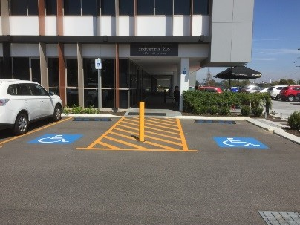

Hot Tip
- Ideally shelter all ticket machines to reduce screen glare and reflection and to ensure comfort of all users.
- If people who use the accessible parking are required to obtain a ticket from a payment / dispensing machine, the machine associated with the accessible parking should be located to allow a person who uses a mobility device to approach, reach the controls and exit.
- Provide wayfinding information in decked or large or featureless car parks to aid user orientation and to aid recall of the location of a parked vehicle.
- The pedestrian route from the car park to the adjacent building(s) and /or access route to the campus must be clearly identifiable to all users.
- In decked car parking the accessible parking bays should be located on the most convenient level and at the most convenient position to the adjacent building(s) and /or access route to the campus.

Pedestrian crossing

Design Criteria
Within the Curtin context pedestrian crossings should:
- Be clearly defined for easy recognition by drivers and pedestrians.
- Be designed to minimise road camber to assist people who use a mobility device making a road crossing.
- Have width and surface that meet accessibility requirements and the Principles of Universal Design. See the section pertaining to Access Routes in this document, for more information.
- Have kerb ramps on either side of the crossing that are orientated so that the kerb ramp slopes align and provide ‘direction of travel’ cueing.
- Have where appropriate, a raised pedestrian crossing that provides a barrier-free path of travel across an internal roadway. As this will result in a flush transition, this style of crossing must be furnished with warning tactile ground surface indicators as per AS1428.4.1 2009.
- There be any associated pedestrian crossing linking to accessible parking or drop off that provides the sole means of access from the parking to the nearby footpath for a mobility device user, the sloped sides to have a gradient no steeper than 1:8 and the width of the crossing must also suffice as a kerb ramp landing as per AS1428.1 2009.

Hot Tip
When specifying line marking products, ensure they are slip resistant when wet.

Campus assistance points

Design Criteria
Within the Curtin context campus assistance points should:
- Be installed on a level surface with sufficient wheelchair approach and turning space. For information on turning spaces for mobility scooters refer to the Appendix - Disability awareness.
- Have intercoms and controls that are easy to reach, simple and intuitive to use. For more information refer to the Internal Amenities section.
- Be lit for night use.
- Be in luminance contrast to the surrounding surfaces and feature clear identification signage.
- Feature easy to read, clear concise informational signage.

Siting and approaches to buildings

Universal Design Principles
To provide a whole of campus with buildings and facilities that are logically arranged, easy locate and identify ensuring low effort and equitable and dignified access for all people.

Arrival points

Design Criteria
Within the Curtin context campus arrival points should:
- Site buildings and entry points in a manner that minimises level changes and distances between accessible parking, transport hubs, campus arrival points, the principal pedestrian routes including the accessible campus route and campus buildings.
- Plan buildings to orientate principal entrances that they are logical and easy to find.
- Provide wide, navigable wayfinding paths that consist of a continuous accessible path of travel leading to the principal and required secondary entrance doorways. These paths of travel are to have a clear shoreline in accordance with AS1428.4.2. Any vertical or horizontal shoreline is to have the appropriate surface treatment as per AS1428.4.2.
- Include a 600mm wide, traversable textural surface contrast to provide ground level wayfinding information to all users, as per AS1428.4.2, where the approach to the building is off a plaza area and a vertical or horizontal shoreline to the building entrance(s) are not provided. Columns and light poles can be used as visual cues to orientate the person to the principal approach path and entrance, however these must be set off the pedestrian path of travel.
- Ensure that any obstacles that abut a path of travel have sufficient luminance contrast to the ground surface, wall surfaces and surrounds to maximise safety and orientation. Any such infrastructure is to work towards aiding orientation rather than creating a barrier or misinforming pedestrians.
- Use artwork, architectural feature or landmark as a wayfinding cue to identify the principal route towards a building and the associated principal entrance.
- Ensure there is a level entry at the principal entrance, managing vertical circulation within, rather than external to, the building.
- Ensure no person is required to take a more complex, longer or more onerous route to gain access.
- Provide directional signage at each wayfinding decision point where there is more than one directional choice, as per AS1428.4.2.
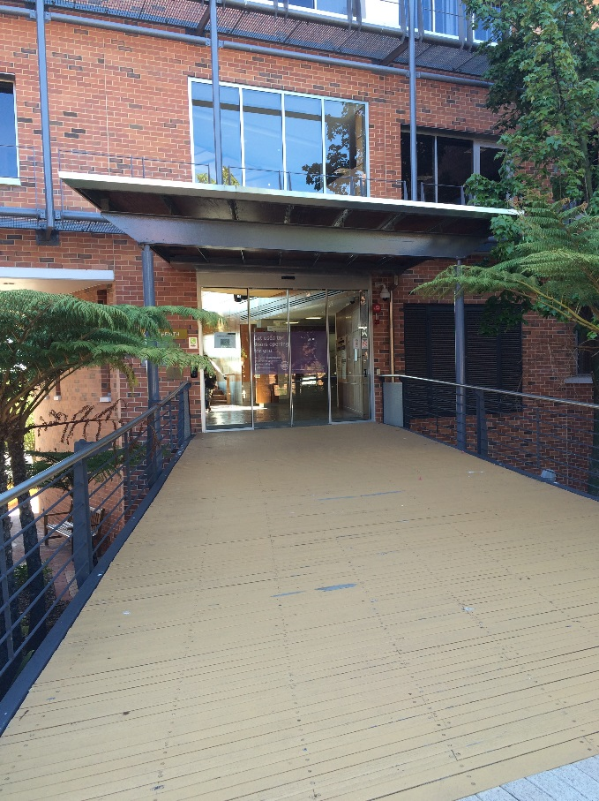

Hot Tip
- Hazards should not protrude into any shoreline more than 100mm.
- If this is unavoidable, hazard protection should be provided where the object protrudes more than 100mm and the lower edge is more than 300mm above ground level.
- Hazard protection on the ground to be provided by a solid kerb or fixed element 100-300mm above floor level under the protruding obstacle so that it detectable by a cane.
- The hazard protection should not extend beyond the front edge of the object, nor should it be set back more than 100mm from its front edge.

Signage
Signage is essential in reinforcing wayfinding within well designed logical environments. There must be efficiency in providing identification and directional signage without cluttering the environment with signs. Signage that meets the needs of people with disabilities, with clear and concise, logically arranged information enhanced with internationally recognised symbols, will be able to be understood by most people.

Design Criteria
Within the Curtin context campus signage should:
- Meet the requirements ofAS1428.4.2 Section 2 – Wayfinding Systems which provides information on the provision of:
  - Wayfinding information points, detailing the means of providing orientation information in a premises that contains more than a sole occupancy
  - Information to be provided at wayfinding decision points
- AS1428.4.2 Section 3 – Signage, provides detailed information on:
  - General design guidelines including glare minimisation
  - Reach ranges for raised tactile and Braille signage
  - Sign types including information signs, directional signs and identification signs
  - Sign specification including general information, font, pictograms and Braille
  - Design requirements for non-raised tactile wayfinding signs for pedestrians with low vision
- Contain information that is clear and unambiguous to read. Use consistent unambiguous words and symbols that are familiar to all.
- Not be over proliferated or be overly complex, as this approach is more likely to cause confusion and be of minimal benefit.
- Incorporate consistent and clearly understood pictorial information, as this is beneficial for people who have learning difficulties, people who have difficulty reading text and people who are not familiar with the English language.
- Give consideration to audible information in addition to visual signs and information.
- Be installed (where it is a wall mounted finger sign) with a height clearance of 2000mm (height of a continuous path of travel). Also ensure there is a corresponding increase in font size of the sign so that it will still be readable.
- Be placed at least 2000mm high, where there is a possibility that it could be obscured at any time, (e.g. by crowds or in a foyer). Locate signage consistently along the accessible path of travel so that it can be readily found, without obstructing the path. Signage and sign boards should not obstruct any building shoreline.
- Afford wheelchair approach and turning space on a firm and level surface adjacent to any signage placed off the path of travel

Artwork, architectural feature or landmark
Deliberate placement of an architectural feature, landmark or artwork is an astute and contemporary method to assist all users identify a building and orientate to the principal pedestrian entrance.

Design Criteria
Within the Curtin context campus artwork, architectural features and landmarks should:
- Be located adjacent to or off the accessible path of travel and in a position where they do not create a barrier to pedestrians.
- Designed and orientated to avoid a head height obstruction.
- Be designed in such a manner that the base can be tactually detectable for a minimum height of 350mm above the floor / ground surface by a person using a long cane where in proximity or adjacent an accessible path of travel.
- Have sufficient luminance contrast to be perceived by as many people as possible. Illuminate the artwork for night time orientation.
- Ensure that the use of illumination as an artwork installation does not create visual confusion along principal access routes or at entrances, does not dazzle or create reflections or glare that may impede navigation of an environment.
- Give consideration to providing additional wayfinding features such as audibly running water, plants with rustling or scent or artwork that incorporates similar visual, tactual and audible features. Ensure if water is a key feature of a landmark or artwork that there is a suitable barrier between any water feature and the adjacent pathway and water overspray does not create a slip hazard on any pathway.

Bollards and chicanes

Design Criteria
Within the Curtin context campus bollards and chicanes should:
- Only be installed when absolutely necessary.
- Be positioned to preserve a 1200mm accessible path of travel.
- Be tactually and visually detectable. Specify bollards at least 1000mm high x 200mm wide. Select a product that is in luminance contrast to the surrounding surfaces in a variety of weather and lighting conditions. Where this cannot be achieved apply a luminance contrasting strip to the top of the bollard 900-1000mm height zone.
- Not be linked by chains (bollards).
- Be positioned (chicanes) to preserve a 1500mm accessible path of travel, including entrance and exit points.
- Have a solid crossbar/rail installed at the base (chicanes) 100-300mm high to be detectable by a cane.
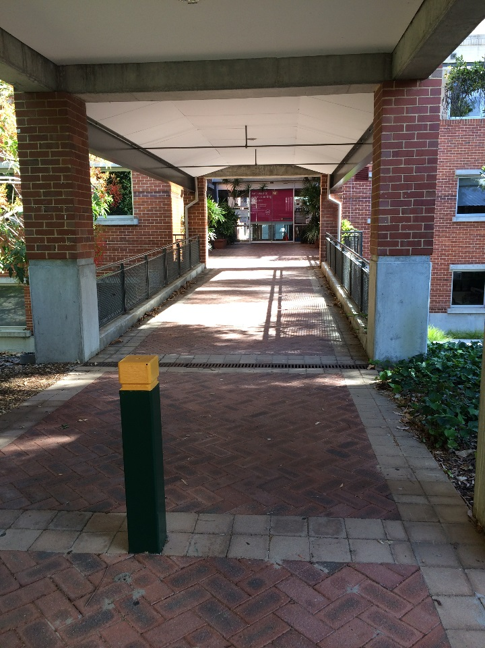

Access routes

Universal Design Principles
Design and construct all external pedestrian access routes so that they can be used by everyone. Position pathways and other means of access between buildings and facilities in a logical manner, eliminating unnecessary complexity and give consideration to designs that requires low physical effort for all users, including people with mobility impairments. Pathways are to be easily detectable and navigable by all people.

All pathways

Design criteria
Within the Curtin context all pathways should:
- Be no less than 2.2 metres wide , greater to manage anticipated pedestrian volume, with water shedding managed by path fall rather than crossfall. Any localised width reduction, for example, between bollards or trees, to be no less than 1200mm.
- Meet the requirement for level changes.
- Have surfaces that are a stable material, have a resistance to subsidence or lifting, are even and do not create unintended tripping hazards or water pooling.
- Have adjacent plantings that do not disturb path integrity.
- Incorporate any breaks in the surface, such as expansion or control joints or gaps between decking boards that are no greater than 8mm, orientated perpendicular to the direction of travel.
- Have bicycle hoops (and parked bikes), light and signage poles, information signage panels , parking machines, drainage grates and service pits (and lids), bins, drinking fountains, seating located off the accessible path of travel so they do not obstruct the pedestrian route or a building shoreline.
- Carefully consider placement of obstacles to physical access in particular on the accessible campus route eg bollards and chicanes, poles, artwork.
- Be constructed with path materials that aid wayfinding and orientation. Avoid the use of contrasting materials (strong patterns or contrasting lines or bands that may be perceived as highlighting a step edge) that may misinform or unintentionally disorientate pedestrians. Use contrasting materials to define path edges and cue to building entrances.
- Splay corners at junctions of pathways to aid manoeuvring and manage crowd flow.
- Provide a pause point at least every 60 metres along the accessible campus route.
- Be well illuminated (non-glare) for night time navigation and safety with even lighting to avoid contrasting pools of light and darkness.

Level changes

Design Criteria
Within the Curtin context all level changes should:
- Be minimised as far as is feasible retaining pathways with a gradient no steeper than 1:60. Where the topography prevents level paths consider the following least restrictive approaches:
  - A well designed pedestrian ramp with a gradient no steeper than 1:16 purposefully positioned to effectively manage a change in level no greater than 1 metre.
  - Where the topography necessitates management of a change in level of 1 to 2 metres consider two ramps with a gradient no steeper than 1:16 separated by a path of 1:60 gradient furnished with a pause point.
  - Any rise in level over 2 metres will require a suitable lift.
- Include a stepped alternative at each ramp and lift.
- Avoid the use of single steps as they can be a tripping hazard even when luminance contrast is provided.
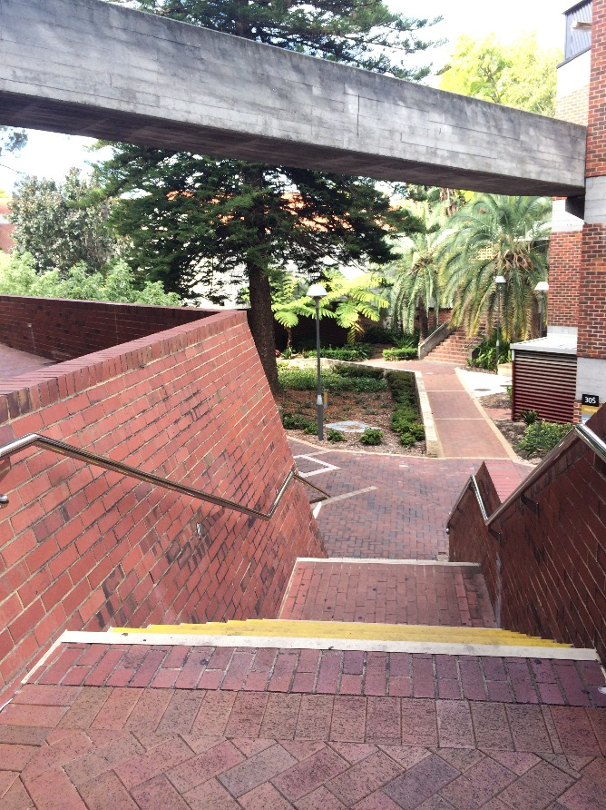

Pedestrian ramp

Design Criteria
Within the Curtin context all ramps should:
- Be designed with shelter and weather protection, where it creates a more circuitous route in excess of that offered by nearby stairs.
- Never be designed with a long series of ramps to address a significant change in level.
- Have straight runs that accommodate changes of direction with flat landings. Curved ramps can be challenging to design without a significant cross fall. A curve and a crossfall can be challenging for a wheeled mobility device user to negotiate.
- Have kerb edges that do not diminish to 0mm at the top, as in descent a wheelchair user may be at risk of riding up onto the kerb edge.
- Be no less than 1200mm wide.
- Apply AS1428.2 1992 Clause 8.1 principles for landing provision.
- Have midway landings (switch back ramps) with sufficient depth to enable wheelchair passing.
- Where there are two or more consecutive slopes in a ramp, have the same gradient.
- Where stairs and a ramp have a shared landing, the base of the ramp is not to lead directly onto the top of stairs. This creates a serious hazard for people using a wheeled mobility device.
- Have a surface colour that contrasts visually to that of the landings.
- Continue handrails through midway landings.
- Provide handrails that are constructed of a heat resistant material and colour that is in luminance contrast to any adjacent wall or nearby materials.
- Be illuminated on the surface, from the sides, to avoid shadow. Light consistently along the ramp length with non-glare illumination.

Hot Tip
- There is a risk with a ramp designed to the minimum Australian Standards that at construction the resultant slope may be in excess of the allowable maximum gradient of 1:14.
- Designing a ramp with gradient not in excess of 1:16 builds in tolerance for error and reduces gradient steepness for the end user.
- At construction ensure water does not pool on landings.

Stairways

Design Criteria
Within the Curtin context all stairways should:
- Be co-located as appropriate with either a pedestrian ramp or lift as they provide an efficient and effective means of moving people between levels. Stairways must not be eliminated from a design.
- Not be the sole means of access between level changes.
- Be of a width appropriate to the purpose of the environment.
- Incorporate regular height risers for the whole stairway. Irregular risers present people who are blind, and those who anticipate consistency and predictability with a serious hazard.
- Meet AS1428.2 1992 Clause 13.2 Figure 8 for stair depth and rise.
- Have a surface that is non-slip, ensuring that water cannot pool on tread and landing surfaces.
- When a ramp and stair arrangement is required, have the ramp orientated in the intended direction of travel and set the stairs off or to the side of the path of travel to avoid the risk of someone unintentionally ‘falling down’ the stairway.
- Be designed with shelter and protection from weather, where it is a long and significant flight.
- Provide handrails that are constructed of a heat resistant material and colour that is in luminance contrast to any adjacent wall or nearby materials.
- Be illuminated on the surface, from the sides, to avoid shadow. Light consistently along the stairway length with non-glare illumination.

Lift

Design Criteria
Within the Curtin context all lifts should:
- Be incorporated, where a change in level on a pathway exceeds 2 metres. This significant rise in level must be managed by provision of a lift in lieu of an onerous ramp arrangement.
- Be of a design suitable for an outdoor environment, in instances where topography results in the change in level being set some distance from nearby buildings and there is no opportunity to co-locate the lift with a building. In this instance the lift and the lift landing must offer shelter and weather protection to the users.
- Where possible be co-located with a nearby building, ideally with direct or lobby access to the lift, ensuring 24 hour access.
- Be of a design that is kept unlocked and can be independently operated by the user.

Activity hub

Design Criteria
Within the Curtin context all activity hubs should:
- Be clearly identifiable by artwork, an architectural feature or landmark and accommodate the needs of many people and amenities appropriate to the purpose of the hub. The hub should be spacious to allow wheelchair approach and turning at key amenities
- Incorporate a variety of seating elements including some that are moveable to allow for flexible use of the space.
- Be linked to, but set off the accessible campus route with a traversable surface with a crossfall not exceeding 1:40
- Provide sufficient power outlets to allow for power wheelchair and mobility scooter charging in addition to charging for electronic devices. The power outlet should:
  - Be within reach range and meet AS1428 2009 Clause 14.1.
  - Have an adjacent spacious, level floor space with sufficient dimension to allow power wheelchair and mobility scooter users to park, charge their mobility device and transfer.
- Include as appropriate a water bottle refill station or drinking fountain, seating, picnic table or bin.

Hot Tip
Shelter supports ideally set into gardens so as not to pose a head height hazard or obstruction to access.
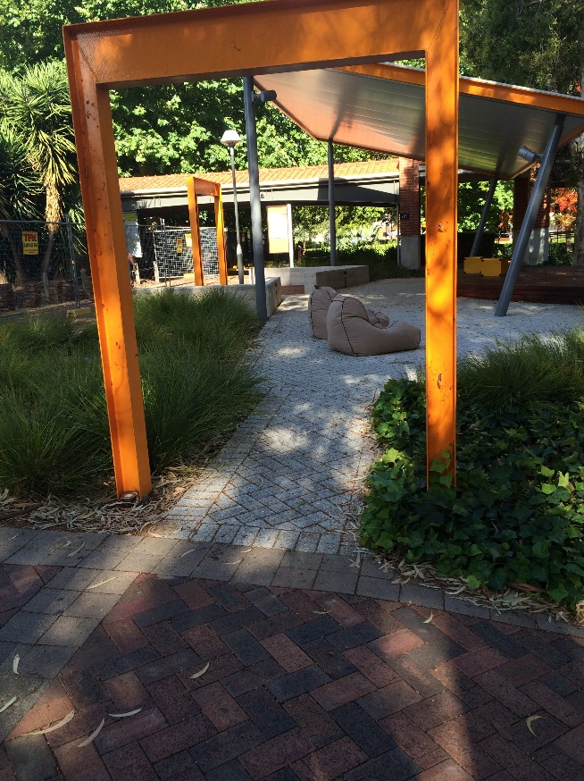

Pause point

Design Criteria
Within the Curtin context pause points should:
- Be provided:
  - At <60 metre intervals along the accessible campus route.
  - At every principal building entrance or location where queuing /waiting may occur.
  - Ideally, at every pedestrian ramp.
  - At campus arrival points where pedestrian drop off and pick up will occur.
  - With adequate lighting for night use.
  - In a location that maximises passive surveillance and safety.
- Include at least one seating element that is connected to but set back at least 500mm from an accessible path of travel

Maintenance and product specification
- Careful design of planting schemes can enhance wayfinding, however ensure:
  - Plants do not overhang or intrude into pedestrian routes or drop leaves, nuts or branches that may render a path impassable, slippery or unsafe.
  - Weeds and roots are managed so they do not lift pavers creating undulations and trip hazards.
- Ensure these issues are addressed as part of the ongoing maintenance program at Curtin University.
- Where an expensive product, or a product that is not locally sourced is used as a surface material, there may be reluctance to repair, given expected cost.

Water bottle refill stations and drinking fountains

Design Criteria
Within the Curtin context pause points should:
- Be located adjacent but not intruding into the accessible path of travel.
- Be located on a traversable surface with a circulation space that enables all users, including people using wheeled mobility devices, to manoeuvre into a position to operate all functions.
- Have a light push button or lever control, located on the front or to the side of the fountain to allow one handed operation.
- Have a finish that achieves 30% luminance contrast between the drinking fountain and the surrounding surfaces against which it is viewed.
- Have functional components, whether drinking from the fountain or refilling a bottle, that meet the height and depth reach ranges, to be operated by all people from either a standing or seated position.
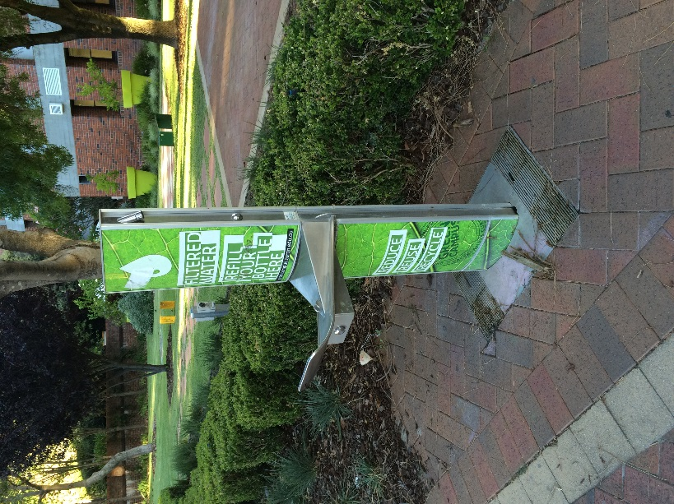

Picnic tables

Design Criteria
Within the Curtin context picnic tables should:
- Be specified as either a café or picnic tables that enables wheelchair access.
- Be orientated so that the accessible section is toward the wheelchair approach, with sufficient space for turning to allow comfortable use of the space.
- Include a firm, level, 2000mm wide traversable surface around the perimeter of the picnic table as this will provide comfortable and useable access to the table for all people.

Maintenance and product selection
- The table is to be fabricated from a non-heat absorbing material and should not necessitate user to negotiate beams or other supports if the table is an ‘all-in-one’ style.
- Moveable tables and seats allow a flexible arrangement to suit the needs of many activities and events.
- Ensure tables are returned with the accessible component orientated towards the accessible path of travel and table / seat surfaces and the table underside are kept splinter free.

Seating

Design Criteria
Within the Curtin context external seating should:
- Be provided at every pause point and activity hub. Whilst no one seating style will meet the needs of all people and a range or seating styles is desirable, provide no less than one seating element that has armrests and a backrest and space adjacent for wheelchair seating, no less than 800 x 1300mm in dimension.
- Be ideally shaded and constructed from a non-heat absorbing material.
- Be in luminance contrast to the surrounding landscape for ease of visual identification.
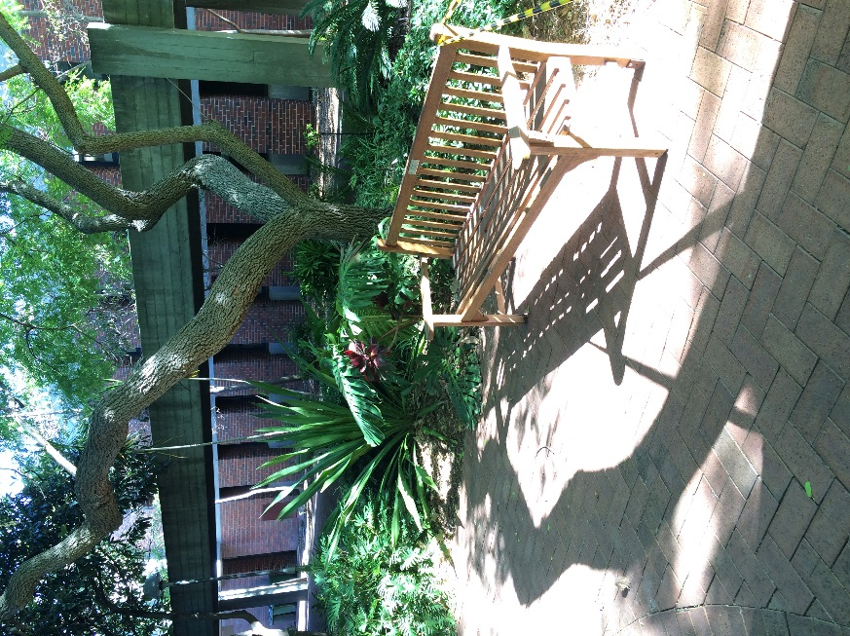

Entrances

Universal Design Principles
Ensure that entrances to all buildings are welcoming and facilitate safe and comfortable access and egress for all people. Entrances are to be clearly distinguishable and easy to navigate, ensuring that architectural features do not pose unintended physical or visual barriers.

Design Criteria
Within the Curtin context entrances to buildings should:
- Be orientated in such a way to reduce travel distances, in context with the surrounds and for visual and intuitive identification.
- Be identified with artwork or a landmark and lit for night time, to ensure visibility from the principal pedestrian route and adjacent buildings.
- Be distinguishable from the rest of the building.
- Be designed so that principal entrance(s) differ in their treatment to minor entrance(s) as this will aid user orientation and reduce arrival error.
- Be designed to that all building entrances, other than service doors, are accessible, welcoming to all building users with a level approach, without need for steps and a ramp.
- Have dimensions that accommodate the anticipated volume of users and the building purpose.
- Provide a suitably dimensioned canopy or shelter, appropriate to the prevailing weather conditions to create an identifiable landmark and to assist in the comfort of all users. The canopied or sheltered area must have a level ground surface with any required grade to manage the shedding of water kept within very shallow tolerances.
- Be designed so that the principal building entrance and any entrance where queuing and / or waiting will occur are furnished with a campus assistance point and pause point (or a nearby activity hub).
- Have the campus assistance point, identification sign, and any building entry controls located under the shelter or canopy.
- Design-in capacity for sufficient building identification signage and directories to avoid the need for building tenants and / or management to place information stands, A-frame signage and the like at building entrances where such items potentially create visual clutter and a physical barrier.
- Be designed so that entrances function as a means of emergency egress for people with a disability.
- Meet AS1428.4.2, with an identification sign at the doorway.
- Be designed with automatic sliding doors at principal building entrances.
- Be designed so that any minor, outward opening doors are recessed or guarded when located along any building shoreline.
- Be designed so that service doors are not furnished with accessible features, as determined through the application of Section D3.4 Exemptions of the Premises Standard. In keeping with Universal Design Principles, such exempted doorways could be ‘painted out’ and door hardware removed or visually minimised to reduce navigational error.

Automatic sliding doors, glazed airlocks and entry lobbies

Design Criteria
Within the Curtin context glazed entries to buildings should:
- Not be designed with fully glazed airlocks as these can be highly reflective, challenging to visually navigate and potentially pose a safety hazard.
- Be protected from any glare with external awnings, window tinting, privacy film or blinds.
- Whilst natural lighting is recommended, over glazing entrances can result in visual confusion due to the masking of any wayfinding features. Whist it is important to have brighter lighting at the entrance of a building, external lights must not dazzle a pedestrian and spotlights should be directed to a feature.
- Have centrally opening automatic doors rather than from the left or right as this provides greater predictability and enhances wayfinding.
- Be installed/ adjusted so that automatic door opening times and speed do not require the user to alter their stride.
- Have door framing in luminance contrast, an application opaque film, colour treatment, a traversable and colour contrast mat or change in floor colour and treatment at the entrance. This strategy will enhance navigation to and through a doorway.
- Have any building entry controls within an entry airlock or lobby, positioned to enable adequate manoeuvring space to access to the controls, for all people.
- Give consideration to soft landscaping directly in front of glazed walls or sidelights as this will prevent users from mistaking glazing as an opening.
- Have a feature that allows automatically controlled doors to be capable of manual operation in the event of power failure.
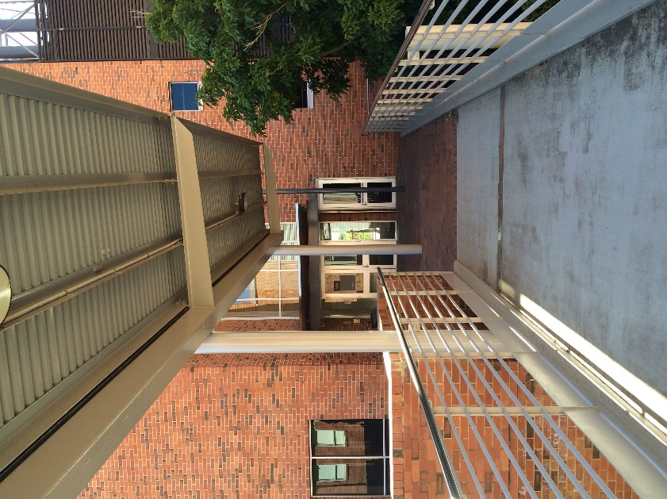

Bridged walkway
Vertical access options to address a topographically challenging landscaping and building siting can be effectively managed by the installation of a well-designed bridge link.

Design Criteria
Within the Curtin context any bridge link should:
- Be covered as there is likely to be increased prevailing weather conditions associated with an elevated bridge link. Cover should protect the bridge and approach to the entrance with appropriate weather protection for the anticipated conditions.
- Be no less than 2500mm wide to accommodate turning for a scooter user and enable wheelchair passing, proportioned to enable an automatic sliding door to be installed rather than an automatic, outward opening swing door.

Hot Tip
An airlock that is designed for the management of internal temperature control or wind tunnelling purposes that is a ‘glazed box’ arrangement can be confusing for people with vision or cognitive impairment as they can be tactually and visually disorientating. Revolving doors are not-allowable and therefore the design of any airlock or wind lock in lieu of a non-allowable revolving door should be considered only in exceptional instances and must be designed to minimise visual disorientation and enhance wayfinding in order to reduce user error and maximize user safety.

Retrofit Hot Tip
In a retrofit situation, a movement sensor activated automatic swing door could pose a safety hazard. Ideally a sliding automatic door would be installed. If an automated swing door provides the only alternative in a retrofit situation, the following to be incorporated:
- The leading edge should be visually contrasting and must be protected so that pedestrians cannot walk into it. The door should not swing into transverse pedestrian traffic.
- The floor surface to be marked out to visually cue to the extent of the door swing.
- Be sensor protected to ensure the door cannot close on a user, including a person who is seated.
- Sensor to be orientated to ensure detection of persons who are seated.
- The door should revert to manual control in the event of a power failure.
- Ideally ensure an audible cue is incorporated as the door swings open.

Decorative/ privacy film on glazing

Design Criteria
Within the Curtin context any decorative/ privacy film on glazing should:
- Be applied to fixed glazed panes with the intent to aid visual orientation to an opening or to ensure a pane cannot be mistaken for an opening. Give careful consideration to:
  - Achieving sufficient opacity to ensure an adequate measure of visual detection. A translucent film may offer very limited visual detection.
  - The type of film applied. A very reflective glazed surface, particularly in the outdoor environment, may render film applied to the inner face of the glazing challenging to see.
  - Patterns or colours used. The application of a highly patterned film may cause visual confusion or disorientation and add unnecessary visual clutter.
  - Applying luminance contrast to doorways. This feature must be applied in accordance with current Australian Standards on access and mobility, must be achieved. The purpose of this application is to aid visual orientation to a doorway. Careful consideration should be given to the combined effect of warning strips, privacy film, decorative film, ad hoc signage and doorway luminance contrast elements to ensure wayfinding is enhanced and legible, rather than creating visual confusion and clutter.

Maintenance and specification
In the specification of products associated with the entrance, consideration must be given to the potential barriers that may be unintentionally created by the specification of inferior products or the incorrect product for the job at hand.

Design Criteria
Within the Curtin context consider:
- Durability of the any mat to ensure no lip or gap is created within the mat well.
- Prevention of water ingress to an internal floor surface creating an unintended slippery surface.
- Glare created off extensive glazing, lighting products, highly polished or reflective surfaces.
- Ongoing maintenance associated with door closing mechanisms and retention of a doorway that is both light to open and slow to close without being challenging or heavy to operate.
- Maintenance / reliability associated with push button, semi-automated door controls.

Internal access

Universal Design Principles
Achieve a logical arrangement of rooms and spaces within a building as this strategy will facilitate independent navigation for all people without undue reliance on signage or assistance. Other features such as use of repetitive materials and surfaces, lighting, plantings or fragrances can aid wayfinding for people with vision and cognitive disabilities.

Design criteria
Within the Curtin context internal access should:
- Give careful consideration, during the planning stage, to the location of internal pillars and columns, locating these outside of circulation spaces.
- Provide floor surfaces without bold patterns. Consider plain, mottled, or small pattern with complimentary colours.
- Avoid designing in large areas of shiny polished surfaces that create glare and reflection. Use matte or satin finishes only.
- Give consideration to all elements that influence the acoustics of a building. These can include the geometry of a room space, surfaces and finishes and the relationship to external noises.
- Be designed so that wayfinding through buildings meets the requirements for wayfinding systems in AS1428.4.2 Section 2, such as shorelines, pathway incorporating a textural surface, wayfinding information points and information at wayfinding decision points.
- Give careful consideration to any glazing. Glazed panels at the end of a corridor will require specific treatment to avoid appearing as an opening. Glazing should not create confusing reflections as this can be distracting and potentially hazardous.
- Provide Luminance contrast between surfaces to highlight focal points such as doors (in addition to mandatory requirements for door luminance contrast) and location of stairways and lifts.
- Where required, have hazard markings in accordance with AS1428.1 2009. Consider the provision of a second band 1400-1600mm above floor level.
- Include signage throughout buildings to meet the requirements of AS1428.4.2 Section 3.

Doorways

Design Criteria
Within the Curtin context internal doorways should:
- Be easy to identify, wide and easy to operate.
- Be recessed for safety, in circumstances where they open outwards into a corridor.
- Be recessed, to assist in wayfinding for people with a significant vision impairment.
- Include the use of a colour contrast flooring within corridors at accessible doorways.
- Have door handles in luminance contrast to the face of the door.
- Where glazed, have the lower edge not less than 300mm and not more than 1000mm above floor level.
- Have vision panels as they enable people to see when another person is approaching the door on the other side and to gauge the type and size of the space that they are about to enter. Visibility panels are to be accessible to all and should be between 400-1600mm above the floor, be at least 150mm wide and positioned no more than 200mm from the leading edge of the door.
- Where required, have door closers that are reasonably light to operate and slow to close.

Vertical access

Design Criteria
Within the Curtin context vertical access should:
- Include both stairs and ramps as they offer an efficient and effective alternative route to lifts. Vertical access should be easy to find, ideally co-located, or clearly signed so that people do not have to ask for directions or be delayed by having to search for an alternative route.
- Not include a single or isolated step as these present a trip hazard.
- Where required, off a wide open space with no perceptible wayfinding cues, consider installation of directional tactile ground surface indicators.

Stairways

Design Criteria
Within the Curtin context internal stairways should:
- Not be eliminated from a design as they are an efficient and effective means of moving people between levels. However, stairways must not be the sole means of access.
- Be located as centrally as possible, either to the side of, or perpendicular to the dominant path of travel. Stairs can present a hazard to people with reduced vision, particularly when located in the direct line of travel.
- Be of a width appropriate to the purpose of the environment. Where a stairway specifically designated as an escape stairs is used as means of regular access for people moving between levels, it should be designed and constructed to the requirements of AS1428.1 2009.
- Ideally enclosed underneath. If a stairway is not enclosed and protection for a potential overhead obstruction is required, designing-in an architectural or physical barrier such as seating, well designed artwork or planting is a more effective and universally understood barrier than installation of warning style tactile ground surface indicators.
- Be lit consistently along the stair flight with non-glare illumination. Light coming through an adjacent window or fully glazed stairwells can disorientate people with a vision loss.
- Have the bottom step set back sufficiently to ensure that handrail extensions and tactile ground surface indicators do not encroach into any transverse pedestrian path of travel.
- Have regular risers for the whole stairway, as irregular risers present people who are blind, and those who anticipate consistency and predictability, with a serious hazard.
- Have the bottom step on all landings offset for one tread length, to ensure that the handrail installation can comply with AS128.1 2009.
- Meet AS1428.2 1992 Clause 13.2 and Figure 8 for stair depth and rise.
- Where hazard strips on stair nosings comprise a metal frame with a coloured insert, ensure that the insert is a single colour only.
- Have stair handrails that are in luminance contrast to background.
- Where a stairway is wide, provide a centrally located handrail. This design is both acceptable and advantageous.

Lifts

Design Criteria
Within the Curtin context internal lifts should:
- Be provided in a central location close to major access stairs.
- Be kept unlocked (available for independent use) at all times that a building is open to students, staff or the public. This includes lifts that are specifically designed for people with disabilities.
- Have a car size that will accommodate any change in direction required to exit the lift. This design detail is also relevant for devices such as low rise lifting platforms.
- Have dimensions for all lift landings, including lifting platforms with manual swing doors that meet requirements for door circulation spaces. Press button controls for semi –automated lift doors to meet location requirements of AS1428.1 2009 Clause 13.5.3(e) & 13.5.4.
- Have wall and ceiling surfaces with a matt finish to reduce glare.
- Have internal lighting levels similar to those outside.
- Consider adding a half height mirror (handrail to ceiling) on the rear wall of the lift car to assist a person using a wheelchair who may need to reverse out. This design also assists a person with a hearing impairment identify if a person is entering the lift car behind them.
- Where possible design in lifts in preference to internal ramps. Internal ramps can be of benefit inside an existing building undergoing refurbishment where steps already exist.
- Provide an emergency call button that illuminates when the operator at the base station has received and understood a call, as this will reduce the anxiety of a person who is deaf. Additional visual information to indicate that the assistance has been dispatched and any expected time delay would also assist.
- Consider specifying an internal large horizontal control panel with large buttons / numbers that can be easily reached and activated by all people.
- Wayfinding and signage for lifts is to meet AS1428.4.2 Section 4.
- Establish a campus wide floor numbering system, ensuring that lift floor numbers between connecting buildings consistently align. Where complex interfaces are unavoidable provide internal lift signage that clearly identifies key elements, for example ‘Exit level for Robertson Theatre’.
- As a lift is generally the only means of access for people using wheeled mobility aids ensure that there is a regular and sustainable maintenance program.

Emergency Egress
Incorporate all possible physical / structural design, fittings, fixtures and equipment to maximise the safe evacuation of all people, including people who have difficulty negotiating a stairway or mobility or communication impairment, in an emergency situation, as efficiently as possible.
“Unless a person can get out of a building in an emergency, then it is not truly accessible at all” Best Practice Access Guidelines. Designing Accessible Environments. Irish Wheelchair Association p110
Provision of universally designed and inclusive evacuation for all people is challenging, particularly in multi storey buildings, residential accommodation and where high volumes of people are accommodated for work, educational and research purposes and should be addressed through the physical structure of the building, supported by robust management procedures. Any proposed strategies should be developed and instigated with a person suitably qualified in fire engineering.

Design Criteria
Within the Curtin context emergency egress should:
- Be designed so that all ground level entrances with approach corridors, door circulation space, hardware*, clear open width and luminance contrast treatment and external pathways are in accordance with AS1428.1 2009, to facilitate unimpeded evacuation for all people to the designated place of safety. Further, egress ramps can be considered from upper levels, where this offers a feasible means of escape.
*Note: All design solutions to facilitate evacuation in an emergency situation must not contravene life preservation requirements embedded in the Building Code of Australia.
- Give consideration to the detail contained within AS3745 2010 Planning for Emergencies in Facilities* when designing new buildings.
*AS3745 2010 Planning for Emergencies in Facilities provides comprehensive information in regards emergency planning and emergency /evacuation procedures with detail in regards provisions for occupants with a disability. In meeting the needs of people with a disability the needs of the broadest number of people are likely to be met in an emergency situation.
- Give consideration to developing individual Personal Emergency Evacuation Plan (PEEP) for staff or regular occupants with disabilities. Any PEEP is to be developed in consultation with the individual.
- Consider the needs of people who are blind and people who are deaf when designing in communication and warning systems. People with hearing impairment require a visual alert and people with a vision impairment require some form of auditory alarm.
- Be enhanced with audible warning systems and visual warning system, installed in accessible areas and male, female and accessible sanitary facilities, with the visual alert visible from all cubicles.
- Consider specification of vibrating systems for persons with a vision or hearing impairment, particularly in buildings where people may be working alone /isolated and in residential accommodation, when a person is sleeping.
- Enhance emergency egress stairs so that, in addition to the minimum BCA requirements, the following are provided:
  - handrails on both sides
  - sufficient stairway width to facilitate variables in body anthropometrics, assisted egress for people with a disability who may require the support of another person or who is reliant on evacuation equipment and to allow for contraflow of emergency personnel
  - a refuge area (see detail below)
- Provide emergency evacuation equipment to facilitate assisted egress.
- Design emergency egress stairs (and all escape routes) so that any proposed evacuation equipment can be stored in a convenient location without risk of the equipment obstructing the escape route.
- Specify lifts within new buildings that can be used for evacuation purposes in an emergency situation. Any such strategy to be resolved with a person suitably qualified in fire engineering.
- Specify and install signage that displays an accessible egress symbol to indicate to all building users accessible egress routes, location /provision of evacuation lifts, egress stairways, location of emergency evacuation equipment and refuge areas.
- Provide evacuation plans at all required areas on all levels of a building at a height to suit people seated or standing, enhancing text with pictograms to aid comprehension.
A refuge area should:
- Be provided in fire-isolated stairways to accommodate a person waiting for assisted evacuation from the building and as a secondary benefit, to offer a space for rest for people with reduced endurance.
- Include no less than a single wheelchair space 900x 1300mm in dimension. This minimum space is to be ideally increased to accommodate more than one wheelchair user and another person. The space is to be located off the escape route, where the people waiting do not cause an obstruction to those evacuating or the contraflow of emergency personnel.
- Ideally be equipped with a two communication system suitable for use by people with vision and hearing impairment, linked to a management control point and situated 900-1100 above floor level for use while waiting for assistance to evacuate.
- Contain instruction as to procedures to be followed and expected response.
- If a place of refuge is provided ensure it displays the access symbol and is clearly marked.
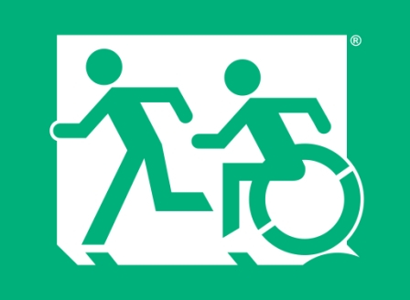

Internal Amenities

Universal Design Principles
The layout, design and specification of amenities provided within a building should all be considered at the beginning of the design stage of any project. By considering the spatial and detailed requirements, e.g. equipment to be installed, of a facility at the outset, Curtin University and designers will be able to provide facilities that meet the needs of the broadest range of people and be universally designed.

Design Criteria
Within the Curtin context internal amenities should:
- Be positioned off the accessible path of travel where there is no potential to create a hazard. Where possible set amenities and equipment such as bins or water dispensers into niches within corridors.
- Be designed so that wayfinding strategies meets the requirements for wayfinding systems in AS1428.4.2 Section 2, such as shorelines, pathway incorporating a textural surface, wayfinding information points and information at wayfinding decision points.

Entry foyer

Design Criteria
Within the Curtin context entry foyers should:
- Position the reception desk so that there is a clear view of from the entry point. Use colour and lighting to make the reception desk, or information point a focal point.
- Be designed so that there is a clear view from the entry point to the lift and stairs, where provided.
- Provide wheelchair circulation spaces that enable appropriate changes of direction for both the receptionist and visitors.
- Include consideration of acoustics that promotes clear speech intelligibility. Balance hard reflecting surfaces with soft, sound absorbing options.
- Provide a variety of seating options for people who are waiting /meeting others.
- Provide a suitable space and amenity that will enable a person using a power wheelchair or mobility scooter to store and /or charge their mobility device. More information about scooter parking and storage is provided in Section 13.5 below.

Hot Tip
An assistance dog is specifically trained by an accredited organisation to enhance the mobility and independence of a person with a disability, for example a guide dog or a hearing impairment dog. An assistance dog will wear a recognised form of identification.
An assistance dog is likely to need access to a toilet area, in close proximity to a building. Furnish an area, close to entry foyers with shelter, a grass patch and a water tap.

Reception desks

Design Criteria
Within the Curtin context reception desks should:
- Provide a standing and a lowered section of counter to facilitate use by people in either the standing or seated position. Knee and footplate space at the lowered section is to be appropriate to the tasks to be undertaken by any visitor using a wheelchair. A balance between an ergonomic posture for staff and accessibility by visitors will need to be achieved.
- Provide even lighting that will adequately illuminate the face of any visitor or staff member, as this will aid visual communication and lip reading. Avoid light sources directly behind the receptionist as a silhouette effect can occur, limiting visual communication.
- Avoid glazed security screen that are subject to a strong light source or grilles that may be a barrier to communication or cause confusing reflections and glare.
- Provide hearing augmentation systems with signage at key, high usage reception counters and those that are furnished with security screens.
- Provide non-reflective surfaces. The front of the reception desk should be in luminance contrast to the work surface so that it is readily, visually identifiable.

Wheelchairs and mobility scooters

Design Criteria
Within the Curtin context entry foyers consider the following for wheelchairs and mobility scooters:
- Mobility scooters are varying sizes and many are considered too cumbersome to move through buildings. However it is reasonable that mobility scooters be parked inside a building, away from any inclement weather.
- Each entry foyer is to have a space outside of the path of travel that is of sufficient space to house a mobility scooter and wheelchair. The footprint sized of the 90th percentile wheelchair is available in AS1428.1 2009 and for information on spaces required for a parked scooter refer to the section on mobility scooters in the Appendix of this document -Disability Awareness.

Power outlets
The contemporary approach to charging power wheelchairs and mobility scooters is to use a power outlet that can charge any electronic device, located in a central, easy to access position.

Design Criteria
Within the Curtin context power outlets should:
- Be within reach range and meet AS1428 1 2009 Clause 14.1.
- Have an adjacent spacious, level floor space with sufficient dimension to allow power wheelchair and mobility scooter users to park, charge their mobility device and transfer out of or transfer into another mobility device for indoor use. Turning spaces for wheelchairs is provided in AS1428.1 2009 Clause 6.5. For information on turning spaces required for mobility scooters refer to the section on mobility scooters in the Appendix of this document -Disability Awareness.

Seating

Design Criteria
Within the Curtin context internal seating should:
- Be provided in reception areas and along routes where waiting is likely. Ideally locate seating close to toilet facilities and reception desks or information points.
- Be lightweight, moveable, where flexibility of spaces is required.
- Meet the needs of all users. As no one style or size of seating will suit all users, where possible provide a variety of styles and sizes.
- Include seating that is stable with a backrest, ideally some with and some without armrests, with a seat height between 450-520mm.
- Be in luminance contrast to the surrounding wall and floor surfaces so that it can be readily identifiable.
- Not encroach into paths of travel. The use of floor finishes that are different in texture or colour can be useful to delineate seating areas from adjacent circulation routes to other facilities, particularly within large waiting areas.
- Include circulation spaces required to access seating, by a person using a pram, wheelchair or scooter, enabling people using mobility aids to position themselves alongside the seating.
- At internal gathering points, be accompanied by a power outlet as described above, to enable recharging of power wheelchairs in addition to electronic devices.
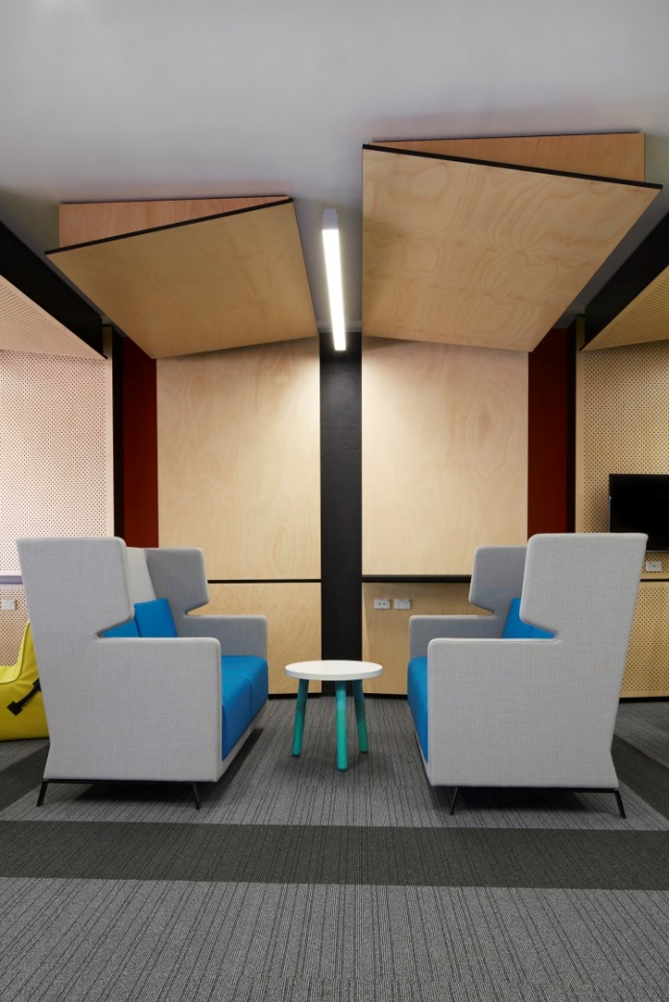

Water dispensers

Design Criteria
Within the Curtin context water dispensers should:
- Be set back from a path of travel, away from the corner of a room, with sufficient circulation space in front to enable a person using a wheeled mobility aid to access via a front or side-on approach. Orientate the spout and controls towards the wheelchair circulation space.
- Provide an activation method that is easy to use by all people and can be operated by the hand, forearm or elbow.
- Be a height that meets the needs of all people, both standing and seated.
- Include any disposable cup dispenser, located within a reach range for all people (700- 1200mm high) and away from an internal corner.

Learning areas
Learning areas include a simple classroom with moveable furniture, a tiered lecture theatre or more complex environment designed for practical learning, such as laboratories and simulated work areas. All areas of all learning spaces must be designed to accommodate people of all abilities and equipment and activities should minimise required effort, provide options for operation, and accommodate right and left-handed students as well as those with a range of physical disabilities.

Design Criteria
Within the Curtin context learning areas should:
- Provide circulation spaces that meet the needs of all users and provide spaces for people using mobility aids at a variety of locations. In some instances light moveable furniture will allow for a flexible space.
- Include flexibility for wheelchair users, within tiered seating areas. This could be obtained by designing in sections of ‘removable seats’.
- Design fixed seating to meet the needs of all people. Refer to Seating above.
- Provide a means of access for all people to raised podiums, platforms and stages. Ensure that all means of access and circulation spaces meet the needs of people using wheeled mobility aids.
- Give consideration to the following. In situations where it is not possible or practical to provide a flexible or accessible designed equipment within more complex learning areas, for example equipment within a chemistry laboratory, ensure that there is a clear continuous accessible path of travel that meets the needs of all users from the entrance to the equipment. Ensure that circulation spaces enable people using mobility aids to maneuver themselves into a position to utilise the equipment. Whilst height adjustable equipment may be a viable option it may be necessary to make modification to complex equipment with specific safety implications, to meet the needs of individuals with specific physical, vision or cognitive needs. Before purchasing or installing equipment give consideration to how the design could be modified if and when required.
- Position presentation equipment, power outlets and controls to meet the needs of all, ensuring that controls are easy to operate by all people.
- Where there is installed Audio Visual equipment, make provisions for students with a hearing impairment. Provide an assistive listening device and identify the space with hearing augmentation signage.
- Specify amenities such as air conditioning, ceiling fans, automatic doors with low background noise levels to reduce interference with hearing augmentation systems.
- Provide lighting that illuminates the face and body of presenters to facilitate lip reading and sign language communication, meeting the requirements of AS1428.5 2010 - Section 8. Lighting Specifications to consider illumination, lighting direction, contrast and glare.

Queuing and temporary barriers
Should queuing be required then the arrangement should enable all people to move along the queue conveniently, safely and as comfortably as possible.

Design Criteria
Within the Curtin context any barriers and queuing should:
- Give consideration to the likely numbers queuing and the speed in which they will move through the queue.
- Provide seating in close proximity.
- Preferably, provide barriers that are firmly fixed to the floor and arranged in parallel and logical lines. In all situations where temporary barriers are used, ensure that adequate circulation space is maintained for all building users and stanchions and belts are in luminance contrast against surrounding surfaces.
- Provide permanent barriers that are tactually detectable by users of a long cane, by provision of a kerb or kerb rail between stanchions, no less than 200mm above floor level.
- Where a kerb or kerb rails are installed circulation spaces should meet the requirements for turning, if required. Where temporary barriers are used circulation spaces are more flexible as wheelchair footplates can pass under the belt, providing a more flexible space to undertake a turn.

Intercoms, switches and controls

Design Criteria
Within the Curtin context any intercoms, switches and controls should:
- Provide luminance contrast between any switch and the background surface.
- Give consideration to appropriately timed automatic lighting, as this will meet the needs of all people.
- Ensure that people are not required to move through an unlit area to locate a light switch. Where required use two way switching.
- Ensure that there is a clear, unimpeded floor area directly in front of any switches, controls and intercoms. The circulation space is to be relative to the maneuvering that would be required by a person using a wheelchair.
- Specify controls that can be used with one hand and are large and easy to grip. Avoid switches that have to be turned or require a small pincer grip.
- Specify control buttons that sit proud of the surface and of a colour that is in luminance contrast to the backing plate.
- Provide large rocker style switches and lever handles that are easy to use and can be operated by an arm or elbow.
- Provide any instructions or information pertinent to controls or intercoms to meet the requirements for Signage above.
- Include any component of an intercom that receives speech at a height capable of detecting speech from the seated position, ensuring that it is not positioned too low for a person who is standing, who may have difficulty stooping or bending.

Tea preparation and kitchens

Design Criteria
Within the Curtin context tea preparation areas and kitchens should:
- Have the following information applied as appropriate to the function of food preparation areas in staff and student communal tea preps and kitchens in residential accommodation.
- Preferably have an open plan arrangement as this maximises circulation space and avoids the need for people to pass through doors whilst carrying trays, plates or drinks.
- Provide a flexible arrangement with opportunities to relocate kitchen items to meet the needs of individuals. For example a microwave oven can be relocated to a bench if required or a boil point, for safety reasons, located above the reach range for a person who is seated, can be supplemented with an electric kettle at bench height.
- Consider designing an L shaped or U shaped arrangements as this design is generally more efficient than galley style kitchens as it provides a continuous work surface which is more useful to people who need to slide rather than carry items from one work surface to another.
- Provide bench heights at two different levels, 900mm for people standing and 760mm for people who are seated (with adequate knee space for people using wheelchairs), or height adjustable work surfaces, as this will meet the needs of the majority of people. Information regarding design elements for accessible benches is provided in AS1428.2 1992 Clause 24.
- Have bench corners that are rounded.
- Provide easy access to the back of drawers.
- Provide bench space adjacent opening doors of appliances.
- Provide one shallow sink as this allows a person who is seated to reach to the bottom.
- Provide knee space under one section of bench. Consider moveable storage units (that can be slid under the open underside of a bench) as a balance between adequate storage and provision of knee space for people who use wheelchairs.
- For ease of access for people who are seated, locate fixed elements such as ovens, fridges and sinks away from an internal corner, enabling a person using a wheelchair to pull up alongside and open a door or operate an appliance.
- Install GPOs at an accessible to all people, no closer than 500mm from an internal corner, 900-1100mm high and within 300mm of the front of a bench.
- Select surfaces that are non-reflective. The front of the cabinetry should be in luminance contrast to the work surface so that it is readily identifiable.
- Select cupboard doors that can be hinged to 180°.

Sanitary facilities
Adopting the Principles of Universal Design will ensure that all sanitary facilities are be easy to find and navigate, require low effort, have easy to use fittings and fixtures and adequate lighting and sufficient luminance contrast to identify the important features.

All sanitary facilities

Design Criteria
Within the Curtin context all sanitary facilities should:
- Be a variety of styles that meet the anticipated volume of users. With layouts that can be used by people of all abilities and styles that are appropriate to all cultural needs, the unisex accessible toilets will be used for the purpose for which they were intended.
- Be conveniently located in close proximity to main entrances, any waiting areas and other key facilities.
- Where feasible, eliminate doors to entrances of male and female toilets, whilst still maintaining privacy and dignity, as this will negate the requirement to open heavy doors on narrow airlocks, aid navigation and enhance the physical safety of users.
- Be kept unlocked. Locating a key or a member of staff may delay access to the toilet causing, at the least, unnecessary comfort for people who experience a sense of urgency.
- Provide adequate lighting in all sanitary facilities and cubicles to enable location of public items and private articles.
- Install both visual and auditory emergency warning systems into all sanitary facilities, parenting and resting rooms.
- Specify sensor or lever taps in all instances.
- Install coat hooks all cubicles and provide adequate shelving adjacent to basins.
- Provide a comfortable and easy to use space in all male and female toilet cubicles. Space should allow maneuverability for all users.
- Install well designed hand basins that adequately contain water, without splashing.
- Consider placement of full length mirror (appropriately framed so it does not appear to be an opening) on an end wall, to assist in the safety of people unable to hear when a person enters behind them.
- Consider installing wall mounted grab rails on either side of urinals to provide both left and right hand support options.
- Provide sensor operated hand dryers that do not require the accurate placement of hands into a restricted aperture. Provide a paper towel option.
- Install any lockers in a communal area at a range of heights suitable for people who are standing or seated.
- Where designated communal change areas are provided, provide circulation spaces and facilities that meet the needs of people with mobility disabilities.

Unisex accessible sanitary facilities (UAT)

Design Criteria
Within the Curtin context all unisex accessible sanitary facilities should:
- Be designed with a seamless transition from adjoining corridors or rooms. Ensure that all approach circulation spaces, at a minimum meet the requirements of AS1428.1 2009, and avoid airlocks and a succession of doors along any entrance corridor.
- Be of an attractive design that is keeping with the aesthetic treatments in male and female toilet facilities.
- Have the required circulation spaces kept clear. It is not appropriate to use this room for additional storage or provide a portable baby change within the room.
- Where emergency call bells are provided, be installed adjacent the toilet pan in a location that can be reached by a person sitting on the toilet pan or a person who may have fallen onto the floor. Ensure that the emergency call bell reset switch is in reach of the user.
- Have any emergency call system supported by a robust and sustainable response procedure, by a person who is trained to give assistance.
- Where toilet and shower facilities are combined, provide a layout that does not require a person, using the toilet only, to walk or wheel over a potentially wet and slippery floor surface.
- Have a grabrail strength towel rail within a combined toilet and shower facility, as this will add additional support for a user.
- Avoid locking any UATs. Should this be necessary, in exceptional circumstances, utilise the Master Locksmiths Access Key (MLAK) system.
- Position fittings and fixtures to allow for limited reach range and ease of use.
- Consider outward opening doors to maximise the use of the internal circulation space. Ensure that any outward opening door is recessed so that it does not create a hazard to any passing pedestrian flow.
- Make every effort to meet the individual needs of a specific staff member or student. Ensure that changes will not restrict usage by others and attempt to make changes in a UAT where there is an alternative located in close proximity.
- Provide equitable and dignified sanitary facilities for all people. Where other staff have access to a toilet designates as ‘staff use only’ also, provide a UAT. Staff should not be expected to use a UAT designated specifically for visitor or public use.
- Only have a baby change table installed in accordance with AS1428.1. Ensure that they are not installed in a UAT that could be dominated by people changing babies where there is a possibility of preventing, or considerably delaying vacancy, for people with disabilities.

Hot tip
Where new UATs cannot be provided on all levels of a multi storey retrofit, give priority to common use areas where demand is likely to be greatest, or a higher percentage of public use may be required and in close proximity to a lift.

Maintenance
Ensure those responsible for cleaning/ restocking UATs understand the importance of restocking and maintaining wheelchair circulation spaces that are clear of obstructions such as bins or storage items.

Changing Places sanitary facility
A Changing Places sanitary facility provides a suitable space, fittings, fixtures and equipment to meet the toileting needs of people unable to access a unisex accessible toilet. It allows people with severe or profound disabilities and their carers to undertake hygiene requirements with suitable equipment, such as an adult change table and hoist, within a dignified environment.
Within the Curtin context any Changing Places facility should:
- Have, in consultation with users, the necessity determined at the early stages of building planning for provision of a Changing Places facility, with an aim to provide across the Curtin university campus regularly placed facilities.
For information on the design, signage and official registration of Changing Places facilities refer to www.changingplaces.org.au

Resting rooms
Within the Curtin context all resting rooms should:
- Be provided for people who have fatigue and need space for recuperation during the day.
- Be able to be accessed and used by all people. Provide sufficient space adjacent a bed to enable a person using a wheelchair to undertake a transfer onto the bed.
- Preferably provide a height adjustable bed. Any fixed bed to have a mattress of a height between 480 – 500mm.
- Have a locking device so that the room can be locked when in use- refer to AS1428.1 2009 Clause 15.2.9 for information regarding door locks and in use indicators.

Parenting rooms
Within the Curtin context parenting rooms should:
- Provide adequate circulation space for a pram and an adult or childe using a wheeled mobility aid.
- Provide supportive seating.
- Include private feeding cubicles that meet the needs of people with mobility impairments. A curtain style partition provides flexibility of circulation space.
- Consider applicable elements of any tea preparation space for example access to a sink and provision of a microwave at bench height.
- Preferably include a wall mounted, horizontal style or bench style change table with knee clearance, rather than moveable, folding styles.
- Provide shelf space adjacent to and at same height as any change table.

Events and construction management

Events- Universal Design Principles
Ensure that all events held by Curtin University or external events managers, both internal and external are accessible to all people. Strategies and procedures for planning events are to include the participation of planners, contractors and external event managers to ensure that any potential barriers to Universal Design are identified and rectified in the early stages of planning.

Design Criteria
Within the Curtin context all events should:
- Include facilities for people of all abilities as an integral component. It is not appropriate to have separate or ‘special’ facilities for people with disabilities, i.e. ticketing, entrances, restricted or separate viewing or seating arrangements or policies for people with disabilities.
- Implement non-restrictive booking systems ensuring access by people with hearing, vision and cognitive impairments.
- Provide an accessible path of travel into and throughout any indoor or outdoor event venue. All paths to be kept clear of clutter including temporary barriers, rubbish bins, power leads and advertising materials.
- Limit the use of rope or chain barriers.
- Provide access to any stage via a temporary ramp and stairs. Ensure that stairs or ramp are fully furnished with handrails and luminance contrast on nosings compliant with AS1428.1. Ensure any temporary ramp does not exceed maximum allowable grades as per AS1428.1 requirements for a pedestrian ramp (1:14) or step ramp (1:10). This may result in limitations to the height of any proposed stage.
- Provide adequate wheelchair approach and turning space on the stage.
- Design in adequate lighting at stage access points to assist all people, including performers and people who rely on lip reading or Auslan to gain information.
- Where appropriate, provide accessible signage through the site to assist with wayfinding.
- Ensure that temporary sanitary facilities are as accessible as permanent facilities, regardless of their location.
- Design any gate access to be accessible to all people, including people using wheeled mobility aids.
- Have any accessible entrance that is adjacent other entrances identified with the International Symbol of Access.
- Design so that any information areas and payment points are located within ‘quiet zones’.
- Install signage and labelling of displays that meets the signage requirements.
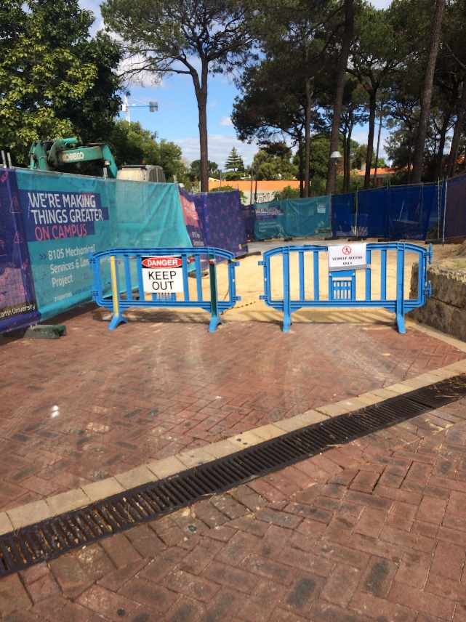

Construction management- Universal Design Principles
All construction management works or processes, on new or existing buildings are to ensure retention of a safe, clear and accessible path of travel for all pedestrians. Temporary barriers are not to be positioned so that they create a barrier or safety risk for any pedestrian requiring footpath access.

Design Criteria
The process of construction work including maintenance and repairs or new building work can pose a significant risk to all pedestrians where:
- Damaged paths or service lids or works are not securely barricaded to prevent unintentional contact with the disrupted pathway, building materials or building / maintenance work.
- Any barricade, scaffold or the like cannot be tactually detected by a person with low vision or a person or who is blind, resulting in a potential trip, fall or head height contact.
- The erected scaffolding, barricade or hoarding significantly encroaches on the pathway width preventing access for wheelchair and scooter users. Or an existing, safe shoreline is disrupted or removed.
- An alternative accessible and traversable path of travel is not provided around or as an alternative to any new building work, unsafe protrusion, or pathway undergoing repair.
- Within the Curtin context all construction management should:
- Install hoardings around significant construction works (in preference to placing scaffolding on or adjacent an accessible path of travel).
- Retain a minimum 1200mm, ideally 1800mm, accessible, traversable, safe pedestrian route. Protruding elements should be avoided where possible, these should be barricaded to maintain the integrity of a safe path of travel.
- Provide an alternative accessible path of travel where a safe clear, traversable route cannot be retained. This will include the provision of kerb ramp access to alternative raised pathways if necessary.
- Provide structures that are rigid and are able to visually and tactually detect. Install a solid crossbar / rail at the base of the barrier 100-300mm high so that it is detectable by a long cane.
- Provide footings/ stabilisers at the base of barricades that are parallel to the accessible path of travel as this will minimise any tripping hazard.
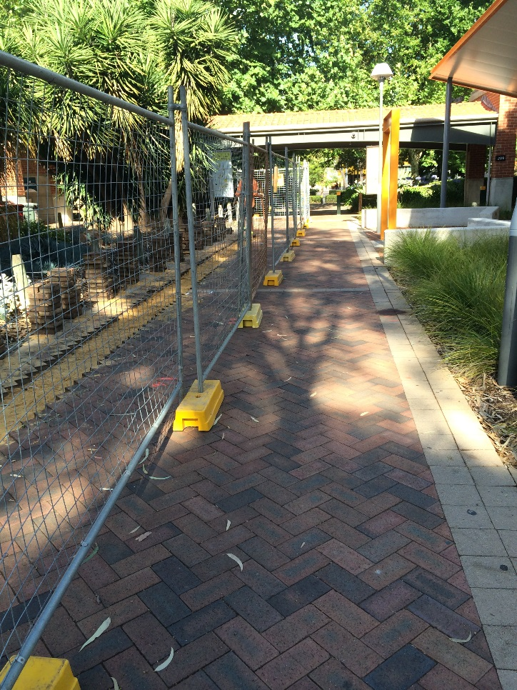

Residential buildings

Universal Design Principles
To ensure that all people can gain access to residential accommodation that actively facilitates independence and participation in all aspects of university residential life.

Accommodation buildings and common living areas

Design Criteria
Within the Curtin context residential accommodation buildings including communal living spaces, in addition to meeting the Universal Design Principles for siting, entrances, internal access and the like, should:
- Have an accessible path of travel that connects to campus arrival points, campus facilities and amenities and academic programs, to and through community, communal and private areas, ensuring that facilities required to be accessible, as a minimum, are designed to the appropriate Australian Standards on Access and Mobility.
- As far as possible have an open plan design, as this strategy maximises use of circulation spaces for all people.
- Be furnished with moveable furniture as this offers additional flexibility of circulation spaces, have windows that are low enough to enable a person using a wheelchair to experience a view.
- Have both visual and auditory emergency warning systems installed into all communal and private facilities. Consider vibrating pager devices where appropriate.
- Have door hardware, intercoms switches and controls that are easy to identify, use and operate.

Accessible bedrooms and ensuites

Design Criteria
Within the Curtin context the designated accessible bedrooms and ensuites (as required in accordance with the BCA), should:
- Be located in close proximity to communal living areas, giving due consideration to emergency egress for all, including people with motor and sensory disabilities.
- With the provision of an appropriately reinforced ceiling, have the capacity for the installation of a ceiling mounted hoist in at least one ground floor accessible accommodation unit within each residential complex.
- The accessible unit / bedrooms should:
- Have sufficient circulation space for a person in a wheelchair to move around the bed and transfer onto and off the bed.
- Provide a minimum 150mm clear open space between the floor and the base of the bed to accommodate a portable hoist, if required.
- Provide additional space to store mobility equipment such as wheelchairs and hoists.
- Feature large, easy to operate controls within accessible reach ranges from the bed and a wheelchair where appropriate.
- Provide sufficient circulation space to approach the wardrobe. Consider:
  - a sliding or concertina style door that achieves wide access
  - adjustable height shelving to accommodate reach ranges for people standing and seated
- Be furnished with:
  - a height adjustable desk or bench
  - open, height adjustable shelving for storage purposes accommodating variations in anthropometrics and reach ranges.
- The accessible ensuites should:
- Where communal, be located in close proximity to the accessible bedrooms.
- Feature adequate storage facilities that do not encroach into the required circulation spaces.
- Be an attractive design that is keeping with the aesthetic treatments in all other communal and private sanitary facilities.
- Have any emergency call bells (supported by a robust and sustainable response procedure, by a person who is trained to give assistance) installed adjacent the toilet pan in a location that can be reached by a person sitting on the toilet pan or a person who may have fallen onto the floor, ensuring that the emergency call bell reset switch is in reach of the user.
- Have a layout that does not require a person, using the toilet only, to walk or wheel over a potentially wet and slippery floor surface
- Include a grabrail strength towel rail to provide additional support.

Hot tip
As the shower seat stipulated in AS1428.1 may not meet the needs of all students; an individual solution of a commercially available height adjustable shower chair may provide a solution.

Hot tip
As individual needs vary it is difficult to design a communal kitchen that meets the needs of all users and in some instances it may be necessary to instigate an individual solution for a specific resident. Should this occur ensure that any modification does not restrict usage by other people.

Kitchens
Kitchens within accessible accommodation and all communal kitchens / tea preparation areas to be designed and constructed to the design criteria documented in section 13.9, the internal amenities of this document.
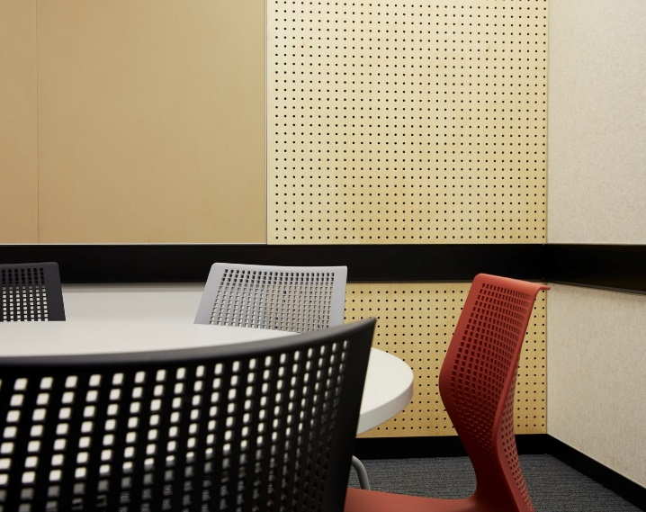

Laundries

Design Criteria
Communal and private accessible laundries should:
- Provide clear circulation spaces to enable people using mobility aids to enter and move through the laundry and turn around and exit where necessary.
- Provide at least one front load washing machine with sufficient circulation space for all people to approach, load and operate the machine.
- Provide at least one front load dryer that can be accessed from the seated position.
- Provide adjustable storage to meet the needs of all residents.
- Provide a GPO within easy reach of all residents.
- Be furnished with a more accessible alternative to a deep laundry tub, for example, a kitchen sink, particularly in private accessible laundries.

Liveable Housing
In addition to the required number of accessible bedrooms and ensuites (as per the BCA), give consideration to designing and constructing 5% of bedrooms and ensuites to the Platinum Performance Level of the Livable Housing Design Guidelines (www.livablehousingaustralia.org.au). This approach will provide flexibility and adaptability of spaces and more appropriately meets the needs of people with ambulant disabilities or orthopedic and neurological conditions who may not use a wheelchair and therefore not require all of the elements of an accessible facility. This style of accommodation should be distributed evenly throughout each residential building, offering choice and flexibility of use.

Emergency egress
Emergency egress strategies and procedures should, where applicable, meet the requirements documented in the Internal Access section of this Guideline.

Governance

Purpose of the Universal Design Guideline
The Curtin Universal Design Guideline has been prepared to guide built form and development within Curtin University’s Bentley campus. The Universal Design Guideline is one of many strategic and operational tools that have been developed to deliver the University’s strategic objective to be the most accessible University campus by 2030.

Where the Universal Design Guidelines apply
All development within Curtin University’s Bentley campus.
Development (as defined in the Planning and Development Act 2005) means the development or use of any land, including -
1. Any demolition, erection, construction, alteration of or addition to any building or structure on the land;
2. The carrying out on the land of any excavation or other works.

How to apply the Universal Design Guideline
The Curtin Universal Design Guideline will be used by the University in a number of ways, it can assist to scope projects, test design outcomes and form part of a compliance approach. These Development Guidelines are intended to create unique Curtin standards for the form and character of all development on campus.
The Curtin Universal Design Guideline may also be used by a number of stakeholders and decision-makers for the preparation of and assessment of Curtin’s Universal Design objectives. The Universal Design Guideline will apply to the different stages of the Curtin University PF+D Capital Works Delivery Model.
- Phase 1 Investigations – The principles of Universal Design and potentially the objectives within the Universal Design Guideline will be referred to in this preliminary phase.
- Phase 2 Planning – As the scope of the project becomes more defined, specific objectives of the Universal Design Guideline can be referred.
- Phase 3 Implementation – There is scope within this phase to include detailed Universal Design Guideline elements and design criteria within the development of the project brief.
- Phase 4 Occupation and Activation – To some extent the Universal Design Guideline can act as a check list for post occupancy evaluation and project closure.
It is expected that over time the application of the Universal Design Guideline will be written into the Curtin University procedures. There will be an opportunity for users to identify when and where to use the guideline as well as refine the design criteria to reflect a specific Curtin approach to Universal Design.
Figure 1 below provides an overview of the Curtin University’s PF+D Capital Works Delivery Model.
Figure 1 Curtin University’s PF+D Capital Works Delivery Model.

In addition to the above model, the Curtin University Properties, Facilities & Development and Planning teams have defined a project delivery framework for capital works. This approach may be of benefit in identifying opportunities to apply the Universal Design Guideline across different stages of projects:
- Initiation of a project
- Schematic design and feasibility
- Construction, mobilization and detailed design
- Handover and commission
This Universal Design Guideline is an innovative approach to access to the campus, as stakeholders take up the opportunity to refer to the Guideline a process will evolve and will be adopted into the day to day practices of the University.
In addition to the Universal design Guideline there are a number of Curtin University guidelines that specifically encourage innovation in placemaking and design. Stakeholders are encouraged to liaise with Curtin Properties, Facilities & Development

and Planning teams to ensure all relevant guidelines and strategies have been considered as part of the planning for a project.

How stakeholders might use the guideline
Stakeholder type | Content of interest | Curtin PF+D Capital Works Delivery Model
Visionaries | Curtin’s Universal Design Guideline Vision  7 Curtin Universal Design principles | Phase 1 Investigations
Implementers | 7 Universal Design Principles  Eight Elements and  Design Criteria | Phase 2 Planning  Phase 3 Implementation
Maintainers | Eight Elements and Design Criteria | Phase 4 Occupation and Activation.
Users  (users of the campus) | Vision – Curtin’s commitment to make a better future  7 Curtin Universal Design principles | Users should be considered at each of the four phases of the Capital Works Delivery Model

Existing buildings
Curtin University is committed to maximising access to buildings and addressing understood or identified barriers to access for all people, to existing buildings. Specific and detailed consideration must be given to the most cost effective method that meets the Curtin University vision, to create an equal and inclusive environment for all people. When a refurbishment or upgrade of an existing building is proposed, the following stages are to be followed:

- A Disability Access Consultant who is an Accredited member of the Association of Consultants in Access, Australia (ACAA) is to meet with Curtin University’s Disability Advisors to gain an understanding of:
- Known access barriers;
- Outstanding complaints as they pertain to the building.
- The Disability Access Consultant is to undertake a comprehensive audit of the existing building and prepare a detailed, technical document that makes recommendations to address:
- Upgrade requirements to bring the building in line with contemporary / mandatory requirements for access for people with a disability;
- Enhancements to the upgrade recommendations, clearly defining those recommendations that are based on the principles of Universal Design.
- Those responsible for the design of the refurbished / upgraded space to incorporate recommendations made, liaising with a Disability Access Consultant, Curtin’s Disability Advisor, Curtin appointed Project Manager and Curtin staff including those responsible for campus operations, maintenance, security and other stakeholders, as relevant to the project.
- Throughout refurbishment works, liaise as necessary with the team, as detailed above.
- At Practical Completion the Disability Access Consultant is to conduct a final inspection of the works to ensure compliance with mandatory requirements (as deemed applicable) and the application of the Principles of Universal Design as agreed at the design stage. A comprehensive report confirming the design meets the Principles of Universal Design, as far as is feasible and practical and as agreed by all stakeholders is to be prepared and issued to the Curtin University Project Manager responsible for the works.

Definitions

Accessible
“Having features to enable use by people with a disability.”
AS1428.1 2009 Clause 4.1
Accessible campus route
A route through the Curtin University Bentley campus as defined on the Bentley Campus Access and Mobility Map 2012 as a ‘universally accessible route’.
Accessible path of travel (or continuous accessible path of travel)
“An uninterrupted path of travel to, into or within a building providing access to all accessible facilities.”
A continuous accessible path of travel, as defined in AS1428.1 2009, shall not include a step, stairway, turnstile, revolving door, escalator, moving walk or other impediment.
A continuous accessible path of travel is clearly defined in AS1428.1 2009 for minimum height, width, passing and circulation space for wheelchair turning, management of changes in level, and flooring and surfaces.
AS1428.1 2009 Clauses 6 and 7
Hearing augmentation
“The communication of information for people who are deaf or hearing impaired by using a combination of audio, visual and tactile means.”
Assistive listening devices and flashing lights and vibrating alert systems are examples of ‘hearing augmentation’.
AS1428.5 2010 Clause 1.4.10

Long cane
A cane used by person who is blind or who has a significant vision impairment when moving independently through the environment. The person generally sweeps the cane in an arc from left to right, just wider than their body.
Luminance contrast
“The light reflected from one surface or component, compared to the light reflected from another surface or component.”
AS1428.1 2009 Clause 4.11
Notes: Luminance contrast is different to colour contrast. Different colours can have similar luminance contrast, for example, red and dark blue may record a similar luminance reflectance value when tested.
Mobility scooter
A battery operated mobility aid with three or four wheels that is generally much larger and heavier than a powered wheelchair. They are generally used for moving over long distances and then ‘parked’ with the user walking short distances, for example, through a door and into a room.
Additional information in regards the needs and circulation space requirements for mobility scooter users is provided in the Disability Awareness chapter of this document.
Personal emergency evacuation plan (PEEP)
“An individualised emergency plan designed for an occupant with a disability who may need assistance during an emergency”.
AS3745 2010 Clause 1.4.25
Sign – Directional (directional signage)
“A sign which shows direction to the locations of wayfinding destinations.”
Note: These may be major features, facilities and services.
(DRAFT) AS1428.4.2 2015 Clause 1.4.14
Sign – Identification (identification signage)
“A sign which identifies wayfinding destinations.”
Note: This may be a room, a facility, a location or a destination.
(DRAFT) AS1428.4.2 2015 Clause 1.4.15
Sign—Information (information signage)
“A sign which provides information about a building or place and identifies building occupants.”
(DRAFT) AS1428.4.2 2015 Clause 1.4.16
Refuge
“Refuges are areas where occupants and visitors may wait for their delayed independent evacuation, or assisted evacuation by Emergency Services or other nominated personnel.
Occupants who have a disability should be attended in the refuge by another person.”
AS3745 2010 Clause 4.2.15
Shoreline
“A continuous physical element which provides a detectable horizontal or vertical outline or edge, for navigation.”
DRAFT AS1428.4.2 2015 Clause 1.4.12
Textural surface
“A surface that provides a profile that is tactually different and discernible from the adjacent surface.”
DRAFT AS1428.4.2 2015 Clause 1.4.19

Textural surface contrast
Textural surface to be in accordance with Shoreline Surface Materials Table of between 100mm to 300mm wide and shall have a minimum 30% luminance contrast with the adjacent pedestrian surface as described in the DRAFT AS1428.1 4.2.
Wayfinding
The method used by all people to find their way around an environment. The concept is broader than signage and encompasses a range of other environment cues.
The DRAFT AS1428.4.2 2015 Wayfinding, provides specific information on wayfinding strategies for people with disabilities. Sections include:
- Site and premises identification
- Wayfinding path
- Shorelines
- Pathway incorporating textural changes
- Wayfinding information points
- Information at wayfinding decision points
Wayfinding decision point
“A place or location where information is provided to enable a building user to make informed choices about their location and intended destination(s) via the provision of information that is legible to the user.”
DRAFT AS1428.4.2 2015 Clause 1.4.21
Wayfinding information point
“A place or location which enables a building user to identify the building and the wayfinding destinations at the initial pedestrian arrival points via the provision of information that is legible to the user and which connects them to wayfinding decision points via wayfinding paths.”
DRAFT AS1428.4.2 2015 Clause 1.4.21

Wheelchair approach and turning
AS1428.1 2009 defines the spaces required to enable a wheelchair user to approach and turn in front of an amenity, furniture item, fixture or fitting.
This may comprise a combination of pathway width no less than that required for an accessible path of travel and sufficient space for a wheelchair user to make a 90° or 180° turn as appropriate.
The wheelchair approach and turning space must be level, have a traversable surface and not be obstructed by permanent or moveable furnishings.
AS1428.1 2009 Clause 6

References

Universal Design
Principles of Universal Design
The Centre for Universal Design
1997: North Carolina State University
http://www.ncsu.edu/ncsu/design/cud/about_ud/udprinciples.htm

Campus arrival
Sport England Design Guidance Note
Accessible Sports facilities 2010
http://www.sportengland.org/media/30246/Accessible-Sports-Facilities-2010.pdf

Best Practice Access Guidelines
Designing Accessible Environments
Irish Wheelchair Association
Edition 3, July 2014
http://www.iwa.ie/downloads/about/iwa-access-guidelines.pdf

Building for everyone: A universal design approach Book 1 External Environment and approach
Centre for Excellence in Universal Design
National Disability Authority
DUBLIN, Ireland
www.nda.ie

AS2890.6 2009 Parking Facilities – Off-street parking for people with disabilities

Siting and approaches to buildings
DRAFT AS1428.4.2 2015 – Design for Access and mobility – Wayfinding

Sport and Recreation- Access for All
A guide to the design of accessible indoor and outdoor recreation and sporting facilities
Sport and Recreation Victoria
1996: Villamanta Publishing Service Inc

Vision Australia Accessible design for public entrances 2011
http://www.visionaustralia.org/business-and-professionals/creating-an-accessible-environment/accessible-design-for-public-buildings

National Code of Practice: Accessible Rail.
Rail Industry Safety and Standards Board
Version 1. 29 March 2011

Best Practice Access Guidelines
Designing Accessible Environments
Irish Wheelchair Association
Edition 3, July 2014
http://www.iwa.ie/downloads/about/iwa-access-guidelines.pdf

International Best Practices in Universal Design
A global Review
March 2006
Canadian Human Rights Commission

Sport England Design Guidance Note
Accessible Sports facilities 2010
http://www.sportengland.org/media/30246/Accessible-Sports-Facilities-2010.pdf

Building for everyone: A universal design approach Book 1 External Environment and approach
Centre for Excellence in Universal Design
National Disability Authority
DUBLIN, Ireland
www.nda.ie

Sight Line; Designing Better Streets for People with Low Vision
Ross Atkin
2010 Helen Hamlyn Centre, Royal College of Art

AS1428.2 1992 Design for Access and Mobility – Enhanced and Additional Requirements – Buildings and Facilities. Clause 17
AS1428.1 2009 Design for Access and Mobility – General Requirements for Access – New Building Works Clause 6.2
AS1428.1 2001 Design for Access and Mobility – General Requirements for Access – New Building Works Clause 14.5.1

Good Signs: Improving signs for people with a learning disability. 2003 UK

Access for All: Opening Doors
English Federation of Disability Sport (EFDS) December 2013
http://cae.org.uk/resources/publications/free-publications/

Access routes
Building for everyone: A universal design approach Book 1 External Environment and approach
Centre for Excellence in Universal Design
National Disability Authority
DUBLIN, Ireland
www.nda.ie

Sport England Design Guidance Note
Accessible Sports facilities 2010
http://www.sportengland.org/media/30246/Accessible-Sports-Facilities-2010.pdf

Sight Line; Designing Better Streets for People with Low Vision
Ross Atkin
2010 Helen Hamlyn Centre, Royal College of Art

Best Practice Access Guidelines
Designing Accessible Environments
Irish Wheelchair Association
Edition 3, July 2014
http://www.iwa.ie/downloads/about/iwa-access-guidelines.pdf

AS1428.1 2009 Design for Access and Mobility – General Requirements for Access – New Building Works

AS1428.2 1992 Design for Access and Mobility – Enhanced and Additional Requirements – Buildings and Facilities.

Sport and Recreation- Access for All
A guide to the design of accessible indoor and outdoor recreation and sporting facilities
Sport and Recreation Victoria
1996: Villamanta Publishing Service Inc

Open Space Landscape Infrastructure Manual
Sunshine Coast Council
Queensland. Australia
2013
www.sunshinecoast.qld.gov.au/sitePage.cfm?code=lim

Entrances
Disability (Access to Premises – Buildings) Standard 2010

Building for everyone: A universal design approach Book 2 Entrances and horizontal circulation
Centre for Excellence in Universal Design
National Disability Authority
DUBLIN, Ireland
www.nda.ie

Evidence Based Standards: Wheelchair Usability
Centre for Inclusive Design and Environmental Access | The State University of New York at Buffalo
Clive D’souza, Edward Steinfeld, Victor Paquet
Presented at ACAA Conference October 7-9, 2015 Melbourne, Australia

Best Practice Access Guidelines
Designing Accessible Environments
Irish Wheelchair Association
Edition 3, July 2014
http://www.iwa.ie/downloads/about/iwa-access-guidelines.pdf

Sport England Design Guidance Note
Accessible Sports facilities 2010
http://www.sportengland.org/media/30246/Accessible-Sports-Facilities-2010.pdf

AS1428.4.2 2015 – Design for Access and mobility – Wayfinding

Vision Australia Accessible design for public entrances 2011
http://www.visionaustralia.org/business-and-professionals/creating-an-accessible-environment/accessible-design-for-public-buildings

Internal Access
Vision Australia Accessible design for public entrances 2011
http://www.visionaustralia.org/business-and-professionals/creating-an-accessible-environment/accessible-design-for-public-buildings

Access for All: Opening Doors
English Federation of Disability Sport (EFDS) December 2013
http://cae.org.uk/resources/publications/free-publications/

Building for everyone: A universal design approach
Book 2 Entrances and horizontal circulation
Book 3: Vertical circulation
Book 4: Internal environment and services
Centre for Excellence in Universal Design
National Disability Authority
DUBLIN, Ireland
www.nda.ie

Best Practice Access Guidelines
Designing Accessible Environments
Irish Wheelchair Association
Edition 3, July 2014
http://www.iwa.ie/downloads/about/iwa-access-guidelines.pdf

AS3745 2010 Planning for emergencies in facilities

National Construction Code Series Volume One. Building Code of Australia, Class 2 to Class 9 Buildings

ABCB Information Handbook: Lifts Used During Evacuation 2013

Fire Safety Risk Assessment supplementary guide. Means of Escape for Disabled People. 2007 Crown copyright. The Stationary Office: UK

Sport England Design Guidance Note
Accessible Sports facilities 2010
http://www.sportengland.org/media/30246/Accessible-Sports-Facilities-2010.pdf

Evacuation of People with Disability & Emergent Limitations: Considerations for Safer Buildings and Efficient Evacuations, Lee Wilson 2014

Internal amenities
Vision Australia Accessible design for public entrances 2011
http://www.visionaustralia.org/business-and-professionals/creating-an-accessible-environment/accessible-design-for-public-buildings

Access for All: Opening Doors
English Federation of Disability Sport (EFDS) December 2013
http://cae.org.uk/resources/publications/free-publications/

Building for everyone: A universal design approach
Book 2 Entrances and horizontal circulation
Book 3: Vertical circulation
Book 4: Internal environment and services
Book 5: Sanitary facilities
Book 6: Facilities in buildings
Centre for Excellence in Universal Design
National Disability Authority
DUBLIN, Ireland
www.nda.ie

AS1428.2 1992 – Design for Access and Mobility – Enhanced and Additional Requirements – Buildings and Facilities.

AS1428.1 2009 – Design for Access and Mobility – General Requirements for Access – New Building Works

Sport England Design Guidance Note
Accessible Sports facilities 2010
http://www.sportengland.org/media/30246/Accessible-Sports-Facilities-2010.pdf

AS1428.5 2010 Design for access and mobility: Communication for people who are deaf or hearing impaired

Events and construction management
National Code of Practice: Accessible Rail.
Rail Industry Safety and Standards Board
Version 1. 29 March 2011

Building for everyone: A universal design approach Book 1 External Environment and approach
Centre for Excellence in Universal Design
National Disability Authority
DUBLIN, Ireland
www.nda.ie

Vision Australia Accessible design for public entrances 2011
http://www.visionaustralia.org/business-and-professionals/creating-an-accessible-environment/accessible-design-for-public-buildings

AS1428.2 1992 Design for Access and Mobility – Enhanced and Additional Requirements – Buildings and Facilities

Residential buildings
Livable Housing Design Guidelines
Livable Housing Australia
2012 2nd ed.
www.livablehousingaustralia.org.au/

Best Practice Access Guidelines
Designing Accessible Environments
Irish Wheelchair Association
Edition 3, July 2014
http://www.iwa.ie/downloads/about/iwa-access-guidelines.pdf

AS1428.2 1992 – Design for Access and Mobility – Enhanced and Additional Requirements – Buildings and Facilities

Disability awareness
Design Resource. DR – 14 Clear Floor Area for Wheeled Mobility: Redefining the ‘common wheelchair’
Clive D’souza, Edward Steinfeld, Victor Paquet, Jonathan White
2010: Centre for Inclusive Design and Environmental Access, University of Buffalo, School of Architecture and Planning
Last updated- January 4 2011

Evidence Based Standards: Wheelchair Usability
Centre for Inclusive Design and Environmental Access | The State University of New York at Buffalo
Clive D’souza, Edward Steinfeld, Victor Paquet
Presented at ACAA Conference October 7-9, 2015 Melbourne, Australia

Informative References

Centre for Inclusive Design and Environmental Access
University at Buffalo
State University of New York
http://idea.ap.buffalo.edu/home/index.asp

Universal Design Handbook
Editor in chief Wolfgang F.E Preiser
Senior Editor Elaine Ostroff
McGraw-Hill
2001

Universal Design Handbook
Editor in chief Wolfgang F.E Preiser
Senior Editor Korydon H. Smith
McGraw-Hill
2nd Edition 2011

Access Guidelines, Facility Requirements within the Built Environment
May 2011, 3rd Edition
Sydney Olympic Park
http://www.sopa.nsw.gov.au/media/pdfs/publications/guidelines_for_accessibility/access_guidelijes_may_2011,_3rd_edition

Shaping Neighbourhoods
Accessible London: Achieving an Inclusive Environment
Draft Supplementary Planning Guidance
April 2014
Greater London Authority
Julie Fleck, Rachel Smalley, Neil Smith
www.london.gov.uk

Oregon State University
Built environment best practices
http://oregonstate.edu/accessibility/bestpractices
http://oregonstate.edu/accessibility/plan
http://oregonstate.edu/accessibility/assessment

Inclusive Design Standards
London Legacy Development Corporation
March 2013
www.londonlegacy.co.uk

Apartment Design Guide
Tools for Improving the design and residential apartment development
NSW Department of Planning and Environment
July 2015

Inclusive Mobility- A guide to best practice on access to pedestrian and transport
Infrastructure, Mobility and Inclusion Unit, Department of Transport 2002
https://www.gov.uk/government/publications/inclusive-mobility

Colour, Contrast & Perception
Design Guidance for Internal Built Environments
Keith Bright, Geoff Cook, John Harris
1997:The University of Reading
Revised 2004
http://www.libraries.carmarthenshire.gov.uk/English/environment/planning/buildingcontrol/Technical%20Guidance/Documents/Colour%20Contrast%20and%20Perception.pdf

has been superseded by http://au.wiley.com/WileyCDA/WileyTitle/productCd-1405195045.html
The Colour, Light and Contrast Manual: Designing and Managing Inclusive Built Environments
Keith Bright, Geoffrey Cook
ISBN: 978-1-4051-9504-1
240 pages
March 2010, Wiley-Blackwell

By all reasonable means: Inclusive access to the outdoors for disabled people
2005 Landscape Access Recreation. Countryside Agency
http://publications.naturalengland.org.uk/publication/45015

Guide to Safety at Sports Grounds
Department for culture, media and sport
5th ed 2008
http://www.safetyatsportsgrounds.org.uk/sites/default/files/publications/green-guide.pdf

Self Examination: How Accessible is Your Campus?
2015 DO-IT University of Washington
(Article)
http://www.washington.edu/doit/self-examination-how-accessible-your-campus

ADA Standards for Accessible Design
2010
(Americans with Disabilities Act 1990(ADA))

https://www.regjeringen.no/globalassets/upload/bld/nedsatt-funksjonsevne/norway-universally-designed-by-2025-web.pdf
Norway universally designed
by 2025
The Norwegian government’s action plan for universal design

APPENDIX ONE - Disability awareness

Physical disability

Ambulant disability
People with an ambulant disability may use an assistive device to aid walking, such as a stick or frame, or walk unaided but could be slow, experience pain, have difficulty bending, be unsteady on their feet or become easily fatigued.
A person with an ambulant disability may be able to walk on a flat or sloped surface, and may prefer to use a well-designed stairway in preference to a ramped surface.

Upper limb disability
This generally describes people who have disabilities such as arthritis or poor control or strength in the arms resulting in restricted arm movements (for example, reaching a lift button) or difficulty turning and grasping objects (for example, turning on taps, opening doors or pushing a small control that sits flush with the surrounds). This also includes complete loss of limbs or functionality.

People who use wheelchairs and scooters
People who use a wheelchair may be limited in how far or high they can reach, or may have difficulty seeing over or around people or other barriers. A wheelchair user requires sufficient clearance under benches, counters and desks to accommodate their knees and wheelchair footplates.
People using manual wheelchairs may become fatigued when moving around a challenging environment, due to longer paths of travel or hilly outdoor environments.
Some wheelchair users are unable to move their legs and may have a loss of sensation. Other wheelchair users may have some leg movement and may be able to stand or walk for short distances.

People who use a mobility scooter
Most people who use a powered mobility scooters as a mobility aid generally have the physical capacity to walk short distances but require assistance when travelling longer distances and around challenging external environments such as Curtin University.
Many people using scooters have the capacity to park their scooter in a safe area and walk through a building to their destination or use another mobility aid such as a walking frame or manual wheelchair to move through the building.
A minority of people will rely on a scooter to transport them both outside and inside of buildings.
These mobility devices are generally larger and less manoeuvrable than a manual or powered wheelchair. Whilst there are no available, conclusive research findings on the footprint (clear floor space dimensions) and turning spaces required for scooters, USA based, ongoing, research indicates the following dimensions:
- Accommodating the 95th percentile for both occupied width and length requires a minimum clear floor space dimension of 837mm x 1435mm.
Design Resources DR – 14 Clear Floor Area for Wheeled Mobility: Redefining the ‘common wheelchair’, by The Centre for Inclusive Design and Environmental Access
- To enable the 95th percentile of scooter users to undertake a 360° turn a clear floor space dimension of 2500mm x 2500mm is required.
Evidence Based Standards: Wheelchair Usability
Centre for Inclusive Design and Environmental Access | The State University of New York at Buffalo

Sensory disability

Blindness
People classified as legally blind may have up to 10% vision. Very few people have no vision at all. Many people who are blind are able to discern day from night and may be able to tell you if the sky is overcast.
People who are blind will require all of their information, including signage, in a non-visual format.
Navigating their environment could be assisted with the aid of a guide dog or a long cane used to detect objects and spaces around them. A person who uses a guide dog will require additional space to manoeuvre, for example on a stairway or lift.
Other environmental cues that may assist people with a significant vision impairment utilise their other senses when moving around an environment are sounds (noisy traffic moving in a certain direction) and smell (a garden or chemical laboratory), a change in temperature, or the ‘feel’ of being in a certain type of environment, such moving outside into an area where there is a canopy or overhead weather protection, moving along windy corridor, or detecting a different ground or floor surface underfoot.

Low vision (vision impairment)
Many people with a vision impairment have sufficient vision to find their way around an environment if designed in a way that is safe, logical and clear (clear shoreline), using good colour and luminance contrast and large, well designed signage.

Deafness
Deafness is defined by degree of hearing loss. These degrees span from profound or total deafness to moderate hearing loss. People with mild deafness would usually be considered to be hard of hearing or having a hearing impairment.
In Australia, many people who are deaf use Auslan (sign language) as their primary language, and usually have knowledge of English, which they consider to be their secondary language. Some people are able to lip read, speak, or read and write English.
People who are deaf require clear signage that is located in a logical position. Adequate lighting is required for signage, lip reading and Auslan interpreters.

Hard of hearing
A hearing loss can come in many forms and can affect the quantity and quality of sound received. People may experience loss of volume, sound distortions or sensations such as ringing in the ear. Good acoustics and hearing augmentation is required for example at public receptions and in lecture theatres and meeting or tutorial rooms.

Cognitive disability
People with ‘Impaired thought processes’ come under the very broad heading of a cognitive disability. People who have an intellectual disability, autism, mental health issues or neurological impairment may have cognitive impairments. This could be apparent in many forms, some of which could be:
- Memory loss or confusion
- Lack of confidence and skills to make enquiries
- Becoming overwhelmed or distressed in an area that is highly stimulating
- Slowness or difficulty processing information
- Difficulty in following instructions or interpreting detailed or complex information
People who have cognitive disabilities require logical, consistent surroundings, signage that is easy to read and are often familiar with recognised pictorial depictions and symbols. A person with a cognitive impairment may find environments that have an over proliferation of information difficult to function in.

Short term, long term and episodic disabilities
A long term disability includes people with a longstanding and ongoing disability. The person may have been born with a disability or have acquired it.
A temporary disability or injury may not lead to a long term disability, but the person may require some form of assistance in the short term (for example a broken leg). This could impact any student, staff or visitor to the University.
An episodic disability includes people who may have occurrences such as back pain or flare up of a fatigue-inducing illness. People with an episodic disability may use a mobility aid on some occasions and not on others.

APPENDIX TWO - Universal Design
Ron Mace in 1988 defined Universal Design as:
‘Universal design is the design of products and environments to be usable by all people, to the greatest extent possible, without the need for adaptation or specialized design’
Contemporary views of Universal Design, while embedded in the rich history of the Universal Design concept include core elements expounded at the ‘Universal Design: a Better Way’ 2015 Conference of Association of Consultants in Access Australia:
Universal Design should be a process that enables and empowers a diverse population.
Universal Design starts with consideration of the user.
Universal Design is internationally recognised as a dynamic and best practice framework for the refurbishment or development of new environments for people of all ages and abilities, now and into the future. The seven principles and thirty guidelines of Universal Design are considered of such importance to this guideline document that they are reproduced below for easy reference:

Universal Design Principles and Guidelines

Principle 1: Equitable Use
The design is useful and marketable to people with diverse abilities.
Guidelines:
1a. Provide the same means of use for all users: identical whenever possible; equivalent when not.
1b. Avoid segregating or stigmatizing any users.
1c. Provisions for privacy, security, and safety should be equally available to all users.
1d. Make the design appealing to all users.

Principle 2: Flexibility in Use
The design accommodates a wide range of individual preferences and abilities.
Guidelines:
2a. Provide choice in methods of use.
2b. Accommodate right- or left-handed access and use.
2c. Facilitate the user's accuracy and precision.
2d. Provide adaptability to the user's pace.

Principle 3: Simple and Intuitive Use
Use of the design is easy to understand, regardless of the user's experience, knowledge, language skills, or current concentration level.
Guidelines:
3a. Eliminate unnecessary complexity.
3b. Be consistent with user expectations and intuition.
3c. Accommodate a wide range of literacy and language skills.
3d. Arrange information consistent with its importance.
3e. Provide effective prompting and feedback during and after task completion.

Principle 4: Perceptible Information
The design communicates necessary information effectively to the user, regardless of ambient conditions or the user's sensory abilities.
Guidelines:
4a. Use different modes (pictorial, verbal, tactile) for redundant presentation of essential information.
4b. Provide adequate contrast between essential information and its surroundings.
4c. Maximize "legibility" of essential information.
4d. Differentiate elements in ways that can be described (i.e., make it easy to give instructions or directions).
4e. Provide compatibility with a variety of techniques or devices used by people with sensory limitations.

Principle 5: Tolerance for Error
The design minimizes hazards and the adverse consequences of accidental or unintended actions.
Guidelines:
5a. Arrange elements to minimize hazards and errors: most used elements, most accessible; hazardous elements eliminated, isolated, or shielded.
5b. Provide warnings of hazards and errors.
5c. Provide fail safe features.
5d. Discourage unconscious action in tasks that require vigilance.

Principle 6: Low Physical Effort
The design can be used efficiently and comfortably and with a minimum of fatigue.
Guidelines:
6a. Allow user to maintain a neutral body position.
6b. Use reasonable operating forces.
6c. Minimize repetitive actions.
6d. Minimize sustained physical effort.
Principle 7: Size and Space for Approach and Use
Appropriate size and space is provided for approach, reach, manipulation, and use regardless of user's body size, posture, or mobility.

Guidelines:
7a. Provide a clear line of sight to important elements for any seated or standing user.
7b. Make reach to all components comfortable for any seated or standing user.
7c. Accommodate variations in hand and grip size.
7d. Provide adequate space for the use of assistive devices or personal assistance.
Reference: 1997 NC State University, The Centre for Universal Design

