Slide 1

Exploring the retention & success of students with disability
Sue Kilpatrick, Susan Johns, Robin Barnes, Darlene McLennan, Sarah Fischer & Kerri Magnussen
December 2015
Slide 2

Project Background & Aim
Students with disability in higher education is increasing
National data show differences in the retention and success between universities but reasons for this are not clear
Success rate of students with disability is lower than for other students
Aim:
Explore the relationship between supports and university adjustments for students with disability, and their retention and success
Slide 3
Methods
Mixed Methods Approach
Research Questions:
- How do universities compare in retention and success of students with various disability types?
- How does students retention and success compare in terms of policy and practice approaches to the provision of adjustments and supports for student with various disability types?
- What approaches should universities take in the provision of adjustments and supports for students with various disability types?
Slide 4

Methods

Mixed Methods Approach - Quantitative
Data requested from the Higher Education Student Data Collection from 2007-2013
Data was broken down into 6 disability types, hearing, learning, mobility, visual, medical and other including if students needed services
Data for commencing students, enrolment, student retention and success were analysed for Table A & B providers
Data was examined by disability type, university grouping and university size
Slide 5

Methods

Mixed Methods Approach - Qualitative

Desktop Audit of Table A &B providers using publically available information from disability section of website
Literature review
Individual semi-structured interviews with disability practitioners (n=9)
interviewees selected purposively to represent a mix in terms of university size, university grouping
Develop and validate guiding principles for good practice with disability practitioners’
Slide 6

Results - Quantitative
Number of students with disability has increased since 2007
Distribution of disability types remains the same
Smaller universities have a larger proportion of students with disability
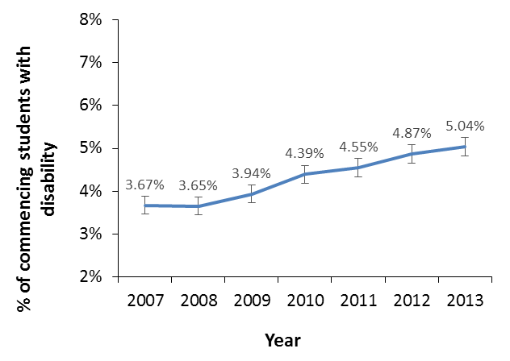
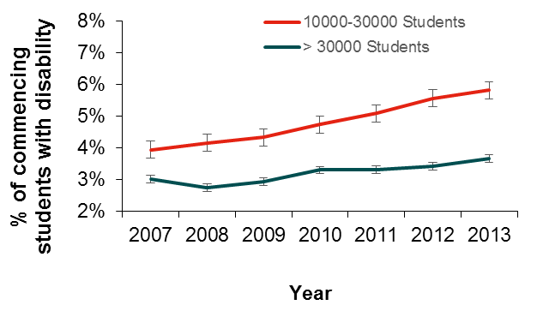

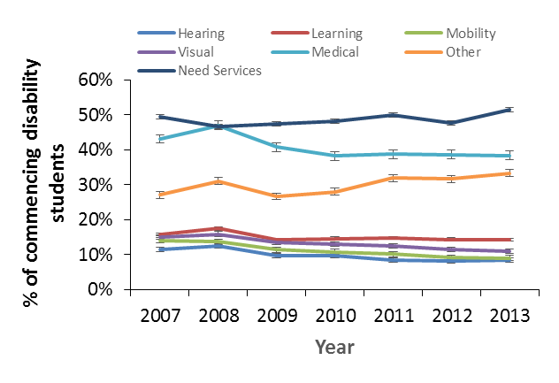
Slide 7

Results – Quantitative
Students with disability have lower success rate than total student population
Students with learning, medical, other or required services performed less well than total disability students
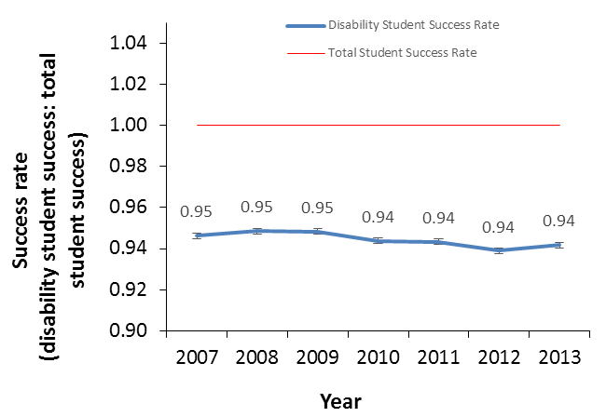
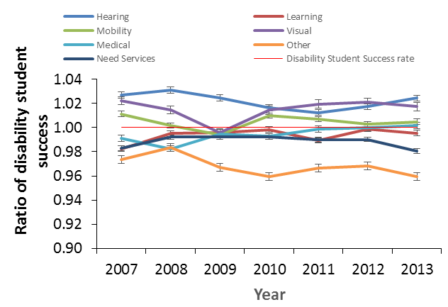
Slide 8

Results - Quantitative
Students with disability have consistently lower retention rate than total student population
Students with learning, disability were consistently retained at a higher rate than other disability students

Slide 9

Results – Qualitative
All universities have at least one disability policy
The DAP were not key drivers of action
increasing importance being placed on formalised procedures
“in my view it hasn’t actually played a very significant role in the way the university has developed its processes around this…it has been more of a lip service” (ATN medium)
“while we don’t have a current disability action plan this doesn’t mean we are not proactive…we conducted accessibility audits and implemented $1-million worth of adjustments to one campus” (IRU inconsistent)
Slide 10

Results – Qualitative
Most institutions described socially inclusive policies and practices and supportive leadership
Collaborative approaches involving internal and external stakeholders can improve retention and success of students with disability
“We are engaged with local disability networks and attend meetings regularly. We try to get the word out that support for students with disability is offered early/sooner in the process [rather] than later” (RUN High)
Relationships between disability advisors and staff and students along with peer-to-peer relationships was seen as key to supporting students
Slide 11

Results – Qualitative
The provision of more services and better support for students with a mental health disability and those with autism is an area requiring further university investment.
Inconsistent categorisation of students with mental health disabilities in national and institutional data collection makes targeting services and tracking performance challenging.
“…anecdotally mental health is one of the big issues affecting student retention and we don’t necessarily pick up those students in the official statistics”. (ATN Medium)
“…and I hazard a guess that many people living with a mental health condition would never consider themselves as having a disability so…do not contact the service…we have a fundamental issue about terminology and how you communicate that… (Unaffiliated High)”
More training for academic and non-academic staff to better support students with disability.

Slide 12

Conclusions & Recommendation
Clear evidence within institutions of shift from medical to inclusive model (eg. location of service units within broader equity/wellbeing structure; university wide responsibility for students with
Need national consistency in categorising students with disability
In particular, students with mental health disability should be encouraged to identify in a single category.
Need to have a conversation about changes to policy and practice that will increase enrolment, retention and success rates of students with disability toward the rates for all students.
This conversation should be informed by the guiding principles for good practice developed by the researchers

Slide 13

Guiding Principles
Operate under a whole of university inclusive framework that includes the concept of universal design
Ensure the policy framework supporting students with disability is current, flexible and relevant to the institutional context
Ensure that financial resources, as well as human resources, are identified and flexible enough to fit student requirements, including the specific requirements associated with different disability types
Ensure disability support services are integrated with student support services.
Have specialist disability support staff who have the knowledge and experience to identify appropriate adjustments
Provide regular training for disability practitioners and other staff with responsibility for supporting and advising students with disability
Develop a staff training and awareness communication strategy in relation to students with disability, and ensure sessional staff are included
Set up mechanisms to facilitate interpersonal relationships in three domains: between disability support staff and students; between disability support staff and both academic and professional staff, and amongst students themselves
Slide 14

Guiding Principles (cont)
Develop an appropriate and sensitive mechanism to identify those students with mental health disability to allow those students with a mental health condition who wish to disclose, or who have not considered disclosing before, to do so
1Develop an appropriate and sensitive mechanism to identify those students with autism spectrum disorder to allow those students with autism spectrum disorder who wish to disclose, or who have not considered disclosing before, to do so
Regularly monitor student outcomes by collecting data on retention and success
Offer inclusive student wellbeing programs that promote and improve self-management and resilience.
Develop formalised (written) learning access plans collaboratively with students that are owned by students. With the agreement of students, put mechanisms in place to ensure appropriate dissemination of plans to relevant staff
Consider students with disability from the perspective of the student lifecycle model, including recruitment and outreach strategies, and career transition strategies.
Partnerships with external organisations that leverage resources are fundamental.
Consider students with disability in the development and use of online learning resources, as well as in learning support services.

Slide 15

Recommendations for Further research
Further research should be conducted to identify appropriate methods of disclosure and data collection, including Commonwealth data collection and reporting, to more accurately reflect retention and success statistics for students by disability type.
It would seem that NDCOs may have a greater role to play in terms of recruitment of students with disability. Further research into the impact of relationships between NDCOs and universities on the recruitment of students with disability is recommended.
Slide 16
Recommendations for Further research cont..
Outcomes from this study will form the basis for a large-scale study into the impact of institutional policies and practices on the retention and success of higher education students with disability. However, more research is needed into institutional and other factors that impact on the retention and success of students with disability, and particularly for different disability types. Such research should adopt a student lifecycle focus, incorporating outreach and recruitment, as well as transition out of university, including transition to a vocation or career.
Slide 17
Other recent Australian research
Resilience/Thriving in post-secondary students with disabilities.
Dr Rahul Ganguly, Dr Charlotte Bronwlow, Dr Jan Du Preezand Dr CoralieGraham, University of Southern Queensland www.ncsehe.edu.au
Supporting tertiary students with disabilities: individualised and institution-level approaches in practice.
Ellie Fossey,Lisa Chaffey,Annie Venville,Priscilla Ennals,Jacinta Douglas,Christine Bigby www.ncver.edu.au
They also produced good practice guide designed to assist teaching staff and disability services staff in both vocational education and training (VET) and higher education institutions to offer individualised or institution-level adjustments in teaching, learning and assessment methods to support students with disability or ongoing ill health
Slide 18

Acknowledgments
National Centre for Student Equity in Higher Education
Interview Participants
ADCET and AUST-EDU listserv for assistance in distributing information
Any feedback or comments please let us know
Darlene.McLennan@utas.edu.au

