Slide 1

Supporting tertiary students with disabilities, mental illness and long term health conditions: Student and staff perspectives of what works

A program of research funded by NCVER

Dr Annie Venville, Australian Catholic University & La Trobe University
Professor Ellie Fossey, Monash University & La Trobe University
March 10 2016

Slide 2

Current thinking about supporting students
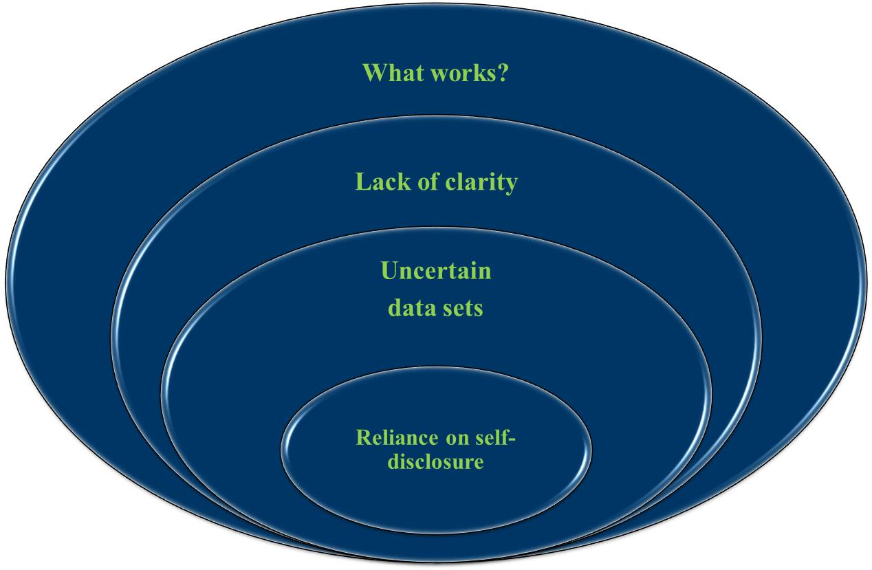
Slide 3

Our Research

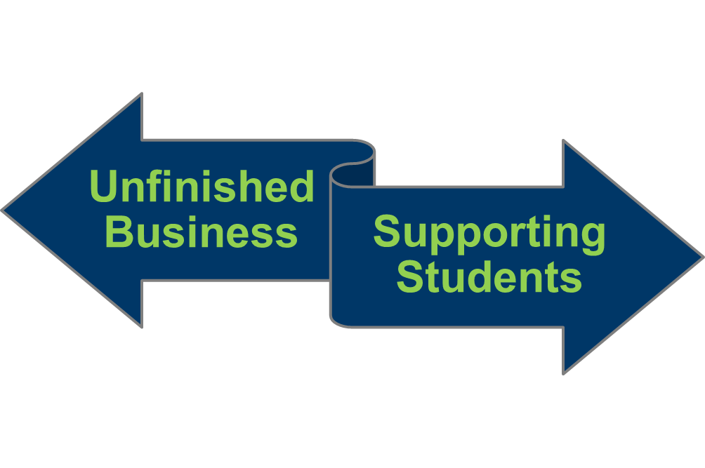

Mental Illness Disability

Slide 4

Unfinished business: student perspectives on disclosure of mental illness and success in VET

Research Aim and Method
To improve understanding of the factors influencing successful course completion for VET students with a mental illness from the perspectives of the students themselves.

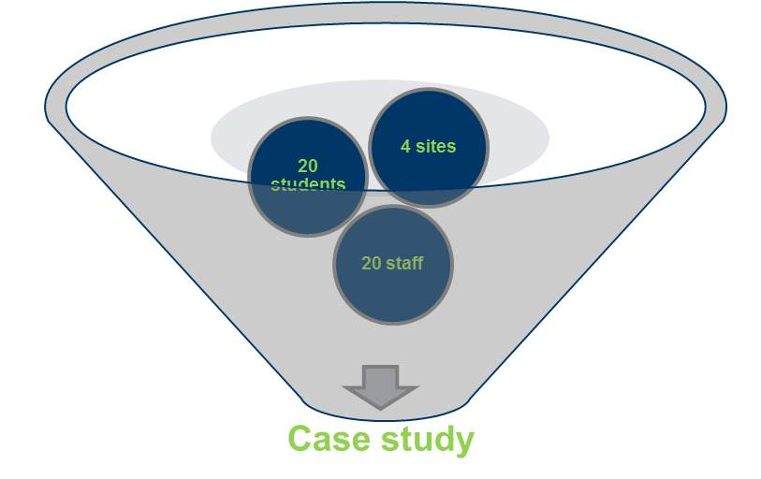
Slide 5

Factors for course success- student and staff perspectives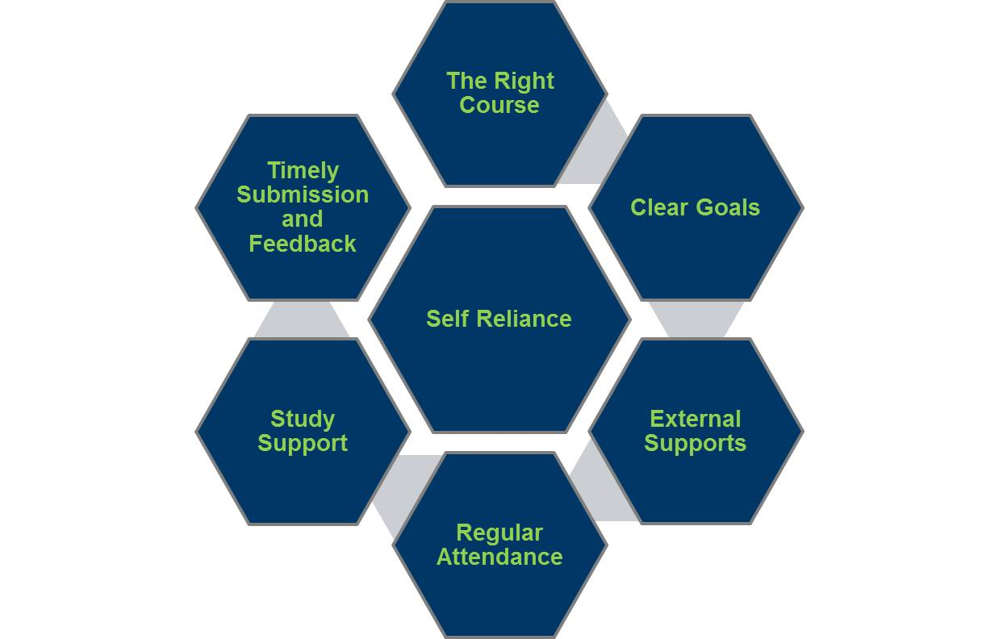

Slide 6

Disclosure of Mental Illness
as the Start Button

- Support mechanisms are predicated on disclosure
- Previous research has focused on ways to increase rates of disclosure
- But…...
students have different understandings of disclosure than do staff and organisations

Slide 7

The Disclosure Dilemma

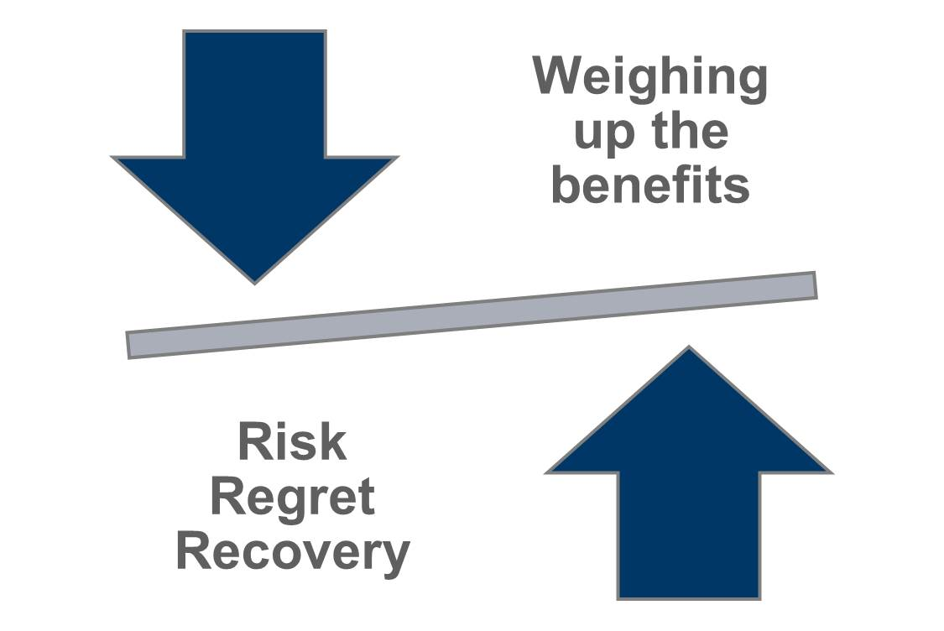
Slide 8

The presentation of a better self:

student perspectives

Well if I, ah… say talk openly with my teachers about depression, or anything like that, you know, because they are in the industry I just fear that you know they...if one day they are to interview me for a job and you know… or to take part in a project, they will think, ‘Oh A, that’s the guy who was depressed… you know, he didn’t cope with his previous job, so he quit’... I just fear that kind of information, you know might escape, I know that this depression I’m going through is just a phase and not something that is going to last forever so, umm, I just want to keep it to myself … I just don’t want to be perceived as depressed, as a depressed person, a sad person, you know (Alain Site 1)

Slide 9

“The right thing to do”: staff perspectives

- Student disclosure was seen as a means of opening the way for access to support services.
  - Despite staff participants expecting students to disclose, they expressed an unwillingness to risk the social stigma potentially created by disclosure of mental illness for themselves.

- Moll, Eakin, Franche, and Strike (2013) hypothesise that staff disclosure decisions are unconsciously embedded in and “shaped by an institutional discourse on what it means to be a ‘good worker’” (p. 175) and so conceal signs of illness.
  - Student disclosure decisions reflect a parallel process

Slide 10

VET Context & disclosure

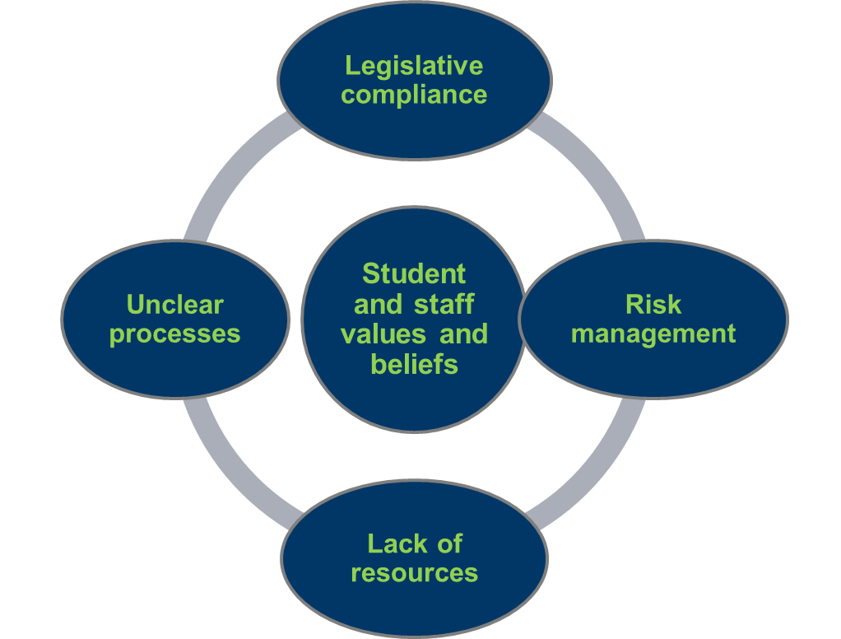

Slide 11

Supporting tertiary students experiencing disability and/or ongoing health conditions

Research aims
To better understand the range of supports offered to students experiencing disability or health conditions disabilities, how these supports are implemented, and their usefulness to students’ learning from three viewpoints:
- Tertiary students experiencing disability or health conditions enrolled in a VET or university course
- Staff providing disability support to VET and university students
- Curriculum / course leaders

Methods

- Guided by a reference group with expertise in VET and university student support and disability services
- Qualitative interviewing

Slide 12

Tertiary students, teaching and disability support staff interviews - differing but interconnecting issues & viewpoints on:

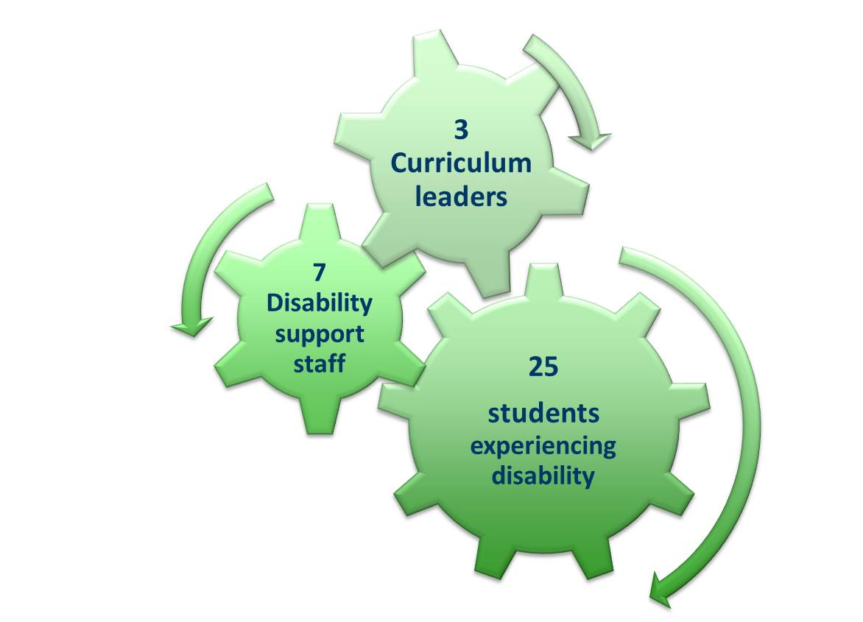

1) Provision of

individualised

reasonable

adjustments

2) Use of

institution-level

learning

supports

2 Sites

Slide 13

Student Learning Supports

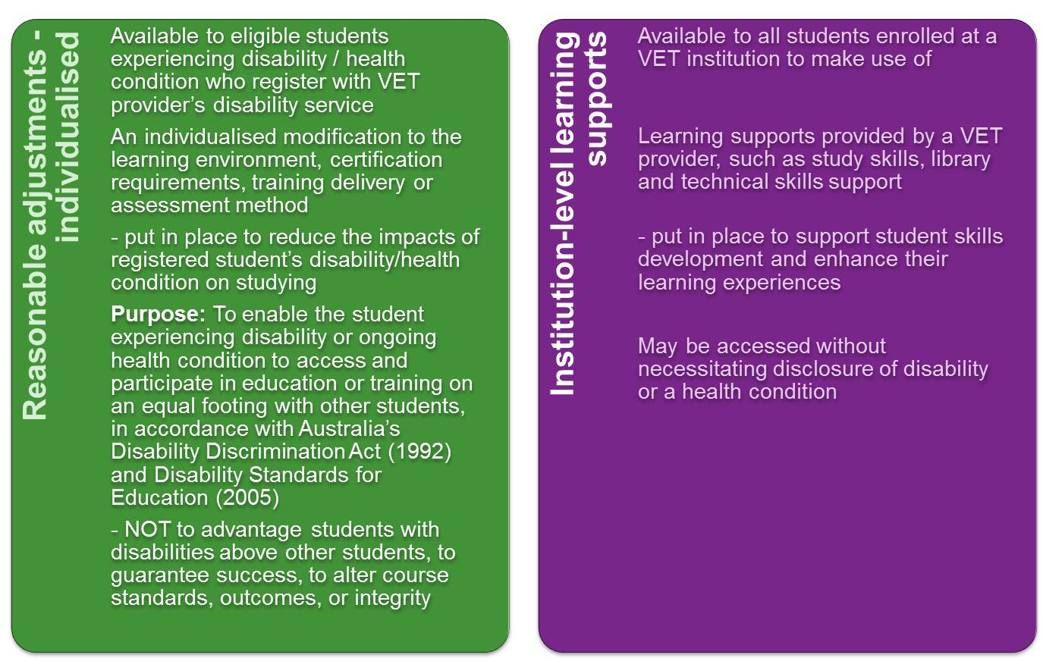
Slide 14

Main findings
Supporting tertiary students with disabilities is complex in practice:
- It involves not only identifying their learning support needs, but also negotiating and implementing learning supports
- Multiple people need to be engaged in these processes: students, teachers & disability staff.

Many types of individualised reasonable adjustments are used by students, reflecting:
- Diversity in students’ learning support needs
- Specific learning tasks, assessments and learning environments, for which the adjustments are intended.

Institution-level learning supports identified as useful for supporting these students’ learning were particularly those involving the use of information and communication technologies, and inclusive teaching practices
Learning supports for students with disabilities could be enhanced through more active use of institution-level learning supports, as well as individualised reasonable adjustments.

Slide 15

Provision of disability supports: 4 processes

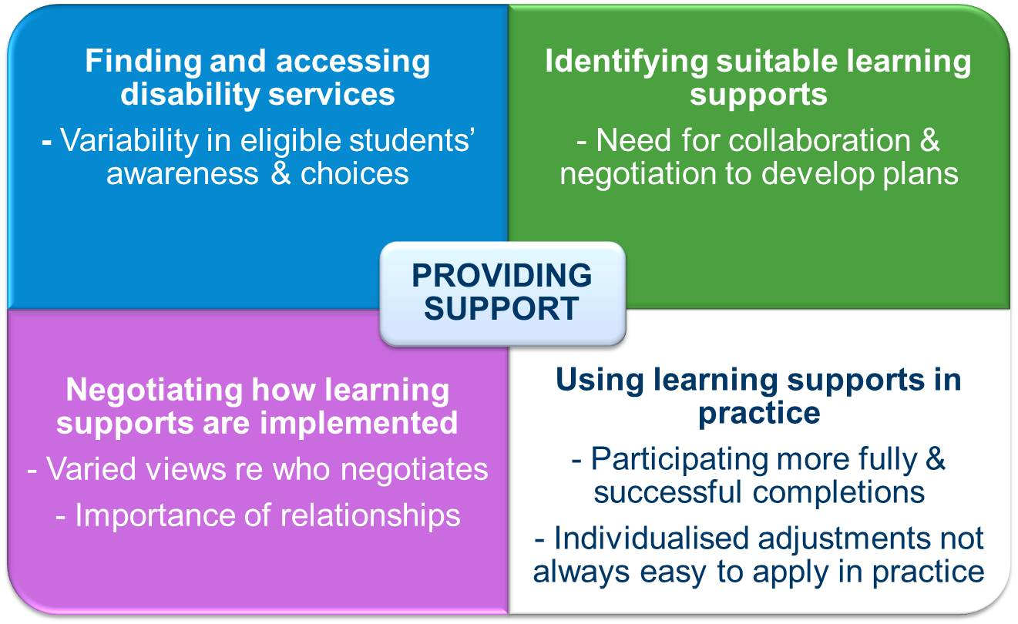
Slide 16

Good practice - WHAT kind of supports

To offer my students?
Decisions about what supports/adjustments to offer should focus on the individual student’ needs
- Consult with the student, teachers/instructors, support people and/or technical experts to:
  - identify learning and/or assessment tasks for which supports/adjustments are needed
  - consider available options - students’ own strategies, learning supports available to all students, and reasonable adjustments

- Collaboration is key in selecting what supports / adjustments are appropriate, how best to implement them, and whether they are working

Slide 17

Reasonable adjustments – some examples

Flexibility in assessments
- Extended assessment due dates and/or changed assessment formats (eg, oral instead of written presentation) and submission methods (eg electronic instead of in person)

Changed assessment conditions
- Provision of a computer / recorder rather than hand writing / use of scribe
- Allowance of food and beverages, extended exam time and/or location in a quiet room

Provision of appropriate adaptive equipment (eg screen reader, audio recorder, adjustable seating, specialist software)
In-class support
- Making study materials and recordings of classes available online for more flexible access & review
- Note takers (who may sit with the student or separately depending on student’s preference)
- Participation support
- Re-formatting of course materials to accommodate specific impairments (e.g., large print, audio-recording)

Other academic support
- Course information provided in varied formats (e.g., printed, online, audio-books)
- Individual tutoring or study skills development
- Regular monitoring, encouragement and seeking feedback

Slide 18

Other learning supports to consider –

some examples

Slide 19

Institution-level learning supports, eg
Flexibility in learning activities or assessment formats
In-class support, eg
- Teaching stress management & coping strategies in class
- Making class materials available online
- Providing ’revision’ classes to supplement regular teaching sessions

Other academic support, eg
- Course information in varied formats (e.g., print & online)
- Teachers being accessible (e.g., ‘open-door policy’, strategies to address accessibility when many staff are part-time/casual)

Student initiated strategies, eg
- Using non-specialist equipment (eg, wheeled bags for carrying books)
- Using mobile devices to organise their schedules, develop study skills, or record, watch and listen to lessons
- Searching online for information resources/tools to assist with their studies
- Listening to audiobooks instead of printed books, where available
- Reducing study loads by studying part-time
- Using stress management strategies

Enhancing inclusive learning supports
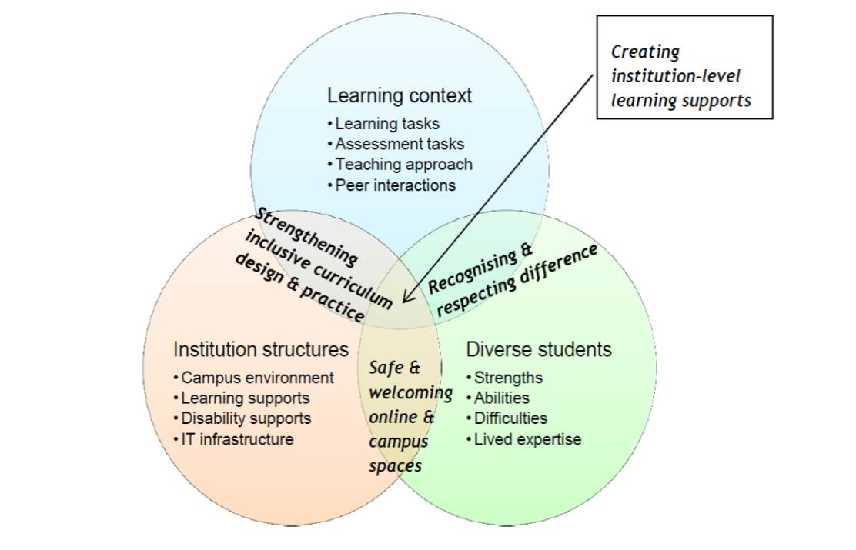
Slide 20

Further resources

Department of Training and Workforce Development Western Australia (DTWD) (2013). Reasonable adjustments: A guide to working with students with disability, Author, Perth.

Ennals, P., Fossey, E. & Howie, L. (2015). Postsecondary study and mental ill-health: A metasynthesis of qualitative research exploring students’ lived experiences. Journal of Mental Health, 24(2), 111-119.

Fossey, E., Chaffey, L., Venville, A., Ennals, P., Douglas, J. & Bigby, C. et al. (2015). Supporting tertiary students with disabilities: Exploring the use of individualised and institution-level approaches in practice. NCVER, Adelaide.

Queensland VET Development Centre (QVDC) (2010). Reasonable adjustments in teaching, learning and assessment for learners with a disability: A guide for VET practitioners, Queensland Department of Education, Training and Employment, Brisbane.

Slide 21

Venville, A., Mealings, M., Ennals, P., Oates, J., Fossey, E., Douglas, J. & Bigby, C. (in press). Supporting students with mental illness or an acquired brain injury to participate in postsecondary education: a scoping review of approaches. International Journal of Disability, Development & Education

Venville, A. & Street, A. (2012) Unfinished business: student perspectives on disclosure of mental illness and success in VET. NCVER, Adelaide.
Venville, A, Street, AF & Fossey, E (2014). Good intentions: teaching and specialist support staff perspectives of student disclosure of mental health issues in post-secondary education. International Journal of Inclusive Education, 18 (11), 1172-1188.

Venville, A., Street, A. & Fossey, E. (2013). Student perspectives on disclosure of mental illness in post- compulsory education: displacing doxa. Disability & Society, 29, 792-806.

Slide 22

Acknowledgments
- NCVER funding
- Participating TAFEs and universities in New South Wales and Victoria
- Student and staff participants
- Expert reference group – members from student services, curriculum development, student advocacy, and disability support services at Northern Melbourne Institute of TAFE (NMIT) & La Trobe University
- Research teams
  - Annie Venville, Annette Street & Ellie Fossey
  - Ellie Fossey, Lisa Chaffey, Priscilla Ennals, Annie Venville, Jacinta Douglas, Chris Bigby & Magnus Tideman

