**Presenta**Wise

Inclusive practice as the standard

in higher education:

Opportunities and challenges

Professor Denise Wood Central Queensland University



# Context

The Review of Australian higher education (Bradley Report) commissioned by the Australian Government in 2008 noted, ‘Indigenous people, people with low socio- economic status, and those from regional and remote areas’ remain under-represented in higher education (*Review of Australian Higher Education*, xii) .

There is a need for Australia to increase the number of highly skilled people by increasing the opportunities for those under-represented within the system to participate in higher education (*Review of Australian Higher Education*, p. xi).

### Transforming Australia’s Higher Education System

* By 2025, 40 per cent of all 25 to 34 year olds will hold a qualification at bachelor level or above.
* By 2020, 20 per cent of higher education enrolments at the undergraduate level will be of people from a low SES background.
* An allocation of $108 million over four years for a new partnerships program, to link universities with low SES schools and vocational education and training providers.
* Allocation of a further $325 million over four years to be provided to universities as a financial incentive to expand their enrolment of low SES students, and to fund the intensive support needed to improve their completion and retention rates.
* Existing higher education Equity Support Program to be replaced and incorporated into these new funding arrangements

# Impact of the Reforms

The Department of Education’s higher education student enrolment summary statistics for the 2013 first half year show:

* An increase of 3.8 per cent of domestic and international students (1,136,041 enrolled in the first half of 2013).
* An increase of domestic student enrolments of 5.4 per cent from the first half of 2012, with 876,637 in the first half of 2013 (77.2 per cent of all students).
* Postgraduate students increased by 4.4 per cent to 278,729 while undergraduate students increased by 3.5 per cent to 831 743.
* Students who self-identified as Aboriginal and Torres Strait Islander comprised 1.0 per cent of all enrolments in the first half of 2013 (up

9.9 per cent to 11,684 students) and 1.2 per cent of commencements (up 8.6 per cent to 4 741).

* Commencements in priority area courses in the first half of 2013 increased.

# 

# Line graph shows 5 different coloured lines reflecting the enrolment trends reported on previous slide. Thre is a vertical line showing the introduction of reforms in 2009 and the lines show the growth in enrolments for each group of people since that time. The first line shows maximum growth for regional people, next major trend evident for low SES, much lower growth but still evident for people with disabilities, those from non-English speaking backgrounds and those from Indigenous backgrounds with lowest growth for those from remote locations.Impact of the Reforms – Graph Depiction

**Figure 1: Impact of the reforms in graph format**

# Impact of the Reforms (King and James, 2013)

King and James (2013) note the following impacts from the changes:

* Universities enrolled an additional 5% of places in 2009 in response to the Bradley recommendations and in anticipation of the implementation of the recommended reforms.
* By 2012 the number of funded places was 21% over the 2009 target under the previous policy.
* Increases in the number of students with an Australian Tertiary Admission Rank (ATAR) of 70 or more and among people with mid level (40 to 70) ATARs.
* Student demand and the supply of places enabled the Australian higher education system to expand and accommodate different groups of students.
* King and James (2013) raise two concerns: 1) Whether HEIs may be recruiting students who may not be capable of [or suited to] higher education pathways; and 2) Whether HEIs can achieve the desired outcomes given the financial resources available to them.

# Implications

* Online enrolments have continued to increase, but as Norton and Cherastidtham note (2014), ‘the distinctions between online and on- campus are blurring’. As he suggests, almost all students now rely on online technologies’.
* Keppell & Riddle (2012) also note that higher education learning ‘is no longer typified by a singular place of learning but a range of places and spaces that we seamlessly move through’ (such as working at home, reading journal articles while commuting, via a learning management system, or attending formal classes on campus).
* Such trends have ‘implications for the place and space of learning and will require digital citizens to have sophisticated literacies to embrace ubiquitous learning spaces’ (Keppell, 2014).
* The need for inclusive online learning environments is particularly salient given the implications of the widening participation agenda and the trend towards increasing reliance on technologies for learning.

# Rethinking Disability and Diversity

* The Social Model of Disability evolved out of resistance to the medical model.
* This Model perpetuated a Cartesian view of disability in attempting to separate impairment and disability; a more holistic social framework is required (Beckett, 2006).
* The biopsychosocial model recognises that it is the combination of the bio-psycho (Thomas, 2001, cited in Gabel and Peters, 2004) with social processes that lead to physical and emotional oppression (Reeve, 2004).
* This is the approach adopted by the World Health Organization in the International Classification of Functioning, Disability and Health (WHO, 2002).

# Recognising Diversity

* Not all individuals with disabilities identify as having a disability (Beckett, 2006; Watson 2000).
* Some people with impairments resist identification as disabled, while others identify by other aspects of their experience, as for example gender, ethnicity, social class (Shakespeare and Watson, 2001).
* Individuals choose to emphasise sameness or difference depending on whether or not they perceive there to be value in identifying either temporarily or in the longer term with the oppressed group to challenge the 'value-structure of the dominant group' (Wendell, 1989, p. 118).

# A More Inclusive Approach

* Need to problematise the categorisation of diversity and adopt a reconceptualisation which deconstructs the normal/abnormal; able bodied/disabled; black/white; male/female binaries that are either sustained or challenged through pedagogical practices in teaching and learning and the ways in which we use technology to enhance learning.
* The inclusive design of technology enhanced learning recognises that there are four core components required to create more inclusive online and electronic learning environments: accessibility; usability; personalisation; and transformative pedagogy.

Inclusive Model for Technology Enhanced Learning

The circular diagram with its four components within which each component has four sub-components and the outer circle showing principles of universal design encompasses the following:
1. Accessible design (curriculum materials should be perceivable, operable, understandable and robust)
2. Usable design (course design should be learnable and memorable, flexible and adaptable, efficient and satisfying and robust)
3. Personalise learning (technologies should be selectable, interoperable, customisable and responsive)
4. Transformative pedagogy (curriculum engages students to discover assumptions, assess those assumptions, challenge their assumptions and take informed actions)
Universal design (provide multiple means of engagement, representation, action and expression)

Figure 2: Framework for inclusive design of technology enhanced learning

# What is Inclusive Design?

* Inclusive education can be defined as the right of every person to access mainstream education regardless of their abilities, race, gender, nationality or any other factor (Gaad, 2011).
* Inclusive education has become an increasingly important global policy issue:
  + UN Millennium Development Goals
  + UNESCO Education for All (EFA)
  + UN Convention on the Rights of Persons with Disabilities
* Article 24 on Education of the Convention on the Rights of Persons with Disabilities recognises the right of persons with disabilities to education.

# What is Accessible Design?

* Online technology makes accessing information ‘anytime, anyplace’ a reality for millions of people worldwide.
* The Internet can also improve communication and increase the independence of people who may be physically, as well as socially, isolated.
* Web accessibility is about ensuring that anyone, using any browser or device is able to access content on the Web.
* Websites designed without considering accessibility guidelines create barriers for millions of people.

# Who Benefits from Accessible Design?

Those who…

* may not be able to see, hear, move, or may not be able to process some types of information easily or at all.
* may have difficulty reading or comprehending text.
* may not have or be able to use a keyboard or mouse.
* may have a text-only screen, a small screen, a slow Internet connection or different browser.
* may not speak or understand fluently the language in which the document is written.
* may be in a situation where their eyes, ears, or hands are busy.

# The Need

* Impact of the widening participation agenda and the need to be responsive to increasing numbers of students from diverse backgrounds.
* Over 4 million Australians have a disability (1 in 5).
* 2.1 million Australians of working age (15 – 64 years) have disability.
* 31% of 55-64 year olds are living with disability. 78% of people with disability acquire their disability aged 16 years or older.

# The Need (Population Characteristics)

* 3.4 million (15%) Australians have a physical disability
* 1 in 6 Australians are affected by hearing loss.
* Vision Australia estimates there are currently 357,000 people in Australia who are blind or have low vision
* Around 668,100 Australians have intellectual and/or development disorders.
* 10% of the population has dyslexia.
* More than 90,000 people have a mental health disorder
* Almost 90 per cent of disabilities are not visible.

# The Legal Context

* The Australian Human Rights Commission (AHRC) reinforces the importance of providing equal access to the Web.
* The DDA states that it is ‘unlawful for a person who, whether for payment or not, provides goods or services, or makes facilities available, to discriminate against another person on the ground of the other person's disability or a disability of any of that other person's associates’ (1992).
* SOCOG Case, Target and now test case against Coles reinforce the legal obligations.

# The W3C Web Accessibility Initiative

* WAI was created to specifically pursue and develop the accessibility of the Web through five areas of work: technology; guidelines; tools; education and outreach; and research and development.
* The main three major areas of WAI work include:
  + 1. Web Content Accessibility Guidelines (WCAG 2.0).
* 2. Authoring Tool Accessibility Guidelines (ATAG).
* 3. User Agent Accessibility Guidelines (UAAG)
* 4. Protocols and Formats.

# The W3C WCAG 2.0

* Since its 2008 release and subsequent ISO approval, WCAG 2.0 is viewed as the definitive standard for Web accessibility. The four POUR WCAG principles are:
* Perceivable - Information and user interface components must be presentable to users in ways they can perceive.
* Operable - User interface components and navigation must be operable.
* Understandable - Information and the operation of user interface must be understandable.
* Robust - Content must be robust enough that it can be interpreted reliably by a wide variety of user agents.

# Ten ‘Quick Tips’ (Vision Australia)

1. Give all images a text equivalent
2. Use structural mark-up to give meaning to content
3. Create consistent presentation and navigation
4. Make links to clearly identify their destinations
5. Use colours with sufficient colour contrast
6. Build pages to work with a keyboard as well as mouse
7. Allow users to resize text and page width
8. Mark up forms and data tables appropriately
9. Use scripting with care
10. Make multimedia accessible

# MS Word and PDF Accessibility issues

1. Give all images a text equivalent
2. Use structural mark-up to give meaning to content
3. Create consistent presentation and navigation
4. Make links to clearly identify their destinations
5. Use colours with sufficient colour contrast
6. Mark up forms and data tables appropriately
7. Make multimedia accessible
8. Save to PDF from Word (do not print to PDF)
9. Make sure scanned PDF documents use OCR
10. Run accessibility checker in Acrobat Professional

# Usability Testing

1. Usability has been defined as 'the extent to which a product can be used by specified users to achieve specified goals with effectiveness, efficiency and

satisfaction in a specified context of use' (ISO 9241-11).

1. Usability testing within a TEL environment addresses factors such as learnability, efficiency, memorability, errors, productivity, learning effects, time of task completion, information literacy, acceptance, and satisfaction.

# Accessibility and Usability Case Study

Mature aged student who works full-time and was enrolled part-time in a non-award certificate course offered by one of the participating universities.

The student identified herself as blind and a proficient screen reader user.

Heuristic testing and the use of semi-automated accessibility testing tools indicated that the course met Level AA conformance standards. However, formal usability testing with this student identified a range of usability and accessibility issues which impacted on her ability to engage in many of the learning activities of the course as described in following slides.

#### Accessibility and Usability Case Study Summary – Semantic Structure

**Usability and accessibility issues identified and associated recommendations**

**Task:**

Find the contact details of the course coordinator and send the coordinator an email.

**Issue:**

As a screen reader user, the student relies on skimming content quickly by locating major headings for the sections of the site. While a block with a label was clearly marked ‘coordinator contact details' the label by default was not marked up as a major heading, which meant the student skipped past the section several times and was only able to locate the relevant section by laboriously tabbing through every link on the page until she came to the relevant section.

**Recommendations:**

While W3C guidelines do require the appropriate use of semantic mark-up of pages using headings (Guideline 1.3), by default, labels differentiating blocks of content do not create heading level text in this implementation of the university LMS. There are two recommendations arising from this observation:

* 1. Teachers should ensure that they apply headings to all major sections of online course materials including labels.
  2. LMS administrators should modify the default template to ensure that labels automatically assign headings when created.

#### Accessibility and Usability Case Study Summary – Navigation and Wiki Accessibility

**Usability and accessibility issues identified and associated recommendations**

**Task:**

Go to the course Wiki and join a group for assessment 3 by adding your name to the group with whom you would like to collaborate.

**Issues:**

This task also posed many challenges for the student. Firstly, she could not find the link to the Wiki without prompting from the facilitator. This was because the link to the Wiki appeared in the Assessment block of content underneath the link to Assessment 3 criteria. The next challenge for the student having located the Wiki with the help of the facilitator was knowing where to type her name, as the Wiki appears to a screen reader as one large form with no designated fields in which to input content.

**Recommendations:**

WCAG 2.0 guidelines require content developers to employ approaches to navigation which help users to find the content and locate where they are (Guideline 2.4) and for pages to operate in predictable ways (3.2). Therefore, to improve accessibility we need to:

1. Ensure that links relating to major sections are located within that section to save unnecessary steps in navigating to related content.
2. Provide alternative means for students to sign up or contribute to course.

#### Accessibility and Usability Case Study Summary – Pop-up Windows in Forums

**Usability and accessibility issues identified and associated recommendations**

**Task:**

Make a posting to the course discussion forum.

**Issue:**

The student located the link to the discussion forum without difficulty, but when she went to add a post to the forum, an unexpected window popped up because she inadvertently clicked in the ‘add file’ option which triggered a pop-up window enabling the selection of a file to attach. This is an inherent problem with the structure and function of the LMS.

**Recommendations:**

WCAG 2.0 guidelines require web pages to operate in predictable ways (3.2).

While teachers cannot alter the functionality of the LMS, the provision of clear guidelines to students about what each of the functions in the discussion forum mean and what behaviours are actioned when selecting different options would provide students with contextual help to warn them in advance of unexpected behaviour on the page.

# Personalised Learning

Personalised learning environments (PLEs) offer great promise in meeting this demonstrated diversity in student learning styles, digital literacy, English language proficiency, access to technologies, and accessibility requirements.

Central to the PLE is recognition of the role of an individual in organising, customising and shaping his or her own learning environment (Attwell, 2007; Siemens, 2007).

However, McLoughlin and Lee (2010, p. 31) argue that PLEs stand in “stark contrast to institutionally controlled, content- centric” LMSs.

#### Personalised Learning Based on Learning Analytics

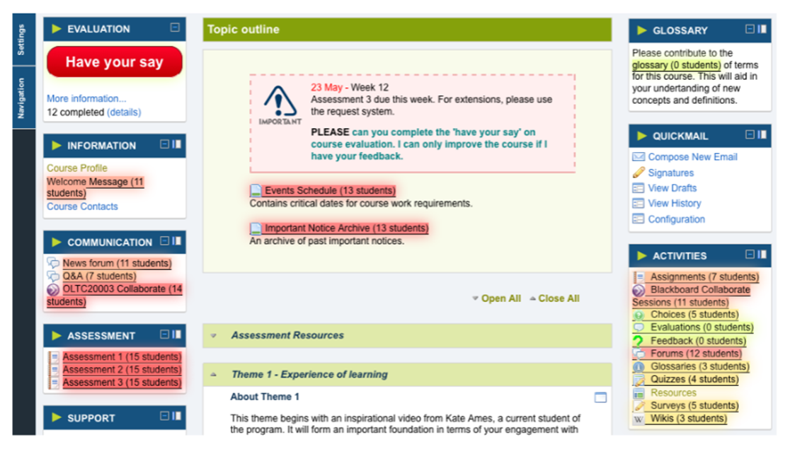

Figure 3. Learning Analytics – CQUniversity Moodle Activity Viewer

# Responsive Learning Environment

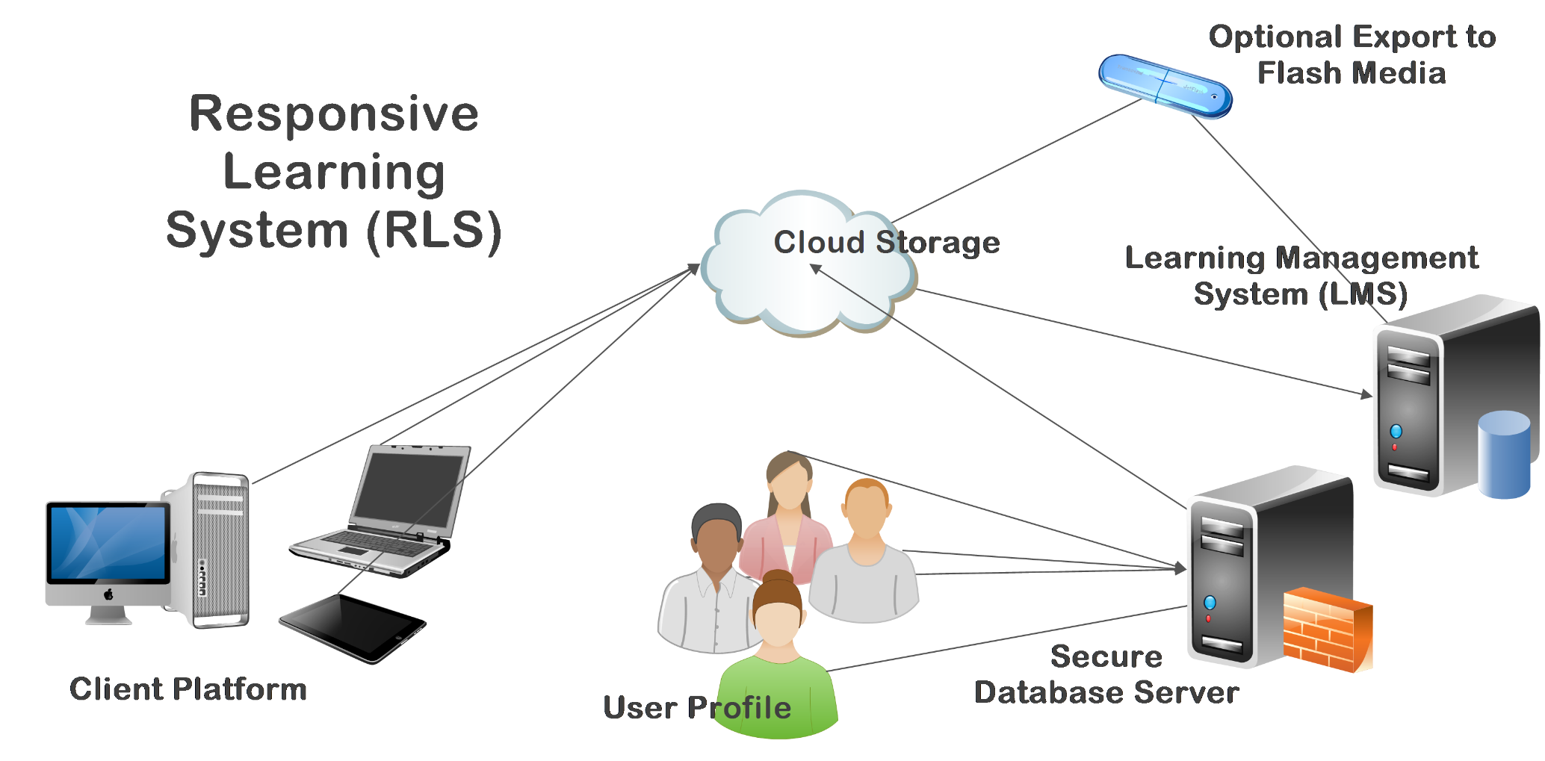

Figure 4. Responsive Learning Design Concept

# Flexible Learning for Open Education (FLOE)

* FLOE provides the resources to personalise how students learn and to address barriers to learning.
* Designed to support students, educators and curriculum designers to develop course materials that accommodate the full diversity of learners.
* Leverages the benefits and of and contributes to the Open Education Resources (OER) movement.

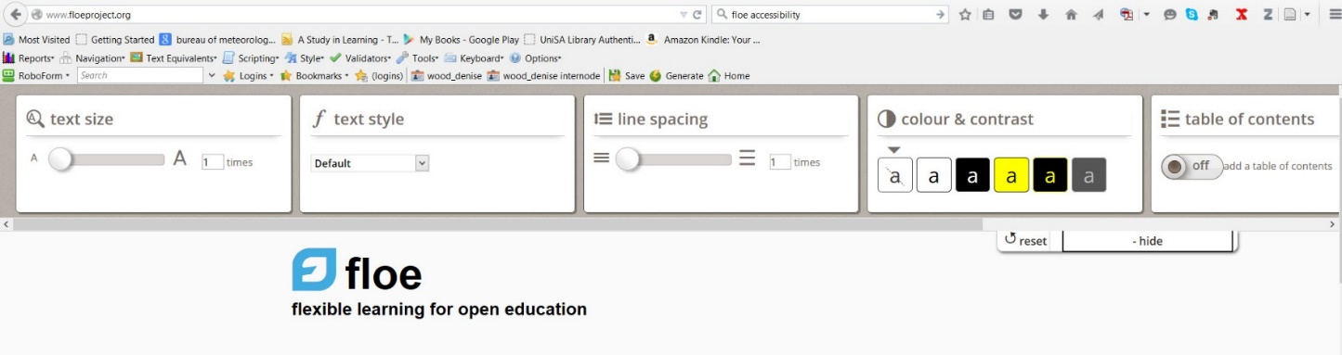

**Figure 3: FLOE open source solution enabling students to personalize the LMS environment** <http://www.floeproject.org/>

# Need for a Transformative Pedagogy

* Despite the differences in the ways that inclusion is defined, its effectiveness is closely related to managing students by minimising disruption in regular classrooms and by regulating 'failure' within the education systems.
* Allan (2004) argues that there has been a failure to apply contemporary understandings of diversity to the 'refashioning‘ of pedagogical approaches.
* The move towards standardisation of inclusion, access and equity through institutional policy has

`reterritorialized difference' leading to a focus on management of, rather than engagement with, difference' (Allan, 2004, p. 420).

# Transformative Pedagogy

* Despite the differences in the ways that inclusion is defined, its effectiveness is closely related to managing students by minimising disruption in regular classrooms and by regulating 'failure' within the education systems.
* Allan (2004) argues that there has been a failure to apply contemporary understandings of diversity to the 'refashioning‘ of pedagogical approaches.
* The move towards standardisation of inclusion, access and equity through institutional policy has

`reterritorialized difference' leading to a focus on management of, rather than engagement with, difference' (Allan, 2004, p. 420).

# Transformative Pedagogy Foundations

* The transformative approach is consistent with Paolo Freire’s (1970) critical pedagogy- social transformation is best achieved by exposing students to opportunities which awaken their critical consciousness enabling them to perceive social, political and economic contradictions and take actions against such oppressive practices (p. 19).
* Learning and teaching strategies designed to develop students’ critical thinking skills have the potential to facilitate such transformative pedagogical change.

# Transformative Pedagogy and Critical Thinking

* Brookfield (2012) outlines four elements of critical thinking:

1. Discovering the assumptions that influence the way we think and act;
2. Assessing whether these assumptions are valid and thus appropriate guides for action;
3. Challenging the assumptions by attempting to view them from multiple perspectives; and
4. Taking informed actions based on the process of critically evaluating assumptions and determining if the available evidence supports the proposed actions.

### Institutional Approach to Inclusive Practice

*'Inclusion is the Standard, NOT the Exception'*

**The institutional approach to inclusive practice shows a circular diagram with the ethic of care as outer circle. The central circle reflects the learning centred focus. The three segments with sub-comonents are:
1. Institutional factors (1. policies and implementation; 2. promise and delivery; 3. systems and processes; 4. monitoring and progress)
2. Program factors (1. learning and teaching academic standards; 2. graduate attributes; 3. inhernet requirements; 4. program outcomes)
3. Individual factors (1. profile-diversity; 2. motivations and aspirations; 3. cultural context such as home and community; 4. workplace factors)**

**Figure 4. Model for ‘Inclusion is the Standard Not the Exception’**

# Institutional Approach (5 Ps Foundation)

* An institutional approach to adopting the inclusive TEL model, needs to address the four previously described components as well as strategies designed to support diverse students to complete their studies.
* The ‘4Ps Framework’ proposed by David Kalsbeek (2013) for improving student retention:

1. Profile (the demographic characteristics of the student)
2. Promise (what the institution) and what it delivers
3. Processes (the systems and processes)
4. Progress (how institution tracks and monitors progress).

* We have added a 5th P – institutional policies and practices.

# Institutional Approach - Components

* Three critical components. These are:

1. Institutional factors (policies, promise; processes; progress)
2. Program factors (learning and teaching academic standards; graduate attributes; inherent requirements; and learning outcomes)
3. Individual factors (profile; motivations and aspirations; cultural context; work related factors)

* Each of these components represent interacting activity systems within which a student must engage.
* Contradictions can arise – by exposing the contradictions, opportunities to address these challenges are identified (Engeström, 2001).

# Institutional Approach

* An ethic of care approach supports students throughout the student life journey.
* Marketing needs to deliver realistic messages about what prospective students should expect in transition.
* At pre-enrolment prospective students need to be informed of the institutional and program requirements to help them identify if any aspect of their diversity may make it difficult for them to meet these requirements and then to be able to access the supports they require.
* Need regular follow-ups and monitoring of student progress to identify challenges and help resolve them as they arise.

# References

* Allan, J. (2004). Deterritorializations: Putting postmodernism to work on teacher education and inclusion.

*Educational Philosophy and Th*eory, 36(4), 417-432.

* Attwell, G. (2007). Personal Learning Environments-the future of eLearning?. Elearning papers, 2(1), 1-8.
* Beckett, A. (2006). *Citizenship and vulnerability: Disability and issues of social and political engagement.*

Houndmills, Basingstoke, Hampshire: Palgrave Macmillan.

* Bradley, D., Noonan, P., Nugent, H. and Scales, B. (2008). *Review of Australian Higher Education: Final Report*. Canberra: Commonwealth of Australia.
* Brookfield, S. (2005). *The power of critical theory: Liberating adult learning and teaching*. San Francisco: Jossey-Bass.
* Engestrom, Y. (2001). Expansive learning at work: toward an activity theoretical reconceptualization. *Journal of Education and Work*, volume 14, number 1, pp. 133–156.
* Freire, P. (1970). *Pedagogy of the oppressed*. New York: Continuum.
* Gaad, E. (2011). *Inclusive education in the Middle Eas*t. New York and London: Routledge.
* Gabel, S. and Peters, S. (2004). Presage of a paradigm shift? Beyond the social model of disability toward resistance theories of disability. *Disability & Society*, volume 19, number 6, pp. 585-600.
* ISO 9241-11, 1998*. Ergonomic requirements for office work with visual display terminals (VDT)s – Part 11: Guidance on Usability*, International Standard.

# References (continued)

* Kalsbeek, D. (2013). *Reframing retention strategy for institutional improvement.* San Francisco: Jossey-Bass.
* Keppell, M. (2014). Personalised learning strategies for higher education. The future of learning and teaching in next generation learning spaces. *International Perspectives on Higher Education Research*, 12, 3-22.
* Keppell, M. & Riddle, M. (2012). Distributed learning places: Physical, blended and virtual learning spaces in higher education. (pp. 1-20). In Mike Keppell, Kay Souter & Matthew Riddle (Eds.). (2012). *Physical and virtual learning spaces in higher education: Concepts for the modern learning environment*. Information Science Publishing, Hershey.
* King, C. And James, R. (2013). Creating a Demand Driven System. In S. Marginson (Ed.). *Tertiary Education Policy in Australia*. Centre for the Study of Higher Education.
* McLoughlin, C. and Lee, M. ( 2010). Personalised and self-regulated learning in the Web 2.0 era: International exemplars of innovative pedagogy using social software. *Australasian Journal of Educational Technology*, volume 26, number 1, pp. 28-43.
* Norton, A. and Cherastidtham, I. (2014). *Mapping Australian higher education*, 2014-15, Grattan Institute, Australia.
* Reeve, D. (2004). Psycho-emotional dimensions of disability and social model. In C. Barnes and G. Mercer,

*Implementing the social model of disability: Theory and research*. Leeds: The Disability Press, pp. 83-100.

* Shakespeare, T., & Watson, N. (2001). The social model of disability: an outdated ideology?. *Research in social science and disability*, 2, 9-28.

# References (final page)

* Siemens, G. (2007). PLEs - I acronym, therefore I exist. *elearnspace: learning, networks, knowledge, technology, community* [weblog].
* *Transforming Australia's Higher Education System (2009).* Canberra: Commonwealth of Australia.
* Tronto, J. (1993). *Moral boundaries.* New York: Routledge.
* United Nations (UN) *Millennium Development Goals*. Retrieved October 3, 2015, from, <http://www.un.org/millenniumgoals/>
* United Nations Educational, Scientific and Cultural Organization (UNESCO). *Education for All (EFA) Global* [*Monitoring Report*. Retrieved October 3, 2015, from, http://www.unesco.org/new/en/education/themes/leading- the-international-agenda/efareport/.](http://www.unesco.org/new/en/education/themes/leading-the-international-agenda/efareport/)
* United Nations (UN) *Convention on the Rights of Persons with Disabilities: Status of Signatories and Parties*, 2006. Retrieved October 3, 2015, from, at <http://www.un.org/disabilities/convention/conventionfull.shtml>.
* W3C, 2008. *Web Content Accessibility Guidelines (WCAG) 2.0*. Retrieved October 3, 2015, from, <http://www.w3.org/TR/WCAG20/>.
* Wendell, S. (1989). Toward a feminist theory of disability. *Hypatia*, 4(2), 104-124.
* WHO, 2002. *Towards a common language for functioning, disability and health: ICF, The International Classification of Functioning, Disability and Health*. Retrieved, October 3, 2015, from, <http://www.who.int/classifications/icf/icfbeginnersguide.pdf?ua=1>.