Word version of PowerPoint presentation by Scott Hollier Tuesday 18 May – ADCET ATEND Webinar

Slide 1

Accessibility & the education experience
Dr Scott Hollier
ADCET 2015

Slide 2

Who is Media Access Australia?
Australia’s only independent not-for-profit organisation devoted to increasing access to media for people with disabilities

Provides expert knowledge and advice on existing and emerging mainstream technologies

Works as a catalyst for change in multiple areas of access

Slide 3

Who am I?
Image of Scott Hollier with the accompanying text.

Professional:
Manager, Major Projects
W3C Advisory Committee
Academic:
Edith Cowan University, Adjunct Lecturer
PhD thesis ‘The Disability Divide’
Personal: Legally blind, first-hand knowledge of access issues

Slide 4

Brief history of access
For the mainstream population, Internet was viewed primarily as an information and communication resource

For people with disabilities, Internet was viewed as a gateway to independence

Slide 5

User experience
People with disabilities generally use assistive technologies to help use a computer
Assistive Technology is the practical implementation of technology to support and help people with disabilities
Old model: specialist AT costs $1000-$2000
New model: OS now contains many of these tools, and free open-source also viable

Slide 6

Windows 7/8.1
Change the icon and text size
Mouse pointer size & movement
High contrast colour themes
ToggleKeys
Visual alerts
On-screen keyboard
Magnifier (touch-enabled in 8)
Narrator screen reader (better in 8)
NVDA: free alternative to Narrator

Slide 7

Mac
Improvements over Windows:
Better screen reader VoiceOver
Braille display support

However…
VoiceOver doesn’t work with the Office suite, works mostly with OpenOffice for Mac

Slide 8

iOS & Apple Watch
iOS (IPhone/iPad)
Great access: VoiceOver, zoom, captioned video, colour changes.
App compatibility improving, AppleVis good crowdsourcing advice website

Apple Watch:
Includes some iOS features such as VoiceOver, zoom, audio in one ear

Slide 9

Android
Google Android phone and tablets:
Talkback screen reader, magnifier, colour contrast adjustments (5.x), global caption support
Good third-party apps like BIG Launcher
More affordable than Apple

However…
Only really a viable alternative if running Android 4.2+

Slide 10

Audio demonstration
App accessibility on Android-based device using the TalkBack screen reader

Slide 11

ICT professionals
Web Content Accessibility Guidelines (WCAG) 2.0 is definitive standard, both as web standard and ISO (40500)

Three compliance levels: A, AA, AAA

Australian requirement by AHRC – WCAG 2.0 Level AA

Slide 12

WCAG 2.0 at a glance
Perceivable:

Provide text alternatives for non-text content.

Provide captions and other alternatives for multimedia.

Create content that can be presented in different ways, including by assistive technologies, without losing meaning.

Make it easier for users to see and hear content.

Slide 13

WCAG 2.0 at a glance
Operable:

Make all functionality available from a keyboard.

Give users enough time to read and use content.

Do not use content that causes seizures.

Help users navigate and find content.

Slide 14

WCAG 2.0 at a glance
Understandable:

Make text readable and understandable.

Make content appear and operate in predictable ways.

Help users avoid and correct mistakes.

Robust:
Maximize compatibility with current and future user tools.

Slide 15

Good design examples
Media Access Australia: www.mediaaccess.org.au
BBC: www.bbc.co.uk
IP Australia: www.ipaustralia.gov.au

Slide 16

Media Access Australia: mediaaccess.org.au

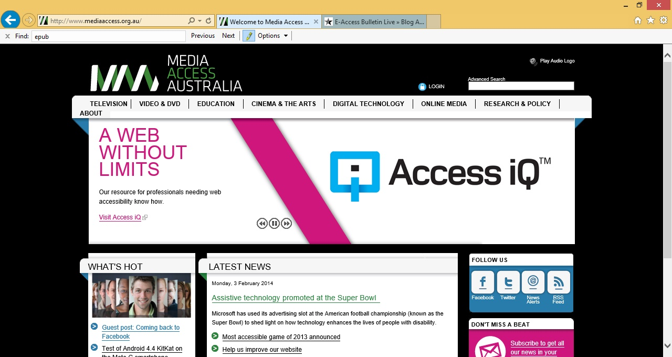

Slide 17

BBC: bbb.co.uk
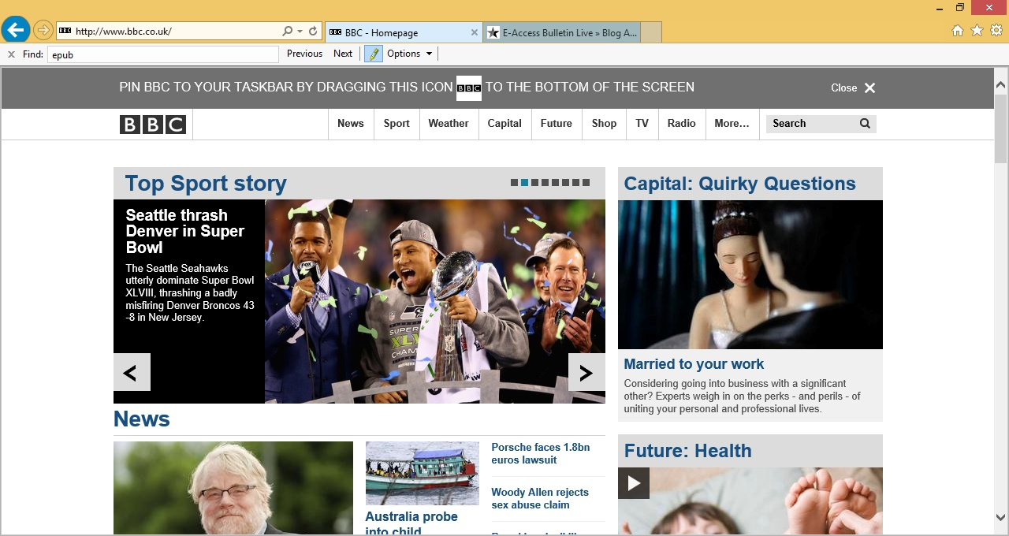

Slide 18

IP Australia: ipaustralia.gov.au
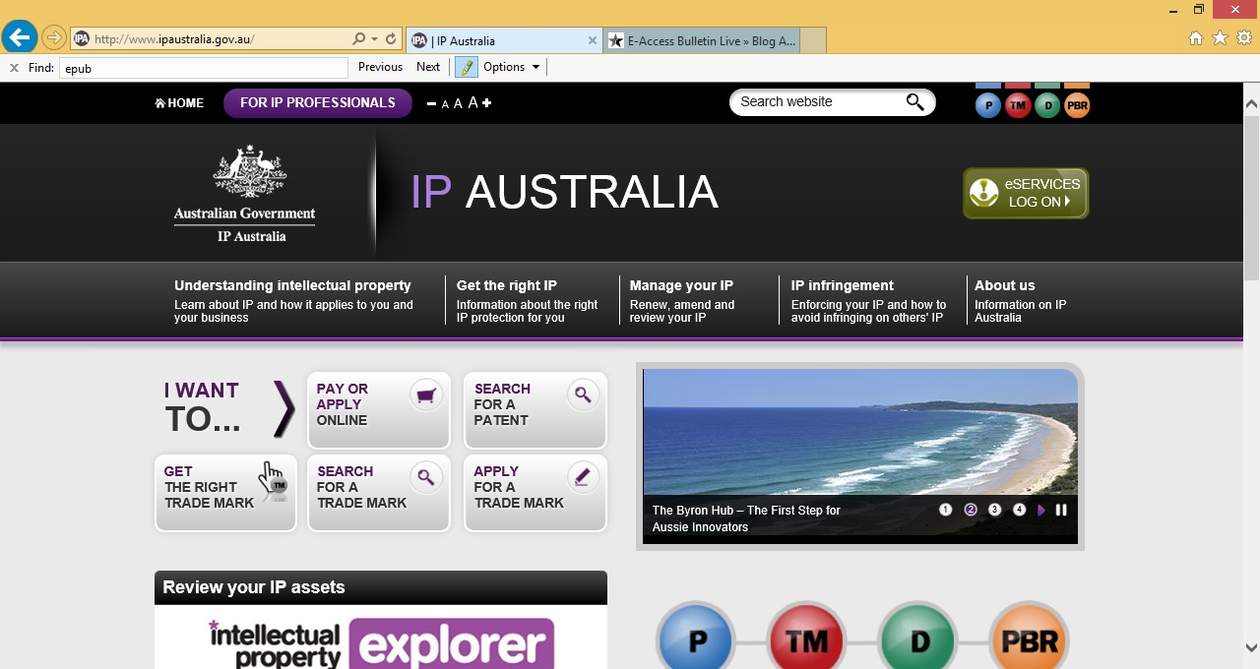

Slide 19

Bad design examples
Mr Bottles: www.mrbottles.com
Fremantle: www.fremantle.wa.gov.au
Yahoo!7: www.yahoo7.com.au

Slide 20

Mr Bottles: mrbottles.com
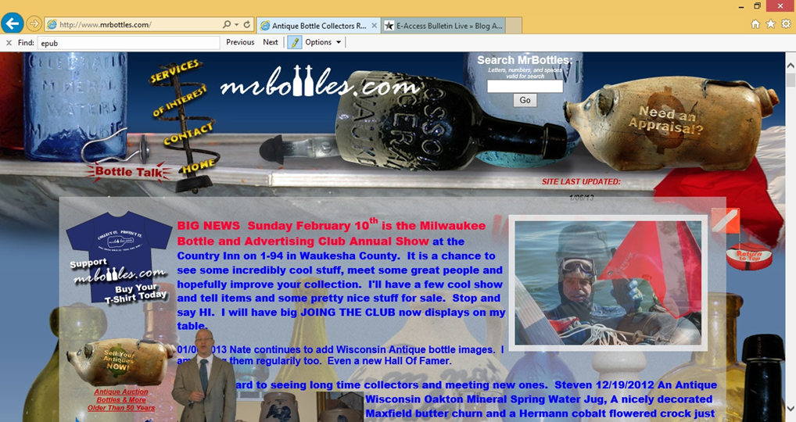

Slide 21

City of Fremantle: fremantle.wa.gov.au

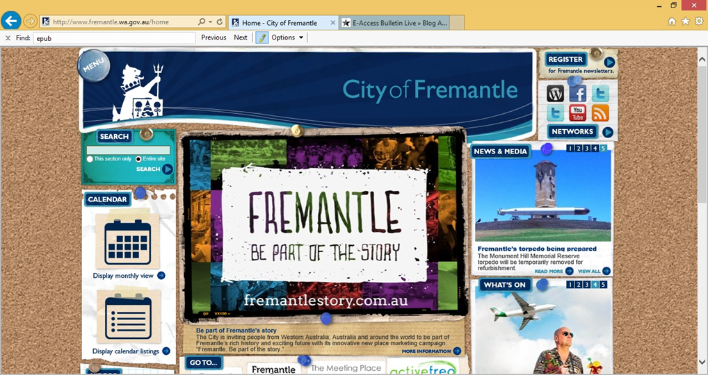

Slide 22

Yahoo! 7: yahoo7.com.au

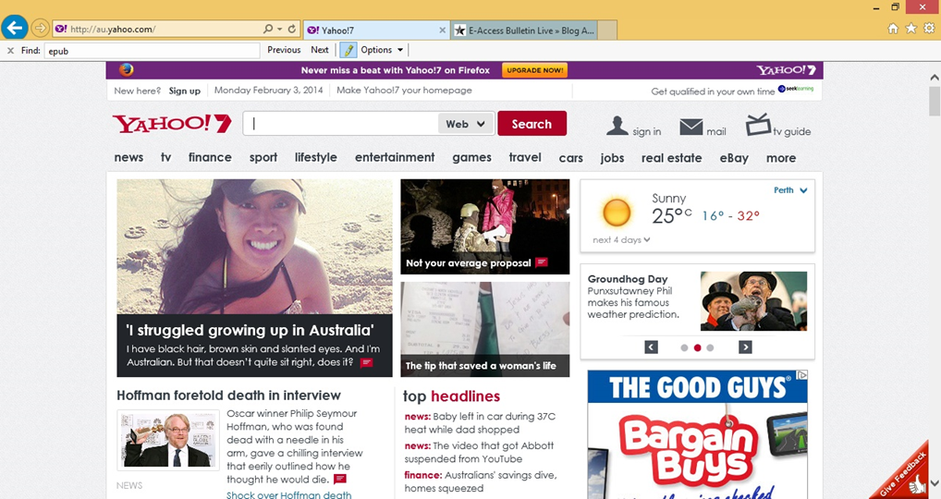

Slide 23

Documents
Consider the best document format (HTML, Word, PDF)

HTML: avoid ‘click here’, be descriptive

Word: use styles and built-in accessibility checker (2010/2013)

PDF: use tagging and create from accessible source

Slide 24

Social media
Dedicated accessibility teams at Facebook and Twitter

Use Twitter hashtags such as #a11y for accessibility

AT helpdesk for Facebook

Easy Chirp for Twitter

Improved caption support on YouTube

Slide 25

Student complaints
Work with ICT staff to ensure they are focused on WCAG 2.0 Level AA compliance

Ensure that there is an obvious way for students to get in touch about web accessibility-specific issues

Keep the student regularly updated about their issue

Progress towards resolving the issue

Slide 26

Professional development in web accessibility
Professional Certificate in Web Accessibility

Six week online course

Tertiary backed, delivered by UniSA and Media Access Australia

For ICT professionals to integrate web accessibility into work practices

Visit: mediaaccess.org.au/learn

Slide 27

Need help with digital accessibility issues?
Digital Accessibility Maturity Assessment

Accessible content workshops

Website testing and auditing

Document remediation

Advice on accessibility:
Geoff Knight
Business Development Manager
E-mail: geoff.knight@mediaaccess.org.au

Slide 28

Further information
E-mail: scott.hollier@mediaaccess.org.au
Telephone:
(02) 9212 6242 (head office)
(08) 9311 8230 (direct)
Website: www.mediaaccess.org.au
Twitter: @mediaaccessaus

