Word version of powerpoint presentation by Sharon Kerr Tuesday 24/3 – ADCET ATEND Webinar

Slide 1

ADCET Webinar: Meeting the Challenges: Serving the Student
Sharon Kerr – Global Access Project – An initiative of the Higher Education Consulting Group

Slide 2

Welcome !
Today’s webinar will be focusing on the theme that:

Technology is an increasingly simple and cost efficient support for students which promotes autonomy, confidence and job-readiness.

Slide 3

Before I get started, I would like to introduce Global Access Project and my colleagues Kylie Colvin and David Wright.

Slide 4

What is GAP?

—A HECG initiative working closely with major technology players including IBM and NUANCE in association with major universities in the US, EU and Canada with the Liberated Learning Consortium.
- Our focus is to provide information and solutions so that students with a disability can access the full learning experience achieve their full potential.

Slide 5

GAP currently provides:
- Information and toolkits to assist students and university support teams
- Conversion services for client universities to enable students using assistive technologies to access the full learning experience
- Universal design of curriculum consultancy and professional development for staff
- Customised solutions for students with unique access needs

Slide 6

GAP is located in Sydney Australia
Our senior team have extensive global experience in
the Higher Education Sector with over 50 years combined experience working in Universities.

Slide 7

Images of Sharon Kerr, Kylie Colvin and David Wright with the accompanying text:

David Wright –Previous

Deputy Vice Chancellor, Macquarie University – Business background - Founding CE0 of One.Tel Networks, T3, Slice Wireless, Monitoring Division Inc & HECG

Sharon Kerr – Previous Manager Macquarie University Accessibility Service – Education background – online education, curriculum development, teacher training, lecturing, school teaching.

Kylie Colvin - Previous Chief of Staff to three VC’s at Macquarie University – Analytics and Operations background – strategic planning, policy and governance, communications.

Slide 8

Logo of CSUN – Annual International Technology and Persons with a Disability Conference

Two major observations since attending the CSUN conference in 2012

- Technologies are getting better, cheaper and easier to use autonomously.
- Challenges that we are facing in Australian Universities and TAFE’s are being experienced internationally.

Slide 9

Litigation has become a reality against US universities for lack of access - remembering that the US has very
similar laws with regard to access to
education as Australia. (Image with names of US universities where Law suits have been successfully filed against the institutions because of lack of accessibility).

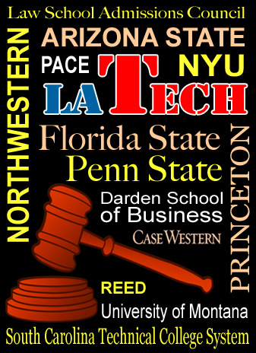
Source: http://blog.lib.umn.edu/itsshelp/news/2013/10/higher-ed-accessibility-lawsuits.html

Slide10

Accessibility is no longer viewed as a responsibility delegated solely to disability support staff.

It is an issue being taken seriously by the Presidents of the universities and their senior teams.

Slide 11

Some of their complaints – resonate with the Australian experience:
• Inaccessible class assignments and materials on the learning management system, Moodle.
• Inaccessible live chat and discussion board functions in the learning management system, Moodle.
• Inaccessible documents that are scanned images on webpages and websites.
• Inaccessible videos, and videos in Flash format, that are not captioned.

Slide 12

And yes there is more:

• Inaccessible library database materials.
• Inaccessible course registration through a website, Cyber Bear.
• Inaccessible classroom clickers.
Source: https://sites.temple.edu/a11ylawsuits/2013/08/university-of-montana/

Slide 13

Response in the US?
From presentations at CSUN there appeared to be the following trends:

1.Auditing of courses and university websites for accessibility – now a cornerstone compliance requirement.
2.Separating the disability support relating to accessibility of learning environments away from other student support services such as counseling. (Accessibility services)

Slide 14

Response in the US?

3.Focus on curriculum being designed and delivered so that it can be accessed by students reliant on assistive technologies.
4.Equipping students with the assistive technologies that they need to engage with the learning experience.
5. A shift away from types of support that have a variable and unreliable outcome such as the use of untrained notetakers.

Slide 15

We need to remember that:
Today with the use of assistive technologies, students with a wide range of sensory, physical and learning disabilities are able to access the full learning experience. All that is required is for materials to be presented in a format that can be accessed by these technologies.

Slide 16

So what are the major assistive technologies?

These fall primarily into 4 categories:

Slide 17

1. Text to speech – eg JAWS, Window Eyes, NVDA, in built screen readers on hand held devices such as iPads.

For students to be able to access text using these technologies the text needs to be live text and not embedded in an image.

Here is a sample of what this technology sounds like.
(play button linking to JAWS sample at https://www.youtube.com/watch?v=IK97XMibEws&fmt=18)

Slide 18

2. Speech to text solutions – this is one of the areas that GAP is working with IBM, NUANCE and the Liberated Learning Consortium for an accurate automated response. There are other solutions too such as the captioning service being provided for this webinar.

N.B For speech to text solutions, assistive technologies can include good recording equipment.

Slide 19

3. Technologies that can be used by students with a range of learning disabilities such as dyslexia. These technologies allow students who can see to OCR their own learning materials either through a program such as Wynn or Read ‘n Write Gold or devices such as PEARL Camera or the RealSAM Voice controlled audio reader.

(Images of RealSAM and PEARL camera)

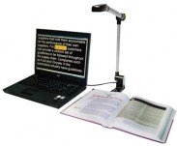*

Source: http://www.quantumrlv.com.au

Slide 20

Everything else – new innovations being developed in response to need - eg music, mathematics, complex disabilities -amazing devices.

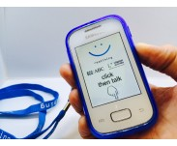

Slide 21

So what were the stand-outs at CSUN?

- Use of 3D printing for a whole range of solutions for students with individual needs – these ranged from book holders for students with paralysis to models for students who are blind. Can see a day when engineers will be employed as part of the accessibility support team.

Slide 22

Image of some of the devices created by Ben Salatin Rehabilitation engineer US Veterans Affairs

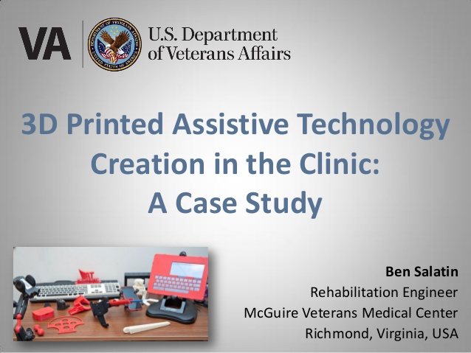
*http://www.slideshare.net/BenSalatin/3d-printing-assistive-techsalatincsun-2015-45561816

Slide 23

- Emphasis on the importance of delivering materials in Braille for students who are Braille users.

Examples:
Dancing Dots – whole suite of products for student’s who are blind learning music http://www.dancingdots.com/main/productsandservices.htm
(Stevie Wonder actually came to the conference to see some of these products.)

Slide 24
Braille displays that can be used with ipads , iphones and other hand-held devices.

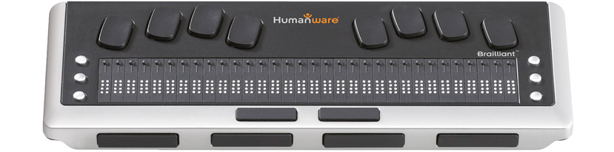

N.B This is about the size of a ruler
https://www.apple.com/au/accessibility/osx/braille-display.html

Slide 25

- Technologies to assist students with severe mobility issues.
Eyegaze technologies
(Image of student using eye-gaze technology)
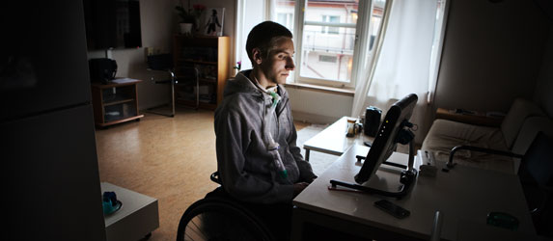

http://www.tobii.com/en/assistive-technology/global/hidden-pages/rehab-sci/benefits-of-eyegaze/sci-computer-access/

Slide 26

4. Final observation - Emphasis on equipping students for employment. Presence of big employers and technology companies at the conference Microsoft, IBM, Apple, CIA

Slide 27

- The bottom line for all of these technologies is that they
Lead to more autonomy and confidence for students and better graduate outcomes for students and businesses

-They also provide cost efficiencies for universities as technology is still 100% claimable under the DSF.

Slide 28

How do these technologies assist international students and those from a CALD background?

Slide 29

Thank you for attending today’s webinar.

If Global Access Project can be of assistance in any way either through doing conversions of text, providing advice on assistive technologies, curriculum design, accessibility plans etc

Either contact Sharon through Sharon.kerr@globalaccessproject.com
Or phone Kylie on 0403302701
Or visit our website at www.globalaccessproject.com

Slide 30

Questions?

Slide 31

Final thought for the day ….
“Having a disability does not mean that a student is academically disabled – nor should it mean that they are to be handicapped by lack of access to the learning environment.
Assistive technologies, universal design of curriculum and conversions of inaccessible materials are the three pillars for access. It is up to us to ensure that all three are implemented.” Sharon Kerr 24th March 2015

