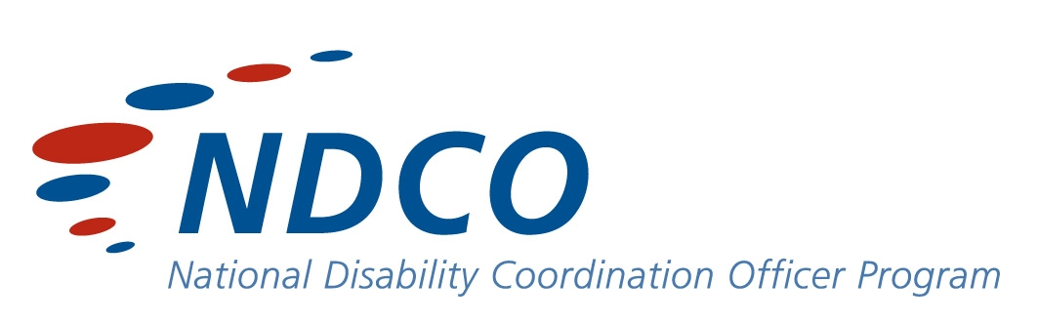
Indigenous Disability DVD

‘Inspire; Include; Increase’

Pathways 9 Paper Submission

The concept of ‘Inspire, Include, Increase’ Indigenous Disability Awareness DVD, stemmed from discussions with stakeholders from the Post Secondary Education and Employment Network (Darwin), and Indigenous communities in the Northern Territory.
In November 2007, a working group was formed to develop the DVD that comprised of a Linguist from Charles Darwin University, Disability Support Officers from Batchelor Institute of Indigenous Tertiary Education and Charles Darwin University, a parent representative, Project Officer with YouthWorX NT LCP and the National Disability Coordination Officer.
It was evident from discussions that the profile of Indigenous Australians with a disability needed to be heightened and raised in a positive light. Not only from a service provision perspective but also within Indigenous communities themselves, as many challenging priorities such as employment, health and housing took precedence over the additional life needs a person has, when they have a disability.
Raising awareness of Indigenous Australians with a disability has a direct impact on an individual’s ability to participate in Vocational Education and Training, Higher Education and their subsequent employment options and Career Pathways.
By raising community and societal awareness, it draws a parallel to the individual’s sense of value (both personal and professional), which influences their capacity and level of inclusion within their individual communities.
The methods of developing the DVD were quintessential for a culturally appropriate, respectful, sensitive and responsive resource to be utilised as an effective learning tool for the future. It was important that the project also had credibility within the Northern Territory Indigenous communities; therefore the group engaged the expertise of Professor Djapirri Mununggirritj from Yirrkala - East Arnhemland as a Cultural Consultant. Professor Mununggirritj has a string of Community responsibilities and is a representative on the 2008 Disability Advisory Council for the Northern Territory Government, who reports to the Minister for Disability on behalf of Territorians with a disability, carers and family.
Time was invested in formulating the questions for appropriateness in language and the way in which questions were to be asked was crucial. Spoken English can be a second or third language for many Indigenous Australians, so questions had to have exact meaning for each interviewee.
The term `disability’ and ‘what does it mean?’ for Indigenous Australians constantly came up in discussion with a range of stakeholders that has led us to believe that for `disability’ as a term, it is neither relevant nor significant within their culture.
Indigenous Australians with a disability view `disability’ primarily as impairment or functionality, with a holistic reality focus that has ramifications for a person’s entirety of life and the capacity to be valued and contribute to their community.

Interviews were conducted with people from a range of age groups and communities across the Northern Territory. The participants were asked to identify themselves and indicate their social history as a means of gauging their experiences. They were also asked questions that explored their disability in respect to how it may have influenced their goals and achievements in life. Qualitative questions enabled interviewees the opportunity to respond from their perspective, regarding disability, in some instances there was no reference to the disability at all. These responses highlight the various perspectives on disability of those Indigenous people and their culture.
The DVD is to be used as a resource for Registered Training Organisations, Schools, Career Pathway Advisers, Business/Industry, government funded Indigenous bodies and community organisations with a future vision to:
- Improve transition for Indigenous Australians with a disability from their school or community into post-secondary education, training and subsequent employment;
- Increase participation by Indigenous Australians with a disability into higher education, vocational education and training and employment;
- Establish better links and understanding between schools, universities, vocational education and training, training providers and disability service providers so that they can work collaboratively to provide the best possible assistance for Indigenous Australians with a disability.

YouthWorX NT and the NDCO program wishes to acknowledge Yirrkala Community Education College for participating in the competition to design the cover; especially Maminydjama Maymuru, Yakayak Wunungmurra, Djakala Wurramarrba, Walpinda Wanambi, Wanydjami Wanambi, Teneka Solarand their Teacher, Trish Gilchrist.

The soundtrack ` I was born blind’ is by Aria Award winner 2008, Geoffrey Gurrumul Yunupingu from North East Arnhemland. Gratitude is extended to Gurrumul and Skinny Fish Music for facilitating the use of this empowering and inspiring track.

This DVD is dedicated to the late Dr. Marika - Mununggirritj.
She was an inspirational strong Yolgnu woman who dedicated her working and community life for her people.

A big thank you to the Marika and Mununggirritj families for
allowing us to enact this dedication.

Summary:
YouthWorX NT Local Community Partnerships, in collaboration with the National Disability Coordination Officer NT, has worked with a series of remote Northern Territory Indigenous communities to identify Indigenous perspectives on ‘Disability’. The perspectives have been compiled into a DVD comprising interviews with Indigenous people with a disability. Key Community Members also highlight their perspective on how disability is perceived and accepted within their community. The aim of the project is to assist in raising Disability Awareness within Indigenous Communities.
The importance of Indigenous perspectives on Disability arises from the unique kinship relationships that exist in Indigenous communities. These kinship ties provide a safety net encompassing all those that are inter-related. These responsibilities can be limiting (in a Western sense); however responsibilities for people with disabilities can be far greater. With this in mind, and with more and more Indigenous people entering a diversity of industry areas for employment, raising the awareness of these perspectives and promoting its importance is essential.

Viewers of the film will be moved by the unique stories and the impact of each person’s attitude and belief in their own selves and their circumstance in the context of each of their lives, whether told through their own voice or just as important, their actions and abilities. It seems that the concept of disability lies with the person who sees the difference. At least for these people, their lives and wonderful successes can be best summed up in the words of Peter Barnes ……. “If they want to ‘dis’ my ability, go ahead”.

Profiles:

Cece Adams
Cece is a young Indigenous woman from Thursday Island. Born into a large family with three sisters and two brothers, Cece has lived most of her life in Darwin with her Grandmother, Margaret, who she calls mum.

Contact with her family on Thursday Island is limited; however they contact her when they can.

“I did get a call on my 18th birthday from my sisters. Dad has just moved back to Thursday Island from Brisbane, he calls me when he can but he is at sea a lot catching crayfish. I love my dad heaps.”

Cece’s extended family in Darwin includes many Aunties, Uncles and Cousins who visit her regularly.

“I have a good friend, Helen, who visits me on a daily basis at meal times and for personal care while mum (Margaret) is at work.”

“I love my house, and all is well in my world!”

Peter Barnes
Peter is from the Kurra Kurra Nation, and lived his young life in Queensland near Rock Hampton. Peter’s focus on self-improvement has driven him to further his knowledge and experience through tertiary studies.

He has lived and travelled throughout Queensland, South Australia and currently resides in the Northern Territory, whilst he completes his academic studies through the Batchelor Institute of Tertiary Education.

A lively young man, Peter is strong in his beliefs and opinions and continues to be a strong advocate of helping people, especially Indigenous Australians, to strive for their best.

“After this job I hope to open doors and help some more people, and yeah I just like sort of helping people to look inside people and not just look at them.”

Dion Beasley
Dion Beasley is a young Aboriginal man who lives with his family in Tennant Creek. He spent most of his early years living with family members in communities in Alpurrurulum and Canteen Creek.
Dion is Deaf and has Muscular Dystrophy which has impacted on his communication with others. Dion is perceived as a shy person, but has the most wonderful sense of humour and is a lively and engaging young man. He enjoys being outdoors and loves to go swimming. Dion is extremely creative, resourceful and delights in learning.
As he developed confidence in his new surroundings his drawings became the avenue through which he began to communicate with others.
It soon became apparent that Dion had a wonderful talent for depicting the many dogs that frequent the community. This love of drawing has been greatly encouraged by family and community and he continues to spend many happy hours absorbed in one of his favourite pastimes.
Dion’s drawings have been reproduced on T Shirts, bags and an increasing array of articles. His drawings have been displayed in Exhibitions and are proving to be very popular.
As his communication skills develop and he becomes more self-assured Dion is beginning to engage with others and take his place in the community.

Joshua Campton
Joshua is a young Larrakia man born in 1988. His many achievements include:
- 2 years as a Australian Army Norforce Cadet (14 – 16 years old);
- Gold, silver and bronze Duke of Edinburgh Awards;
- Invitation to perform with Chamber Crescent Theatre in a production for the Darwin Festival in 2006;
- Achieving top marks for a Northern Territory Certificate of Education (NTCE) subject in 2006;
- Completing his NTCE in 2007;
- Giving `Welcome to Country’ speeches on behalf of the Larrakia including:
- Disability Awareness Week August 2008
- Dion Beasley Exhibition 2008
- Master of Ceremonies for the Disability Awareness Week Launch in 2008
- Disability Awareness Week in August 2007
- Career Advice Australia Northern Territory State Conference 2007
- NTCOSS Conference 2007

Josh regularly attends the gym; enjoys acting, dancing, movies and videogames. He is currently employed part-time at the Northern Territory Electoral Commission.
Joshua’s aspiration for the future is to study acting and be employed as an actor.

Joseph Lannigan
“All my life I’ve been pioneering and breaking new ground. From a young age I was taken from a desert background to a Victorian way of life. As a young person I found it easier to adapt to that way of life. Being so young I was not so set in my ways. I have wondered about my sisters and my parents and how I would fit into their way of life if I go back and live with them.
I’ve had to make choices and one of them was to live in the city for the rest of my days. My choice may be questioned by many, but it is one that I have made for myself. Coming to Batchelor has helped me to find my direction in life. The studies I have done have opened up doors to show me a broader way of life. For instance, I am glad I am studying Mental Health because there is a cry for Mental Health Workers.
Meeting with Staff and Students at Batchelor Institute has been worthwhile. And it’s not to say it’s been plain sailing. Through it all the outcomes have been in my favour with the support that I’ve had.”

