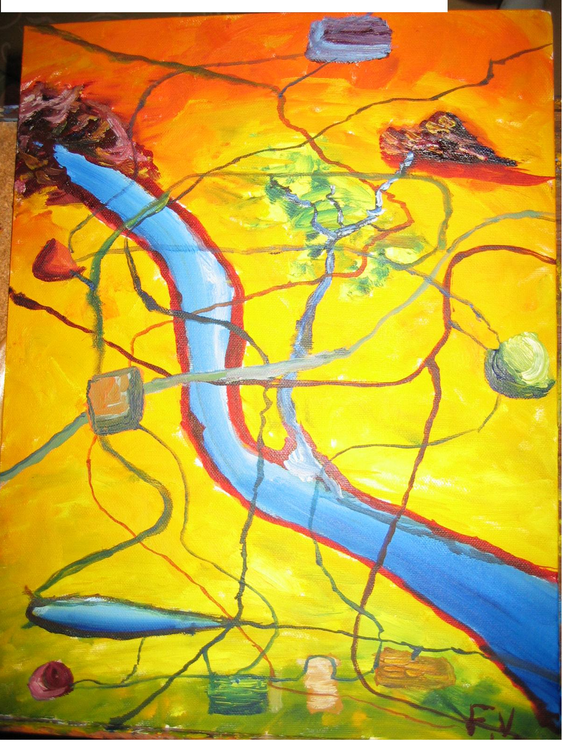

"Finding a Pathway and Traversing the Map of Learning"

Francis Vicary

Because this paper draws upon images of land, travelling across lands and gathering together, at common places, to engage in the sharing of ideas, knowledge and wisdom, I would like to again acknowledge the traditional owners of the land.

I feel like I should be presenting this paper using a set of scales and weighing up the benefits of the supports offered by external or internal studies. Yet, this method would presume that there were only ever either/or options and locks students into binary systems that are designed for the maintenance of institutional, hierarchical, and bureaucratic structures. For this reason, this paper is presented as a journey across a map, which – although having fixed ‘edges’ – has no boundaries. The edges could, potentially reveal other landscapes of learning that are equally navigable. The physical representation of a “Map of Learning” – like the learning environment - has been multiply transformed, through the multi-media of the conference CD, projected onto the screen using PowerPoint and social features of physical painting. Yet, the origins of the map are more organic than that. They originate from many points:
- firstly, from a landscape in the physical sense, housing roads, buildings, rivers ……….all natural and built characteristics of a landscape;
- secondly, the map takes a bird’s eye view and could have been imagined using satellite technology, and computer generated; then,
- thirdly into an imagined map that can be painted using oil paints and perspectives and read as a metaphor.
Along with viewing the map, both in its original and digitally projected form, this paper will lay down the metaphor that will assist you to conceptualise physical and abstract features of the map of learning. You will then be better equipped for the role of tour guides to students who might be lost in the map/system, or who might need to traverse the system in different ways.

Who, you might ask, are the tour guides to students? They are everyone who works in the system of education to make it an inclusive and accessible environment. This includes people from all spectrums and levels within the system. For example, policy makers, who write policies which could be read as the directions on how to use the map, are also ‘tour guides’, in this sense. This broad reading includes Learning Assistance Officers, Special Needs Officers, Librarians, Book Shop Assistants, Lecturers, Deans, Vice-Chancellors and Chancellors, because unless everyone is willing to give and to take direction or advice, people will get lost on the map and fall out of the landscape.

In thinking about the range of people in the aforementioned list of potential ‘tour guides’ and assistants, I am referring to the extent to which they might influence someone’s learning outcomes, as they make their way through the system. In writing this paper, and thinking about how every person in the administrative and academic hierarchy is a potential ‘tour guide’, I am reminded of my first year at the University of New England. Having completed very delayed and disrupted schooling, I enrolled as a mature-age student, aged 22, at the University of New England. (This was 6 months younger than the age cut-off for mature-age students, but the system was flexible in this respect.) I had filled in the forms; mentioned my disability, the fact that I lived at home with Mum, Dad, and family as primary and extended carers; got the General Practitioner to sign the form that authenticated my description of my disability. (It’s a good thing I knew what I had as the GP would often say, “What are we going to write?”. In the end, we kept the letter on file and just changed the date). I had also notified the university that, because of the above, I would not be attending the ‘compulsory’ residential schools.

Having climbed these metaphoric mountains and used GP’s certification as bridges to cross bureaucratically created rivers, the university accepted me and then were going to “exclude” me for not going to residential schools. But, this was not to be. I had dipped my toes into the river of learning and tasted the water. I had glimpsed the tall peaks of knowledge and peered into the abyss that invites critical analysis and I was staying. I merely took a slight detour, across a different bridge or road, and wrote a letter asserting my rights (which, by the way, had not quite been awarded under legislation). Writing this letter was like walking through a dark forest at night. I knew in which direction I wanted to go but finding the words to light my way was difficult. This was because I had only ever completed Year 10 English and had very limited knowledge of bureaucratic speak, but – I confess, my sister, is an English teacher and has always been brilliant at telephone advice.

To digress briefly, I was fortunate that my family are, and have always been, great explorers, navigators and tour guides. They instilled in me a belief that I could/can do anything and there is ALWAYS a way to cross “that river”, bridge that gap.

So, with this innate belief in my right to gain a tertiary education, I found my way through the forest, wrote to UNE and waited. The wait came to a very fruitful conclusion but illustrates that everyone, including Chancellor, has a very important role to play in helping people with diverse needs to navigate the system. One night, yes night, my dad answered the phone and was rather surprised to be speaking to the Chancellor of the University of New England , who requested to speak to me. He had rung to tell me that my letter of appeal had been accepted and I was not excluded but rather to keep studying and that the university would look at granting exemptions from residential schools every year. Looking back, this is almost the most important phone call of my life. The Chancellor at UNE had given me support and encouragement, had taken the time to call me and encourage me to keep studying, and had personalised the letter of official notification.

What he had done was given me a metaphoric compass, in the form of permission to, and reward for, challenge[ing] the system. It was a compass that I have often used.
You too are the ‘givers of compasses’. Everyone in this room has the potential to impact upon many people’s lives, the way that the Chancellor of the University of New England impacted upon mine.

If for no other reason, this is why you should go to work in the morning, to change the ways in which the system interacts with people. This includes all people, not just people with special needs or people who identify as having special needs. Have you ever thought how by ticking that one extra box on the form, the box that identifies you as someone who has a disability or, in ‘university speak’ as someone with ‘special needs’ causes a whole ton of other forms to cascade into your letter box. These forms require the disclosure of intimate personal details about the person’s disability and, you will argue, are needed so that the university can meet their needs. However, in the “learning landscape” these forms are like extra piles of bricks placed upon the road, around which the people must travel, or move aside, brick by brick, form by form. Even when you do fill in the forms, there is no guarantee that you will get everything that you identify as requiring.

In an article, titled “Friendship and Our Children”, Jeff Strully writes of the systems that separates children and people with disabilities saying,
What matters is that a [person] has a place to call home, a place where mom, dad, brothers, and sisters, aunts, uncles, grandparents and neighbours are just part of life…then you need to attend the local neighbourhood school [and so on, and so on to college]
(Strully, J, Strully, C, 1983: 225)

This degree of separateness, Strully argues causes people with disabilities to be put on a different learning path, sometimes even a different map, to other students.

Not only are you ‘different’ because you identify as having special needs….What you receive, too, varies from university to university, campus to campus, department to department, school to school. Dwelling upon negatives achieves very little, so let us explore how to prevent the landslides from occurring and how to maintain traversable pathways, with multiple choices, across the whole map of learning. This involves looking at what learning institutions do presently, determining what works and does not work and, somehow, melding the many different practices into a flexible model that meets the needs of as many students as possible.

Having studied in four different universities, both internally and externally, worked in one and worked delivering self-paced learning guides and regular structured lessons in competency-based training, I have had a relatively high degree of exposure to a diverse range of learning environments. By studying the aspects of each, it is possible to draw up a matrix of options that will increase student success rates within all settings. Some students prefer faces to faces instructions and interactions, while some can study externally and have the ability to engage with learning through other media. It should be remembered, however, that students on campus will not do well unless they can negotiate the physical and textual environs.

It is well documented that students do well when they have access to resources, tuition and discussion with other students. Yet, how these are delivered varies from site to site. Studying externally, I found that as long as I could get the GP to keep signing the forms and the university to grant residential school exemptions, I could get everything I needed. This was because all external students could ring/e-mail/write and request books, articles, journals or photocopying and they would be delivered in the appropriate format, to the door. Also there was no need to take lecture notes, these were printed in neatly bound books that I could just circle and write extra points in at my desk. The external system also offered me, and other students, equal access to material along the same chronological time-frame. Students will special needs are not disadvantaged by having to have assistance to access library resources, as these are delivered in the same mode to all students.

The only things that external studies do not offer are the community spirit of belonging to a group, living in a close-net, collegial community and socialising in this protective, supportive circle. However, when your peer note-taker attends lectures with you but then has to deposit the notes in an unmarked envelope in the library: this is not “collegial”. To find the right mix means looking at the systems and assessing how they can be made more flexible.

If we return to the map, and physical geography of metaphor, we can assert that external studies are similar to having a helicopter, or some other form of free floating, craft where you can dip into learning and get what you need then get on with the work without being disrupted by having to negotiate the difficult points in the landscape.

The same can now be said for electronic access to resources. Although, here there can be difficulties, as one can become tangled in a mismatch of technologies and things can go very wrong. This is especially true for students with diverse needs who use different accessibility options or who have specific programs on their computers so that everything interfaces and works well together. A further obstacle to the use of Information Technology to answer all learning needs is the fact that some students, with special needs, are also economically vulnerable and do not have access to the technology they would need to study.

When these technology needs are met by the university, the equipment is often stored in something akin to an “ivory tower” away from other students. This is not to say that there should be no separate, quite area for people who require either assistance or quiet. Rather, I am suggesting that not all “special needs room” be located in the eagle eerie of the library, as this re-enforces the stigmatisation of separatism.

Getting back to generic technology, and particularly pertinent in the Northern Territory is the fact that, unless you have cable or a faster form of access than dial up, you will spend your day merely waiting for the junk mail to download so you can delete it. I know about this. I travel between my city-based dial-up network to my Mum’s satellite dial-up access and the drop back to 11000 to 12000 bits/second can be traumatic. Imagine if you were trying to access multiple webpages, that were not cascading, and had to wait for each one to download. Sometimes you have to work your way between two to five web pages to get to the information you need. If you are trying to do this using dial-up that is less than 56k, you will give up and become frustrated.

This example is not given to discourage the use of web-based learning but rather to highlight that web-based learning requires careful thought around compatibility with screen-reading software and the band-width required to download pages. If these criteria can be addressed, the use of on-line resources is one way in which the accessible resources of external studies can be provided to both internal and external students. This technology can also be utilised to increase the communication interactions between students themselves and between students and lecturers or teachers.

In an ideal world of learning, all students would have access to all of the resources they require to enhance their knowledge and develop the skills required to progress through the course. This is where the deployment of a multifaceted strategy is required. To do this, universities and higher education providers should work to assist all students, equally, to navigate their way around, across, into, the map of learning. Such a strategy might include some radical changes, such as having only one to complete to identify as a student with special needs; having to only provide one lot of documentation of disability and having that accepted and stored on the students’ files. This would minimise the ‘paper’ landslides that often fall across the path of students with special needs. A further way of providing more relevant and time responsive assistance to students would include placing the discretionary “special needs” funding with the Faculties, Departments, or even Schools in which students are enrolled. This way, students would be able to access assistance from the area in which they are studying.

One of the greatest frustrations I experienced in the transition from external to internal studies was the means by which to access the library. As an external student I could e-mail or telephone the library with a request. This could be accomplished quickly and easily and at a convenient time and the resources would be mailed to me. In this way, my access to the knowledge held on the “map of learning” was facilitated by a bird’s-eye, freely accessible methodology.

However, as an internal student I had to arrange a convenient time at which to meet with a person employed by the university and tell them how to use the equipment and retrieve the books. This was excessively frustrating as I felt as if I were transferring from the external system, where my access to resources was equal to other students, to a system of internal studies, where my access differed greatly from that of other students. It is an experience that I did not enjoy and often questioned why the people putting books back on the shelves could not merely take them off the shelves for me.
If you take this a step further, you can imagine the ridiculousness of a university that has both external and internal students. The external students get books posted, photocopying and literature searches performed by librarians; yet, internal students have to take someone to the library to assist them.

This is a system without equity, in universities that pride themselves on such traits.

In highlighting these issues, and representing the higher education system as a “map of learning”, I have tried to demonstrate that no one path, road, track, method, process of doing something or acquiring something is the only path. If students are getting lost in the forest of learning, swept down-stream by the river of learning, drowning in the lake of learning, or just plain perishing in the desert then the role of “tour guides” is to highlight alternative pathways. This is where the title of the conference “Include, Inspire, Increase” must be applied. All higher education providers should equally include students with diverse needs, inspire students to achieve and increase the overall access of all students to the rivers, mountains, valleys and lakes of learning. It is only through having free, uninhibited, choice that students will reach their full potential.

This paper has not really addressed the statistical differences between internal and external studies and resource allocation. It has, rather, asked that educational providers step back from the counting of resource dollars and allocations, and take a fresh look at why these exist. These resources are to assist people with different needs to access education, learning, thought, to learn and so that we can all can skills. Surely if a student number can be stored from year to year and, even, reactivated after many years, a disability record should have the same validity. The disability actually has a far greater impact upon the person.

The way for is to keep a picture of the bigger issues in our minds. We are all part of this map of learning and we are all potential ‘tour guides’. Ask people who tick the box that says “they’d like some help”, what they need? What would make their learning easier? Do not stack a whole lot of prefabricated, financially equated, Federal Funding accountable boxes in their path and say, “the answer you required is in one of these boxes”. This is not only intellectually irresponsible but probably costs more than merely giving the person what they need. Let us more the balance of providing assistance in the map of learning back to the people. Let’s listen to each other and guide each other through the hills, forests, mountains and valleys, to sup from the cool, clear streams of knowledge and drink from the deep lakes of wisdom. Let us gather and talk and listen, write and learn together. Let there be many paths to the one place and blocked roads that separate people from each other.

Bibliography

Strully, J., Strully, C. 1983. “Friendship and Our Children”, JASH, Vol 10, No 4, 224-227.

