Sharing Resources and Reaping the Benefits :
Collaborating in the Provision of Accessible Tertiary Materials

Litsa Ellis ¹, Donna Runner ²
Access Librarian¹ ,Digital Environment Manager²
Learning Services, Deakin University, Geelong, Vic.

Introduction
At the 2002 Pathways conference, the second author presented a paper on integrating the provision of information resources to students who have a print disability with procedures already in place for providing information resources to other students. Inclusive Course Material Provision continues at Deakin University. As a consequence, hundreds of Master files of accessible works have been created. The Copyright Agency’s Masters catalogue contains information about these Master copies, as reported under section 135ZQ of the Copyright Act 1968. [http://210.11.40.229/expresso/cmdl/Home.do]

This paper will recommend that all universities reap the benefits of our combined production by sharing our accessible information resources. Production time and costs will be reduced and this, in turn, will result in a better service to all our students with a print disability. [The views and opinions expressed are the authors’ and are not necessarily those of Deakin University.]

Background
Australian universities have both a philosophical and a legal commitment to the principles of access and equity. Therefore, we are obliged to offer students with a print disability the same education as offered to the rest of society.

“… throughout the country, most tertiary institutions are struggling in their attempts to provide efficient and effective … services to meet the needs of increasing numbers of students entering the sector.”..... “It is evident that service provision is adhoc, diverse in nature and that there is a lack of coordination across the sector and nationally.” (Barrett 2002, pp. 3-4)

Data collected by the Higher Education Division of the Department of Education Science and Technology (DEST) indicated that since 1996 there has been a marked increase in the number of students with disabilities enrolled in Universities. From 1996 to 2001, there was a 58% increase in the number of students identifying themselves with a visual disability. (McDonald and McLaren, 2002, p.3)

The term “accessible format material” is used to describe alternatives that are required by people who have a disability that prevents them from using standard (10- or 12 – point) print.

At Deakin University, students are encouraged and trained, if necessary, to use electronic formats on adaptive equipment available in Deakin’s computer labs and libraries. All Deakin students are expected to develop facility with online learning. Such expectations for students with print disabilities are part of the inclusive nature of Deakin’s course provision.
This page is a table of data showing the number of students, the number of course units, and the outputs produced by Deakin University during the period from 2001 to 2004.

 |  |  |  | Disability  Of students |  |  | Format  Used by students |  |  |  |  | Items converted
Year | Sem-ester | No. of students | No of units | Vision | Learning | Physical | html | rtf | pdf image | audio | large print | Course material | texts | Journal articles and book chapters
2001 |  | 21 | 39 | 12 | 2 | 4 |  | 18 | 1 | 6 | n/a | 13 | 90 | 19
2002 |  | 35 | 109 | 24 | 5 | 6 | 22 | 27 | 3 | 6 | 8 | 91 | 195 | 145
2003 | 1 | 28 | 51 | 20 | 6 | 2 | 16 | 4 | 1 | 2 | 5 | 58 | 142 | 65
 | 2 | 35 | 68 | 20 | 12 | 3 | 21 | 9 | 3 | 5 | 7 | 110 | 144 | 6
total |  |  | 119 |  |  |  | 37 | 13 | 4 | 7 | 12 | 168 | 286 | 71
2004 | 1 | 35 | 70 | 20 | 11 | 4 | 23 | 8 | 7 | 2 | 3 | 39 | 112 | 12
 | 2 | 33 | 59 | 15 | 12 | 4 | 28 | 1 | 1 | 3 | 0 | 48 | 58 | 48
total |  |  | 129 |  |  |  | 51 | 9 | 8 | 5 | 3 | 87 | 170 | 60

Current Situation
The current situation for provision of material in accessible format to print disability students is that universities:
- ..... are legally obliged to provide print disability students with the information necessary to successfully complete their units of study
- ..... are legally allowed to make the information available to them under the Copyright Law
however
- ..... they often do not have adequate time, staff and financial resources to fulfill the high support needs that university students with print disability require.

So, sharing of resources is an essential next step in minimising turnaround times for delivery to students and reducing costs.

Universities may apply to Department of Education, Science and Training for the reimbursement of part of the expenditure which they have incurred in providing educational support services or equipment for students with a disability. Funds are provided in retrospect. However, these funds do not meet the full cost of provision, nor, do they meet any of the cost of inclusive services that are available to all students regardless of their ability/disability.

“…. Universities [such as Deakin] have developed a variety of approaches to dealing with the economic, technological and process challenges that they face in providing accessible-format materials … the most significant [being whether] to outsource the production of accessible-format materials, or whether to handle most or all production requirements within the university by establishing in-house production capacity.”
(Human Rights and Equal Opportunity Commission 2002, p.5).

Deakin has outsourced the production of accessible format materials. However, when the digital files are received, the master files are quality checked and archived.
On this page are 2 photos. On the left is a photo of one of the casual staff scanning a textbook before sending it to the course materials conversion provider. On the right is a photo of two of the staff who do quality checking and send the textbook on a CD-ROM through Express Post to a student.

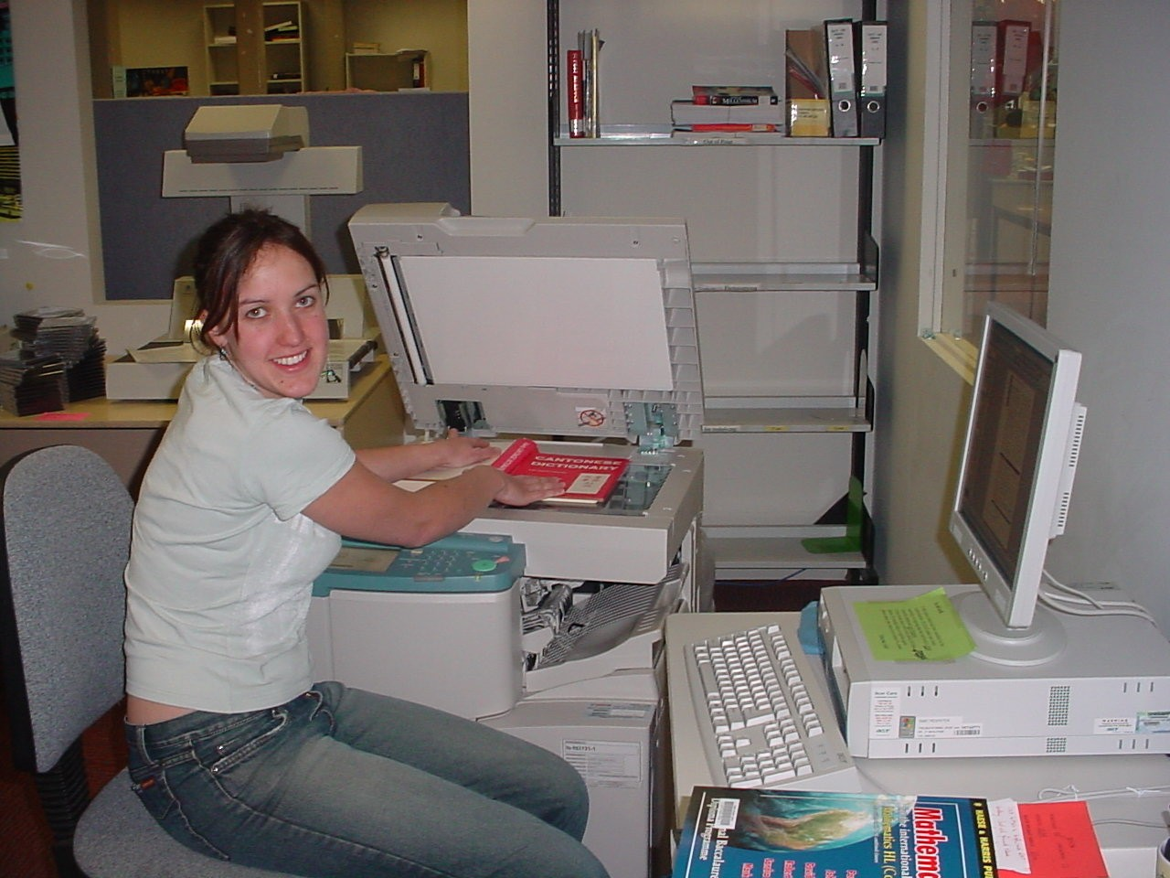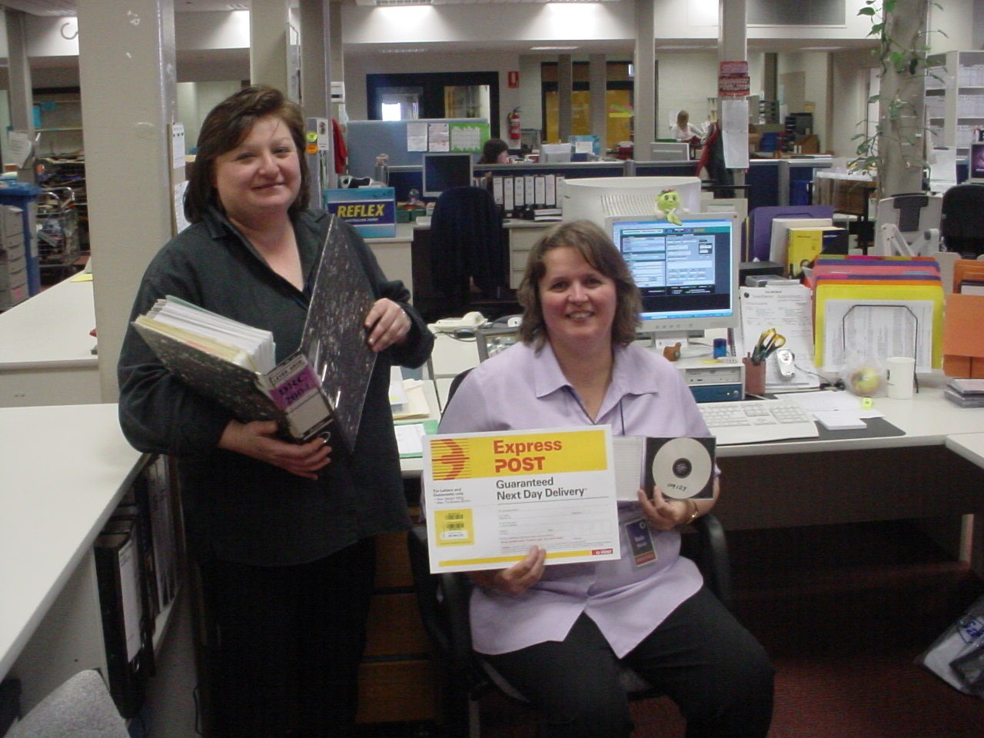

An increasingly important part of the process is the regular report to the Copyright Agency Ltd of the materials that have been converted.

COLLABORATION MAKES SENSE!

At the moment, there is insufficient sharing of knowledge, expertise or resources between universities undertaking this production. There is much to be gained by universities participating in collaborative projects or initiatives.

Interested individuals are sharing knowledge when and how possible. For example, the Victorian universities have formed a group that has met annually and exchanges occasional email messages about disability issues for librarians [TLDIG – tertiary libraries disability interest group]. Deakin has exchanged visits and information with the University of Melbourne. There has been some communication through email with Macquarie University and Griffith University. University of Tasmania is coordinating the development of a Framework for Good Practice, funded by the Australian Universities Teaching Committee Research Project [AUTC].

Expertise can also be shared by universities contacting each other, and by using the AUTC framework, the Round Table on Information Access for People with Print Disabilities Inc. Guidelines, and consultation with the National Information and Library Service.

National resource sharing [ultimately leading to international resource sharing] is the logical next step ! It makes sense to develop a database which contains a list of the titles that have already been produced, and the format of the Master copy. The authors strongly recommend that Universities develop a coordinated, collaborative approach to the production of information in accessible formats for print disability students. The collaboration must be 3-pronged : national standards and guidelines, a national database of master copies, and a national resource-sharing protocol.

National standards and guidelines for production
Universities which have accessible-format production facilities will ensure that materials produced by those facilities conform to national standards and guidelines. Such standards and guidelines should be developed through the participation of students and their universities, production agencies and other relevant organisations.

These standards must include turnaround times. Deakin considers that a 95% accurate file delivered in week 1 of the semester is of greater value to most students than a 100% accurate file delivered a week prior to final exams.

National Database
Universities can collaborate with the Copyright Agency Ltd. [CAL] to develop and improve the national database of existing accessible tertiary materials, and a mechanism for cataloguing newly-produced material.

Universities can work with the Australian Publishers Association and other groups to investigate (and where necessary develop) guidelines for the creation of an electronic repository of newly-published materials, suited to use by individuals with a print disability.

National Resource Sharing
Universities can use existing resource sharing arrangements among university libraries to deliver alternatively formatted materials.

Benefits of National Database and Resource Sharing
Sharing resources is the next step in minimising turnaround times for delivery to students and reducing costs. The United Kingdom and Canada have already progressed towards national resource sharing for alternatively formatted texts.

At http://www.collectionscanada.ca/accessinfo/index-e.html there is information about the establishment by the Canadian Library Association of a Working Group to Design a Nationwide Equitable Library Network which will provide library services to the print disabled, equivalent to the library service now available to all other Canadians.
The UK has RevealWeb. Revealweb is a web based catalogue bringing together information about available titles produced in accessible formats from a wide range of organisations. For more information see http://www.revealweb.org.uk/
The closest equivalents in Australia at present are the National Information and Library Service website at http://www.nils.org.au/ and the Copyright Agency Limited [CAL] catalogue of master copies for use by institutions assisting people with disabilities at http://210.11.40.229/expresso/cmdl/Home.do . Deakin has now contributed over 700 title records to the CAL catalogue of master copies.
The photo below is of the shelves of Master copies on CD-ROM at Deakin with two of the staff who process and maintain the Master copies.
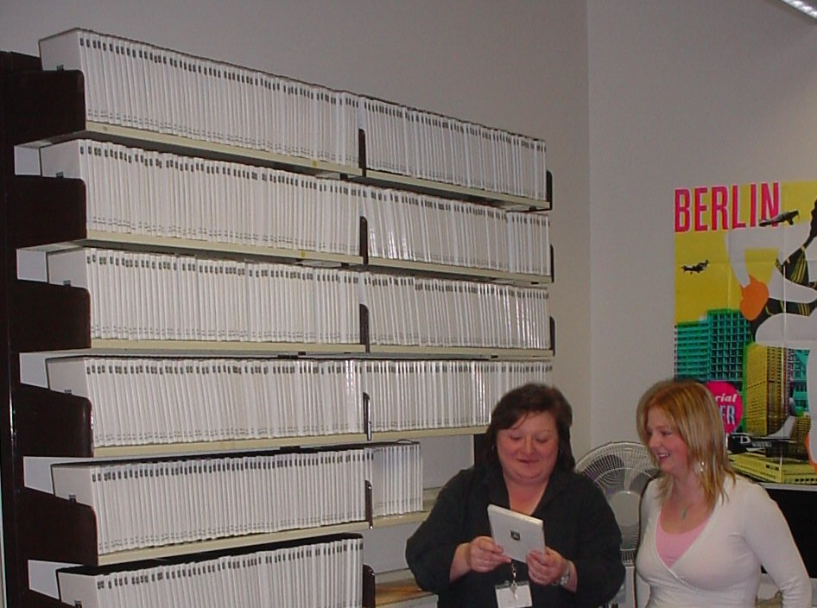
Australians need to develop the national database. At the 2nd Forum on Library Services for People with Disabilities in December 2003, participants were encouraged to continue adding records to the CAL catalogue of master copies. A conversation with Sandra Henderson (October 2004) indicated that the National Library plans to use the CAL catalogue of master copies when the records are added to the National Library database.
In the months of September and October 2004, Deakin was able to assist in the provision of five texts to two other universities through interlibrary loan. This benefited the students who received the texts quickly. It also benefited the universities who did not have to pay the cost of production.
Deakin wants to continue sharing information resources that have been produced for students with print disabilities. However, we also hope that other universities will contribute the lists of master copies to CAL for the benefit of our students!
Once we have a national database and effective resource sharing at the national level, we can seek to work with Canada, the U.K. , and others internationally.

CALL TO ACTION
The authors seek the adoption of a more coordinated and collaborative approach between Australian universities in the production of information into accessible formats for students with a print disability.

We recommend that this collaboration commence with the improvement and increased use of the existing national database, developed by the Copyright Agency Ltd. Increasing use of this database will foster resource sharing and collaboration.

The implementation of the recommendations: National standards, National database and Resource sharing, minimise duplication of effort, and reduce the high support costs which universities are encountering in providing accessible information resources for their students.

References

Barrett, J. (2002) A Review of Transcription Services for Students with Vision Impairment and others with Print Disability in Post-Secondary Educational Institutions in Tasmania, University of Tasmania. As quoted in Storm or Sea-Change: Meeting the Challenges of Providing Tertiary Materials in Accessible Formats for Students with Print Disabilities [Online] Available: http://www.hreoc.gov.au/disability_rights /education/forumdp.htm [Accessed 27 October 2004]

Henderson, S. (2003) ‘Forum on Library Services for People with Disabilities’. National Library of Australia Gateways, no.67, February 2004. [Online] Available: http://www.nla.gov.au/ntwkpubs/gw/67/html/17LSPDisab.html [Accessed 28 October 2004]

Human Rights and Equal Opportunity Commission (2002) Storm or Sea-Change: Meeting the Challenges of Providing Tertiary Materials in Accessible Formats for Students with Print Disabilities [Online] Available: http://www.hreoc.gov.au/disability_rights/education/forum02/papers.htm [Accessed 27 October 2004]

McDonald, B. and McLaren, H. (2002) ‘Department of Education Science and Training Perspective’ in Storm or Sea-Change: Meeting the Challenges of Providing Tertiary Materials in Accessible Formats for Students with Print Disabilities [Online] Available: http://www.hreoc.gov.au/disability_rights/education/forum02/ dest%20perspective.doc [Accessed 27 October 2004]

