A Computing Education for the Vision Impaired

Iain Murray¹, Scott Hollier²

Lecturer, Dept of Electrical & Computer Engineering, Curtin University of Technology, Perth, Western Australia¹, PhD Candidate, Dept of Electrical & Computer Engineering, Curtin University of Technology, Perth, Western Australia²

Introduction
In recent years there has been a significant and rapid change in the delivery of educational content. The use of the Internet and web based instructional aids, once thought experimental, are now viewed as a integral part of the learning environment. This has resulted in students receiving unprecedented access to information and the creation of new learning opportunities. Although few would argue against the merits of online learning, it is clear that in the rush of online implementation, students such as those with disabilities have been left behind due to the lack of an accessible content delivery system. Blind and vision impaired students, who are particularly affected by this technological change, have faced a range of difficulties from the act of typing a letter to the use of computers in educational institutions. The increasingly widening gap between the people who are technologically able and those who cannot gain access to technology are cause for great concern. The research described in this paper aims to examine both the learning environments faced by people who are blind or vision impaired and the unique accessibility requirements of such people. This is achieved through the comparison of both students who are able-bodied and students who are blind or vision impaired, jointly pursuing an existing, best practice eLearning curriculum. This project, undertaken by Curtin University in conjunction with Cisco Systems and the Association for the Blind WA, aims to identify appropriate learning tools and techniques that can be used to support vision impaired students studying computing at a tertiary level. The resulting information will then be used to modify and deliver a specialised user interface explicitly designed to deliver technological and engineering skills to people who are blind or vision impaired.
Course outline
The Cisco Networking Academy Program (CNAP) is an Internationally renowned networking administration training organisation, launched by Cisco Systems in October 1997. Curtin university of Technology, Department of Electrical & Computer (ECE) joined the CNAP in 2001. The Cisco Networking Academy Program prepares students for the Cisco Certified Network Associate (CCNA) and Cisco Certified Network Professional (CCNP) certifications. A student with CCNA certification can install, configure and operate LAN, WAN, and dial access services using a variety of protocols over networks with nodes of 100 or fewer. Such skills qualified students for jobs as networking help-desk engineers or field technicians. Students earning CCNP degrees are qualified work on networks with increased complexity.
“The Networking Academy program is an e-learning model that delivers Web-based educational content, online testing, student performance tracking, and instructor training and support, as well as hands-on labs. With a curriculum developed by education and networking experts, the Networking Academy program is offered by high schools, technical schools, colleges and universities, community-based organizations, and other educational programs worldwide. It demonstrates a highly successful alliance among Cisco Systems, educators, governments, international organizations, leading technology companies, and nonprofit organizations that prepares graduates for the demands and opportunities of the new global economy.”(Cisco,2002)
Although the CNAP is effective for able-bodied engineering students, it was noted that very few people with disabilities were participating in the course. Further studies revealed that the online curriculum, although effective for able-bodied students, did not contain an accessibility focus. With this in mind and in conjunction with the Association for the Blind WA and Cisco Systems, the department has been delivering the CCNA course to students with vision impairment for the past 18 months.
The importance of this endeavour is based on the fact that routers are primarily text-based systems and as such it is relatively simple to translate that text into an audio stream, allowing people who are blind or vision impaired to easily understand a router’s output of information. Additionally, the topology of data networks is a logical arrangement of devices, not necessarily relating to the physical layout of the network. This logical arrangement is relatively easy for blind students to understand, whereas spatial concepts, as discussed later, can cause some difficulties for students who have been blind since birth. While it is not unheard of for blind or visually impaired individuals to work as networking engineers - two such people earned CCNA certification in the US in recent years - the lack of tools for visually impaired technology students and engineers greatly inhibits their ability to learn networking skills and access technology. As such, Curtin University launched a modified version of the CNAP, known as the Cisco Academy for the Vision Impaired (CAVI). There are presently 15 legally blind, students enrolled in the CAVI project. The students range in age from 18 to 55 years, 7 of whom have no vision and one is deaf/blind.
It is intended to utilize the CNAP curriculum, initially the CCNA, as a benchmark. This course is well accepted by industry and educators as an effective and worthwhile certification at high school, TAFE and university levels. There are currently over 10,000 educational institutions in 159 countries with nearly 100,000 students (Cisco, 2004). The main difficulty in the delivery of the CAVI project is the online content which is delivered as “Flash” web pages (Figure 1). This style of delivery is unsuitable for most vision impaired people as the curriculum relies too heavily on visual keys to illustrate learning objectives. Difficulties include the inaccessibility of diagrams, the arrangement of frames (causing the screen reader to vocalise material in an illogical order) and the lack of correct ALT labels (text equivalents of buttons) add to the complexity of the presented material.
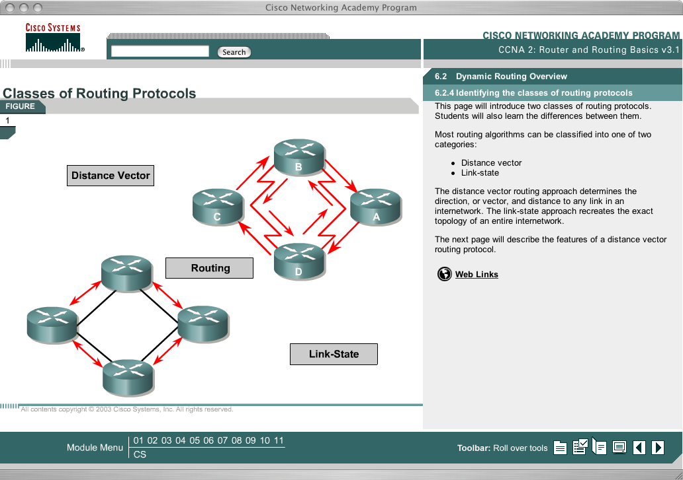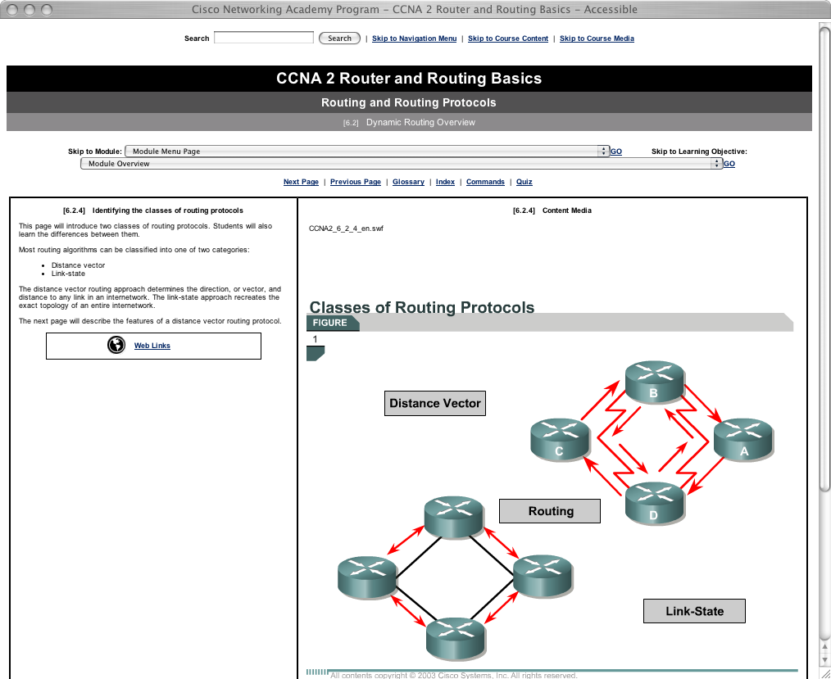Figure 1: Standard curriculum (left) Accessible curriculum (Right)

The Vision Impaired Learner
There are different forms of vision impairment, each of which can significantly affect the learning opportunities of an individual. These impairments range from the congenially blind, who are blind from birth or from a very early age, through to the adventitiously blind, who lose their sight in varying degrees as a result of accidents, disease or the effects of medication. The difference between temporary and partially sighted students and permanently blind students is considerable, particularly with relation to student expectations and staff support as the two groups exhibit different study patterns and difficulties (Shepherd 2001).
Of more concern in specialist fields such as information technology and engineering are the effects of the impairment on the student’s ability to comprehend essential parts of the curriculum, normally taught using visual means.

Overview of the Project
The research being undertaken aims to examine both the unique accessibility requirements and the optimum learning environments for computing students with vision impairment. The research will utilize existing, successful curriculum for the on-line Cisco Network Academy Program (CNAP) with the following objectives:
- Describe the difficulties that students with vision impairment face when trying to access or visualise information and concepts
- Investigate how students with severe vision impairment can utilize cognitive and perceptual properties of non-visual sensory modalities to learn (as compared to sighted students)
- Develop new visualization techniques utilizing various feedback methods to allow students with vision impairment to use and understand complex information
- Develop a novel user interface explicitly designed to deliver technological and engineering skills to students with vision impairment, and
- Investigate how these new techniques can be incorporated into future systems.
The final outcome will be a train-the-trainer manual and training module, designed to assist teachers involved in the delivery of technology subjects to create accessible learning environments for students with impaired vision by application of the universal access perspective.
Task analyses will be carried out individually with current students to gain an understanding of the human computer interface as it relates to students with vision impairment. The strengths and weaknesses of the existing interface are being identified and this will act as a comparison to examine and improve the current methods of e-learning in this area.
In-depth interviews and focus groups will be held with students with vision impairment to describe the difficulties they encounter when learning complex concepts without access to visual information and the strategies that they utilize (cognitive, perceptual, visualization, etc). It is estimated that a minimum of 20 students with vision impairment will be willing to participate in the program.
Tools used
In order to effectively deliver universal access to a mainstream online course, numerous tools have been used and implemented as part of an overall multi-modal design. When configuring network equipment, a braille display is used due to complex terse command structure of the Internet Operating System (IOS). Although speech programs such as JAWS are used in other areas, the Braille display offers greater clarity in the delivery of this form of textual information. The only difficulty with this type of interface is that it is very expensive and as such access to the disability is limited.
An example of equipment developed is the “IP Subnetting Pegboard”. This device, depicted in Figure 2, is utilised to teach binary, hexadecimal and decimal numbering systems. Students place a peg in the hole to represent “1” and no peg for “0”. This was also found to be of great benefit to sighted students as it provides a tactile method to “see” how numbering systems are represented.
The Dominoes depicted in the lower right section of Figure 2 are used to replace on screen or printed network diagrams. An example of a network diagram as it appears in the on line curriculum, is shown in Figure 1
Additional tools used in this environment include pipe cleaners representing sine waves, Braille labels on equipment, Braille lab manuals and a greater hands-on focus within the classroom. Other tools to be investigated include devices similar to the PHANToM 3D force feedback joystick and a tactile computer mouse based upon touch. The Dominoes depicted in the lower right section of Figure 2 used to replace on screen printed network diagrams diagram similar to the example that appears in the on line curriculum, is shown in Figure 1.
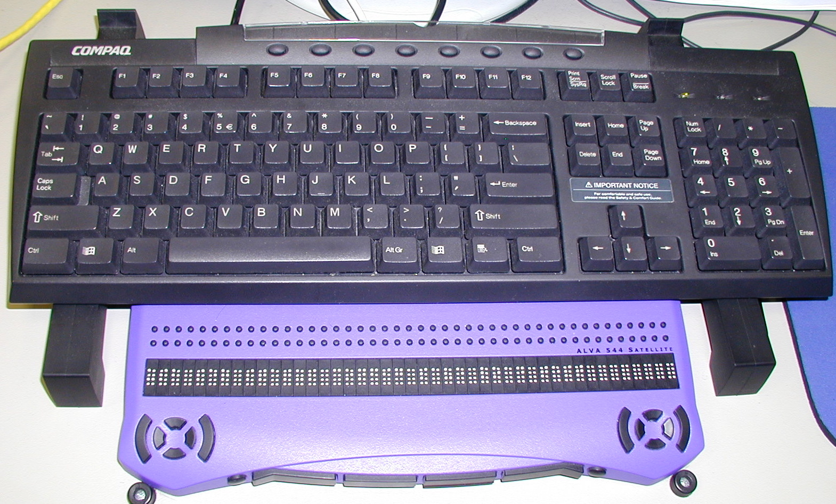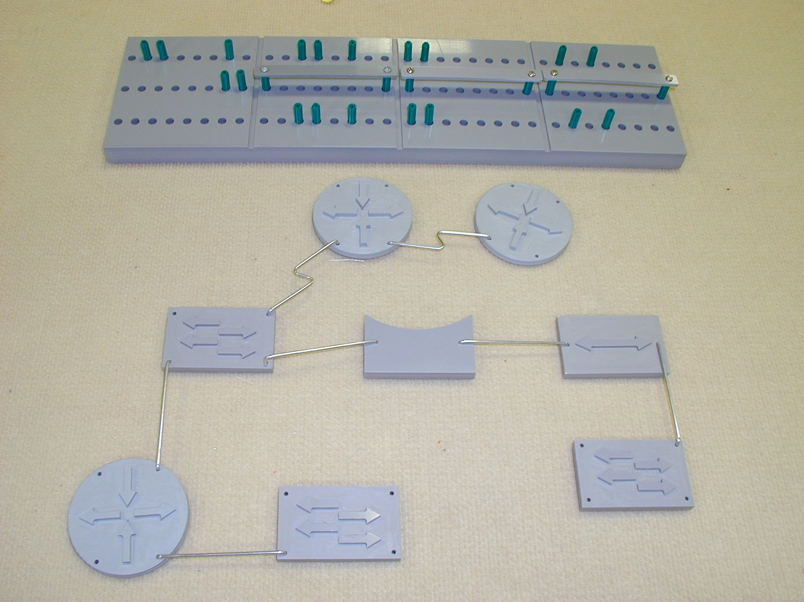
Figure 2: Braille Display right, Pegboard upper right, Dominoes lower right
Progress
One of the difficulties in teaching to people who are blind or vision impaired is the fear of damaging equipment and the associated lack of self-confidence. The need to ‘play’ in order to learn in a computer engineering environment is vital to the learning process. Practical application assists in the assimilation of new knowledge (supporting Piaget’s theory of cognitive development) thus solidifying learning. As students with vision impairment tend to have more highly developed memory capacity than their sighted counterparts, the importance of practical experience is raised even more.
The second serious learning obstacle observed in students with serious vision impairment is their difficulty to comprehend spatial concepts. Jacobson, Kitchin, Garling, Gollege and Blades (1998) presented the difference theory of spatial cognition, proposing that the cognitive map knowledge of adventitiously blind persons are different from sighted persons (rather than underdeveloped or used inefficiently). Individuals with no or limited vision rely on sequential learning using tactile, proprioceptive and auditory senses to construct spatial relationships and in absolute terms, limited vision leads to limited spatial knowledge (Bigelow 1996). Hence an alternate means of developing an understanding of more than two dimensions is required for those students with serious vision impairment. The loss of vision is often accompanied by an increased development of other senses including touch, hearing, memory and intuition and the research aims to tap into those enhanced abilities. The human computer interface of the CCNA curriculum has been altered to incorporate unique visualization strategies to aid conceptualization and these are being monitored on an ongoing basis.
Future Developments
Beside providing visually impaired individuals the opportunity to work as professional networking managers, the CAVI program helps boost the students' confidence and gives them a custom-tailored environment to interact with peers and find support.
"It's so nice to understand, learn and soak it all up. Plus I now sort of have a ticket to the geek circle. Technology is a way for me to bond with other people who are not blind. There are a lot of situations in life where people see the 'blind' person first rather than the just the person. CAVI is helping people see me as more than a blind person." (CAVI Student, 2003)
The exploration of the CAVI project within the Department of Electrical Engineering also provides numerous collaborative opportunities. As the need for new tools arises In the classroom, other students In various Electrical Engineering courses are willing to participate In the development of new products and services to assist blind and vision impaired students. Some of these products Include the development of prototype wireless headsets and Braille notetaking devices, all of which are proving beneficial In the multi-modal learning environment.
Conclusion
The Cisco Access for the Vision Impaired (CAVI) project is succeeding in providing access to the internationally renown CCNA curriculum to people who are blind and vision impaired. This vital endeavour, in partnership between Curtin University, the Association for the Blind of WA and Cisco Systems, ensures that the content delivery of this course is presented in a manner that is accessible and within the conceptual framework of universal access and design.
The tools and resources used, including Braille displays and haptic devices, allow blind and vision impaired people to explore their unique cognitive abilities in the exploration of networking concepts. The project, although in it’s early stages, has achieved significant progress and has assisted in the internal development of other assistive technology devices.
References
Bigelow, A.E. (1996), Blind and Sighted Children’s Spatial Knowledge of the Home Environments, International Journal of Behavioural Development, 19, 797-808
Dept Training & Employment (2000), Building Diversity Project 2000, Western Australian Department of Training and Employment, Government of Western Australia
Jacobson, D., Kitchin, R., Garling, T., Golledge, R. & Blades, M. (1998), Learning a Complex Urban Route Without Sight: Comparing Naturalistic versus Laboratory Measures, Proceedings of Mind III: Annual Conference of the Cognitive Science Society of Ireland, University College, Dublin, August 17-19.
Levtzion-Korach, O., Tennenbaum, A., Schnitzen, R., & Ornoy, A. (2000), Early motor development of blind children, Journal of Paediatric and Child Health, 36, pp 226-229
Shepherd, I. (2001), Providing Learning Support for Blind and Visually Impaired Students Undertaking Fieldwork and Related Activities, University of Gloucestershire, [Online] http://www.glos.ac.uk/gdn/disabil/blind/index.html

