Slide1. Title Slide: Intentional Re-design of a Chemistry Laboratory Program
Susan Hemsley, Educational Designer
Pierre Naeyaert, Lecturer and Director of Senior Chemistry Laboratories
School of Chemistry, Faculty of Science
The University of Sydney

Slide 2. Acknowledgement of Country
We recognise and pay respect to the Elders and communities — past, present, and emerging — of the lands that the University of Sydney’s campuses stand on. For thousands of years they have shared and exchanged knowledges across innumerable generations for the benefit of all.

Slide 3. Introduction
- This presentation describes our journey to date in improving the design of the assessments and LMS site for the 3rd year Chemistry undergraduate laboratory program at USyd
- We will cover:
  - The context
  - Issues with original structure/site
  - Approach to re-design
  - Changes made
  - Feedback about the user experience
  - Next steps and takeaways

- 

Slide 4: Context
- The lab program is inherently complex
  - Includes students from three 3rd year Chemistry Units of Study
  - Each student undertakes one of five major projects per unit (therefore 1, 2 or 3 projects, depending on pattern of enrolment).
  - Each project has multiple experiments, each experiment has multiple small stakes guided experiment-associated assessment tasks, culminating in larger stakes assessments based on an investigative project designed by the students
- The program ran as 2 half- Semester blocks with students completing 1 or 2 projects and associated assessments over 6 weeks
- A single LMS (Canvas) site is shared by all students

Slide 5. 2025 Lab Schedule
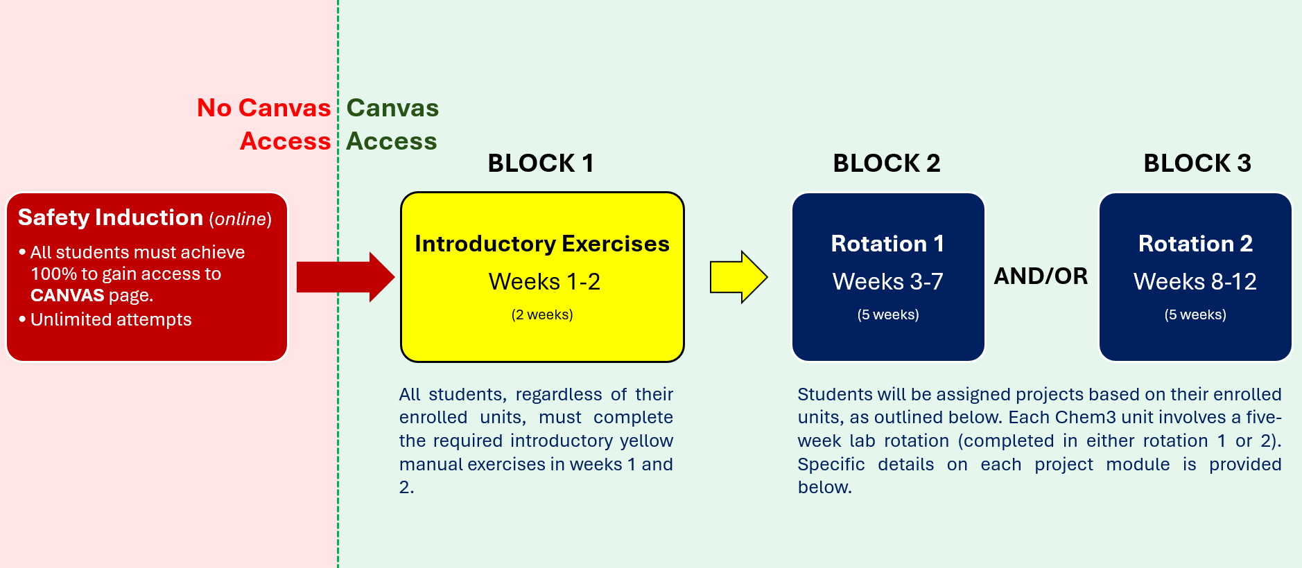

Slide 6. 2025 Lab Program Structure Canvas Information
The yellow introductory manual experiments in weeks 1-2 require two afternoons/week of lab work, regardless of the total number of CHEM3 units a student is enrolled in. After completing these, students are required to attend the rough equivalent of four hours per week for the rest of the semester for every unit in which they are enrolled. However, these four hours may be arranged in varying ways, as shown below:
Number of Chem3 Units | Total hours | Number of Afternoons/week
1 | 40 | Two for 5 weeks (either weeks 3-7 or 8-12).
2 | 80 | Two for 10 weeks (weeks 3-12) or four for 5 weeks (either weeks 3-7 or 8-12).
3 | 120 | Four for one 5 week rotation (e.g. weeks 3-7) plus two for the other 5 week rotation (e.g. weeks 8-12).

Slide 7. 2025 Mark Distribution Communication
- Presentation of assessment weightings for Part 1 (of 3)
- Covers requirements for all projects for all Units
Format | Mark distribution
Part 1  Electronic Notebook (ELN) | TOTAL: 20 Marks  For projects B & C:  ELN report: 19  HIRAC: 1  For projects E, G, J, N & O:  ELN report: 7  HIRAC: 1  Samples: 12  For project S  ELN report: 7  HIRAC: 1  Proforma #1: 12

Slide 8. Specific Barriers to Learning Identified
- Condensed lab program
- Rushed assignments
- Delayed feedback
- Confusing Canvas site navigation.
- Canvas site housed a large number of assignments, which appeared overwhelming
- All material visible to all students although only a subset was relevant to an individual.
- Lack of attention to digital accessibility

Slide 9. Approach
- Primary driver - academic management of the lab program
- Three main aims:
1. Enhance engagement
2. Support executive functioning
3. Improve accessibility
- The re-design was done intentionally and was aligned with UDL Guidelines 3.0
- Sat within broader context of a School-wide strategy of ‘embracing UDL’

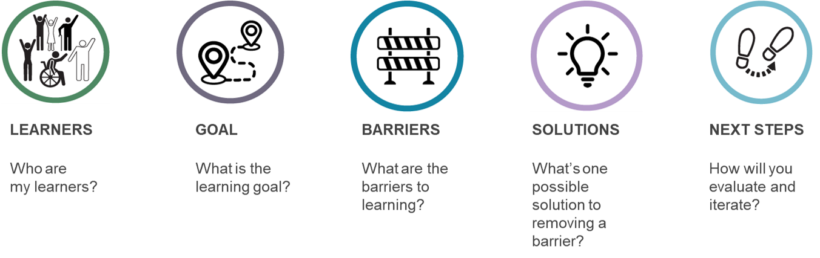

Slide. 10 Specific Aims
- Reduce time pressure
- Make lab program structure simpler and assessment aims and processes clearer
- Decrease requirements to complete work outside of class
- Build in immediate constructive feedback
- Build in scaffolding for the independent experimental component
- Make it easier to find the relevant information and reduce distractions within Canvas.
- Improve accessibility of Canvas content

Slide 11. Changes Made to Program and Assessment Structure
- Program ran over the full 13 weeks
- Reduction in number of projects with student choice rather than allocated
- Assessment structure changes:
  - much could be completed in the laboratory, with staff available for immediate support and feedback (consideration 8.2)
  - timely feedback on assessment tasks with an emphasis on formative learning (8.5)
  - clear, multi-format communication about goals, expectations, logistics and relevance of tasks (1.2 and 7.2)
  - scaffolded build up to students designing, managing and presenting their own experimental work (6.2 and 6.4).
  - Changes were explicitly explained to the students in an introductory video

Slide 12. 2026 Lab Program Structure Canvas Information
Extract from the 2026 Canvas site (found on homepage created for each of Unit)
Week 1 Lab Safety Hurdle (All Students)
The tasks in the Week 1 module are a mandatory, 0-mark hurdle. To access your project modules (e.g., G or J), you must complete all items below.
Before your first lab session (complete at home)
- Online Lab Safety Induction Quiz (must be completed before you attend the lab)
In your first lab session (completed in the Yellow Introduction Manual, provided in your first lab session)
- Intro Worksheet (completed in the lab and checked off by a demonstrator)
- Project Specific Exercise (completed in the lab and checked off by a demonstrator)
- HIRAC for your first experiment (completed and checked in the lab)
Projects (Weeks 2–13)
Each student is allocated one project for the semester – either Project G (Organic Reactions) or Project J (Metal Complexes).
Your allocated project is shown in your timetabled lab name (e.g., CH3118-Monday-G = Project G)) and reflected in your Canvas modules and assignments assigned to you.

Slide 13. 2026 Lab Program Structure Canvas Information
Experiment | Assessments
Lab Safety & Intro | Safety quiz, HIRAC (experiment 1), Lab Map Check-off
Experiment 1 | ELN, Technique check, Sample, Short Report
Experiment 2 | HIRAC, ELN, Technique check, Sample, Short Report
Experiment 3 (Part 1) | HIRAC, ELN, Technique check, Sample
Experiment 3 (Part 2 - investigative) | HIRAC, Poster Submission
VIVA | Poster VIVA

Slide 14 2026 Mark Distribution Communication

Mark Distribution for Projects
Component | Weight (%) | Description
HIRACs | 10 | Mandatory pre-lab risk assessments.
Electronic Notebook (ELN) and Discussions | 10 | Data recording & in-lab discussion sign-off.
Lab techniques | 10 | In-lab practical skill checks.
Sample Submissions | 10 | Quality/Yield of physical samples.
Short Reports | 20 | Written reports for Exp 1 & 2.
Poster | 10 | Investigative project poster
Poster Viva | 30 | Oral defense of your poster (Week 13).
- Much more clearly laid out but not there are still many subcomponents – a total of 19 for this project, although many were moved to be done in-lab

Slide 15. Changes Made to the Canvas Site
- Attention to accessibility (consideration 4.2)
  - using Canvas accessibility checker
  - chunking blocks of text
  - clear delineation of buttons and tables
  - using clear language
  - video content created for major pain points - captioned and a transcript provided (1.2)
- Improved site structure and navigation (4.1 and 7.4)
  - more intuitive movement through the site
  - site navigation video created
  - multiple possible ways of navigating the content)
- ‘Sections’ used so individual students see only content relevant to them (7.4)

Slide 16. Canvas Accessibility Checker
- In-built accessibility checker is an easy way to check things like colour contrast, heading styles, table compliance etc.
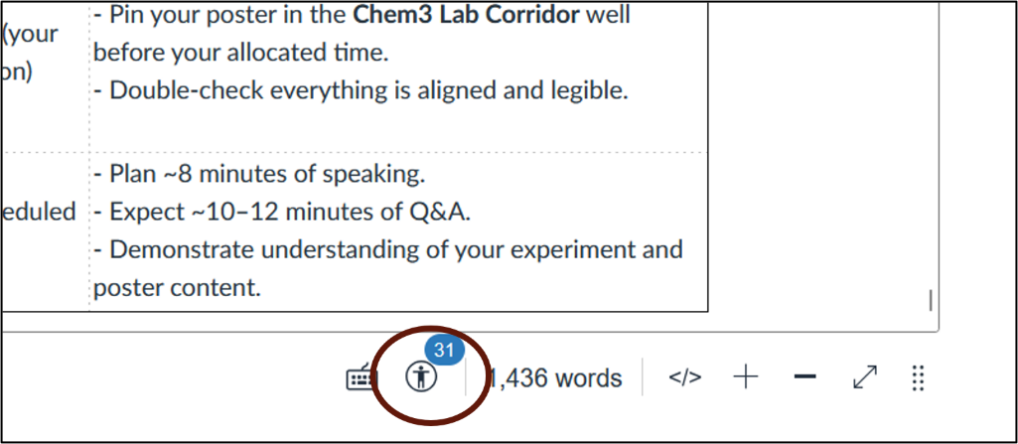
A page in the 2025 Canvas site in ‘edit’ mode
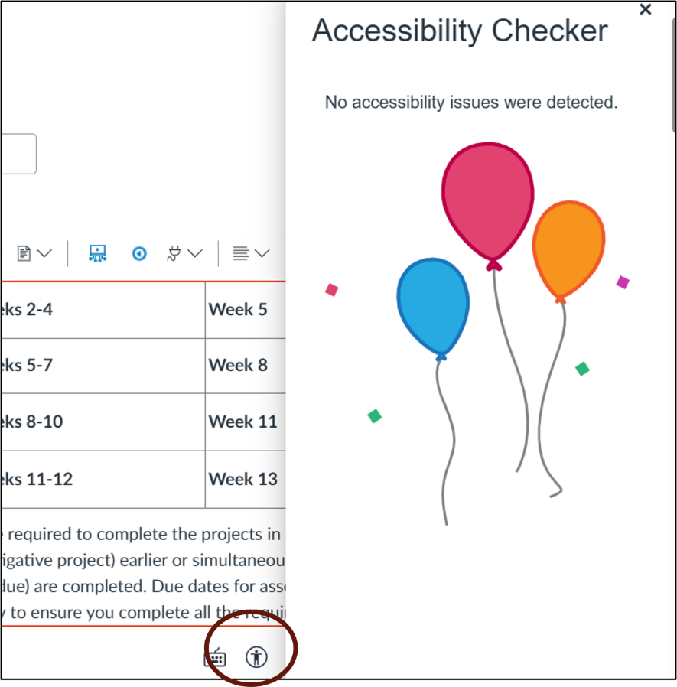
A similar, edited, page in the 2026 Canvas site

Slide 17. Accessibility: Beyond Accessibility Checker
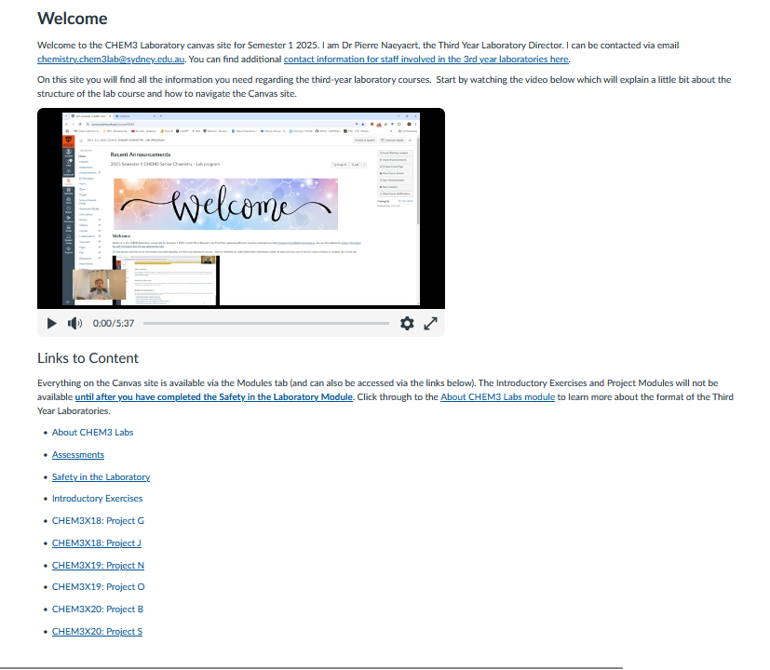
Homepage 2025 Canvas site
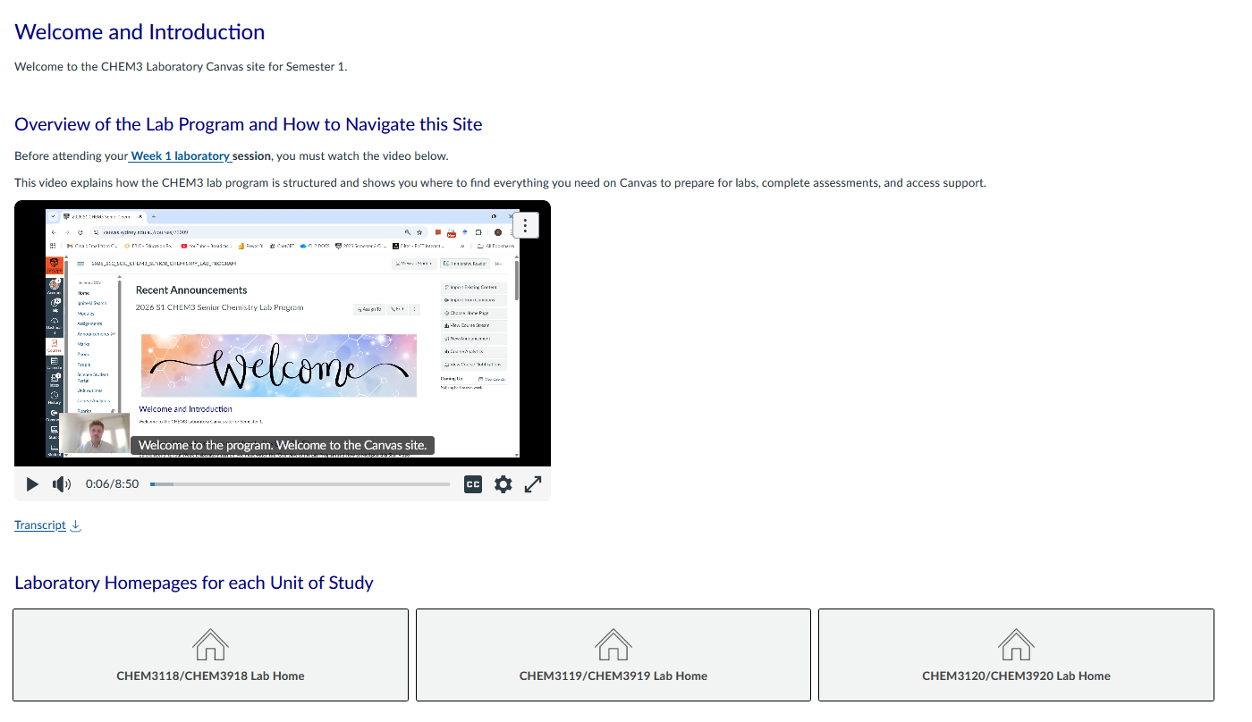
Homepage 2026 Canvas site

Slide 18: Navigation (1)
- Can navigate via the ‘Modules’ area of Canvas or follow the linked pages inside the site
  - modules and their content are restricted only to students needing the material
  - module content organised in a logical sequence according to the order in which the tasks need to be completed
  - internally, the sequence of pages to visit is clearly signposted

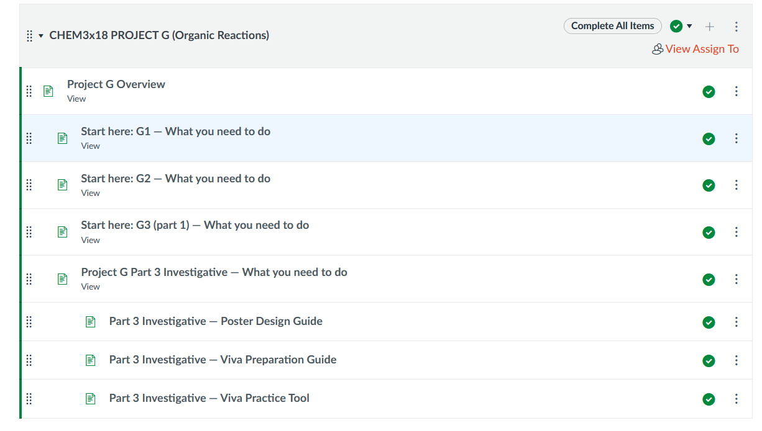
Main module for Project G

Slide 19. Navigation (2)
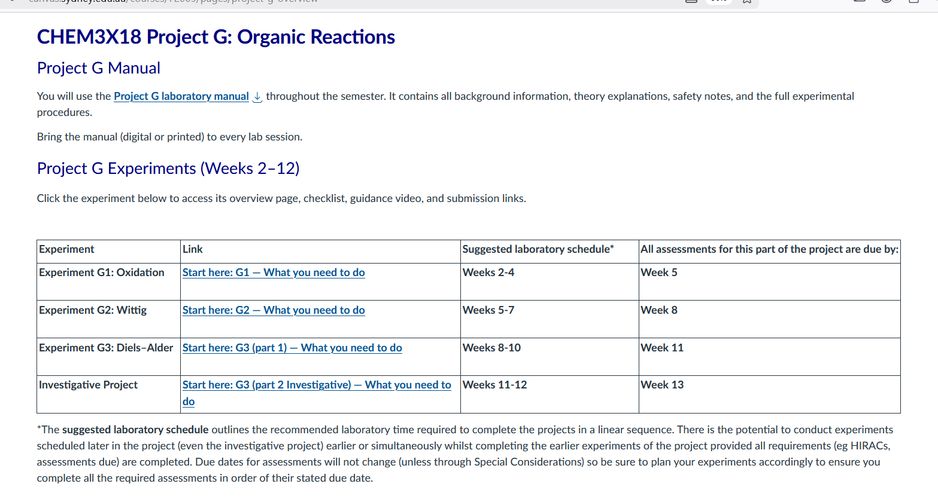
Main overview (home) page for project G

Slide 20. Student Feedback (1)
- Paper-based in-class survey
  - response rate 40/120, 16 students had experienced the lab program previously
- For returning students
- > 75% found that both the learning experience and Canvas site were improved
- Specifically:
  - less time pressure
  - less stressful
  - being able to self-pace
  - opportunities to discuss work with demonstrators during lab.
- Suggestions for further improvement:
  - too many assessments (esp. a problem if doing multiple Units)
  - still some confusing aspects to Canvas

Slide 21. Student Feedback (2)
For all respondents
- The most beneficial aspects were:
  - receiving feedback in time to apply it to later work or remediate work before submission
  - immediate feedback (verbal check ins with demonstrators)
  - clear structure and expectations
  - demonstrators were knowledgeable and supportive (highest rating).
  - Canvas rated well (but not as highly as the other aspects )
- What they would most like to change:
  - too many pieces of assessment

Slide 22. What Next?
Review and iterate!
- Look more closely at ‘who are my learners’?
- Review assessments- number and weighting
- Revisit Canvas navigation – need to tease out specific aspects that can be improved
- Consider alternative representation of program/assessments – e.g., graphic timeline
- Review accessibility of uploaded documents and any other course material
- Gather more feedback, consider focus groups

Slide 23. Takeaways and Tips
- We aimed to showcase positive changes that are transferable to other contexts.
- This comprehensive redesign took a large collaborative effort but picking one aspect of one change could be applied in a ‘Plus 1’ approach.
- For example:
  - clear communication about goals, expectations, logistics and relevance of tasks
  - immediate feedback where practical
  - scaffolding assignments with feedback received in time to apply to later tasks
  - some autonomy in learning opportunities
  - navigational and assessment guidance videos
  - accessibility checks
  - providing content in different formats of material (e.g., video + text)

