UDL Symposium 2026 Presentation
Table of Contents
UDL Symposium 2026 Presentation 1
Embedding UDL 3.0 in Institution-Wide Academic Support Resource Design 2
Acknowledgement of Country 2
Why We Developed an Institution-wide Assessment-focused Resource 3
Initial Approach: Tool-driven Design 3
Our Resource Design Framework 4
Key Insights from the Design Process 4
How UDL 3.0 Principles Informed Our Resource Design 5
From the Perspective of Engagement 5
Scenario-based Entry Points 5
Community and Belonging 5
From the Perspective of Representation 6
Multiple Ways of Accessing Information 6
Managing Complexity 6
Clear and Supportive Communication 6
From the Perspective of Action & Expression 7
Practice and Self-Evaluation 7
Guided Expression 7
Accessible Learning 7
Reducing Barriers Through Platform Design 7
Alternative Formats 7
Accessibility Monitoring 8
Flexible Access 8
What Students Are Saying 8
Next Steps: Continuing to Improve the Resource 9
Experience the Resource as a Student 9
Thank You slide 9
Reference list slide 10

Embedding UDL 3.0 in Institution-Wide Academic Support Resource Design
Dr Boya Zhang
Learning Adviser
Southern Cross University
Project developed collaboratively by the Learning Advisers in the Study Support Team.


Acknowledgement of Country
We acknowledge Widjabal Country as the Country where Southern Cross University originated and grew, and from where it continues to grow. It seeded the growth of our Gumbaynggirr Campus in Coffs Harbour, our Yugambeh Campus in Coolangatta and it planted the seeds to transform the Countries we are on.
Understanding our origins will make each step into the future a more purposeful one, leading all to transform tomorrow.


Why We Developed an Institution-wide Assessment-focused Resource
Student Needs
- Many students need support to navigate assessment requirements and expectations.
- SCU’s educational model encourages early engagement with assessment tasks.
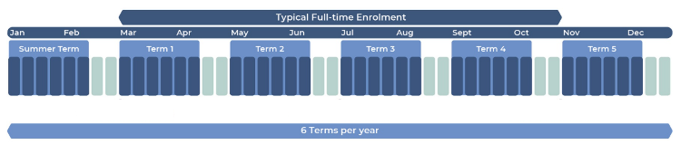
Research Evidence
- Assessment literacy can be developed through explicit teaching and targeted learning resources (e.g. Liu & Li, 2014; Smith et al., 2013).
- Assessment literacy helps students build confidence in their learning and assessment performance (e.g. Price, 2012; Saligari et al., 2024).

Initial Approach: Tool-driven Design
What We Planned
- Interactive H5P books combining multimedia content and practice activities.
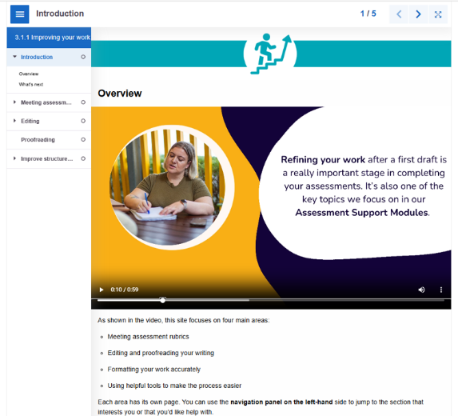

What We Assumed
- Greater interactivity and technology would increase student engagement and support learning.
What We Learned
- Accessibility barriers, particularly for screen-reader users, highlighted the need to prioritise pedagogy and accessibility alongside technology.
This led us to redesign the resource within Blackboard Ultra.

Our Resource Design Framework
- Understand learners and their context
- Identify the assessment literacy skills students need
- Identify potential learning barriers
- Identify the support Learning Advisers can provide and how to provide it
- Apply UDL 3.0 principles to resource design
- Review and refine the resource

Key Insights from the Design Process
Time-poor students
- Keep resources concise, easy to navigate, and organised into manageable chunks.
Learner variability
- Resources should provide multiple pathways to support diverse learning needs and preferences.
Pedagogical approaches
- Explicit teaching, modelling, and guided practice support assessment literacy development.
Purpose and agency
- Choice and clear purpose support motivation and self-regulation.

How UDL 3.0 Principles Informed Our Resource Design
Engagement: Support motivation, relevance, and agency
Representation: offer multiple ways to access and process information
Action & Expression: supporting practice, self-monitoring, and skill development.

From the Perspective of Engagement

Scenario-based Entry Points
- Students choose pathways based on their assessment needs rather than following a single sequence.
- Supports autonomy, relevance, and self-regulation.

Community and Belonging
- Create a Discussion space where students can share their experiences.
- Supports connection, belonging, and collective learning.
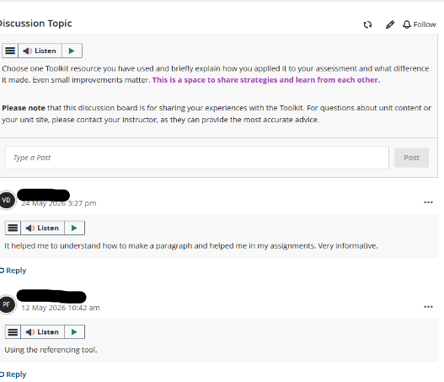

From the Perspective of Representation

Multiple Ways of Accessing Information
- Text, diagrams, icons, videos, and worked examples support different ways of processing information
- Alternative text and video transcripts support accessibility.

Managing Complexity
- Content is organised into manageable sections with clear navigation and transitions to reduce cognitive load.
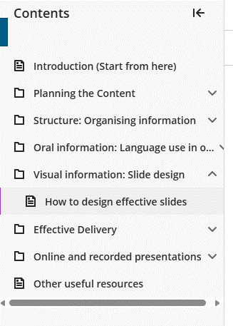

Clear and Supportive Communication
- Student-friendly language and an encouraging tone support understanding and confidence

From the Perspective of Action & Expression

Practice and Self-Evaluation
- Students engage in H5P activities that allow them to apply and monitor their learning.

Guided Expression
- Planners, templates, and scaffolded prompts support students in applying assessment skills to authentic tasks.

Accessible Learning
- Core learning content is provided through Blackboard Ultra.

Reducing Barriers Through Platform Design

Alternative Formats
- Blackboard Ally automatically provides alternative formats, including audio and screen-reader-friendly versions.
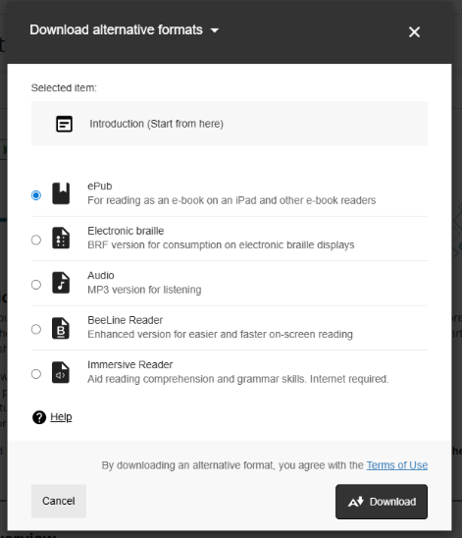

Accessibility Monitoring
- Ally accessibility checker prompted us to review content for accessibility issues, such as adding alternative text to informative images.
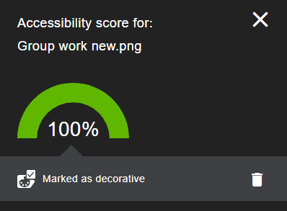

Flexible Access
- Blackboard Ultra supports text-to-speech.
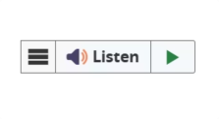

What Students Are Saying
Student Survey responses (n = 69)
- 85% found the resource helpful or very helpful
- 87% reported gaining skills they could apply in future study
Student valued
- Clear, step-by-step explanations
- Opportunities to apply learning
- Increased confidence
- Transferrable skills

Next Steps: Continuing to Improve the Resource
- Accessibility: Gather more feedback from students, particularly those with accessibility needs.
- AI-Supported Navigation: Explore AI-enabled features to help students navigate resources and identify support relevant to their needs.
- Partnership: Continue working with colleagues and UDL specialists to strengthen the resource design.

Experience the Resource as a Student
Scenario
- You are a first-year student working on a group presentation
- The assessment is due in three weeks.
- Your group has just been formed.
- You are worried that some members may not contribute equally.
- You are unsure how to organise meetings and make the most of your group's meeting time.
Your task
- Review the Group Work Module Overview page and choose the option(s) you would select first to support yourself: Group work assessments: Introduction

Thank You slide
Questions and discussion
Dr Boya Zhang
Learning Adviser
Southern Cross University


Reference list slide
Liu, X., & Li, L. (2014). Assessment training effects on student assessment skills and task performance in a technology-facilitated peer assessment. Assessment & Evaluation in Higher Education, 39(3), 275-292. https://doi.org/10.1080/02602938.2013.823540
Price, M., Rust, C., O’Donovan, B., Handley, K., & Bryant, R. (2012). Assessment Literacy: The Foundation for Improving Student Learning. Oxford Brookes University.
Saligari, M. J., Fox, J. L., Rivera Munoz, C. A., Frankland, S., & Willems-Jones, A. (2024). Undergraduate Science and Agriculture Students Perceive Improved Academic Judgement Upon Use of an Assessment Literacy Module. International Journal of Innovation in Science and Mathematics Education, 32(5), 25-40. https://doi.org/10.30722/IJISME.32.05.002
Smith, C. D., Worsfold, K., Davies, L., Fisher, R., & McPhail, R. (2013). Assessment literacy and student learning: The case for explicitly developing students ‘assessment literacy’. Assessment & Evaluation in Higher Education, 38(1), 44-60. https://doi:10.1080/02602938.2011.598636

