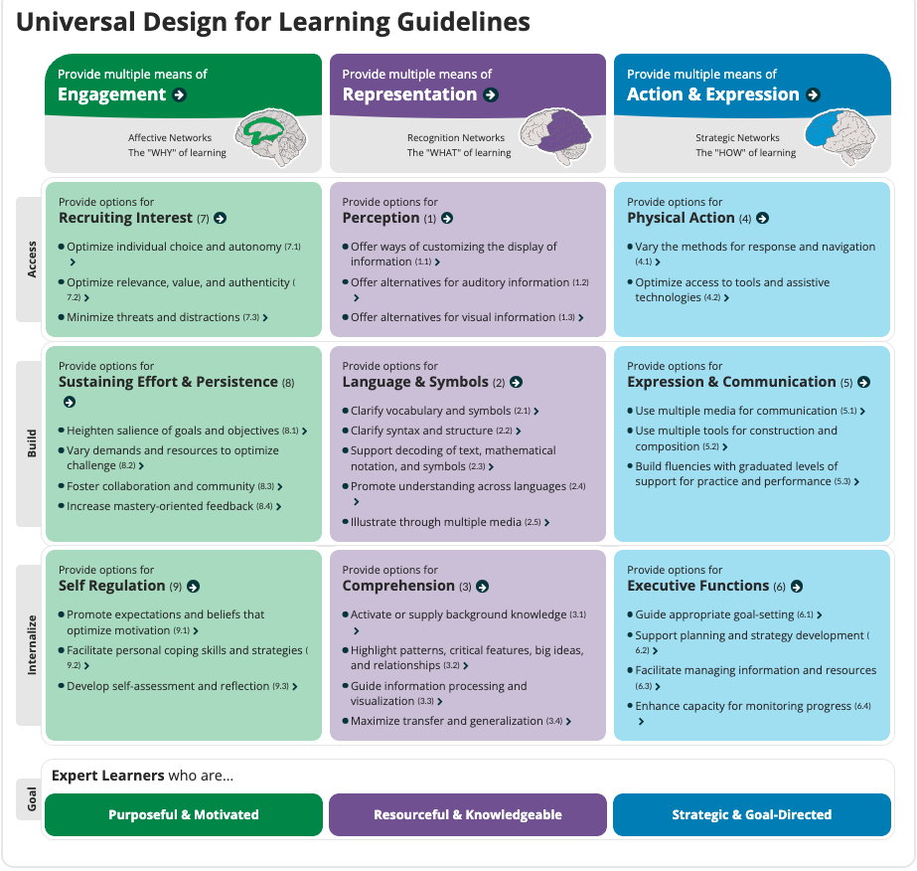
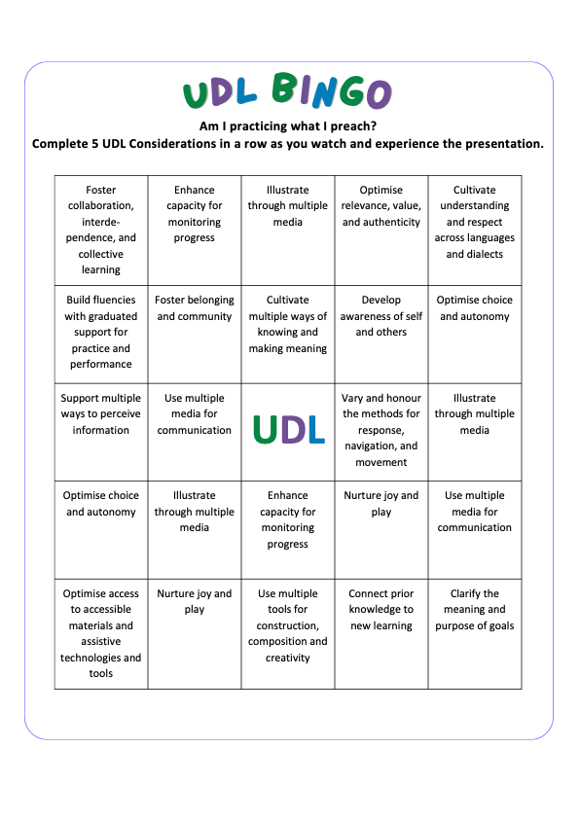

Handout - 11 Interview questions for initial teacher educators

ADCET UDL Symposium 2026 Presentation - Universal Design for Learning in Initial Teacher Education: Do we Practice what we Preach?

Dr. Samantha Woo

Answer these 11 questions and reflect on how you used UDL. Do you practice what you preach?

1. What kind of educator would you describe yourself as?
____________________________________________________________________________________________________________________________________________________________________________________________________________________________________________________________________________________________________________________________________________________________________________________________________________________________________

2. Describe your ideal tutorial room set-up.
____________________________________________________________________________________________________________________________________________________________________________________________________________________________________________________________________________________________________________________________________________________________________________________________________________________________________
____________________________________________________________________________________
____________________________________________________________________________________

3. Which of these strategies below do you use in your tutorials to ensure all learners can access and engage with the content?
- Differentiation of learning materials
- Flexible participation options
- Creating a safe and supportive environment
- Regular feedback and formative assessment
- Use of assistive and digital tools
- Scaffolded instruction

4. Do you include any of these aspects when designing your tutorial plans to accommodate diverse learners with varying needs and abilities?
- Provide choice and autonomy
- Use real-world connections and culturally responsive examples
- Incorporate collaborative and individual learning options
- Present information in varied formats
- Pre-teach and reinforce key vocabulary and concepts
- Provide accessible materials (captioned videos, screen-reader-friendly documents, alt text for images)
- Scaffold tasks with models, exemplars, checklists, and step-by-step guidance
- Offer multiple options for demonstrating understanding
- Scaffold tasks with models, exemplars, checklists, and step-by-step guidance

5. Can you share an example of a tutorial or activity you have implemented that was particularly effective for learners with different learning preferences?
____________________________________________________________________________________________________________________________________________________________________________________________________________________________________________________________________________________________________________________________________________________________________________________________________________________________________

6. How do you gather information about your learners' strengths, challenges, and learning styles, and how does that inform your teaching approach?
____________________________________________________________________________________________________________________________________________________________________________________________________________________________________________________________________________________________________________________________________________________________________________________________________________________________________

7. Do you do any of the following to encourage learner choice and flexibility in the way they demonstrate their understanding of the material?
- Allowing learners to select from a range of formats (e.g., written responses, presentations, visual projects, or discussions) to demonstrate their learning
- Requiring all learners to complete the same assessment task in a standard written format to ensure consistency
- Providing optional scaffolds such as templates, exemplars, and guided steps while allowing flexibility in how responses are structured
- Offering opportunities for learners to work individually or collaboratively and choose tools or platforms that suit their learning preferences

8. Do you think the assessment tasks in your subject were designed to be fair and accessible to all learners? Why or why not?
____________________________________________________________________________________________________________________________________________________________________________________________________________________________________________________________________________________________________________________________________________________________________________________________________________________________________

9. What were some of the common barriers to learning that you observed in your learners during tutorials?
- Difficulty understanding complex concepts or unfamiliar terminology without sufficient scaffolding
- Limited confidence or reluctance to participate in discussions or activities
- Variability in prior knowledge and academic preparedness among learners
- Challenges accessing materials due to language barriers, accessibility needs, or unfamiliarity with digital tools

10. Do you think there are any barriers to implementing UDL in your classes?
If so, what are they?
____________________________________________________________________________________________________________________________________________________________________________________________________________________________________________________________________________________________________________________________________________________________________________________________________________________________________

11. Which of the following changes to the physical and built environment, or to university systems, need to be made for education to be accessible to all?
- Improving physical accessibility across campus (e.g., ramps, lifts, accessible seating, clear signage, and sensory-friendly spaces)
- Ensuring all learning materials and digital platforms meet accessibility standards (e.g., captioned videos, screen-reader compatibility, flexible online access)
- Embedding inclusive teaching practices and Universal Design for Learning (UDL) principles across all courses and staff training
- Providing more flexible policies (e.g., varied assessment formats, extended deadlines, hybrid learning options) to accommodate diverse learner needs

