Presentation for ADCET UDL Symposium 2026
Dr Samantha Woo, Associate Lecturer in Inclusive Education, Western Sydney University
Presenter/s: In-person (Thursday afternoon, 25 June 2026)
Presentation: 30-minutes
Level: Beginner
Theme: Engagement, joy and play
Title: Universal Design for Learning in initial teacher education: Do we practice what we preach?
Contents
[Slide 1] Introduction 2
[Slide 2] UDL BINGO 2
[Slide 3] Context 2
[Slide 4] Problematic? 2
[Slide 5] Research questions 3
[Slide 6] Materials and methods 3
[Slide 7] Do we practice what we preach? 4
[Slide 8] Initial findings 4
[Slide 9] Interview overview 5
[Slide 10] 6
[Slide 11] 6
[Slide 12] A tale of two tutors 6
[Slide 13] Do ITEs who teach UDL practice inclusive education? 7
[Slide 14] What are preservice teachers' perceptions of their initial teacher educators' pedagogy and teaching style? 8
[Slide 15] Final thoughts 9
[Slide 16] Any questions? 9

[Slide 1] Introduction
Good afternoon and thanks for joining me for this presentation titled ‘Universal Design for Learning in initial teacher education: Do we practice what we preach?
I’m Samantha or Dr. Woo as I’m occasionally called by my learners. And since I submitted this abstract under the theme of ‘Engagement, joy and play’, I hope the next 20 minutes will engage you, spark joy or allow you space to play.
My goals for this presentation are to:
- Outline our research
- Gather survey data from you
- Challenge you to reflect on your practice or that of an educator who has made a significant impact on you
- Display our initial findings and offer some key ideas and themes, and
- Listen to your questions and answer them

[Slide 2] UDL BINGO
But before all that, let’s play UDL BINGO! Who knows their UDL Considerations?
Grab a handout and take out your pen, or for our online participants, download the handout available and get ready to highlight. Note that the middle box is a ‘free space’ meaning any row it is on only needs 4 other spaces to be complete.
First one to complete a row of 5 and yells “Bingo!” or puts their hand up in the chat box, wins major bragging rights for the remainder of the Symposium.

[Slide 3] Context
In 2015, the United Nations called on countries to ensure fair access to inclusive, high-quality, and lifelong education for all people by 2030 (UN General Assembly, 2015). As a result, many countries have prioritised inclusive education, including in higher education (HE).
In Australia, the push for inclusive practice in the tertiary sector has increased, especially as the population becomes more diverse (Edwards, 2022; Stentiford & Koutsouris, 2021; Timus et al., 2024). However, compared with primary and secondary education, HE has been slower to adopt inclusive education practices (Morina, 2017).

[Slide 4] Problematic?
This reflects ongoing challenges in Australian HE and initial teacher education, including the limited and inconsistent provision of UDL programs and professional learning (Cumming & Rose, 2022; Leif et al., 2023).
CAST’s UDL framework (2024) is a core component of inclusive education. Although many universities promote UDL on their websites, there is little evidence of its consistent use in Australian HE (Cumming & Rose, 2022).
This is particularly problematic for initial teacher educators (ITEs) teaching inclusive education and UDL to preservice teachers (Reupert et al., 2010), as it can create a mismatch between what is taught and how it is taught. Preservice teachers cannot be expected to implement UDL effectively in schools if they have not experienced it, or seen it clearly modelled, in HE.

[Slide 5] Research questions
Our research project asked, ‘Do we practice what we preach?’
We therefore came up with the following research questions:
- What do ITEs know about UDL?
- Do ITEs who teach UDL practice inclusive education?
- What are preservice teachers' perceptions of their ITEs' pedagogy and teaching style?

[Slide 6] Materials and methods
AKA what we used and what we did to try and answer the research questions.
Design: an ongoing concurrent mixed methods study from 2022–2026 using qualitative and quantitative interview and survey data. This presentation focuses on three semesters from 2024 to 2025 .
Setting: an Australian university with a high percentage of diverse learners: e.g., learners with disability, low SES, First Nations learners, and learners who are CALD. The research was situated in a School of Education ITE program with subjects that taught UDL.
Participants: group 1 were ITEs with varied teaching experience teaching in early childhood to secondary; and inclusive education experience). Group 2 were Master of Education learners studying a subject that taught UDL.
Data Collection
Interviews: our research assistant (RA) conducted 1-hour, semi-structured interviews with 4 ITEs via Zoom. 11 questions were asked regarding the ITEs’ knowledge and practice of inclusive education.
Surveys: we used university Student Feedback on Subject (SFS) (12 items) and Student Feedback on Teaching (SFT) (10 items), which included Likert scales and open-ended responses.
Data Preparation: Data was cleaned and deidentified prior to analysis.
Data Analysis
Interviews: were analysed in NVivo 15 using a coding matrix based on the UDL Guidelines 3.0 (36 Considerations across Engagement, Representation, Action & Expression). In vivo coding captured additional themes.
Qualitative Surveys: SFS and SFT open-ended responses were analysed using the same UDL coding matrix and in vivo coding.
Quantitative Surveys: Due to low response rates (n < 10), results were analysed using percentage explicit agreement (“Agree/Strongly Agree”) and compared against School of Education and University benchmarks.
Data Triangulation: Findings were cross-checked across all the databases to enhance credibility and when addressing the research questions.

[Slide 7] Do we practice what we preach?
My second goal for this presentation was to collect survey data from you. So, before I share our initial research findings, I challenge you to take 3 minutes to reflect on and answer these 11 interview questions that our RA asked the ITEs. You can choose from:
Paper
Online - https://forms.gle/NxFLsrofgoHdpmsBA
Game - https://view.genially.com/6a139ed9c3cb7d4423a143ff
Scan the QR code or click onto the hyperlink if you have access to these slides.

[Slide 8] Initial findings
Initial findings from the interview and survey data are presented in two parts:
Interview Overview, which addresses Research Question 1, and
The Tale of Two Tutors, which addresses Research Questions 2 and 3.
Interview Overview:
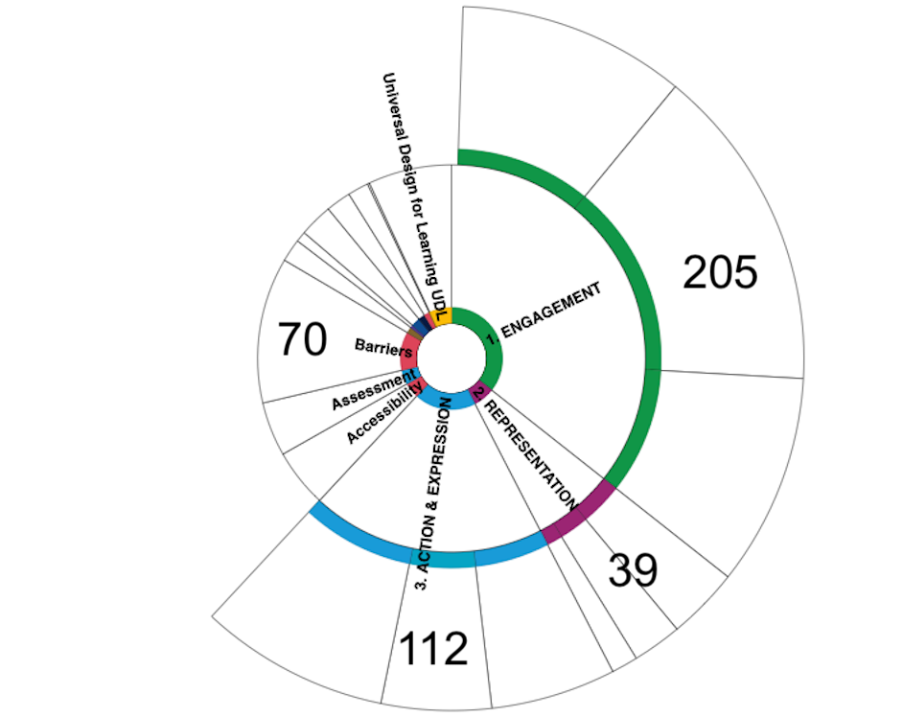
The pie graph shows the number and type of coding references across four interviews. Most references related to Engagement (205), followed by Action & Expression (112) and Representation (39). Among the in vivo codes, Barriers appeared most frequently (70 references), indicating that participants discussed barriers to UDL or inclusive education in considerable depth. References from all three parent codes appeared in all four interviews.
In response to, Research Question 1: What do initial teacher educators know about UDL? The data suggests that all four participants had a strong understanding of UDL.

[Slide 9] Interview overview
This table displays how many times each ITE discussed barriers to implementing UDL or inclusive education, and Multiple means of Engagement, Representation or Action & Expression. The 36 UDL Considerations were used as the coding references.
In response to Research Question 1, the table tells us that overall, the ITE with the greatest amount of UDL coding references was Tutor 2. This could be interpreted as Tutor 2 being the ITE who knows most about UDL.
No. of coding references | Tutor 1 | Tutor 2 | Tutor 3 | Tutor 4
Barriers | 25 | 20 | 14 | 11
Engagement | 65 | 67 | 42 | 31
Representation | 9 | 24 | 1 | 5
Action & Expression | 28 | 46 | 25 | 13

[Slide 10]
To support the quantitative interview data, let me share some quotes from the ITEs which are displayed on the slide.
Coded under ‘Barriers’, Tutor 4 remarked:
“When you've got an assignment with one question and [one set of] instructions about… criteria...very, very often, there is just one way that students are expected meet that [criteria].”
While Tutor 1 commented:
“I just think the whole funding process is really problematic… and some of the assessments are just not suited to the type of students that we have.”

[Slide 11]
Coded under ‘Foster belonging and community’, Tutor 3 noted:
“Relational. Relational. And relational. … if you can't reach them, you can't teach them… At the heart of education is the education of the heart. I believe that absolutely. After 52 years, no one will ever convince me otherwise.”
Similarly, Tutor 2 commented:
“First tutorial… I ask them to tell me their name ... Tell me something you have difficulty with and then something that you're good at. I can put a name to [the] person and the thing that they said and then find ways to connect.”
So, from what the interview data has shown us, it seems that all ITEs can describe what they know about UDL and barriers to UDL. Logically we would assume that knowing and understanding UDL would translate to the ITEs’ practice as well.

[Slide 12] A tale of two tutors
To illustrate the rest of the initial findings, I thought I would tell you a story. To ensure that you all stay engaged, we will have a buzzword. Whenever you hear or read this buzzword, you must simultaneously catch someone or avoid being caught. Now how are we going to do this in our limited space? Very simple, hold out your right hand, palm facing up and flat. Take the index finger of your left hand and place it on the right hand of the person sitting to your left. This might require a bit of moving around and shuffling so that everyone can reach and is somewhat comfortable.
Now you have a finger to catch and a finger – your own - which must avoid being caught! Is everyone ready for the buzzword? PLAY. The buzzword includes stemmed words e.g. playing, playful plays or words that have play in them e.g. playwright, display or horseplay.
Let’s do a practice round: “I love going to the theatre. Musicals are my favourite. I’ve seen Les Misérables, Hamilton, and Wicked, just to name a few. Such Sweet Sorrow I watched on campus recently, a play based on Shakespeare’s Romeo and Juliet.”
Are we ready for the story – ‘A Tale of Two Tutors’?
Play audio recording of story, with captions:
Once upon a time, there were two educators - Pratiksha and Colleen. Both were tutors teaching the same inclusive education subject, at the same university. They enjoyed this subject, which included teaching UDL. They were a part of a supportive team that had worked together previously. The tutors prioritised their learners.
In Autumn semester 2024, Pratiksha began a permanent position at this university, where she and Colleen both casual tutors. By Spring, Pratiksha was made subject coordinator and was balancing admin, teaching, and research. She downplayed how much work this job was. On Saturdays, she would even bring her two children to her office to get a bit more work done. Pratiksha’s kids loved playing where their mum worked. They ran down empty hallways, played card games and drew on post it notes, giving their mum space to work.
One big change that Pratiksha added to this subject, was to introduce a new group assessment that included presenting a roleplay. Colleen knew how busy Pratiksha was and offered Pratiksha support in whatever ways she could. Colleen gave weekly feedback on how learners engaged with the new group assessment, which included 20 minutes at the end of tutorials to work on the assessment. Some groups effectively used those 20 minutes each week, while other groups did more horseplaying than roleplaying.
But despite her best efforts, by the end of 2024, Pratiksha was burnt out. Even with marking relief from Colleen, personal leave and a reduced workload, Pratiksha still entered Autumn 2025 feeling tired and overworked. Thankfully, she knew that she could count on her team of inclusive educators and felt ready for whatever the semester might bring. The End.

[Slide 13] Do ITEs who teach UDL practice inclusive education?
If I were to simply provide you with the table of statistics on the slide, with the title, ‘A Tale of Two Tutors’, we could correctly interpret that Tutor 2 and Tutor 3, who taught in the same subject across three consecutive semesters, were rated quite differently.
A Tale of Two Tutors
Year/Semester | Explicit Agreement  Tutor 2 | Explicit Agreement  Tutor 3 | Explicit Agreement School | Explicit Agreement University
2024  Autumn | 80% | 100% | 82% | 85%
2024  Spring | 0% | 100% | 81% | 85%
2025  Autumn | 33% | 100% | 81% | 83%

Learners’ responses to survey item 8: I was satisfied with the quality of this staff member's teaching, show that Tutor 2 had high variability (0%–80%), often below School of Education and University benchmarks, while Tutor 3 consistently achieved 100% agreement, and was above benchmarks.
This survey data also does not reflect the expected results from the interview data. That is, while Tutor 2 was the ITE who spoke the most times about UDL in the interview, it clearly did not translate into practice, since learners rated the quality of Tutor 2’s teaching poorly.
Apart from these numbers, what were learners’ thoughts about Tutor 2 and Tutor 3?

[Slide 14] What are preservice teachers' perceptions of their initial teacher educators' pedagogy and teaching style?
To address research question 3. What are preservice teachers' perceptions of their ITEs' pedagogy and teaching style?, here are a few SFT and SFS survey comments in response to: – Best Aspects or Needs Improvement.
“Tutor 2 is a lovely teacher and subject coordinator however I did not enjoy any aspect of this unit. The content was very interesting, but delivery methods and activities were repetitive … tedious. Classes were not engaging at all and rather boring. Time seemed to stop whilst in this class.”
“Everything! Is there anything Tutor 3 can't do? OK specifics. Role model for how I should be running my classes, has amazing social skills, again a role model for teacher student relations. Encourages participation, ties humour in with teaching. Too much to list.”
“I have never been so dissatisfied with the behaviour and lack of empathy of a subject coordinator. [Tutor 2]”

[Slide 15] Final thoughts
Praise for Tutor 3 continues:
“I was incredibly lucky to have Tutor 3. She is engaging, knowledgeable, and an incredible role model ... our first tutorial, she stated teaching is about relationships. We went around the room and introduced ourselves. She then went around the room and remembered all our names. This activity made me feel acknowledged and was the first time in my Master’s degree I understood teaching is so much more than curriculums and standards. “
One learner commented:
“Tutor 2 was approachable and interacted with all of her students.”
While another learner remarked:
“Tutor 2’s class is not engaging, and the provided literature is not relevant.”
To sum up, our initial findings – while quite interesting – cannot provide us with concrete answers to our 3 research questions. More interviews need to be conducted with other ITEs, and thus more survey data could be collected from learners.
What we can say for certain is that there are intersecting factors that have an impact on whether ITEs who teach UDL practice what they preach, such as TE’s interpersonal skills, system-wide limitations such as budgets, traditional lecture and tutorial delivery modes, and barriers to equitable and accessible assessment.
And if you hadn't figured out already, our two Tutors - Pratiksha and Colleen - were Tutors 2 and 3, who had participated in the research study.

[Slide 16] Any questions?
That concludes my presentation. Thank you so much for your time and participation. I will happily take some questions in a couple of moments.

