Beyond Accessibility: Neurodivergent Students’ Experiences of Universal Design for Learning in Higher Education
Thursday 10:20am-10:50am
Ari Star (she/her)
ari.star@mq.edu.au

Introduction (slide 2)

Defining neurodiversity

What is neurodiversity?
- Collectively by autistic activists in the 1990s¹
- Refers to the variation in human neurology¹
- Argues against the idea that conditions like Autism, ADHD and Dyslexia are pathological issues that should be ‘treated’ or ‘fixed’¹
- The neurodiversity paradigm offers a model for interpreting such diversity²
- Botha, M., Chapman, R., Giwa Onaiwu, M., Kapp, S. K., Stannard Ashley, A., & Walker, N. (2024). The neurodiversity concept was developed collectively: An overdue correction on the origins of neurodiversity theory. Autism, 28(6), 1591-1594. https://doi.org/10.1177/13623613241237871
- Walker, N., & Raymaker, D. M. (2021). Toward a neuroqueer future: An interview with Nick Walker. Autism in Adulthood, 3(1), 5–10. https://doi.org/10.1089/aut.2020.29014.njw

Introduction (slide 3)

Thesis aims
- Number of neurodivergent university students increasing^{3,4,5}
- Disproportionate challenges (executive functioning, challenging sensory environments) ^{3,4,6,7}
- Proposed beneficial inclusive education framework: Universal Design for Learning (UDL)⁸
Thesis aim: Investigate the role of UDL on neurodivergent students’ university experiences.
3. Tan, D. W., Rabuka, M., Haar, T., & Pellicano, E. (2024). https://doi.org/10.1177/13623613231219744
4. Australian Government Department of Education. (2021, October). https://www.education.gov.au/higher-education-statistics/student-data/selected-higher-education-statistics-2021-student-data
5. United Nations. (2016). https://www.ohchr.org/en/documents/general-comments-and-recommendations/general-comment-no-4-2016-article-24-right-inclusive
6. Stockwell, K. M., Robertson, Z. S., Lampi, A. J., Steinmann, T., Morgan, E., & Jaswal, V. K. (2025). https://doi.org/10.1089/aut.2023.0139
7. Newman, L., Wagner, M., Knokey, A.-M., Marder, C., Nagle, K., Shaver, D., Wei, X., Cameto, R., Contreras, E., Ferguson, K., Greene, S., Schwarting, M., & Buckley, J. A. (2011).
8. CAST. (2024). https://udlguidelines.cast.org
Image: Venn diagram illustrating the three principles of Universal Design for Learning (UDL). A purple circle on the left is labeled “Representation,” a blue circle on the right is labeled “Action and Expression,” and a green circle at the bottom is labeled “Engagement.” The circles overlap, creating lighter blended areas where the principles intersect. At the center, where all three circles overlap, a light gray area is labeled “UDL.” The diagram visually conveys that Universal Design for Learning is achieved through the integration of multiple means of representation, action and expression, and engagement.

Systematic Review (slide 4)

Thematic analysis of 20 studies
Three major themes derived from neurodivergent students' university experiences:
- Inflexible institutional policies and lack of respect​
- The value of intentional inclusive practice and supportive lecturers​
- The impact of genuine inclusion​
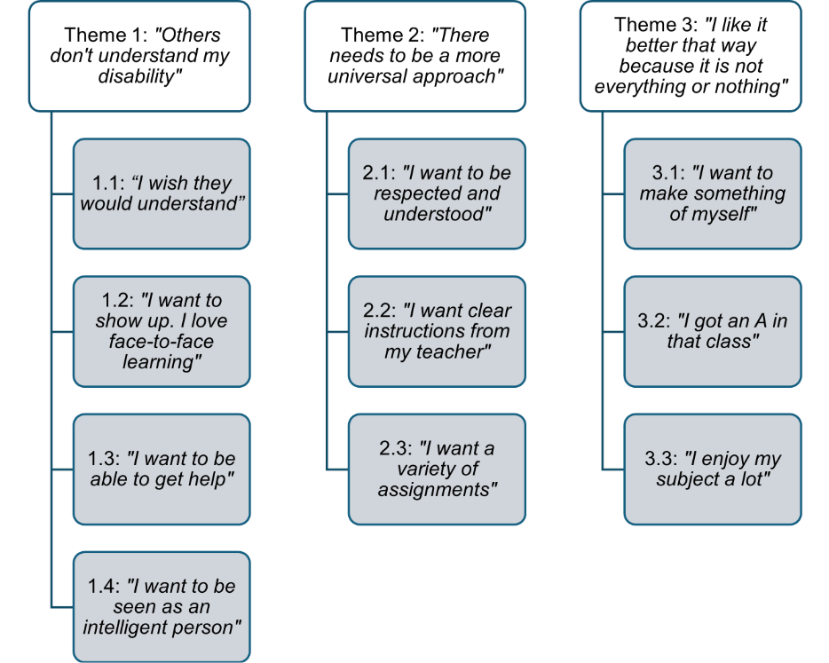
Figure 2 Thematic map related to neurodivergent students’ experiences of UDL.
Adapted from Exploring the Influence of Universal Design for Learning on the Experience of University for Neurodivergent Students (Version 1), by A. A. Star, 2025 (Master’s thesis, Macquarie University), Figshare. https://doi.org/10.25949/31301548.v1

Systematic review (slide 5)

Conclusion
- UDL offers valuable guidance for inclusive practice, but it does not fully address the relational, structural, and affective drivers of educational exclusion
- Neurodivergent students still face barriers that UDL does not address
- UDL informed approaches do have strong benefits, especially flexible assessment
- Effectiveness is grounded in lecturers' genuine care and commitment to inclusion

Method (slide 6)

Surveys
Lecturer survey
- 25 university lecturers
- Lecturers worked in Australia, England, New Zealand, Belgium, Netherlands, United Kingdom
- 92% female, 8% male
- 40% were neurodivergent themselves
Neurodivergent student survey
- 51 neurodivergent students​
- Students attended universities in Australia, United Kingdom, Canada, Ireland, New Zealand, United States
- 63% female, 18% male, 18% non-binary, 2% no gender identity
- 65% ADHD, 61% Autistic​

Method (slide 7)

Interviews
Neurodivergent student interview
- 15 of these neurodivergent students​
- Students studied in Australia, United States, United Kingdon
- 47% undergraduate, 53% postgraduate
- 60% female, 27% non-binary, 13% male
- 60% ADHD, 40% Autistic

Results (slide 8)

Lecturer survey with 25 participants and student survey with 51 participants
Lecturers
100% use strategies to increase engagement
96% present information in multiple ways
80% allow multiple ways to show understanding
Students
57% saw strategies to increase engagement
33% reported information being presented in multiple ways
49% were given multiple ways to show understanding

Interview Results (slide 9)

Thematic analysis from interviews with 15 neurodivergent students
Four major themes:
- Challenges experienced
- Impact of challenges
- Effective teaching practices
- Role of relationships
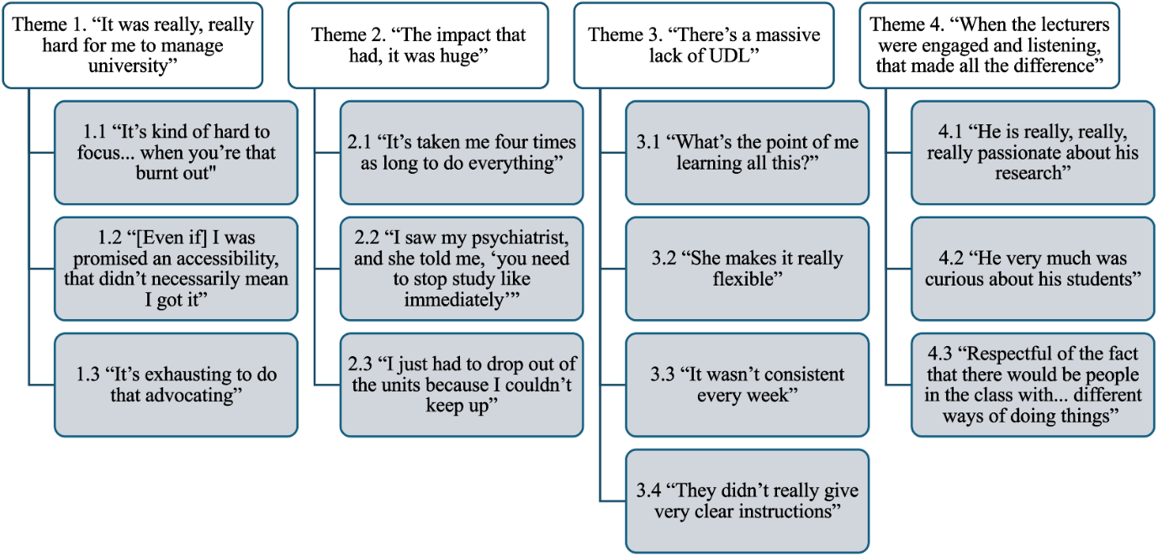
Figure 3 Thematic map related to neurodivergent students’ experiences of UDL.
Adapted from Exploring the Influence of Universal Design for Learning on the Experience of University for Neurodivergent Students (Version 1), by A. A. Star, 2025 (Master’s thesis, Macquarie University), Figshare. https://doi.org/10.25949/31301548.v1

Conclusion (slide 10)

Literature and empirical findings
Key Insights:
UDL has the potential to positively shape neurodivergent students’ experiences, but its impact depends on successful implementation.
- Positive Outcomes (where UDL was applied effectively):
- Flexibility and choice boosted student motivation
- Improved understanding of content
- Fostered positive lecturer-student relationships
This highlights the need for universities to support lecturers to refine and apply its principles through a compassionate approach that anticipates and responds to student diversity.

Q&A (slide 11)
To connect: ari.star@mq.edu.au or LinkedIn @aristar1
Read Ari’s thesis here:
Star, A. A. (2025). Exploring the influence of universal design for learning on the experience of university for neurodivergent students (Version 1) [Master’s thesis, Macquarie University]. Figshare. https://doi.org/10.25949/31301548.v1

Upon Completion
Feel free to use this space to write any questions that you may think of
_________________________________________________________
_________________________________________________________

