ADCET Symposium

Art-Based Learning: A Creative Approach to Teaching Theory

Presenter: Annika Patmore (JCU)
Table of Contents
Introduction 2
Presentation Learning Objectives 2
The Challenges of Teaching Theory 2
Rethinking the Design 3
‘Art Series’ in Practice 3
‘Art Series’ Student Examples 3
Impact of Integrating Art into Teaching Theory 5
Lessons Learnt Along the Way 6
Pedagogical Frameworks 6
Conclusion 6

Introduction
This presentation is facilitated by Annika Patmore, Occupational Therapist and Lecturer at James Cook University (JCU). The presentation begins with a formal introduction, followed by acknowledging traditional custodians as the first artists and creatives of Australia, whose living cultures continue to shape and enrich contemporary artistic and educational spaces today.

Presentation Objectives
The session outlines several key objectives:
- To discuss the challenges associated with teaching theoretical content in occupational therapy education;
- To reflect on the process of reimagining traditional teaching approaches;
- To describe the development and implementation of an art-based teaching strategy referred to as the “Art Series”;
- To provide practical examples of this approach;
- To briefly situate this work within relevant pedagogical frameworks
An opportunity for questions is available at the end of the presentation. Audience questions are encouraged throughout via a Padlet platform, enabling both in-person and online participants to contribute questions in real time.
Link to Padlet: https://padlet.com/jamescookuniversity/art-based-learning-a-creative-approach-to-teaching-theory-rcdomg4v76k0fty6

The Challenges of Teaching Theory
The presentation provides contextual background regarding first-year Occupational Therapy (OT) education at JCU. Within first-year curriculum, students are introduced to foundational theoretical models that underpin OT practice. These models are essential for developing clinical reasoning and form a critical part of students’ progression into subsequent years of study. However, it was observed that students frequently experience these models as abstract, complex and insufficiently engaging. Commonly taught frameworks, such as the Canadian Model of Occupational Performance and Engagement (CMOP-E) and the Model of Human Occupation (MOHO), are identified as visually dense and conceptually demanding, presenting challenges in both comprehension and application.
Traditional teaching approaches are described as relying heavily on lectures, prescribed textbook readings and written tasks requiring detailed explanation of model components and their interrelationships, followed by application to case studies. This structure, repeated across multiple weeks and models, is reported to contribute to disengagement among students. Observations indicate that many students struggle to sustain attention, feel overwhelmed by the volume of reading required and have difficulty visualising how theoretical components interact. These issues raise concerns regarding students’ capacity to meaningfully engage with foundational theory and to effectively apply this knowledge in both academic progression and future clinical contexts.
The need for change is further reinforced through Annika’s reflective consideration of prior learning experiences, where similar challenges with dense theoretical content were encountered. At the same time, the presentation acknowledges the practical constraints faced by academics, including limited time and competing curriculum demands, which can make substantial teaching redesign difficult to prioritise despite recognised need.

Rethinking the Design
In response to these challenges, the presentation outlines a shift in teaching design informed by, primarily, clinical OT practice. While not initially developed with Universal Design for Learning (UDL) as an explicit framework, the development of the Art Series drew from the concept of ‘health literacy’ which centres on adapting communication to meet the individual needs of the receiver, rather than expecting the receiver to adjust to be able to understand. The Art Series approach reframes teaching as a process that should similarly respond to learner diversity; emphasising the importance of presenting information in ways that are accessible and meaningful to the learner.
Within this context, art-based learning was identified as a suitable and purposeful strategy. The intention was not to introduce novelty without pedagogical value, but to create an approach that actively supports understanding of complex theoretical material. Central to this redesign is the concept of constructing knowledge through hands-on engagement.

‘Art Series’ in Practice
Lectures remain as preparatory material, while tutorials are redesigned to prioritise active, collaborative and experiential learning. Students begin by identifying key elements of each model in small groups with the opportunity for paper-based brainstorming, followed by the construction of a physical representation of each model using various art materials. This process requires students to engage closely with the structure and relationships within each model.
Formal written explanations are no longer required at this initial stage. Instead, understanding is developed through discussion, guided questioning and interaction within tutorial groups, with the educator facilitating exploration and clarification. Application of models to case scenarios remains an integral component, although tasks are more carefully scaffolded to support understanding without overwhelming students.

‘Art Series’ Student Examples
The artistic activities are intentionally aligned with the structure and conceptual features of each model. For example, the CMOP-E model is represented through layered or three-dimensional constructions, and the Kawa Model through symbolic representations using natural and edible materials. This alignment ensures that creative engagement remains closely linked to conceptual understanding.
  - CMOP-E Model ‘Art Series’ Examples
Image: A Diagram of  the CMOP-E Model  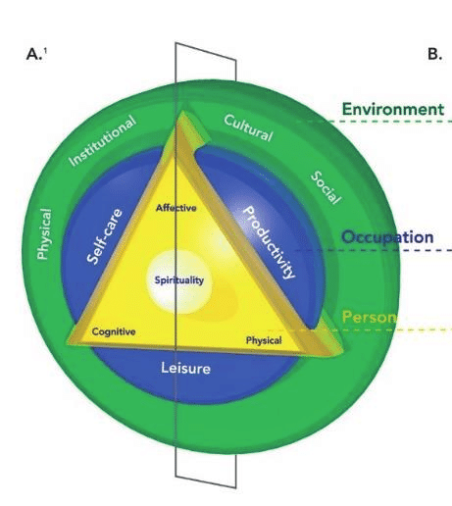 | 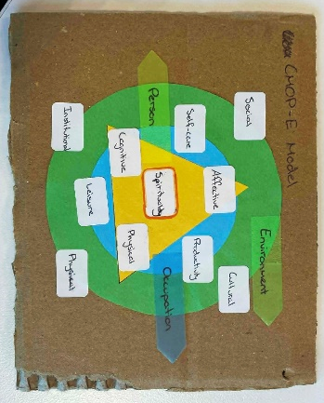  Image: CMOP-E Model  - Student Example | 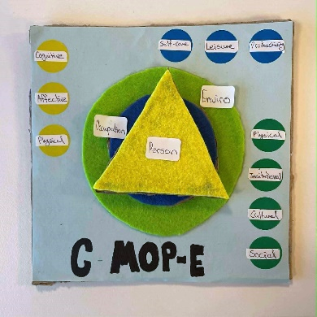  Image: CMOP-E Model  - Student Example
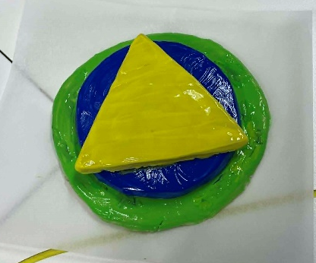  Image: CMOP-E Model  - Student Example | 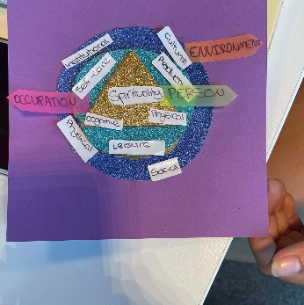  Image: CMOP-E Model  - Student Example | 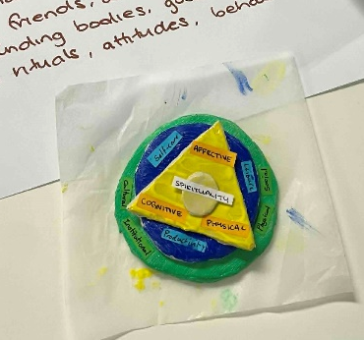  Image: CMOP-E Model  - Student Example

  - The Kawa Model ‘Art Series’ Examples
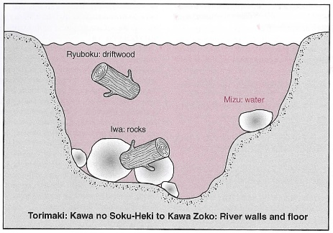  Image: A Diagram of the  Kawa Model | 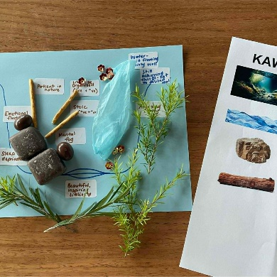  Image: Kawa Model  - Student Example | 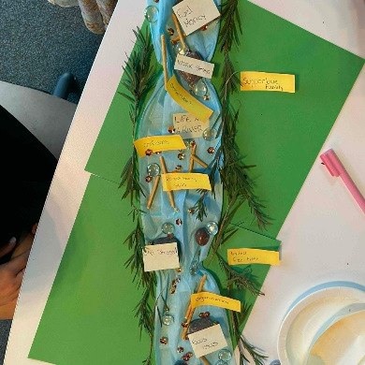  Image: Kawa Model  - Student Example
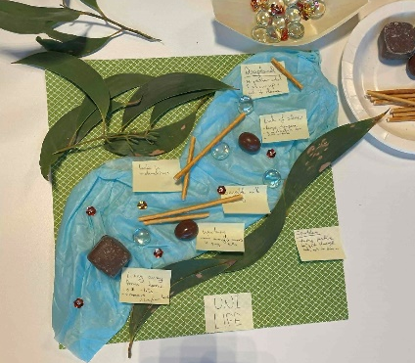  Image: Kawa Model  - Student Example | 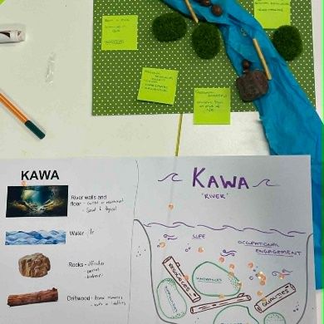  Image: Kawa Model  - Student Example | 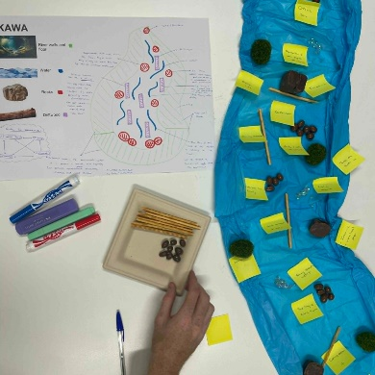  Image: Kawa Model  - Student Example

The Impact
The impact of this approach is described as both immediate and observable. There is a notable increase in student engagement, peer interaction and overall classroom energy. Student feedback indicates that hands-on, creative activities enhance understanding of complex concepts, improve retention and increase confidence in applying theoretical knowledge, particularly in preparation for assessment.
  - Examples of Student Feedback
- “It was very interactive and [the art series] helped me understand the content better than just typing the information”
- “It helped us understand the frameworks more in depth while making learning fun”
- “I found the "hands-on" activities, such as drawing diagrams in class, really helpful as I was able to visualise challenging topics”
- “I enjoyed the making of the models and breaking every step down, so it was clearer and answered my questions that I had before having to ask”

Lessons Learnt Along the Way
It is recognised that not all students prefer or enjoy alternative sensory or hands‑on activities and as such, no single teaching method is universally effective. This reinforces the importance of offering diverse approaches to accommodate different learners. The goal is not to completely replace traditional teaching, but to broaden it - to offer multiple entry points for learning.
Additional challenges include the time, planning and financial resources required to implement the approach, as well as environmental considerations associated with material use. Strategies such as sourcing materials from second-hand outlets and using natural resources are identified as ways to mitigate these impacts. Capturing student feedback is seen as an important step in building the case for continuation and scalability of the series.

Pedagogical Foundations
This approach is grounded in the belief that students learn best when learning is engaging, creative and offers some choice. Although not originally designed using Universal Design for Learning (UDL), it aligns with UDL 3.0 by supporting learner agency - encouraging students to take intentional ownership of their learning, draw on their own strengths and ideas and make active decisions about how to approach learning. Rather than relying only on reading and writing, the Art Series provides multiple ways for students to engage through hands-on, visual and discussion-based activities.
Connections are also drawn to Aboriginal Pedagogy framework “8 Ways of Knowing” (with recognition of Western New South Wales Regional Aboriginal Education Team, based in Dubbo, and the traditional owners of Western New South Wales who helped developed it). Particular relevance is drawn to the ‘Symbols and Images’ element which states that use of imagery and creative expression in learning supports understanding and knowledge retention.
Link to the ‘8 Ways’ webpage: https://www.8ways.online/

Conclusion
Ultimately the ‘Art Series’ approach is linked to the concept of health literacy. Along with the UDL underpinnings discussed above, it is hoped too that by engaging with diverse modes of learning, students may develop a greater capacity to communicate complex information in accessible ways, an essential skill for health care professionals. Overall, this approach as a meaningful and adaptable strategy to enhance engagement, support diverse learners and improve understanding of foundational theoretical content.

