Exploring the Third Space: Facilitating learner engagement in Higher Education across Academic/Professional Binaries.
[Abstract] Learning and student support advisors occupy a unique position within higher education. Situated between academic and professional realms, advisors often work one-on-one with students providing support with learning and/or navigating university administrative systems (Fenton-smith & Gurney, 2022). This presentation argues that advising plays a key role in facilitating Universal Design for Learning ‘beyond the classroom’ and across higher education institutions by breaking down barriers to accessible learning. To do so, we clarify the role of an advisor, focussing particularly on the contribution of the advising space to the UDL guideline of ‘engagement’. We draw on two case studies of ongoing academic consultations and degree support to explore strategies that advisors can use to help students define their learning goals and promote learner agency. These case studies use practitioner reflections and qualitative student survey data to highlight the positive impact of these support services on student learning. Furthermore, we argue that these examples support claims regarding the necessity of an institution-wide approach to UDL in order to support students’ executive functioning and help them sustain effort and persistence in their studies (Norman & Newham, 2018). Our presentation also foregrounds engagement by offering opportunities for personal responses and reflection, and incorporating storytelling. In doing so, we hope to extend discussion of UDL into student support spaces and promote a collaborative approach to learning that bridges the gap between professional and academic spaces.

References:
Fenton-Smith, B., & Gurney, L. (2022). Collaborator, applied linguist, academic, expense? Exploring the professional identities of academic language and learning professionals. Higher Education Pedagogies, 7(1), 160–178. https://doi.org/10.1080/23752696.2022.2130390
Norman, L., & Newham, E. (2018). The role of learning advisors and support staff within an increasingly differentiated student community. Journal of Academic Language & Learning, 12(1), 128-140. Retrieved from https://journal.aall.org.au/index.php/jall/article/view/545
-----------

[Slide 1] Exploring the Third Space: Facilitating learner engagement in Higher Education across Academic/Professional Binaries. Presenters: Dr. Lucy Petchell and Amelia Yarwood, University of Sydney.
https://padlet.com/ameliayarwood/design-for-engagement-mh8522zf40w49jm7
Introducing our context, goals and case studies
[Slide 2] The advising context
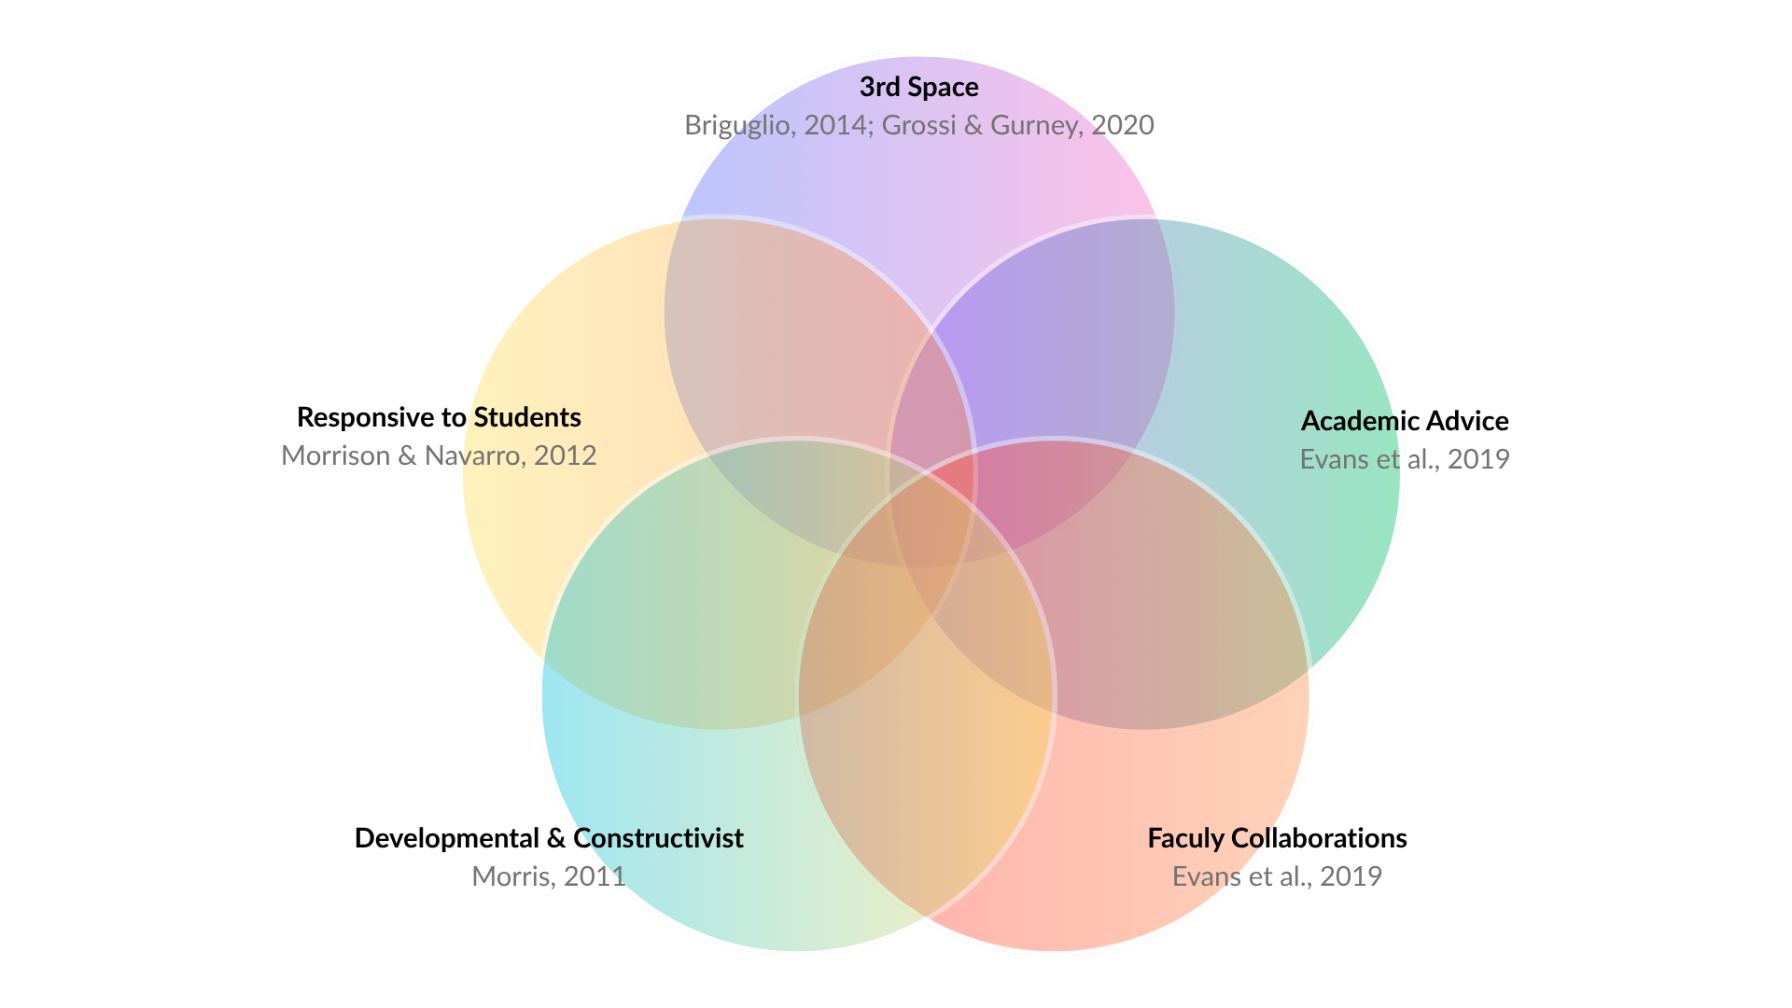

Advising in the past (and in the minds of some still today) operated on a deficit/remedial model in which students behind on their academics would receive tutoring or advice to meet the standards of a course. Today, the advising context has expanded and can be represented by a Venn Diagram that includes a 3rd space (Briguglio, 2014; Grossi & Gurney, 2020), the provision of academics-related advice (Evans et al., 2019), use of developmental and constructivist approaches (Morris, 2011), is responsive to the needs of the individual through the adopting of new practices and discourse patterns (Morrison & Navarro, 2012) and which engages in collaborations with faculty (Evans et al., 2019). In this way, we view advising as a kaleidoscope in which these elements overlap and change continuously. As a result, our roles as advisors also vary depending on who we are working with, and on what tasks. For example, one of my favourite parts of being a Learning advisor is working with the Master's of Occupational Therapy teaching team. The team identifies and refers to me students who need to develop their clinical communication skills. With my background in applied linguistics and collaborative dialogue, I then work with the students in a 1:1 capacity, while always referencing the materials shared with me by the teaching team. This brings together the 3rd space, faculty collaboration, developmental and constructivist and responsive to students lens of our kaleidoscope.

[Slide 3] Gaps in university UDL
Advisors can have many roles in the higher education environment, but these are not always recognised. Some of my roles include sessional academic and student success advisor in the Faculty of Arts and Social Sciences which also means that I’m partly a degree planner, academic progression advisor, administrator, coach, and learning success advisor. However, as Ben Fenton Smith and Laura Gurney note, higher education environments tend to be partitioned along professional/academic divides, which do not reflect the lived experience of professionals like myself and Amelia. This split is reflected in the range of UDL materials available for higher education practitioners which are developed largely for classroom use, but there are less available for professionals that sit in between these two categories. Our goal is to raise awareness of the collaborative opportunities that exist in between these spaces supporting and scaffolding individual development for learners as they navigate the wider learning environment of the university. Services like student success and learning success advising make UDL an institution-wide project by fostering learning agency and goal setting, shifting student support away from a deficit/remedial model, and thereby increasing learning engagement within the classroom.

[Slide 4] Introducing Noor (our case study)
I’d like to introduce you to Noor, a second-year student studying Media and Communications in the Faculty of Arts and Social Sciences at the University of Sydney. Noor is feeling disengaged with her major and is uncertain of whether her degree is right for her. She speaks to her tutor who is unfamiliar with the university administrative processes and directs Noor to get academic advice from the portal. And so, Noor submits a request for academic advice. Alongside the details of Noor’s degree, the request also outlines Noor’s question, as well as her goals, strengths and challenges which we have displayed here. In addition to the information she provided through the portal, I learn through speaking to Noor that she feels uncertain about her future more generally. Although she enjoys some aspects of her degree like independent research, she’s unsure how relevant her degree is to her future beyond university. In addition to this, her additional care responsibilities make it difficult to hand in assessments, and she’s also balancing study with work, so managing time feels exhausting. At times, she’s demotivated. She wants to know if she should choose an easier degree so she can finish her studies faster. What can we do here?

[Slide 5] Supporting Noor through advising
One option would be to send Noor information about how to change her major and/or her degree. However, making learning accessible here is not just about the administrative process itself or about the academic content. Noor’s request sits in-between academic and professional spaces. This is both a challenge and opportunity to apply UDL practices outside of the classroom to facilitate learning within the classroom.
There are several steps that we might take when supporting students to increase learner engagement. I am going to focus on 3 of these here: framing the conversation, degree planning, and referrals.

Noor meets with the Student Success Team
[Slide 6] Framing the conversation: Framing the conversation involves clarifying Noor’s goals, defining the boundaries of our conversation, and contextualizing my role as a student success advisor within the wider institution. This helps reduce threats, barriers and biases by aligning our expectations and laying out a plan for the rest of our chat. Together, we identify what I am able to assist with directly, and collaborate on a plan for support beyond the immediate conversation. I ask Noor if she wants some support with degree planning, and whether we can revisit some of the other things she’s raised towards the end of the session to complete some referrals if she’s comfortable.

[EXAMPLE: “My own disciplinary background is in Theatre and Performance Studies, but I have some interdisciplinary knowledge and I’ve been working in advising for a long time so I have some grounding in the administrative processes and policies at the university. I may not know all the answers, but if I don’t know the answer, we can find out. What about you? I’d love to hear about your study background and hopes for this chat!”]

[Slide 7] Scaffolding degree planning skills: It may surprise you, but reading degree handbooks and complex university policy is not always interesting to all students. However, by highlighting how these policies are relevant to Noor’s goals, breaking down how to interpret a course handbook and scaffolding a degree plan together, Noor begins to see herself as an active agent in shaping her pathways through the degree. We look at Noor’s current selections and use a template to scaffold how to use the handbook.
Throughout this process, I utilize storytelling and metaphor to make this process more interesting, and to emphasise Noor’s choices. This also provides opportunity for joy and play in the selection of Noor’s units. There may be some opportunities for experimenting with different elective units and nurturing new interests. We also emphasise Noor’s unique strengths and interests: if Noor enjoys independent research, what kinds of units might offer this opportunity? Could postgraduate research be something Noor might be interested further along? By showing Noor how the structure of her degree works, we are also highlighting the choices that are embedded within the degree planning process and making these processes relevant to her. Noor begins to feel empowered in her current degree. Originally, she was interested in changing her degree, but she has more options within the current degree structure than she thought. If she wishes to transfer, she has made an informed decision that aligns more closely with her future goals.

[EXAMPLE: “We’re going to work with your degree handbook and unit of study tables to determine the requirements of your degree. Looking at this will give us a sense of what you still need to complete and how much time that might take. One thing that I really like about this is that there’s no single correct way to plan a degree… and I know that can be scary, but it might also be exciting! Within your degree structure, there may be some opportunities to choose units based on your interests and strengths. How do you feel about the idea of exploring some new areas of study?”]

[Slide 8] Referrals: As I alluded to earlier, uncertainty around degree planning is only one facet of the barriers that have impacted Noor. We can now revisit other things that Noor raised to explore other support options and remove barriers. Reaching out to more services in a large institution can add to a learner’s cognitive load and increase learning barriers, so I offer Noor the option of referral to inclusion services to consider academic adjustments for her carer responsibilities or to the Learning Hub for support with time management. Both services are free and confidential, and even once the referral is completed, Noor has a choice about whether to engage or not. However, doing the referral supports Noor’s executive function by ensuring that Noor does not need to reach out again.

[EXAMPLE: “You mentioned that time management has felt difficult. If you like I could put in a referral to the Learning Hub so that they can reach out to you. It’s free and confidential. Would that be helpful?]

With Noor’s consent, I complete referrals for Noor that detail what we have spoken about and how we’re hoping these services can support Noor. Having submitted these referrals, I am assured that one of my wonderful colleagues from the Learning Hub and Inclusion Services will reach out to Noor. This is where Amelia first meets Noor.

Noor goes to the Learning Hub
When we meet, Noor reaffirms her desire to develop her skills around balancing her academics and career responsibilities.
[Slide 9] Open questions: I ask open questions about Noor’s aims for the courses she is taking, and the challenges she has faced in recent weeks. The next set of questions I ask are about the strategies she has already tried and the degree to which she feels they are serving her needs. These open questions function to understand Noor’s priorities and lived experiences so we can build on what is working and ensure decisions are achievable given the realities of Noor’s life. Furthermore, this dialogue provides the groundwork for a developmental, strength–based approach – already I can affirm Noor’s courage and determination as evidenced by her help-seeking behaviours.

[EXAMPLE: “Some students in similar situations to yours just want to hand in and pass their assessments, what about you? What is your goal for this semester?” “How are your tutors and unit-coordinator supporting you during this period of time?” “What are some of the things you’ve already tried?” “How do you feel about the things you’ve already tried?” ]

[Slide 10] Giving space: Time management is just as much about emotion as it is scheduling, and so it is important to me to give space for the uncertainty, frustration and even shame and/or guilt Noor may be experiencing. Noor uses the metaphor of dragging herself through an ocean of mud which allows us to collaboratively unpack the barriers to successful time management: isolation; restrictions; endlessness. The metaphor evolves – we can’t get rid of the mud that restricts her movements, but we can turn the ocean into streams (focus on priorities and short-term goals) and throw a rope in (accountability partner and study tools). Selective self-disclosure can further aid Noor in feeling understood and less alone.

[EXAMPLE: “If you were to use a metaphor, how would you describe your current situation?” “Listening to your metaphor, I am struck by the idea of an ocean. This makes me think maybe you’re feeling like the present hardship is endlessness. Would that be an accurate interpretation?” “Okay, so how might we turn the ocean into a smaller, more manageable body of water?”]

[Slide 11] Collaborating on a plan: Together, we explore a plan. Noor doesn’t feel she has the mental capacity for trying new things, so we agree she will experiment with small modifications to her current strategies for now. We also identify institutional supports she can access, such as special considerations for assessments she is behind on and trusted tutors she could speak to to clarify content questions. Noor indicates an interest in having someone to check-in with for accountability purposes, so I offer to schedule regular consultations with her for this purpose.

[EXAMPLE: “How are you feeling about testing out some new strategies?” “Based on our discussion so far, what do you feel is your priority?” “Is there anything that you might need to help you achieve your goals for the next few weeks?”]

What to do next, why it matters, and what’s your +1?
[Slide 12] Call to action The two cases, tied together by Noor, demonstrate how advising dialogues align with UDL guidelines for ‘engagement’ and can empower students as active participants within their learning. To us, this is an example of UDL as an institution-wide project. Our hope is that our presentation here shows how higher education can provide wrap-around care for students through advising services, and encourage you to think of collaborative opportunities with the services at your institution.

[Slide 13] The impact of collaborative UDL The impact of this approach can be seen in the feedback we’ve gathered from students like Noor. Although advisors are situated between professional and academic roles, this work is integral to removing learning barriers across an institution. These responses highlight the way that third spaces can support students in the moment, as well as scaffolding and developing learning skills for the future that support student engagement within the classroom.

[Slide 14] So, what’s your +1? We’d love to hear from you about how you might be able to use third spaces in your own learning environment. What engagement strategies do you use? Which services can you collaborate with?

