# If you were able to identify a useful UDL strategy to implement in your context, please share which strategy. Please provide as much detail as you like.

|  |  |
| --- | --- |
|  | * Including closed captions for presentations. * Providing information in various formats. |
|  | * Adjusting assessment/portfolio options to include a video reflection or a podcast reflection instead of written ones. |
|  | * Structuring the exam so students can choose which questions to answer from several options. |

# Which topics or aspects of the workshop did you find most useful/valuable?

The circle diagram shows responses from our UDL level 1 participants. The largest portion (75%) highlights the immersive activity as most valuable. Smaller equal portions (13% each) represent discussing teaching strategies with others, group discussion to brainstorm UDL strategies based on pinch points, and modelling of diverse teaching material formats.

The stacked bar titled "Please let us know to what extent you agree or disagree with the following statements" summarises UDL level 1 participant feedback. Participants strongly agreed or agreed with all statements, indicating overall positive reception and perceived value of the workshop content and format.

A circle diagram titled "How likely would you recommend this workshop to your friend or colleague?" shows that 63% of participants responded 'likely' and 38% responded 'very likely', indicating strong overall satisfaction and willingness to recommend the workshop.

The circle diagram titled "Would you be interested in attending another more in-depth UDL workshop in the future?" shows that 88% of participants answered 'yes' and 13% answered 'maybe', demonstrating strong interest in further UDL training.

UDL level 1 follow-up survey

# Please comment on the positive impacts on your students and teaching practice

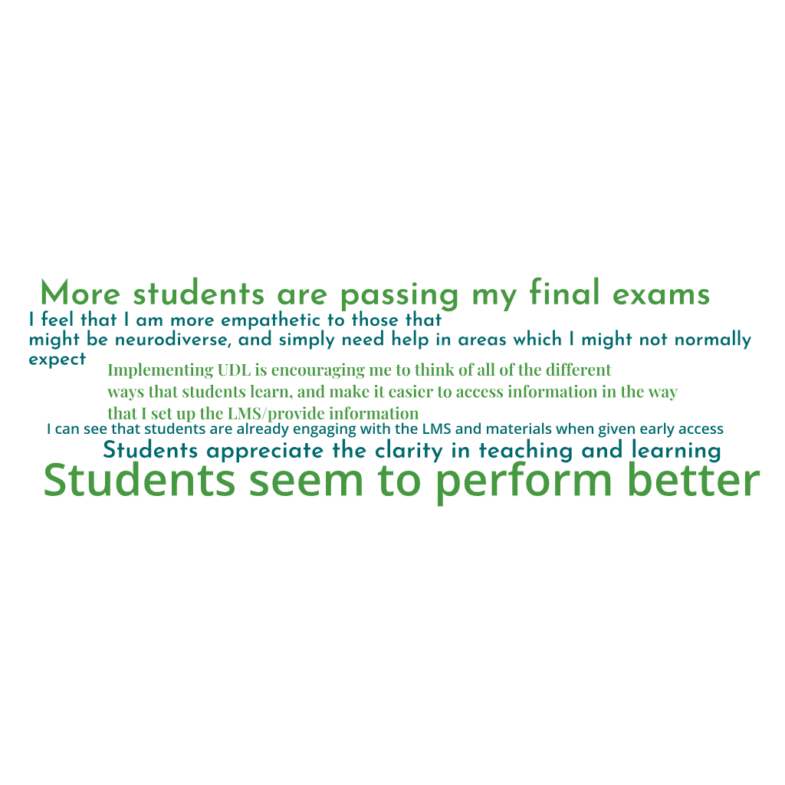

The word web includes the following statements: students seem to perform better, students appreciate the clarity in teaching and learning, I can see that students are already engaging with the LMS and materials when given early access, I feel that I am more empathetic to those that might be neurodiverse, and simply need help in areas which I might not normally expect, more students are passing my final exams, implementing UDL is encouraging me to think of all of the different ways that students learn, and make it easier to access information in the way that I set up the LMS/provide information.