Teaching UDL by doing UDL: Modelling Inclusive Design in Initial Teacher Education

Contents
Teaching UDL by doing UDL: Modelling Inclusive Design in Initial Teacher Education 1
Title slide 2
Overview 2
Context: Initial Teacher Education 2
Gaps in teacher education 2
Opportunities: Online learning 2
Embedding UDL 3
What aspects of online learning have you found challenging or unhelpful? 3
Subject design: Learning Management System (LMS) 3
Engagement and motivation 3
Multiple means of representation 4
Scaffolds and self-monitoring 6
Example: Takeaway messages 6
Assessment design 6
Response options 7
Example: choiceboards 8
Student feedback 9
Key learnings 9
Recommendations 9
References 9

Table of figures
Figure 1Example of Padlet activity discussion 4
Figure 2 Example of lesson plan 5
Figure 3 Example of visual to represent photosynthesis 5
Figure 4 Example of reflective question 6
Figure 5 Example of assessment pre-submission checklist 7
Figure 6 Example of drawing in assessment task 7
Figure 7 Example of software use in assessment task 8

Title slide
Title of presentation. Teaching UDL by doing UDL: Modelling inclusive design in initial teacher education
Presenter: Dr Ana Garcia-Melgar, La Trobe University
Includes decorative picture of La Trobe University Bundoora campus.

Overview
- Context, challenges and opportunities
- Embedding UDL in initial teacher education
- Multiple means of engagement: building interest and self-regulation
- Multiple means of representation: accessibility and supporting knowledge construction
- Multiple means of action and expression: assessment formats
- Student feedback
- Key learnings and recommendations

Context: Initial Teacher Education
- Bachelor of Education (Primary and Secondary pathways)
- Inclusive Education Specialisation delivered entirely online
- Student diversity: diverse cohort in terms of teaching experience, knowledge of inclusive education, demographics.

Gaps in teacher education
Research consistently shows significant gaps in pre-service teachers' understanding and application of inclusive learning design:
- Knowledge gap: unprepared to support diverse learners effectively (Stites et al., 2018)
- Skills Gap: traditional teacher education often focuses on theoretical understanding rather than practical application of UDL principles (European Agency for Special Needs and Inclusive Education, 2019)
- Experience Gap: pre-service teachers rarely experience UDL as learners themselves, making it difficult to implement authentically in their own practice (Evmenova, 2018)

Opportunities: Online learning
Online learning settings provide unique opportunities to model UDL principles:
- Flexibility in engagement: multiple pathways for interaction and participation
- Multiple representation modes: various media formats and content delivery methods
- Firm goals, flexible means: multiple ways to demonstrate learning and understanding
- Built-in accessibility features

Embedding UDL
- Rationale: need to see UDL in practice to be able to apply it to their teaching
- Steps: work through priorities based on student feedback and own observations (e.g. student assessment tasks)

What aspects of online learning have you found challenging or unhelpful?
This slide contains a link to an interactive poll to gather participants’ experiences in online learning, in particular, aspects they have found less helpful or challenging.

Subject design: Learning Management System (LMS)
- Consistent LMS layout with signposting
- Multiple means of representation: short videos, guided readings, podcasts, individual and group activities
- Focus on accessibility and reducing cognitive load

Engagement and motivation
- Multiple and flexible opportunities for participation in synchronous and asynchronous activities
- Diverse case studies and examples
- Choice in assessment format and content
- Includes a snapshot of Padlet activity which was completed synchronously, then embedded into the LMS for students to add to or reflect on.
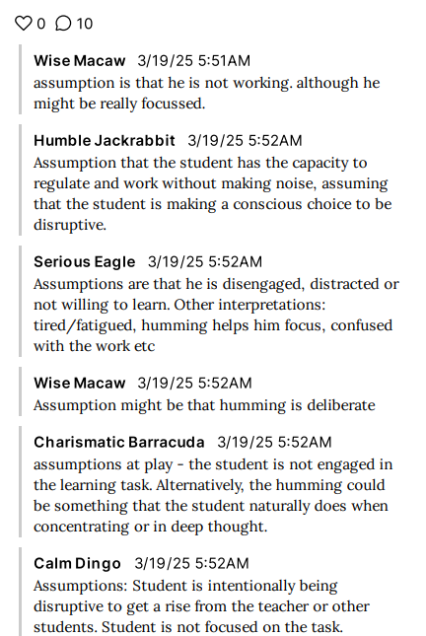
Figure 1Example of Padlet activity discussion

Multiple means of representation
During online synchronous sessions, students engaged in group activities using their preferred mode of expression. In this example, students sourced and contributed different written, graphic and visual examples on what learning materials they would use in a unit on photosynthesis.
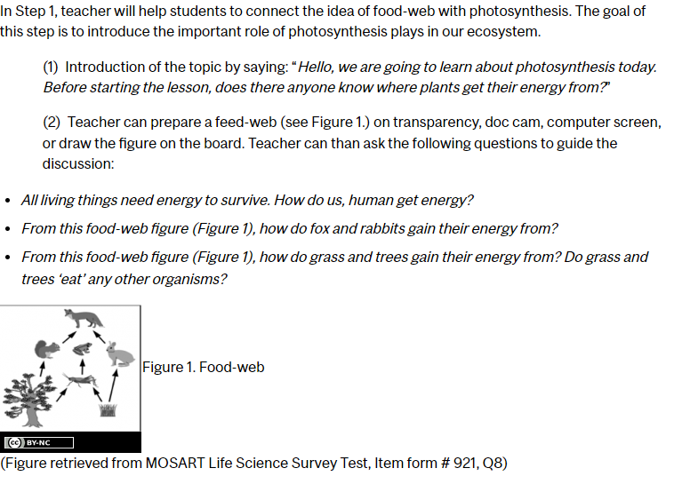
Figure 2 Example of lesson plan
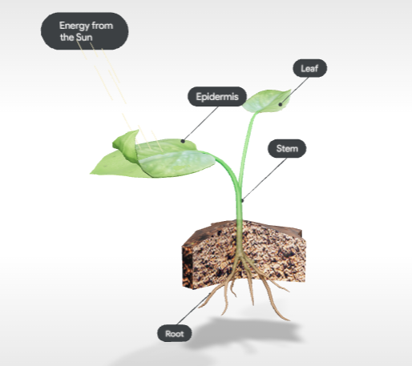
Figure 3 Example of visual to represent photosynthesis

Scaffolds and self-monitoring
- Weekly self-check activities (e.g. polls, quizzes)
- Reflection questions to connect theory with practice
- Mindmaps linking new and prior knowledge
- For example, reflective questions embedded on the LMS supported students to make connections between the theoretical bases of the UDL framework and their experiences of UDL as learners and pre-service teachers.

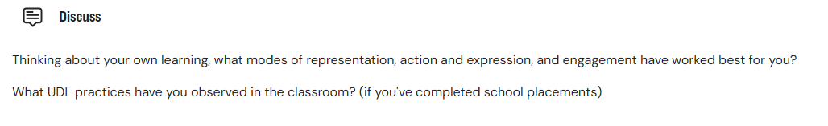
Figure 4 Example of reflective question

Example: Takeaway messages
At the end of each online session, students were prompted to note key messages (i.e. their takeaway messages). In the first sessions, I modelled this strategy to prompt students to identify relevant aspects, then removed this scaffold as the weeks progressed.

Assessment design
- Flexibility in submission formats to demonstrate learning in assessment tasks
- Choice on content (providing guidelines and requirements)
- Assessment checklists
- Assessment checklists were also used in all assessment tasks as a means of providing multiple ways to access task instructions and as a self-monitoring tool for students.
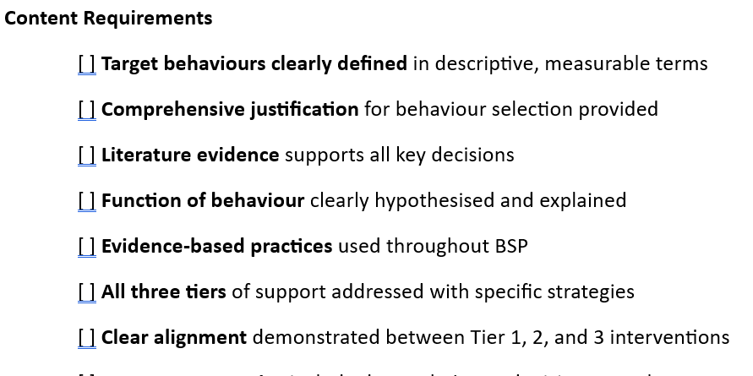
Figure 5 Example of assessment pre-submission checklist

Response options
Students used diverse tools to complete assessment tasks, including written tasks. For example, when asked to design and justify the physical aspects of an inclusive learning environments, students could draw the learning environments, use software, take pictures, or use a combination of tools.
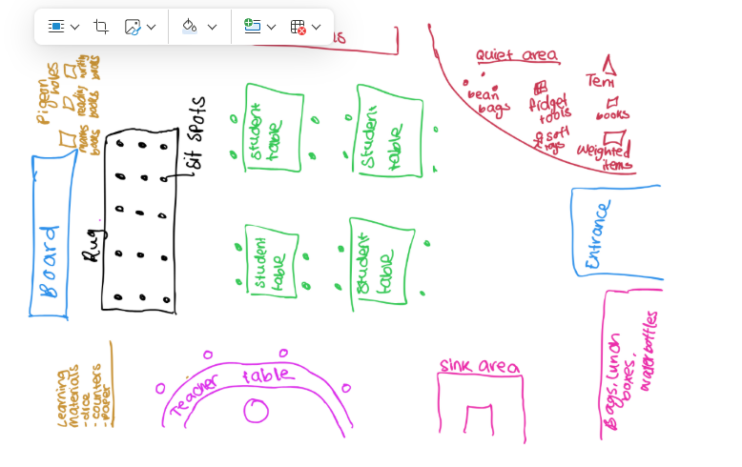
Figure 6 Example of drawing in assessment task
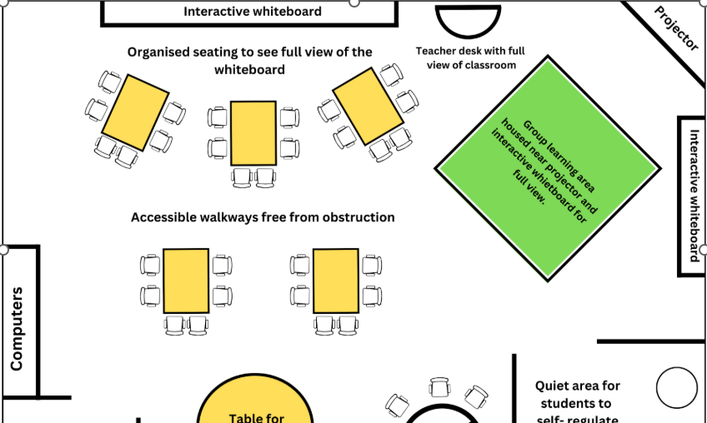
Figure 7 Example of software use in assessment task

Example: choiceboards
Choiceboards were used during synchronous online sessions. The typical structure was to start with a recap of key content covered that week, then followed by options within activity themes (e.g. go through worked example of UDL lesson plan, or apply multiple means of representation to case study). Other options included working on assessment tasks alongside peers (with tutor support) or question & answer time with tutor. Optional activities were provided to reinforce academic skills (e.g. referencing). This is an example:

- All: mini-lecture on key topics. Recap of weekly content.
- Activity 1 – Choose from:
-Go through worked example of UDL lesson plan
-Work on case study: apply multiple means of representation
- Activity 2 – Choose from:
-Work on first assessment task with peers
-Q&A with tutor
- Optional: referencing refresher

Student feedback
- Increased confidence
- Improved engagement
- Satisfaction with subject design
- Clear expectations
- Embedded supports

Key learnings
- Pre-service teachers need to see UDL in practice to truly understand how it works
- Deeper understanding of UDL and how to apply it to their own classrooms
- Encourage self-reflection
- Balance between choice and structure
- LMS capabilities

Recommendations
- Start small
- Focus on access
- Gather feedback and make adjustments

References
European Agency for Special Needs and Inclusive Education. (2019). Teacher professional learning for inclusion: Literature review. Odense, Denmark: European Agency for Special Needs and Inclusive Education.
Evmenova, A. (2018). Preparing teachers to use Universal Design for Learning to support diverse learners. Journal of Online Learning Research, 4(2), 147-171.
Stites, M. L., Rakes, C. R., Noggle, A. K., & Shah, S. (2018). Preservice teacher perceptions of preparedness to teach in inclusive settings as an indicator of teacher preparation program effectiveness. Discourse and Communication for Sustainable Education, 9, 21-39

