ADCET Workshop 2: Accessibility Basics.

This document is to be used in conjunction with the second workshop for you to work alongside the presenters, or to practice after the workshop, in applying techniques that improve the accessibility of this document. This document continues on from workshop 1, so if you have not worked on that document then we strongly recommend you start with that document first.

Summary: Context is king. Structure matters. Make your content meaningful to everyone.

# Useful links for this workshop and for working with this document.

## ADCET Resources and Information

* [ADCET Accessibility Basics](https://www.adcet.edu.au/inclusive-teaching/accessible-content/accessibility-basics)
* [Creating Accessible Documents](https://www.adcet.edu.au/inclusive-teaching/accessible-content/accessible-documents)
* [Universal Design for Learning](https://www.adcet.edu.au/inclusive-teaching/universal-design-for-learning)
* [How to structure documents correctly (ADCET Webinar by Andrew Downie)](https://www.adcet.edu.au/resource/10106/webinar-how-to-structure-documents-correctly)

## ADCET Guidelines

* [Supporting Blind and Vision Impaired Students Online](https://www.adcet.edu.au/our-work/online-access-for-tertiary-students-who-are-blind-or-vision-impaired)
* [Supporting Deaf and Hard of Hearing Students Online](https://www.adcet.edu.au/resource/10475/guidelines-supporting-deaf-and-hard-of-hearing-students-online)

## Tables

* [How to create accessible tables in Word](https://support.microsoft.com/en-us/office/video-create-accessible-tables-in-word-cb464015-59dc-46a0-ac01-6217c62210e5)

## Colour and Contrast

* [Colour Contrast Analyzer (CCA)](https://www.tpgi.com/color-contrast-checker/) – Standalone app for PC and Mac
* Online [WebAim Contrast Checker](https://webaim.org/resources/contrastchecker/)

## Testing Accessibility

* [Improving Accessibility with the Microsoft Office Accessibility Checker](https://support.microsoft.com/en-us/office/improve-accessibility-with-the-accessibility-checker-a16f6de0-2f39-4a2b-8bd8-5ad801426c7f)
* [Silktide Website accessibility simulator](https://chromewebstore.google.com/detail/silktide-website-accessib/okcpiimdfkpkjcbihbmhppldhiebhhaf)
* [Silktide Accessibility Tools](https://chromewebstore.google.com/detail/silktide-website-accessib/okcpiimdfkpkjcbihbmhppldhiebhhaf)

**Mac iOS Microsoft Word Instructions**

* [Insert a table in Word for Mac](https://protect-au.mimecast.com/s/u_69CQnzVqtkV4W6WfkpWgH?domain=support.microsoft.com)
* [Create accessible tables](https://protect-au.mimecast.com/s/U6XCCROAWrhvYPLrLSq4rPZ?domain=support.microsoft.com) (Mac and Windows)
* [Make your Word documents accessible to people with disabilities](https://support.microsoft.com/en-us/office/make-your-word-documents-accessible-to-people-with-disabilities-d9bf3683-87ac-47ea-b91a-78dcacb3c66d#PickTab=Mac) (Mac and Windows)

# Using Tables

Context: you need to add some tabular data to your Types of Farming document that shows the reduction in dairy farm numbers in Australia.

Firstly, reflect on the reason and context of the data/ information and decide if it is necessary to use a table. You may be able to display the information more clearly in a bulleted list or as a series of sub-headings.

* It is very important in Word to have uniform tables. That is, each row should have the same number of cells.
* Do not merge cells together across columns or rows.
* Include headers for columns and rows as appropriate.

## Not all tables are created equally

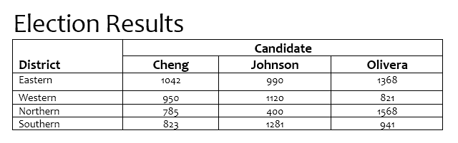

**Election Count**

**District Cheng Johnson Olivera**

Eastern 1042 990 1368

Western 950 1120 821

Northern 785 400 1568

Southern 823 1281 941

Update the table to be more accessible and provide additional meaning such as alternative text.

To create a table in Microsoft Word with column and row headings:

* Select the whole table, the Table Design and Layout ribbon menu items will appear
* In the Layout menu to select Repeat Header Rows
* In the Table Design menu select Header Row and First Column options.

Table 1: Number of registered dairy farms across Australia

|  |  |  |  |  |  |  |  |
| --- | --- | --- | --- | --- | --- | --- | --- |
| Period | NSW | Vic | Qld | SA | WA | Tas | Aust |
| 2013/14 | 710 | 4,268 | 475 | 264 | 156 | 435 | 6,308 |
| 2014/15 | 704 | 4,127 | 448 | 252 | 157 | 440 | 6,128 |
| 2015/16 | 690 | 4,141 | 421 | 246 | 151 | 430 | 6,079 |
| 2016/17 | 661 | 3,889 | 406 | 240 | 148 | 427 | 5,771 |
| 2017/18 | 626 | 3,881 | 393 | 228 | 159 | 412 | 5,699 |
| 2018/19 | 575 | 3,516 | 356 | 212 | 150 | 404 | 5,213 |
| 2019/20 | 534 | 3,462 | 327 | 206 | 135 | 391 | 5,055 |
| 2020/21 | 523 | 3,080 | 307 | 198 | 132 | 378 | 4,618 |
| 2021/22 | 494 | 2,984 | 280 | 181 | 116 | 365 | 4,420 |
| 2022/23(p) | 466 | 2,774 | 278 | 182 | 112 | 351 | 4,163 |

Source: State milk authorities and Dairy Australia

# Using Colour

When using colour it is important to ensure that the colors you use can be clearly distinguished from other colours, particularly for text on coloured backgrounds.

For all text, use foreground/background colours that have high contrast. If you’re not sure about the contrast levels of different colours, play it safe by sticking with the default style colours or use the accessibility checker to determine if the text and background colour has high enough contrast.

For example white writing on a light background can become difficult to read, if not impossible.

Click here for some important information about your first assignment.

Week 5 Recommended readings

Don’t use colour or shape as the only way to identify something in your document.

Be mindful when referencing color for instructional purposes, for example ‘click on the green button to continue.’

A green rectangle with white text that reads Click Here.  In the shape of a standard computer interface button.

# Use Clear and Concise Language

The W3C Web Accessibility Initiative (WAI) develops standards and support materials to help you understand and implement accessibility. This is what they say about writing for accessibility.

Use simple language and formatting, as appropriate for the context.

* Write in short, clear sentences and paragraphs.
* Avoid using unnecessarily complex words and phrases.
* Expand acronyms on first use. For example, Web Content Accessibility Guidelines (WCAG).
* Consider providing a glossary for terms readers may not know.
* Use list formatting as appropriate.
* Consider using images, illustrations, video, audio, and symbols to help clarify meaning.

Source: [Keep content clear and concise (WAI)](https://www.w3.org/WAI/tips/writing/#:~:text=with%20learning%20difficulties-,Keep%20content%20clear%20and%20concise,-Use%20simple%20language)

## 3 examples of not-so-concise and concise writing

Concise writing in education  
The importance of conciseness in education for accessibility cannot be overstated. Concise communication serves as a linchpin for inclusivity by distilling complex information into easily digestible formats. This is particularly crucial in accommodating diverse learning needs and cognitive variations among students. By minimizing verbosity, educational materials become more approachable and less overwhelming, catering to individuals with attention deficits or processing disorders. In the digital age, where online platforms and assistive technologies play a pivotal role, concise content enhances accessibility for learners using tools like screen readers. Furthermore, linguistic inclusivity is bolstered, as succinct information is more easily comprehensible to those with varying proficiency in the language of instruction. In essence, embracing conciseness in educational practices is a deliberate stride toward breaking down barriers, fostering a universally accessible learning environment that caters to the cognitive, linguistic, and technological diversity of the student body.  
ChatGPT, 2024

### Concise writing in education

Conciseness in education is crucial for accessibility. By presenting information in a clear and brief manner, complex concepts become more easily understood. This benefits students with diverse learning needs, including those with attention deficits or processing disorders. In the digital age, concise content is essential for compatibility with assistive technologies like screen readers. Additionally, it promotes linguistic inclusivity, making educational materials more accessible to students with varying language proficiency. In essence, prioritizing conciseness dismantles barriers, creating a universally accessible learning environment that caters to the diverse cognitive, linguistic, and technological needs of all students.

### Make you writing easier to understand

Concise and clear writing is important for everyone to understand the content. It helps students with different learning needs and works well with assistive technologies. Concise writing is easier to understand for people who generally speak a different language. Making things short and clear breaks down barriers and makes learning accessible to everyone.

## Resources

[How to write concisely (Monash Uni)](https://www.monash.edu/student-academic-success/excel-at-writing/improve-your-writing/write-clearly/write-clear-sentences#:~:text=How%20to%20write%20concisely)

[Expressing yourself clearly and concisely (UniSA)](chrome-extension://efaidnbmnnnibpcajpcglclefindmkaj/https:/lo.unisa.edu.au/pluginfile.php/1687796/mod_resource/content/1/Expressing%20yourself%20clearly%20and%20concisely_2022.pdf)

[Writing Clearly and Simply (WebAIM)](https://webaim.org/techniques/writing/)

<https://chat.openai.com/>

<https://www.grammarly.com/>

## Activity

**Make this more concise and share in the chat.**

The imperative of engaging in structured physical exercise during the process of aging is underscored by a plethora of physiological, biomechanical, and metabolic intricacies. Physical activity, specifically tailored to the aging population, serves as an indispensable catalyst in ameliorating the progressive decline in muscle mass, strength, and bone density. This orchestrated exercise regimen plays a pivotal role in optimizing cardiovascular function, mitigating the deleterious effects of oxidative stress, and enhancing neurocognitive capabilities. In summation, the judicious integration of exercise into the aging paradigm is paramount for the preservation and enhancement of multifaceted physiological attributes.

# Naming Files

Giving your files meaningful file names can have a large impact on the discoverability and understanding of the information. Your students are more than likely studying more than one subject and helping them distinguishing your files and their purpose can assist them bypassing the “where is it?” and get directly into “studying it”.

* Do you use a file naming convention for your files?
* How easy are your files to search for or find?

Let users know what the files are by applying an appropriate and consistent naming convention.

Poor file names:

* Lecture slides.ppt
* UBE_Final(3).pdf
* Assessment.doc

Better file names:

* UBE Week 1 Introduction Lecture.ppt
* UBE Assessment 1 Template.pdf
* UBE Assessment 2.doc

## Activity

You have created a graphic organizer (Venn Diagram) in a MS Word document as the third (3rd) activity for students to download and complete during an online tutorial in week 4 in your subject *HLTH4870-Introduction to Nutrition*. The Topic is the *Pros and Cons of Plant based diets*. After completing the activity students need to save it for reference later in the unit/ course.

**What would be a good file name for this resource? Share your ideas in the chat.**

# Using the in-built Accessibility Checker

Context: The accessibility checker tool, which is available across the Microsoft Office suite of programs, will help you identity and remedy accessibility issues in your document.

How to use the accessibility checker:

* Select the Accessibility button in the lower left footer of the Microsoft Word window, or
* Select the Accessibility ribbon menu and select the Check Accessibility option in the Inspect group.

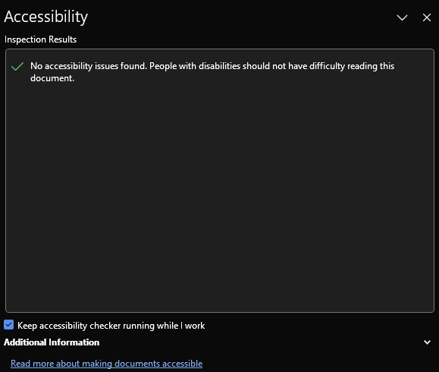

Newer versions of Microsoft Office have a built-in accessibility checker that allows you to identify and fix potential issues with your document. It is important to understand that automated accessibility checkers have limitations and cannot automatically fix or detect all accessibility issues that may be present. Microsoft has released [Improve Accessibility with the Accessibility Checker](https://support.microsoft.com/en-us/office/improve-accessibility-with-the-accessibility-checker-a16f6de0-2f39-4a2b-8bd8-5ad801426c7f) and [Rules for the Accessibility Checker](https://support.microsoft.com/en-us/office/rules-for-the-accessibility-checker-651e08f2-0fc3-4e10-aaca-74b4a67101c1?ui=en-us&rs=en-us&ad=us) – guides that outline what can be tested for and limitations in the testing.