ADCET Workshop 1: Accessibility Basics.

This document is to be used in conjunction with the first workshop for you to work alongside the presenters, or to practice after the workshop, in applying techniques that improve the accessibility of this document.

Summary: Context is king. Structure matters. Make your content meaningful to everyone.

# Useful links for this workshop and for working with this document.

## ADCET Resources and Information

* [ADCET Accessibility Basics](https://www.adcet.edu.au/inclusive-teaching/accessible-content/accessibility-basics)
* [Creating Accessible Documents](https://www.adcet.edu.au/inclusive-teaching/accessible-content/accessible-documents)
* [Universal Design for Learning](https://www.adcet.edu.au/inclusive-teaching/universal-design-for-learning)

## Image Description and Alternative Text resources

* WebAIM: article on image descriptions and [Alternative Text](https://webaim.org/techniques/alttext/)
* The Diagram Centre created the [POET tool](https://www.adcet.edu.au/resource/9920/describing-images-poet-training-tool) to assist you in writing effective image descriptions.
* [How to Write Accessible Descriptions for Interactive Charts](https://www.adcet.edu.au/resource/10647/how-to-write-accessible-descriptions-for-interactive-charts) by Highcharts

## ADCET Guidelines

* [Supporting Blind and Vision Impaired Students Online](https://www.adcet.edu.au/our-work/online-access-for-tertiary-students-who-are-blind-or-vision-impaired)
* [Supporting Deaf and Hard of Hearing Students Online](https://www.adcet.edu.au/resource/10475/guidelines-supporting-deaf-and-hard-of-hearing-students-online)

**Mac iOS Microsoft Word Instructions**

* [Add a heading](https://protect-au.mimecast.com/s/XbUuC2xZ6AHprowkwT8ycJu?domain=support.microsoft.com)
* [Add alternative text to an image and other elements](https://protect-au.mimecast.com/s/MbYbCOMxQoFpYrKAKTv487Q?domain=support.microsoft.com)
* [Create or edit a hyperlink in Office for Mac](https://protect-au.mimecast.com/s/vGWlCP7yRptKgAx4xf19Otl?domain=support.microsoft.com)
* [Insert a table in Word for Mac](https://protect-au.mimecast.com/s/u_69CQnzVqtkV4W6WfkpWgH?domain=support.microsoft.com)
* [Create accessible tables](https://protect-au.mimecast.com/s/U6XCCROAWrhvYPLrLSq4rPZ?domain=support.microsoft.com) (Mac and Windows)

# Headings

Context: You are putting together a brief article discussing two types of farming practices.

How to add headings:

* Select the text you want to make a heading, or place the cursor within the text, and select the appropriate heading level (1, 2, 3 etc.) from the Styles section of the Home ribbon, or
* Select the text you want to make a heading, or place the cursor within the text, and press CTRL+ALT+ (the heading level you want to apply, ie. CTRL+ALT+1 will apply the Heading level 1 style, CTRL+ALT+2 will apply the Heading level 2 style and so on.

Types of Farming

There are many different types of farming practices that are used around the world. These practices vary based on factors such as climate, soil fertility, and the needs of the farmer. Other types of farming include subsistence farming, mixed farming, nomadic herding, commercial plantation, and livestock rearing, among others. Each of these methods has its own unique benefits and challenges, and farmers must choose the method that best suits their needs and resources. In this short article we will briefly discuss two common types of farming.

Complimentary Farming

Complimentary farming is a lesser-known method of farming that pairs plants based on natural pest repellent qualities, root depth, and other factors. This method is highly efficient and can produce enough wheat in one square acre for a loaf of bread while also providing both flowers and other crops. Complimentary farming uses no pesticides and usually includes plants that replenish the soil, making fertilizers unnecessary in most cases.

Benefits of Complimentary Farming

Complimentary farming has several benefits over traditional farming methods. Some of these benefits include:

* Increased Efficiency: Complimentary farming is highly efficient and can produce more crops per acre than traditional farming methods.
* Reduced Pesticide Use: Complimentary farming uses no pesticides, making it a more environmentally friendly option.
* Improved Soil Health: Complimentary farming includes plants that replenish the soil, making fertilizers unnecessary in most cases.
* Diverse Crops: Complimentary farming can produce a variety of crops, including flowers and other non-food crops.

Drawbacks of Complimentary Farming

While complimentary farming has many benefits, it also has some drawbacks. Some of these drawbacks include:

* Higher Labor Costs: Complimentary farming requires more labor than traditional farming methods, making it more expensive.
* Less Predictable Yields: Complimentary farming can produce less predictable yields than traditional farming methods, making it harder to plan for the future.
* More Complex: Complimentary farming is more complex than traditional farming methods, requiring more knowledge and expertise.

Dairy Farming

Dairy farming is a type of agricultural practice that involves raising milk-producing livestock, such as cows or goats, and harvesting their milk. This milk can be exported with or without processing or turned into other dairy products such as cheese or butter.

Benefits of Dairy Farming

Dairy farming has several benefits over other types of farming. Some of these benefits include:

* Steady Income: Dairy farming can provide a steady source of income for farmers, as milk is always in demand.
* Versatility: Milk can be used to produce a variety of dairy products, including cheese, butter, and yogurt.
* Reduced Soil Erosion: Dairy farming can help reduce soil erosion by providing ground cover and reducing the need for tilling.
* Fertilizer: Cow manure can be used as a natural fertilizer, reducing the need for chemical fertilizers.

Drawbacks of Dairy Farming

While dairy farming has many benefits, it also has some drawbacks. Some of these drawbacks include:

* High Startup Costs: Starting a dairy farm can be expensive, as it requires a significant investment in land, equipment, and livestock.
* Labor-Intensive: Dairy farming requires a lot of labor, as cows must be milked twice a day, every day.
* Milk Spoilage: Milk spoils quickly, so dairy farmers must have a plan in place for processing and distributing their milk.

Limiting Drawbacks to Dairy Farming

Some of the drawback to dairy farming can be mitigated with appropriate planning/investment:

* Shared dairy facilities with adjacent farms
* Automated milking facilities
* Effective processing and storage facilities for the milk, including backup power generation.

Source: Conversation with Bing, 18/01/2024

# Alternative Text for Images

Context: you have added in the following two images to your Types of Farming document.

How to add alternative text:

* Right click the image and select View Alt Text, or
* Select the picture, then select the Picture Format ribbon from the main menu, then select the Alt Text button.

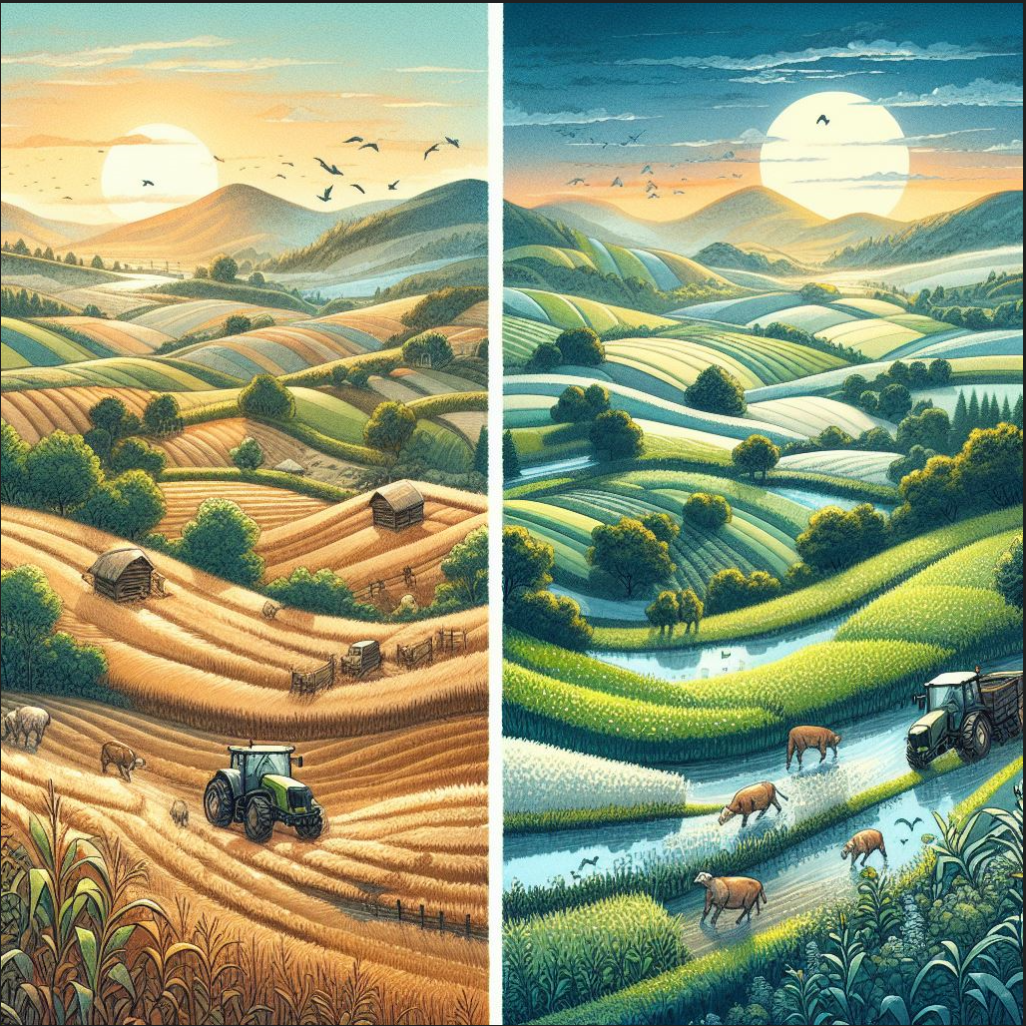

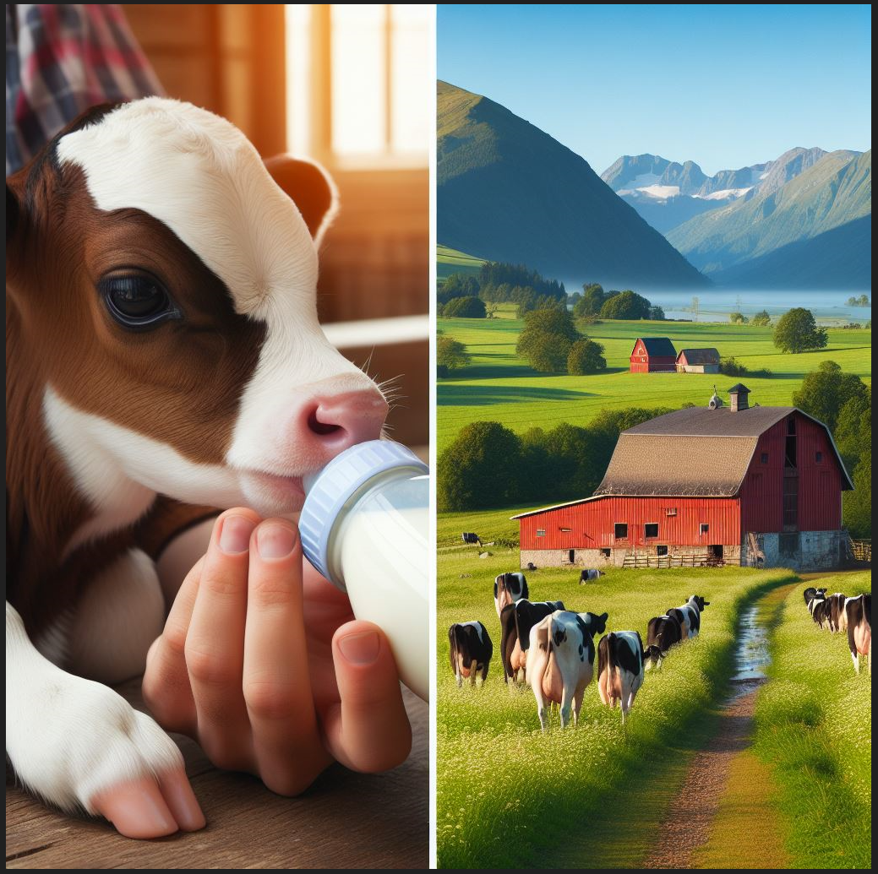

Image source: Generated with AI, Microsoft Bing Image Creator from Designer – 18 January 2024.

# Meaningful Links

Context: you have added in the following links to your Types of Farming document.

Update the following links to be meaningful.

How to add alternative text:

* Right click the link and select Edit Hypertext, a dialog box will open, change the ‘Text to display’ information, or
* Select the link or put your cursor inside the link and press CTRL+K to open the dialog box and change the ‘Text to display’ information.

Context: This link is for the dairy farming section as a resource that provides information on the Employment and Rewards for dairy farming and the model code of practice.

<https://thepeopleindairy.org.au/employment-rewards/share-dairy-farming/>

Context: This link provides an interactive farm to fridge game for young children and a range of other resources for primary and secondary students. Added to highlight one method of educating children on farming practices.

<https://www.dairy.edu.au/resources/interactive-resource/farm-to-fridge-interactive>

Context: This link contains farm performance data for the 2020-21 to the 2022-23 period from the Australian Government Department of Agriculture, Fisheries and Forestry and added to allow readers to analyse data across this period.

<https://www.agriculture.gov.au/abares/research-topics/surveys/farm-performance-broadacre-and-dairy-farms>

Context: This PDF article on Mediterranean Complimentary Crop-Livestock farming and was added to highlight some of the threats to the current practice

<https://www.iucn.org/sites/default/files/2023-05/practice_j.-complementary-crop-livestock-farming_final.pdf>

Context: This link is added to highlight some of the other types of farming, in addition to the two main ones discussed in our article.

<https://www.differenttypes.net/types-of-farming/>

# Using Tables

Context: you need to add some tabular data to your Types of Farming document that shows the reduction in dairy farm numbers in Australia.

Update the table to be more accessible and provide additional meaning such as alternative text.

Table 1: Number of registered dairy farms across Australia

|  |  |  |  |  |  |  |  |
| --- | --- | --- | --- | --- | --- | --- | --- |
| Period | NSW | Vic | Qld | SA | WA | Tas | Aust |
| 2006/07 | 924 | 5,346 | 734 | 354 | 222 | 475 | 8,055 |
| 2007/08 | 886 | 5,422 | 664 | 332 | 186 | 463 | 7,953 |
| 2008/09 | 860 | 5,462 | 648 | 320 | 183 | 451 | 7,924 |
| 2009/10 | 820 | 5,159 | 621 | 306 | 165 | 440 | 7,511 |
| 2010/11 | 807 | 4,588 | 595 | 286 | 170 | 437 | 6,883 |
| 2011/12 | 778 | 4,556 | 555 | 275 | 162 | 444 | 6,770 |
| 2012/13 | 731 | 4,284 | 518 | 268 | 160 | 437 | 6,398 |
| 2013/14 | 710 | 4,268 | 475 | 264 | 156 | 435 | 6,308 |
| 2014/15 | 704 | 4,127 | 448 | 252 | 157 | 440 | 6,128 |
| 2015/16 | 690 | 4,141 | 421 | 246 | 151 | 430 | 6,079 |
| 2016/17 | 661 | 3,889 | 406 | 240 | 148 | 427 | 5,771 |
| 2017/18 | 626 | 3,881 | 393 | 228 | 159 | 412 | 5,699 |
| 2018/19 | 575 | 3,516 | 356 | 212 | 150 | 404 | 5,213 |
| 2019/20 | 534 | 3,462 | 327 | 206 | 135 | 391 | 5,055 |
| 2020/21 | 523 | 3,080 | 307 | 198 | 132 | 378 | 4,618 |
| 2021/22 | 494 | 2,984 | 280 | 181 | 116 | 365 | 4,420 |
| 2022/23(p) | 466 | 2,774 | 278 | 182 | 112 | 351 | 4,163 |

Source: State milk authorities and Dairy Australia