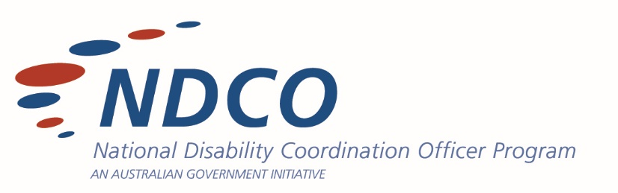

GRADUATE EMPLOYMENT FOR STUDENTS WITH DISABILITY

Programs and Services Overview

There are a range of programs and services designed to support people with disability prepare for and move into graduate employment roles, some of these include:

The Australian Association of Graduate Employers (AAGE)
https://aage.com.au/
The Australian Association of Graduate Employers (AAGE) is the peak industry body representing organisations that recruit and develop Australian graduates. The AAGE provides members with regular opportunities to connect with employers, universities, industry partners, student societies and candidates. The AAGE is a well recognised and respected organisation that provides comprehensive services and supports to their members. They also hold annual graduate expos in major capital cities, called The Big Meet, which students can attend.
Main target audience: employer

University Specialist Employment Partnership/ TAFE Specialist Employment Partnership (USEP/TSEP)
https://www.adcet.edu.au/resources/usep-and-tsep
University Specialist Employment Partnerships (USEP) is a specialist employment on-campus service developed for graduates with disability in Australia. TAFE Specialist Employment Partnerships (TSEP) is an employment service based at the TAFE campus to meet specific needs of graduating or graduate students with disability. This project is set-up to provide a self-service online toolkit resource to tertiary education providers and/or disability employment services who are interested in establishing this type of service on-campus.
Main target audience: tertiary education

GradWISE
https://wiseemployment.com.au/gradwise-graduate-jobs/
GradWISE is a graduate employment program, developed with Australian Universities, helping graduates and tertiary students who have a disability find work. This program is well established and supported by a national team within WISE Employment Services, however, it is not available in all areas.
Main target audience: tertiary student

Australian Network on Disability (AND)
https://and.org.au/
The Australian Network on Disability is a member-based organisation for employers seeking to improve the accessibility and inclusivity of their recruitment practices and increase the diversity of their workforce. They help members to employ people with disability and design their products and services for customers with disability. Additionally, offers mentoring and internship programs for students with disability. Selection for these is merit-based.

Career Development Learning Hub project and resources
https://www.adcet.edu.au/resources/cdl-hub
The CDL Hub is a suite of evidence-based resources which have been developed to add value to and complement existing sites and sources of information. The co-designed resources are based upon best practice principles and strength-based approaches to career development for people living with disabilities, and were informed also by students, parents and key stakeholders.
Main target audience: varied – The resources are all freely available and will be useful for anyone with an interest in CDL for students with disabilities, including school and tertiary students, family members, friends/supporters, career development practitioners, teaching staff, employers and industry.

National Careers Institute (NCI)
https://www.dewr.gov.au/nci
The NCI was established to ensure Australians have access to accurate careers information and resources, whatever their age or career stage. The foundation of the NCI’s work is the world-leading labour market intelligence provided by Jobs and Skills Australia (JSA).
Main target audience: individuals, schools, VET

JobAccess
https://www.jobaccess.gov.au/home
JobAccess is the national hub for workplace and employment information for people with disability, employers and service providers. JobAccess also manages the government funded Employee Assistance Fund, which can provide assistance with the costs associated with implementing workplace adjustments for employees with disability.
Main target audience: employers, DES providers

Australian Public Service Commission (APS) RecruitAbility Program
https://www.apsc.gov.au/working-aps/diversity-and-inclusion/disability/recruitability
RecruitAbility is a scheme which aims to attract and develop applicants with disability and also facilitate cultural changes in selection panels and agency recruitment. RecruitAbility can be applied to all vacancies across the APS, including Senior Executive Service roles.
Main target audience: graduates, individuals, hiring managers Australian Government

AHRC’s IncludeAbility
https://includeability.gov.au/
IncludeAbility is a disability employment project that aims to improve employment opportunities for people with disability. IncludeAbility aims to address the participation gap in employment for people with disability by building greater capacity among employers to address employment barriers for people with disability.
Main target audience: individuals, employers

ACEN
https://acen.edu.au/
The Australian Collaborative Education Network (ACEN) is the national professional association for work-integrated learning (WIL) and collaborative education. ACEN advances collaborative, quality and inclusive WIL through scholarship, partnerships, and professional learning.
Main Target audience: Higher education and vocational education work-integrated learning stakeholders

