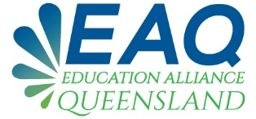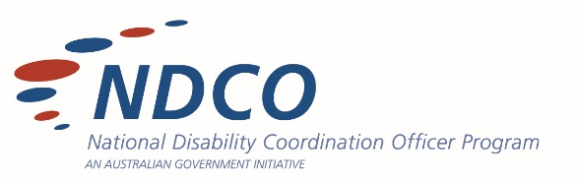

**STAKEHOLDER ANALYSIS SURVEY**

Education Alliance Queensland aims to improve transitions for people with disability to access and participate in tertiary education through collaboration and effective interactions within the Queensland Education & Training sectors.

With this in mind, the Qld NDCOs invite you to complete the survey below; providing us with a clear snapshot of the education and training environment and the sector gaps/barriers. Thank you.

1. What percentage of services available to them (estimate)?

* Less than 20%
* 20%-49%
* 50%- 80%
* 80%-100%

1. Do you think increased collaboration between Secondary and Tertiary Education and Training providers will improve successful transitions and outcomes for students?

* Yes
* No

1. What information or services would you like to see to improve post-school transitions for students with a disability?
2. What’s the most efficient and effective way to receive information about post-school transition options? Please select the top two best methods for you.

* Face to face contact by individual service providers
* Networking events
* Conferences (including online events)
* Emails
* Website
* Social media
* Postal delivery
* Other (please specify)

1. Do you feel prospective VET students are aware of available supports prior to enrolling into their course?

* Yes
* No

Do you have any ideas for how this could be improved on?

1. Do you feelthat prospective University students are aware of the supports available prior to enrolling into their course?

* Yes
* No

Do you have any ideas for how this could be improved on?

**Questions 7 & 8 - VOCATIONAL AND UNIVERSITY EDUCATION PROVIDERS ONLY**

1. With the statistics in mind of 1 in every 5 people having a disability, think about your educational facility. Of your enrolled students is 20% representative of the number of students with disability? If not, how can we look at targeting the gap for those students who are not making that connection and therefore not receiving appropriate supports.
2. What strategies have you found successful in engaging and informing students with disability about graduate and employment providers?