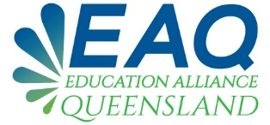 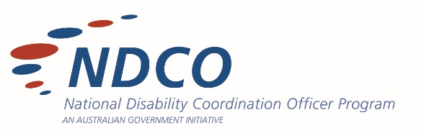

**REGISTRATION**

The NDCO Education Alliance Queensland (EAQ) initiative brings together all areas of secondary education, further education and training in a collaborative space to create opportunities to discuss shared learnings, identify barriers and gaps and workshop solutions.

# **Please complete your details below:**

## **Email Address:**

## **First Name:**

## **Last Name:**

## **Location Sample:**

* South
* Central
* Mid-West
* Remote West
* North

## **Sector:**

* School
* University
* RTO
* Alternative Learning
* Government Department
* Other

## **Organisation**

## **Position**