 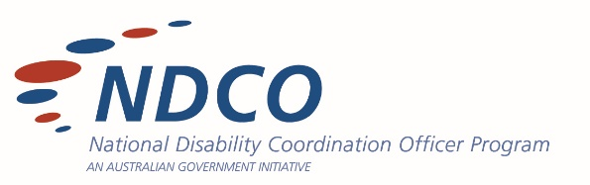

1st January, 2022  
  
**RE: TEST TEMPLATE**  
  
Dear Recipient Name,

To get started, click placeholder text and start typing.

Use your cover letter to show how your talent and experience will solve a problem or drive results for your future employer. For example, if you say you’re collaborative, give an example of how you used your collaboration skills at your last internship, and then show how that experience will benefit the employer.

It’s all about personalization. Write a cover letter that uniquely presents the real you and the future impact only you can make at the company.

To get started, click placeholder text and start typing.

Use your cover letter to show how your talent and experience will solve a problem or drive results for your future employer. For example, if you say you’re collaborative, give an example of how you used your collaboration skills at your last internship, and then show how that experience will benefit the employer.

It’s all about personalization. Write a cover letter that uniquely presents the real you and the future impact only you can make at the company.

Sincerely,  
  
Test Name

ndcoqld.org/education-alliance-queensland