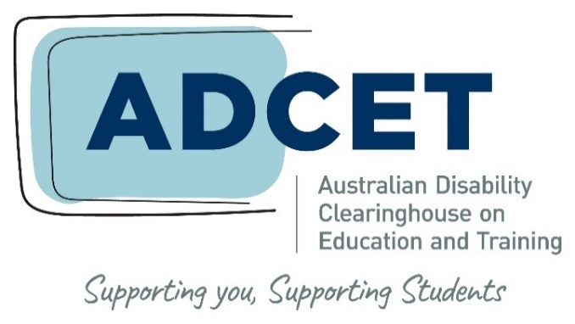

Developing a guide to inclusive communication: a resource for tertiary education providers

Acknowledgements

ADCET is committed to the self-determination of First Nations people. We acknowledge the Palawa/Pakana peoples of Lutruwita upon whose lands ADCET is hosted. We also acknowledge the traditional custodians of all the lands across Australia and pay our deep respect to Elders past and present.

ADCET uses person-first language as it puts the person before their disability (e.g., ‘student with disability’). However, this approach does not suit everyone, and many people prefer identity-first language (e.g., ‘disabled student,’ ‘Autistic person,’ ‘Deaf person’). It is up to the individual how they choose to identify. We encourage you to ask individuals what they choose. We also acknowledge the deep history behind all these terms.

ADCET is funded by the Australian Government Department of Education and is hosted by the University of Tasmania.

Project team

Program manager
Darlene McLennan, ADCET, University of Tasmania

Project lead / author
Gabrielle O’Brien, ADCET, University of Tasmania

Program advisory group
Elicia Ford, National Disability Coordination Officer – Illawarra and Southeast NSW, Centre for Disability Studies, The University of Sydney
Stevie Lane, Equity Projects Coordinator – Equity Projects Office, Access and Equity, Edith Cowan University
Emma Prior, Equity Practitioner and Communications Consultant
Barbara Webb, Equity Practitioner
Published May 2023

Contents
Acknowledgements 2
Project team 2
Contents 3
About this Guide 4
Content warning 4
Why is inclusive communication important? 5
Who is this guide for? 5
Why create an inclusive communication guide? 5
An inclusive culture 5
Your bottom line 6
Managing risk and responsibilities 6
So where to start? 7
Steps to developing and introducing a guide 8
Step 1: What are your key objectives for this guide? 8
Step 2: Find your leadership sponsors and champions 9
Step 3: Establish an Advisory Committee 9
Step 4: Conduct an environmental scan 11
Step 5: Develop a draft 13
Step 6: Gain executive approval 14
Step 7: Disseminate and promote 15
Step 8: Monitor and evaluate 15
Summary 16
References 17
Appendix 1: Resources 18

About this Guide
Many tertiary education providers are developing their own inclusive communication guide as one of a suite of strategies towards creating an inclusive and welcoming culture for students and staff. This document is a blueprint for developing an inclusive communication guide for your organisation which encompasses inclusive language and visual representation. The aim of this guide is not to simply tick this exercise off a checklist and then forget about it. Rather, embedding inclusive language and visual representation should be woven into the fabric of your organisation to enhance respectful engagement in all spheres of activity.

ADCET feels this is particularly important to improve the inclusion of people with disability but also recognises the need to take an intersectional and holistic approach to inclusion. This means encompassing a wide range of identities, perspectives and diversity dimensions such as Aboriginal and Torres Strait Islander perspectives; race, ethnicity and culture; diverse genders, sexuality and innate sex characteristics; disability and health; class; age; and faith or belief.

This resource includes the range of factors your organisation needs to consider when putting together your guide including working with the relevant communities mentioned above. As part of this process, you should find your leadership champions; work across all departments, business units and faculties; and harness additional resources in order to develop and embed this guide successfully.

There is no one right way to develop your guide and your local context, culture, expertise, and student and staff community will determine how your guide develops. The information provided is not meant to cover all situations and as language evolves your organisation will need to update the guide by working with the relevant groups.

For more resources and this guide got to the ADCET website at www.adcet.edu.au/resources/inclusive-communication

Content warning
In discussing inclusive communication, we have used resources and examples which may use negative language sometimes used toward minority groups. This negative language is outdated, offensive and may be distressing for some.

Why is inclusive communication important?
Inclusion matters and the language and imagery we use is powerful. It can include and exclude. Everyone wants to be valued and respected wherever they choose to live, work, study and play. As tertiary education providers, you want to attract a diverse range of students and staff to your organisation and ensure they feel a sense of belonging, inclusion and safety. Your organisation also works with a wide range of external stakeholders so creating inclusive, accessible and positive interactions is also important.

Who is this guide for?
Any tertiary education provider can use this guide to improve diversity and inclusion and highlight your organisation as a welcoming and inclusive place for students, staff and visitors. The ideas and strategies in this guide may also be transferable to a broader range of organisations.

Why create an inclusive communication guide?
An inclusive communication guide has a range of positive impacts on an organisation:
- fostering a culture of diversity and inclusion which supports different communities to feel a sense of belonging and empowerment
- making a positive impact on your bottom line
- protecting the organisation and its people by meeting legislative obligations and standards and managing risk.
In the section below we have outlined in more detail these key areas of impact.

An inclusive culture
An inclusive culture reinforces the values of your organisation around respect, inclusion and opportunity. When you embrace an inclusive culture, you are saying that you welcome diverse voices, perspectives and contributions in order to achieve the mission and goals of your organisation.
Inclusion can be empowering to people and communities. Educational institutions have a fundamental role to play in this through the positive influence and contributions they make to individuals, communities and society. Having an organisational culture that is attractive to a diverse student and staff community creates opportunities for positive change.
Inclusive communication can:
- improve whole-of-institution strategy which supports diversity and inclusion
- build capacity in your workforce around inclusion and meet relevant performance indicators
- enrich teaching and learning elements e.g., curriculum, assessment, work-integrated learning, research
- enhance graduate capabilities or employability skills to improve employment outcomes for students.

Your bottom line
A strong commitment to diversity and inclusion is good for your organisation’s balance sheet. Studies show that organisations with diversity and inclusion strategies and cultures create a range of benefits outlined in Figure 1.

Figure 1: Economic benefits of diversity and inclusion

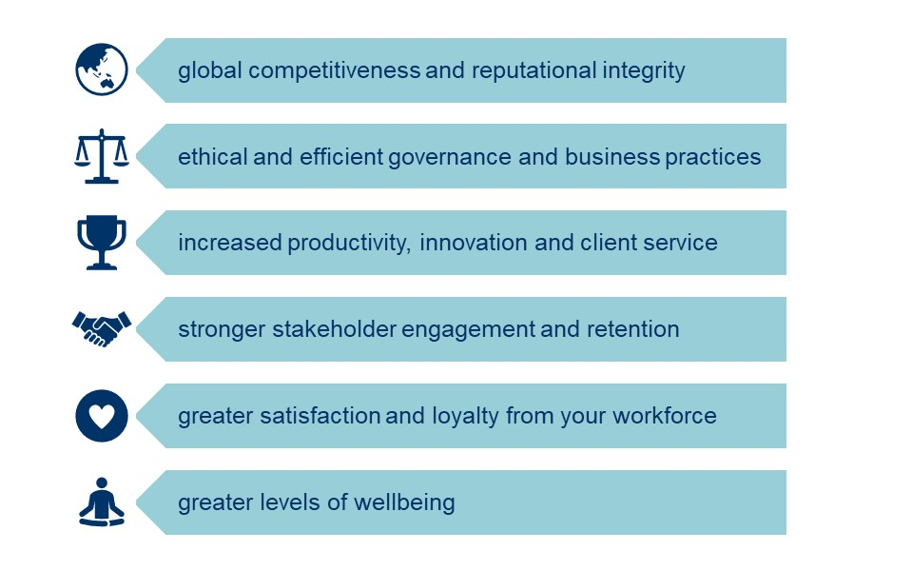

Managing risk and responsibilities
As education providers you have a duty of care to the people who study and work at your organisation. You are also responsible for compliance responsibilities to a range of federal and state/territory legislation and standards.

Many organisations have specific strategy, policies or compliance protocols underpinned by relevant legislation and standards. It is important to consider some of these legislative obligations and standards listed below and how your organisation manages responsibilities, compliance and risk. It is also important to have the appropriate complaints mechanisms in place if people feel they have been discriminated against.

Legislation and Standards
- Higher Education Standards Framework (Diversity & Equity, Part A, Section 2.2)
- Standards for Registered Training Organisations (2015) (Cth)
- Federal anti-discrimination legislation
- State anti-discrimination legislation
- Relevant standards such as the Disability Standards for Education 2005
- International conventions such as the Universal Declaration of Human Rights, the UN Convention on the Rights of Indigenous Peoples and the UN Convention for the Rights of People with Disabilities

Diversity and inclusion strategies assist with accountability and compliance. With respectful behaviours, language, and visual representation reinforced through inclusive communication, issues such as discrimination, harassment and bullying are reduced. The risk to reputation through formal complaints brought through breaches of anti-discrimination legislation and organisational policies are also decreased.

So where to start?
Every organisation is at a different stage of development of an inclusive communication guide as part of their diversity and inclusion strategy. Before you start developing your guide take a look at where your organisation is on its diversity and inclusion journey through the reflection questions below.
Reflection
What inclusive communication strategies does your organisation have or is considering?
- protocols for addressing Aboriginal and Torres Strait Islander peoples within your organisation, region and community e.g., Acknowledgement of Country
- strategies for inclusive language and visual representation for Aboriginal and Torres Strait Islander peoples
- starting to have conversations about inclusive communication
- inclusive communication is limited to marketing
- inclusive communication is encouraged in learning and teaching contexts
- inclusive communication is embedded in learning and teaching contexts
- the use of existing guides such as the Australian Government Style Guide is encouraged in business and learning contexts
- currently developing or redeveloping a guide
- currently developing or redeveloping formal policies for inclusive language and visual representation.

Regardless of where you are in this journey there are some important steps to consider. Our steps to developing an inclusive communication guide are consultative, collaborative and contextual.

Steps to developing and introducing a guide
We recommend the following eight (8) steps to developing or redeveloping your inclusive communication guide.

Figure 2: Steps for developing an inclusive communication guide

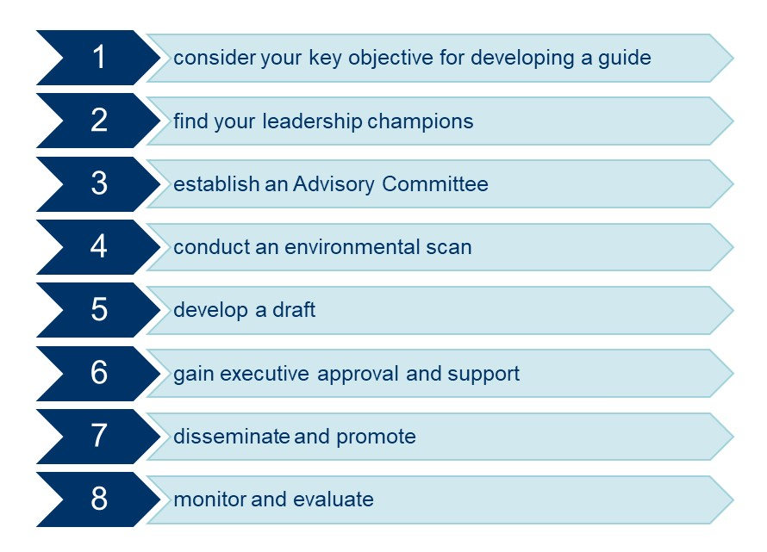

Step 1: What are your key objectives for this guide?
Before you embark on this project consider the value of an inclusive communication guide for your organisation (apart from the benefits mentioned on page 5 and 6). Answering these questions can assist it clarifying your rationale, aligning the guide with existing strategies, and forming the framework for the guide.

Some questions to ask include:
- why is inclusive language and visual representation important to your organisation?
- how does it align with existing strategy and policies?
- how does it align with your corporate vision, values, and mission?
- who is the beneficiary of this guide and the audience? Is it for staff, will it be embedded into the curriculum, and/or is it for improved stakeholder engagement?
- is this guide only for internal audiences? Is it for students and/or staff?
- what diversity dimensions are you covering and why are these important to your organisation e.g., disability, race, gender diversity, LGBTIQA+ inclusion etc
- who will you consult with? Senior leaders, subject matter experts (internal or external), users (e.g., staff and students)
- how will you prioritise or elevate the voices of people with lived expertise and lived experience (e.g., consultation at each stage, co-design, advisory group etc)?
- how will you implement this guide? What is your timeframe? For example, identifying leadership roles to sponsor the project, identifying who has corporate responsibility, embedding into corporate or business units and processes, recruiting champions, inviting interest for an advisory group with people with lived expertise and lived experience, embedding in the curriculum?
- what systems, process, policies, portfolios, and departments need to make changes to embed inclusive communication into their sphere of activity? Consider any additional activities you need to do – e.g., change systems, change content on web or course materials, marketing, HR performance, inclusive teaching, signage etc.
- how will you monitor implementation and evaluate impact?

Step 2: Find your leadership sponsors and champions
A top-down/bottom-up approach is essential in disseminating diversity and inclusion strategies such as this. Therefore, it is important to identify sponsors in leadership positions who can drive the implementation from the top. In addition, identify diversity champions who can assist to further disseminate and embed the guide across all areas of your organisation.

As part of your planning identify these sponsors and champions within your existing organisational structure. This may include:
- Vice-Chancellor, Director, Board of Directors or CEO
- Leadership Executive such as Deputy-Vice Chancellors, Executive Directors, or Heads of Department
- Aboriginal and Torres Strait Islander leadership or Elders groups
- Senior Administrators, Unit and Course Coordinators, Heads of Teaching Departments
- Administrative Managers in areas such as Human Resources, Marketing, ICT, Facilities, Security etc
- committees responsible for Diversity, Equity and Inclusion, Teaching and Learning, Student Support Services, and Governance
- existing Communities of Practice and advocacy groups which support marginalised groups e.g., Ally Network, LGBTIQA+ groups, disability support groups, Student Unions etc.

Step 3: Establish an Advisory Committee
Once you have established who your champions are, and the rationale and focus for your guide you should establish an advisory committee to assist with the development and implementation of your guide.

To ensure a successful Advisory Committee consider these key things:
- identify your sponsor. They should have the appropriate executive approval and authority to drive and influence the project.
- identify a project coordinator. Ideally this project should be driven by someone as part of their substantive role. Consideration should be given to existing workloads for this person if the activity is in addition to their normal duties.
- identify your members. A mix of people with expertise in diversity and inclusion and inclusive communication, staff with a strategic understanding of how to embed the guide within the organisation (in business units, teaching and learning etc), people with lived expertise and lived experience, and your target audiences should be considered.
- Recruitment should include opportunities for people across the organisation to express an interest (EOI) in participating. Your EOI should include clear information about what the role will involve and for how long. Members should be provided with support from their supervisor to participate including consideration of their existing workload. Be mindful that your EOI process is sensitive and confidential as students and staff may be sharing personal information with you and the group. A useful resource for all involved is Disclosure | Choosing your Path.
Keep numbers reasonable. If your committee is too large it will be unwieldy. Consider if you have some members with professional expertise, lived expertise and/or lived experience rolled into one.
- develop your Terms of Reference. This document will guide what will be achieved and how, it will set clear parameters around the objectives of the committee and set reasonable timeframes. It should include meeting schedules and responsibilities.
- consider who you are including in your guide. Most inclusive communication guides address the full spectrum of identity and diversity (see Figure 3 below). This includes considering how the overlap of these characteristics represents the complex dimensions of the human experience, but also how attitudes, systems and structures in society and organisations can interact to create inequality, exclusion and discrimination. This is intersectionality.
Intersectionality has developed to explain how various aspects of a person’s identity can expose them to cumulative or overlapping forms of discrimination and marginalisation. A useful resource that ADCET has included on our website is Everyone Belongs: A Toolkit for Applying Intersectionality by the Canadian Institute for the Advancement of Women.
By understanding diversity, identity and intersectionality your Advisory Committee is in a better position to decide what to cover in your guide and it will inform who you talk to. Key diversity dimensions may include:
  - Aboriginal and Torres Strait Islander peoples
  - age
  - class
  - disability and health (consider how diversity in disability considered through a range of communities e.g., neurodiversity, physical disability, Blind or vision-impaired, Deaf or hard of hearing, mental health etc)
  - diverse genders, sexuality and innate sex characteristics
  - race, ethnicity and culture
  - religion and belief.
Figure 3: Dimensions of diversity and identity

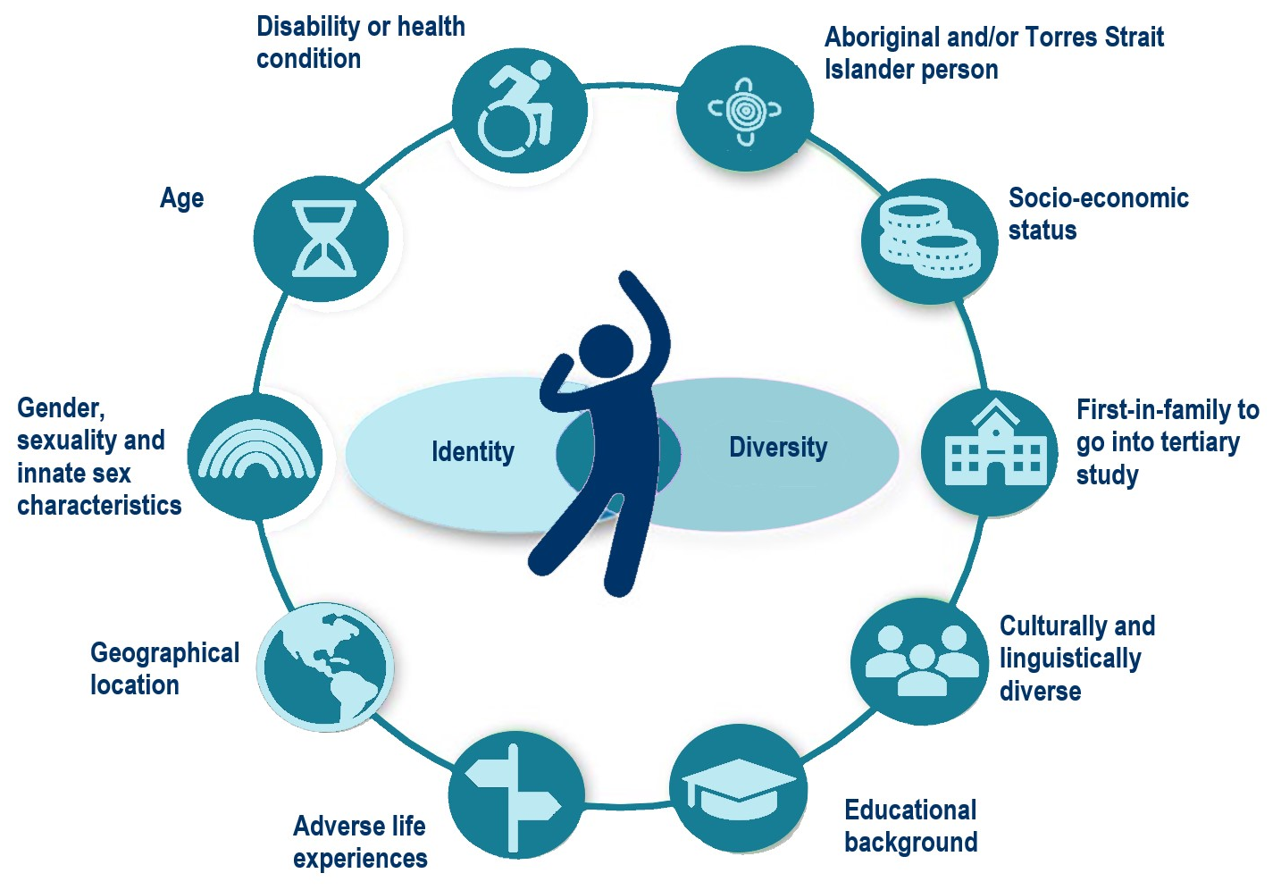

Step 4: Conduct an environmental scan
You should conduct an environmental scan / benchmarking exercise to gather background on existing guides, resources, research and other considerations in developing your guide.

Existing resources
Researching and reviewing existing inclusive communication guides is a crucial part of your environmental scan / benchmarking exercise. There may be an existing guide that you can adopt, or an existing example which includes elements that fit well with your organisation. Many organisations will be happy to share their guide with the appropriate acknowledgement. You can find some useful information in Appendix 1: Resources section to get you started and on the ADCET website.
Questions for discussion
  - Are there existing guides that could be adopted outright? Are these right for your organisation?
  - What are the common features of these documents you might adopt?
  - What elements will work for your organisation?

Research and consultation
Your environmental scan should also include researching and reviewing guidelines and resources from internal specialists, peak bodies, and key advocacy and community groups. This might include:
- Aboriginal and Torres Strait Islander staff within your organisation as well as Elders groups, local advocacy and community groups, and students
- diversity and inclusion specialists within your organisation including both professional and academic staff experts
- diversity and inclusion specialists like the Diversity Council of Australia, Australian Network on Disability, Pride in Diversity, People with Disability Australia etc
- LGBTIQA+ advocacy groups or national resource hubs e.g., LGBTIQ+ Health Australia and Transhub
- national, state or local groups representing culturally and linguistically diverse communities
- religious organisations
- national or state-based disability advocacy groups, particularly those led by people with lived expertise and lived experience
- federal and state human rights commissions.

Internal stakeholders
You should also talk to key stakeholders or departments across your organisation about your project. Key questions to ask include:
- how will the development of this guide impact this business unit and its activities?
- will it impact any computer systems or technological processes?
- will there need to be changes to policies, business protocols or procedures?
- will there need to be training provided as part of the implementation?
- what format will the guide take e.g., print or digital (will it be provided in accessible or alternative formats)?
- will this guide by publicly accessible?
- what challenges can departments see in implementing this guide and how will these be mitigated?
- are there any costs to be considered e.g., project costs, signage changes, printing, consultation?
- who can the Committee contact as the guide is developed for feedback?
- who might be the local area champion for the completed guide?
- who will be responsible for revising the content in the future?

Some key departments or areas to include in consultation may include staff from:
- Aboriginal and Torres Strait Islander Units
- Equity, Diversity and Inclusion Units
- Human Resources
- Workplace Health and Safety
- International Office
- LGBTIQA+ and Ally networks
- Disability, Accessibility and Inclusion Units
- Marketing and Communications
- Governance
- Learning and Teaching
- Facilities and Built Environment
- Digital and IT areas
- Anti-discrimination experts e.g., complaints handlers, Student Ombudsman
- Student Union or Guild advocates.

In the draft stage you should incorporate some small test groups such as
staff and students without specific knowledge / extensive exposure to inclusive language and visual representation, staff with lived expertise and people with lived experience.

This test group will assist to check inclusivity, key information, and whether it makes sense. You might also consider some ‘critical friends’ from other educational institutions or community organisations who can identify any issues. Bear in mind their time is precious so consider how you might be compensating them for their time.

The final product
What is the final format for this document? This is an important consideration as it may influence how the content is collected, produced and presented. Discuss the following with your Advisory Committee:
- print and/or digital? If this is a printed document, will it also be provided in a digital and other alternative and accessible formatting? If this is a digital document, is it accessible (e.g., html, accessible PDF, audio, video)? (Don’t forget a publication and review date.)
- will digital formats include captioning and transcripts (highly recommended), Auslan, Easy Read, other languages?
- will there be additional or companion resources such as promotional posters, QR codes, short URLs, changes to signage?
- will there be changes to systems e.g., field codes for gender, disability or ethnicity.

Step 5: Develop a draft
It is now time to flesh out your draft. To help you with developing your draft here is some of the common content and concepts that you should discuss with your Advisory Committee for inclusion in your guide.

Guiding principles
- consider whether your organisation will preference person-first language or identify-first language
- recognise that we don’t all have one identity and include reference to intersectionality
- acknowledge that diversity and inclusion has developed because marginalised groups have experienced disadvantage and discrimination due to systemic issues. This includes things such as colonisation, influence of dominant culture and perspectives (e.g., western perspectives, patriarchy, heteronormativity, middle class etc), racism, gender disparity, homophobia, ableism, stereotyping and unconscious bias
- acknowledge the continuous evolution of language and the differences of language within communities. Build in a review process and be open to ongoing development to remove outdated language and imagery
- include the correct spelling and pronunciation for Aboriginal and Torres Strait Islander peoples or culturally and linguistically diverse communities
- context is important. Recognise that some language is appropriate for the ‘in group’ (those who identify as part of the community) but not for others
- consider the way your guide addresses inclusion in all forms of communication (spoken, written, symbolic or visual). Also consider how your guide translates into other languages including Auslan, Easy Read and in global contexts.

Structuring your guide
When contemplating the structure of your guide here are some recommendations around the key topics you might consider:
- your rationale for developing a guide for your organisation
- key diversity dimensions your guide may want to include
- examples of inclusive language and visual representation for each dimension
- interventions for bystanders and complaints processes
- further resources including diversity training opportunities
- a glossary of terms.
ADCET has included some good practice examples on our website and in Appendix 1.

Gleaning feedback
A document such as this will be an iterative process in order to make sure you have included all the vital information, checked with your experts and cross-checked with your background research and key organisations.

To facilitate the feedback process:
- set deadlines for providing feedback
- be open to discussing the feedback with the Advisory Committee
- get further clarity if you are not sure on a particular issue
- accept that you won’t be able to please everyone and there may be dissent on some terms or approaches. Remember language is constantly evolving so recognising this in your guide is an important caveat.

Step 6: Gain executive approval
Once you have a final draft that has been endorsed by the Advisory Committee it will need to go through a raft of approvals. To facilitate this:
- give senior leadership ample time to review but set deadlines
- be aware of the approval processes required to finalise the document. This might include making changes to governance or policy documentation
- allow time for the process of uploading the document to relevant web or intranet locations, or for graphic design and production of any additional resources
- anticipate any particularly challenging issues that may be raised and ensure you have the appropriate research or rationale to support the decision.

Step 7: Disseminate and promote
Now it is time to share your guide across your organisation. Draw on the expertise of you internal communications experts to hatch a plan to disseminate your guide. In putting together your communications plan there are some key things to consider:
- who are your audiences (internal and external) and what are the usual channels for communication for latest information (email, newsletter, web/intranet, promotional materials, system notifications, social media)?
- what are the key messages you want to convey about this new guide? For example, why is this guide important, how will people use it, and who is the target audience?
- work with your senior leadership (e.g., VC, CEO, Director) to launch the guide. This might be through their official communication channels, a media release, internal digital promotions, newsletter or an event.
- consider collating testimonials, quotes or video vignettes from members of the Advisory Committee, your champions, and communities involved in development to demonstrate why this guide is valuable
- encourage feedback and keep a log of feedback once it is released, so it can be collated into a future iteration.

Step 8: Monitor and evaluate
It is important to be able to monitor and evaluate the impact of embedding your guide into the everyday business of your organisation. This might also include embedding it in the curriculum and making system changes.

Consider what existing implementation and evaluation tools you already have within your organisation. This may include social marketing models, basic evaluation model or program logic model. A program logic model could be applied at the commencement of the project. This would provide a useful structure across the life of your project.

Figure 4: Program logic template

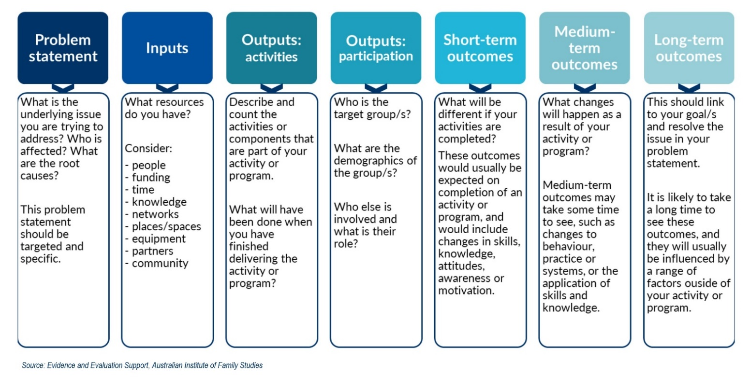
The key to developing, evaluating and monitoring the effective implementation of your guide would include key steps outlined below:

Establish a problem statement:
Your problem statement should be targeted and specific. Key questions to ask:
- what is the challenge/problem/issue you want to address?
- what are the causes of the problem?
- who is impacted?

Consider your inputs
What resources do you have at your disposal to address the issue?
- people
- funding
- time
- knowledge and networks
- places, spaces and equipment
- partners, community, stakeholders

Consider your outputs
- what outputs or activities are being undertaken to address the problem?
- what will be achieved once you have delivered the activity or program?
- who are the target groups for your activities or program?
- who else is involved in delivery and what is their role?

Clarify your desired outcomes
- short-term: what immediate outcomes do you expect. This might include measuring changes in awareness, attitudes, skills or motivation. It could also include measuring engagement with activities.
- medium-term: how will you measure outcomes where changes to systems, practice or processes take a little longer to come to fruition?
- long-term: outcomes at this point should link strongly to the changes you articulated in the problem statement. Has there been a shift or change?

Additional considerations
- what are the underlying assumptions? How or why do you think the program will work e.g., institutional commitment, community support etc
- what external factors may impact implementation e.g., political, social, cultural, geographic. That is, what is outside your control but may impact your implementation?

Summary
We hope you have found this guide useful for developing your organisation’s inclusive communication strategy. We have provided additional references and resources that you might find useful. Further information and this guide are located on ADCET’s website at www.adcet.edu.au/resources/inclusive-communication

Don’t hesitate to reach out to ADCET is you have questions or want to provide feedback on these documents. You can contact us at admin@adcet.edu.au

References
ADCET. (2023). Inclusive Communication. Accessed February 2023 at https://www.adcet.edu.au/resources/inclusive-communication
Australian Disability Clearinghouse on Education and Training (ADCET). (2023). Inclusive Communication. Accessed February 2023 at https://www.adcet.edu.au/resources/inclusive-communication
Australian Government. (2023). Inclusive Language Style Manual. Accessed February 2023 at https://www.stylemanual.gov.au/accessible-and-inclusive-content/inclusive-language
Australian Human Rights Commission. (2023). Business and Human Rights. Accessed February 2023 at https://humanrights.gov.au/our-work/business-and-human-rights
Australian Institute of Family Studies (AIFS). (2016). How to develop a program logic for planning and evaluation. How to develop a program logic for planning and evaluation | Australian Institute of Family Studies (aifs.gov.au)
Canadian Institute for the Advancement of Women (2009). Everyone Belongs: A Toolkit for Applying Intersectionality. Accessed February 2023 at www.criaw-icref.ca/publications/everyone-belongs-a-toolkit-for-applying-intersectionality
Deakin University. (2023). Inclusive Language Guide. Accessed February 2023 at https://blogs.deakin.edu.au/iccb/toolkit/language/guide/
Diversity Council of Australia. (2022). Words at Work. Accessed February 2023 at https://www.dca.org.au/inclusive-language-0
Edith Cowan University. (2021). ECU Inclusive Language Guide. Accessed February 2023 at https://www.ecu.edu.au/about-ecu/commitment-to-equality-and-diversity/equity-diversity-and-inclusion/news-and-events/2021/09/words-matter-ecus-inclusive-language-guide
El-Amin, A. (2022) The Business Case for Implementing a Diversity and Inclusion Quality-Based Strategy in Implementing Diversity, Equity, Inclusion, and Belonging Management in Organizational Change Initiatives. ICI Global.
O’Leary, J. and D’Almada-Remedios, R. (2019). Inclusion@Work Index 2019–2020: Mapping the State of Inclusion in the Australian Workforce. Diversity Council Australia.
People with Disability Australia (PWDA). (2023). Language Guide. Accessed February 2023 from https://pwd.org.au/resources/language-guide/
Queensland University of Technology (2010). Working with Diversity: A Guide to Inclusive Language and Presentation for Staff and Students.

Appendix 1: Resources
Below are some existing resources to reference or draw on. This is not a complete or comprehensive list so consider further research.

Inclusive language guides from other organisations
- Inclusive language | Australian Government Style Manual
- Inclusive Language | Diversity Council Australia (dca.org.au)
- Quick guide to inclusive language - Disability Inclusion Guide - Be You
- Inclusive Language & Events Guide - Amnesty International Australia
- Inclusive Language Guidelines (apa.org)
- Inclusive language - Content - Atlassian Design System
- Appendix 3: inclusive language | Victorian Government (www.vic.gov.au)
- Three recommended inclusive language guidelines for scholarly publishing: Words matter - Ashwell - Learned Publishing - Wiley Online Library

Good practice examples from unis
- ECU: https://www.ecu.edu.au/about-ecu/commitment-to-equality-and-diversity/equity-diversity-and-inclusion/news-and-events/2021/09/words-matter-ecus-inclusive-language-guide
- RMIT: Inclusive Access to Education - RMIT University
- Cultural Diversity and Inclusive Practice Toolkit (scu.edu.au)
- Inclusive language guide - Inclusive Education (ICCB) (deakin.edu.au)
- Monash: https://www.monash.edu/about/editorialstyle/writing/inclusive-language
- Inclusive language | Charles Darwin University (cdu.edu.au)

Training
- Advocacy at the Intersections: Working alongside LGBTIQA+ people with disabilities – Disability Advocacy Resource Unit (DARU) Excellent training for LGBTIQA+ and Disability intersectionality
- ADCET. Disability Awareness
- Core Cultural Learning Professional development | AIATSIS
- Reconciliation Australia. Share Our Pride
- SBS. Inclusion Program

Further resources
- Inclusive Communication | ADCET
- Video - ADCET Webinar: Words Matter - Developing inclusive language guides in a tertiary setting
- Video - ADCET Webinar: LGBTIQ+ inclusive practices for people with disability
- Video - ADCET Webinar: Affirming LGBTIQA+ people with disability
- Everyone Belongs: A Toolkit for Applying Intersectionality | Canadian Institute for the Advancement of Women

Inclusive language for specific groups

Aboriginal and Torres Strait Islander peoples
- Aboriginal and Torres Strait Islander peoples | Australian Style Manual
- Aboriginal arts | Creative Spirits
- Acknowledgement of Country | Common Ground
- Indigenous Art Code
- Aboriginal and Torres Strait Islander people | AIATSIS
- Narragunnawali - A Guide to Using Respectful and Inclusive Language and Terminology
- Map of Indigenous Australia | AIATSIS
- Reconciliation Australia
- Supply Nation | Australia's largest national directory of Indigenous businesses
- Welcome to Country | AIATSIS
- Welcome to Country or Acknowledgement of Country | Indigenous.gov.au

Age
- Age Discrimination Act 2004 (Cth)
- Age discrimination | Australian Human Rights Commission
- Age Diversity | Australian Government Style Manual
- Age-positive language guide | National Ageing Research Institute Limited
- Age-inclusive language and content | NZ Digital government
- Ageism and intergenerational solidarity – Ageing Equal | ageing-equal.org
- Age bias is subconscious, study indicates | Flinders University
- Language of Ageism: Why We Need to Use Words Carefully | The Gerontologist
- Mind Your Language: Promoting An Age-Inclusive Workforce | AIB Review
- Workplace discrimination | Fair Work Ombudsman

Class
- 4 Problems with the Way the Media Depicts Poor People | Everyday Feminism
- Australian Council of Social Services (2018). Inequality in Australia. UNSW
- Class at Work | Diversity Council Australia
- Dropping off the Edge | dote.org.au
- Household Income and Wealth, Australia, 2019-20 financial year | ABS
- Inclusive language: Socioeconomic status | Yoast
- Socioeconomic status | apa.org
- Socioeconomic status | Style guides | University of Bristol
- Working class or affluent? Find out where you fit in Australia | ABC

Disability
- Australian Network on Disability
- Australian Disability Clearinghouse on Education and Training (ADCET)
- ADCET Disability Awareness Training
- Disability Discrimination Act 1992 (Cth)
- Disability images and human reality | AHRC
- Disability and the Media | United Nations Enable
- Disability Standards for Education 2005
- Disclosure – Choosing your Path | westernsydney.edu.au
- I'm not your inspiration, thank you very much | Stella Young
- IncludeAbility | AHRC
- Inclusive language: words to use and avoid when writing about disability | gov.uk
- People with disability | Australian Style Manual
- Language guide | People with Disability Australia
- Mindframe Guidelines
- Quick Guide on Neurodiversity and Neurodivergence | Lived Experience Educator
- Recovery Oriented Language Guide | Mental Health Coordinating Council

Gender, sexuality and innate sex characteristics
- Brotherboys, sistergirls and LGBT Aboriginal and Torres Strait Islander peoples | AHRC
- Engaging men on gender equality | Diversity Council Australia
- Gender and sexual diversity | Australian Style Manual
- Gender-inclusive language | United Nations
- GLAAD Media Reference Guide
- Inclusive Language Guide: Respecting People of Intersex, Trans and Gender Diverse Experience | LGBTIQ+ Health Australia
- Intersex | Human Rights Australia
- LGBTIQ+ Inclusive Language Guide | Victorian Government
- LGBTIQ+ Health Australia
- Pride in Diversity | ACON
- QLife
- Rainbow Health Australia | Rainbow Tick
- Sex Discrimination Act 1984
- TransHub

Race ethnicity and culture
- 25 Examples of Biased Language | Ongig Blog
- A Guide To Diversity, Equity And Inclusion In Communications | Forbes
- All Together Now
- AMA Manual of Style | Oxford Academic
- Cultural and linguistic diversity | Style Manual
- GLAAD Media Reference Guide - 11th Edition
- Help Stop Racism | australia.gov.au
- Racial and ethnic identity | apa.org
- Racial Discrimination Act 1975 (Cth)
- Racism. It Stops with Me
- SBS. Inclusion Program
- Use of language: race and ethnicity | Advance HE (UK)
- What is Racism? | AHRC
- 'Where are you really from?' How to navigate this question of race and identity | ABC

Religion and belief
- Australia's diversity of religion and spiritual beliefs | racismnoway.com.au
- Creating inclusive multi-faith workplaces
- Factsheet: Guide to the protections for freedom of religion (2019) | AHRC
- Faith & Media Initiative
- Queensland Faith Communities Council's (QFCC). Food Guide.
- Religious inclusion: why it’s important and how to get it | DCA
- Religion, faith and belief | Style guides | University of Bristol
- Religious affiliation in Australia | ABS
- The Role of Inclusive Language in an Inter-Religious Dialogue and Communications | researchgate.net
- UN calendar of the international days

O’Leary, J. and D’Almada-Remedios, R. (2019); El-Amin, A. (2022) – see References for detail.
Australian Human Rights Commission
Developed out of resources from the Australian Human Rights Commission, Australian Institute of Family Studies, Edith Cowan University and Diversity Council of Australia – see References for detail.

