Tips for educators to support the educational and career journeys of students with disability
Research with students with disability, stakeholders and parents/carers into how to best support the career development learning (CDL) of students with disability led to the development of a set of Best Practice Principles.
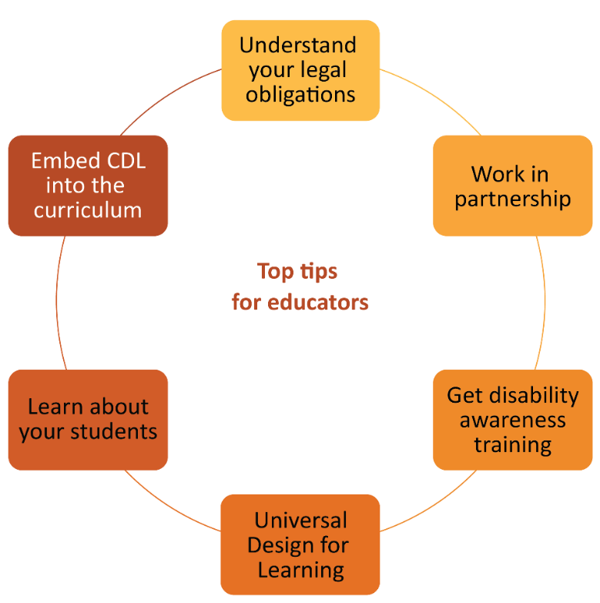
This document for teachers, academics, support staff and others working in educational institutions highlights top tips that should be implemented to support the educational and career journeys of their students with disability. The document deliberately foregrounds the voices of parents/carers and students with disability.

Understand your legal obligations
Understand the regulatory and legal requirements for your work and the educational institution.
Ableism, that is, discrimination in favour of able-bodied people, is considered by students with disability and their parents/carers as a barrier to all students meeting their educational and career goals. Discrimination because of disability is also illegal.
Also be aware of the differences in the social and medical models of disability. According to a social model of disability, impairment is considered an expected part of human diversity and should be accommodated by the physical, attitudinal, communication and social environments. This contrasts with the medical model, which sees disabilities as health problems that should be fixed or cured.
Top Tip!
Watch this short video and learn about the social model of disability.
Diversity and inclusion need to be embedded in practice, rather than existing only in policy and intent.
There is a lot of conscious and unconscious ableism out there in schools and in the wider community.
Mother of 17-year-old student with autism, Tourette syndrome, developmental coordination disorder (DCD), attention deficit hyperactivity disorder (ADHD) and generalised anxiety disorder

Reflective questions
- What is the relevant anti-discrimination and inclusion legislation for my work?
- What is the inclusion and diversity policy of my institution?
- How can I actively promote diversity and inclusion?
- How well do I understand the most appropriate language and terminology
of disability?
Top Tip!
Read about your rights and responsibilities around disability in higher education here.

Work in partnership
Understand and be part of the communication, coordination and provision of student education and support that occurs across university units (e.g. access/equity and careers services, student services) and faculty or institutions.
Students with disability and their parents/carers identify siloed support services as a barrier to their educational and career journeys.
It was problematic trying to get hold of the right TAFE person to talk to … it wasn’t a coordinated approach. I was passed around to four different people because they weren’t sure how to answer some of my questions.
Mother of 18-year-old with autism, ADHD and learning difficulties

Reflective questions
- What services exist in my institution to support the educational and career journeys of students with disability?
- How much do I know about what each of the other services does?
- How can I actively contribute to improved coordination of these services for students?
- How can I more fully support the students I work with by having a more holistic knowledge of their needs and of the services that exist?
- How can I engage students in the design and delivery of CDL programs and resources?
- If a student asked me how to access disability support services at my institution, would I know where to direct them?

Get disability awareness training
Undertake education and training in disability awareness, disability confident career coaching or unconscious bias. Familiarise yourself with strengths-based thinking and reflective practice to ensure that your praxis does not slip unintentionally into deficit thinking.
Top Tip!
Complete an Australian Disability Awareness eLearning course for free!
Students with disability and their parents/carers value educational environments that are inclusive and whole-person focused with high expectations of students. Understanding the strengths and needs of individual students is important to achieving these things.
Neurotypical educators need to be given a real world understanding of what it’s like to live and learn on the spectrum.
Mother of 12-year-old student with autism, ADHD and anxiety disorder

Reflective questions
- What language do I use when speaking about students and their disabilities? Is it deficit or strengths-based?
- What does my language reveal about my underlying attitudes towards people with disability?
- How much do I understand about the lived experiences of people with disability?

Universal Design for Learning
Apply Universal Design for Learning (UDL) to ensure that course outcomes are accessible and that content is engaging and representative of all students of all abilities, whether they disclose disability or not. Content that is not accessible to all students can result in low motivation and poor engagement with learning.
Top Tip!
Complete an Australian course in Universal Design for Learning in Tertiary Education
for free!
Educators should include students with disability as co-creators, co-designers and decision-makers where appropriate. Such activity can improve the accessibility of course content and empower students.
We hoped further education would be more welcoming, but this isn't the case.
I don't think they even know what UDL is.
Mother of 19-year-old with Down syndrome

Reflective questions
- Are my course materials and activities accessible for as many students as possible?
- Could I partner with a student(s) to help review my course materials and check for accessibility?

Learn about your students
Speak to your students and get to know their strengths and limitations as well as the supports that they require. These conversations might be intimidating ones to have (for both you and your students) and if unsure, you should ask whether a student is comfortable discussing their disability with you. Also let the student know that they do not have to share anything that they are not comfortable with.
Once you know about your students, have high expectations of them and provide them with the levels of support that allow them to achieve. UDL, scaffolding and adjustments are the key approaches to successfully supporting all students.
I would make a virtual appointment … to have a really good talk about my limitations. I'd tell myself to swallow my pride and have the chat because people can't help you if they don't know there's an issue.
University student with disability
His disability allows him to complete work to a very high standard and his attitude would make him a great employee.
Male carer of an 18-year-old student with autism

Reflective questions
- How well do you know your students?
- Do you have unexamined assumptions about the possibilities for any of your students?
Top Tip!
Conversation starters
“Do you have any condition or disability that you think could have an impact on your studies? Would you be okay with talking to me about how it might affect your studies?”
“You can tell me as much or as little about your condition or disability as you like – there is no pressure or requirement to disclose. My main priority is that you feel safe and comfortable talking to me.”

Embed CDL into the curriculum
Embed CDL into the curriculum so that students can continuously make connections between their studies and the world of work while building the skills, attitudes and knowledge required for future careers. Support them to investigate and access authentic, supported work experience opportunities.
Genuine connections to work and experiences of being part of employment relationships were identified by parents/carers of students with disability as supports that would enable career goals to be achieved.
Work experience benefits my brother the most.
Carer of 39-year-old student with a mental health condition
Barriers are employers who do not have the time or patience. He can learn, but it takes longer than with typical students.
Mother of 17-year-old student with autism and fragile X syndrome

Reflective questions
- Does my course material make connections between the subject content and workplace applications?
- Does my course encourage/promote the acquisition of authentic work experiences for all students?
Top tips for educators to support the educational and career journeys of students with disability:
- Understand your legal obligations
- Work in partnership
- Get disability awareness training
- Apply Universal Design for Learning
- Learn about your student
- Embed CDL into the curriculum

Source: O’Shea et al. National Career Development Learning Hub for students with disability. National Careers Institute Partnership grant (2021–2023). The research involved interviews and surveys with students, parents/carers and stakeholders and analysis of existing data sets. Total participant responses = 774.
Deficit language and thinking centres around what a person lacks or can’t do. Strengths-based language and thinking focuses on what a person can do, what qualities and resources they possess, and their strengths.

