Using the Microsoft Translator App

App is available on Android and Apple
It is a free, personal translation app for more than 70 languages, to translate text, voice, conversations. Can translate text in photos also
Single person translation or multi-person conversation in same or different languages – translated
This is a great app for auto-captioning access when there is no other access – as it’s on your phone it is with you wherever you go. I your usual app fails – MS Teams will sometimes fail on auto-captions – I have been in meetings, and they are just not there – so this allows me to position my phone near speakers on computer and still access auto captions. In small gatherings and large gatherings – it is my go to back up and is as accurate as most auto-caption apps on market – also free, no limit on hours of use.
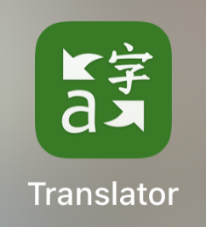
Microsoft Translator on the App Store
Microsoft Translator on Google Play
Steps in use of Translator for a meeting / lecture: (after download)
- Enter Name and Language you use for first time use – this will automatically come up every time you use Translator, then the
Image Description: Hello in a language – this changes every time you open. Then there are 4 icons
In middle screen – a Large single microphone
Below this is a Keyboard image to left
and two person conversation to the right
Below this is a Camera icon
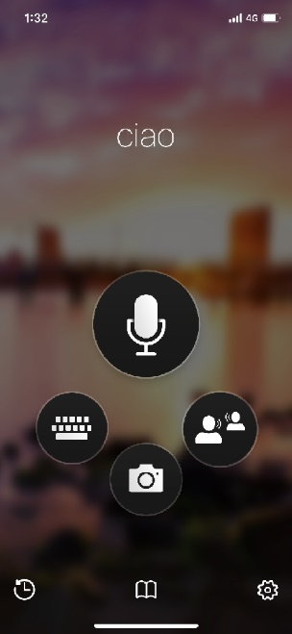

- If you select the large single Microphone icon – this will perform single translations. These translations can be English to English, English to any other Language or any other language to English
Tap the Microphone and speak. The translation will appear on Screen and below (or at bottom of the screen – dependent upon which phone or iPad you use) this is a speech button which will read aloud the translation in the language selected – Spanish, Chinese etc – translating from your spoken English or vice versa.
You can pin the translation if it is a phrase you want to use often – using the pin icon – there is a send icon also – allowing you to send this to message, phone, email… and so forth.

- If you select the Two-person Conversation Icon – below to the right of the large single microphone icon – you can use this for closed captioning on the fly – in meetings or lectures.
  - You are asked to enter a conversation. Either to can join a conversation or start a conversation. If you are wanting caption a meeting with a few participants, you can start a conversation share the code and all can join – this then will allow for each participants name to appear with what they are saying – thus making it easier to follow. Great for study groups – not so good for lectures or large meetings for auto captioning access.
  - For captioning on the fly – just hit start
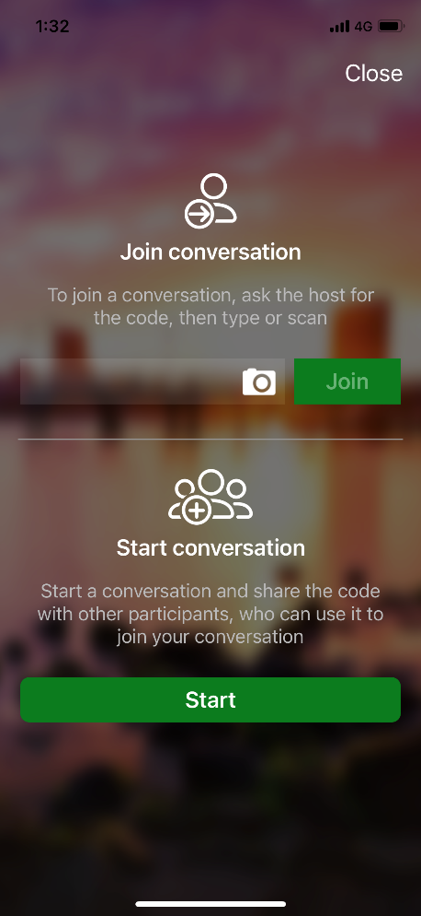

  - After selecting start you are asked to select your Name and Language. If you have already entered this it will be shown as your answer – you only have change his if needed in a conversation where others might see this. Select Enter
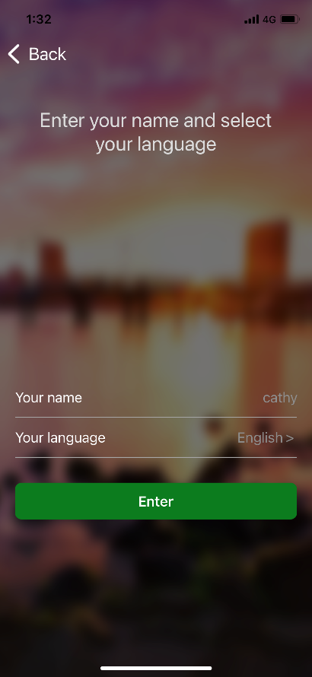

  - Screen with Conversation Code and QR Code will appear for you to share with a button. And a large Green Enter button towards the bottom of the screen. Select Enter (you do not need to share anything to use the app for captioning in a lecture.)
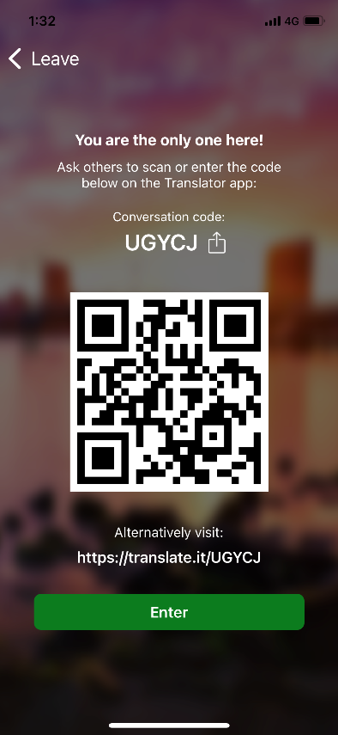
  - Then you are in the Conversation App where text will appear once select Microphone. But first you need to select the Settings wheel at the top right of the screen
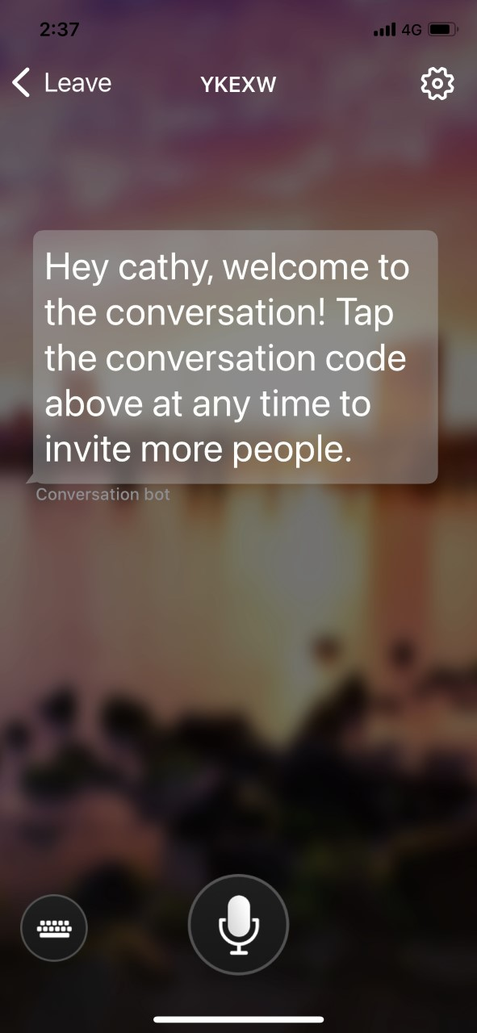
  - This takes you into App Settings – where you can select “presenter mode”. By selecting presenter mode, the translator mic stays on permanently while in this conversation and will not stop – or require you to continually turn on the microphone and you can see continual captions / translation. The presenter mode button is midway down the screen.
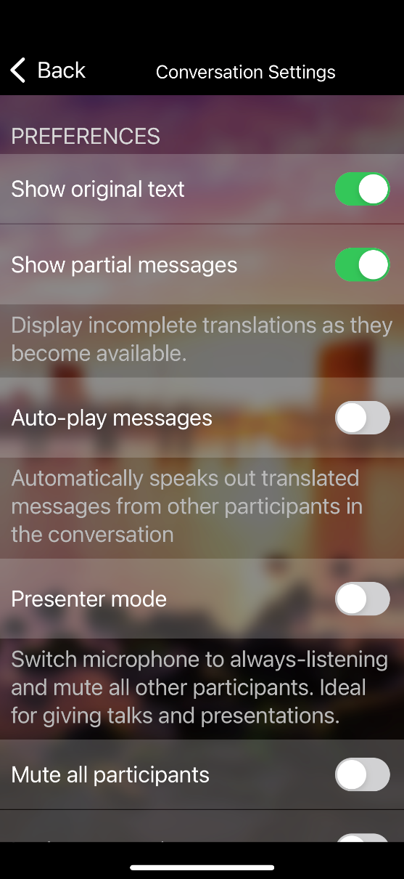
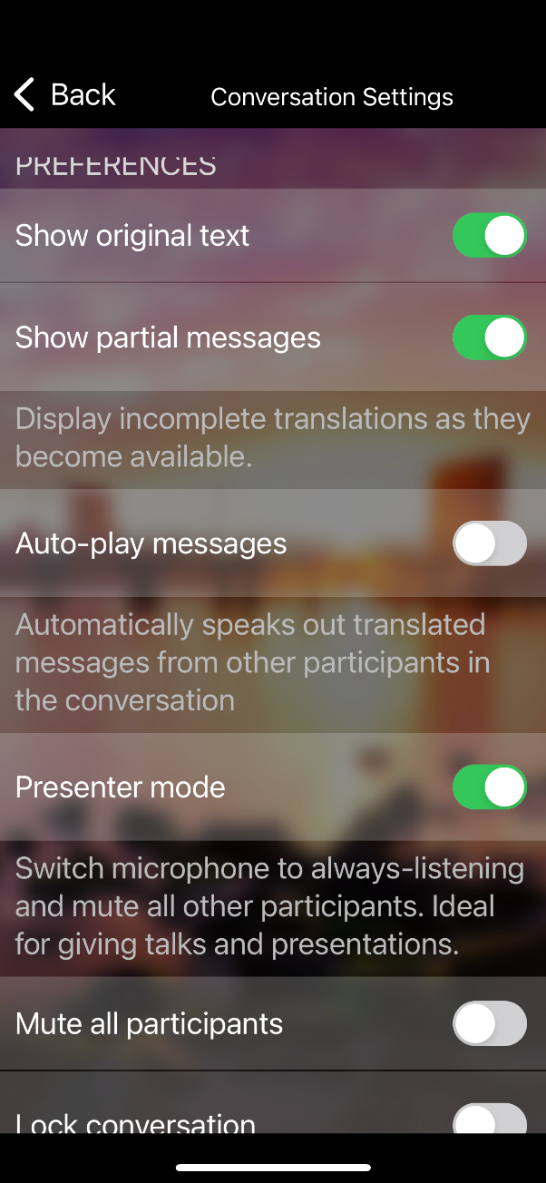

  - Select Back to conversation at the top of the Setting screen after turning on presenter mode and return to the conversation
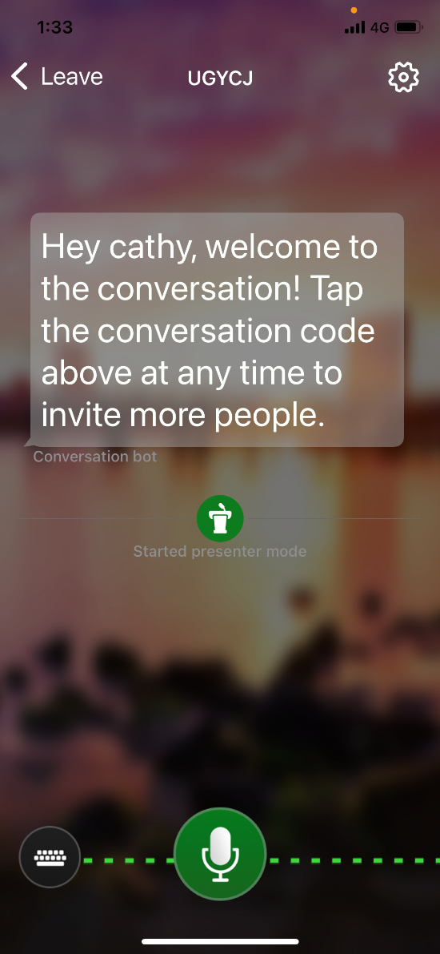
  - You are now in Presenter mode – make sure the microphone has turned green to indicate it is on and watch the text appear on screen continually – Prop the Phone in a position for viewing so you can follow the text along with what else you need to do – write notes, watch the screen…
  - If you were using this with a couple of people, they both see the screen. They see names of who is saying what and they can use the keyboard to type text to other participants if they cannot speak also. See sample below of conversation in presenter mode
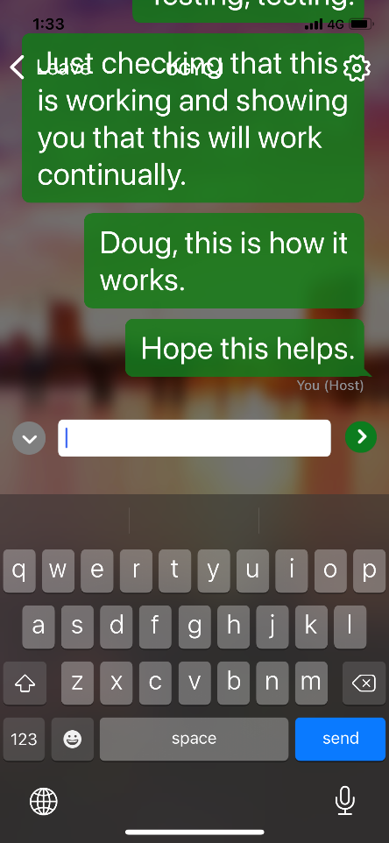

- When using for other languages you can use in Single Conversation mode to translate English to another language and vice versa. Select the language outputs and tap the microphone button and translation will appear on screen.
