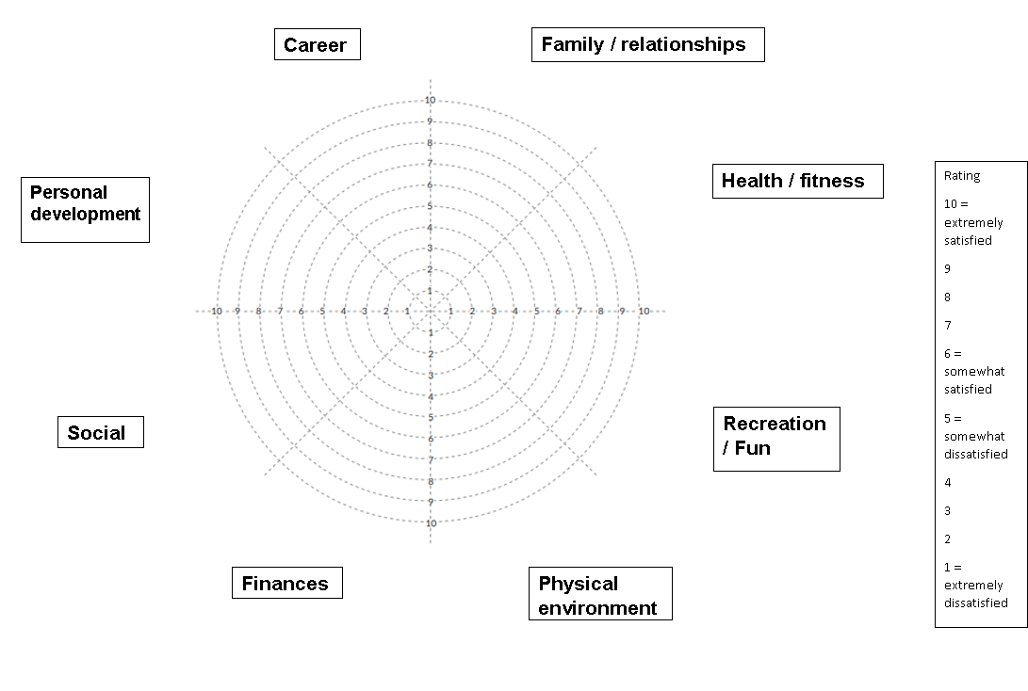
The classic wheel of life includes a range of areas in your life that surround around a wheel and spoke system. It consists of 10 concentric circles coming out from a central point labelled from 1 in the middle to 10 at the most distant with the spokes all intersecting in the centre to divide the wheel evenly between the different areas of your life. The numbered concentric circles represent a rating scale from 1 to 10. 1 represents extremely dissatisfied, 5 somewhat dissatisfied, 6 somewhat satisfied and 10 being extremely satisfied.
How would you rate your ‘wheel’ of life?
- Business & Career: Alternative labels include Vocation, Work, Business, Motherhood, Fatherhood, Parenting, Volunteering, etc.
Questions to ask yourself:
– How happy and fulfilled are you by your work?
– Is your business/career thriving or not?
– Where is it right now? Where would you like it to be?
- Finances: Other label ideas include Money, Wealth, Financial Security and Financial Wellbeing.
Questions to ask yourself:
– How comfortable do you feel about your financial situation?
– How is your financial education?
– How does your bank/savings accounts look like?
– Do you manage your finances effectively?
– How would you like to feel about your financial status?
- Health & Fitness: Alternatives include Wellbeing, Fitness, Body, Physical. This category could also be split into Physical Health and Emotional Health, in addition it can include Spiritual Health.
Questions to ask yourself:
– How happy are you with your overall health?
– How do you feel about your energy levels and vitality?
– Do you exercise regularly?
– Do you think that you are at the athletics level that you would like to be?
– Are you happy with the general state of your physical body?
- Family & Friends: Alternative labels might be Community, Social Life. Family and Friends category can be split into separate categories of “Family” and “Friends”.
Questions to ask yourself:
– How is your relationship with your family and friends?
– Do you spend enough time with them? Do you feel connected to them?
- Relationship: Alternatives include Dating, Intimate Life, Significant Other, Significant Other, Life Partner.
Questions to ask yourself:
– How would you rate your life with your partner/your loved one?
– Is it a romantic life?
– Do you spend enough time together?
– Do you understand each other?
– Do you express yourself well enough to be understood?
– Do you love and feel loved?
- Personal Development: Alternatives include Learning, Self-Development, Personal Growth or Spiritual.
– How do you see yourself growing as an individual?
– Do you think you are investing enough in your personal growth?
- Fun & Recreation: Some other ideas for this category label include Leisure Time, Hobbies, Sports, Play, Creativity and Enjoyment.
Questions to ask yourself:
– Do you let yourself to spend enough time to rest, have fun and rejuvenate?
- Physical Environment: Other labels for this category could be simply “Home”, “House” or “Apartment”. The category could be split into two for work and home environments. It is especially important right now when many people start working from home.
When reviewing your wheel you might like to ask yourself these questions:
  - Are there any surprises for you?
  - How do you feel about your life as you look at your Wheel?
  - How do you currently spend time in these areas?
  - How would you like to spend time in these areas?
  - Which of these elements would you most like to improve?
  - How could you make space for these changes?
  - Can you effect the necessary changes on your own?
  - What help and cooperation from others might you need?
  - What would make that a score of 10?
  - What would a score of 10 look like?

https://digitalhygge.com/life-balance-wheel-pdf/

