Designing online education that works for more/all students

Slide one. Who are we?
- Erin Leif
- Laura Alfrey
- Christine Grove
- Stella Laletas
- Umesh Sharma
Faculty of Education at Monash University

Slide two. Today
- Background
- Context
- Practical and research-informed approaches for designing engaging and accessible online learning experiences

Slide three. Background
- The impact of online coach education on the inclusion and participation of individuals with ASD in sport
- Quality Matters Continuing and Professional Education Rubric, Second Edition (www.qualitymatters.org)
- Universal Design for Learning (UDL) Principles
- Transgressive Concept of Inclusion (DeLuca, 2013)

Slide four. Transgressive Inclusion (DeLuca)
- student diversity = generation of new knowledge
- stereotypic labelling of difference is limited
- provokes a multiplicity of practical and conceptual responses to inclusive education leading to more intentional practices, policies, curricula, and pedagogies.
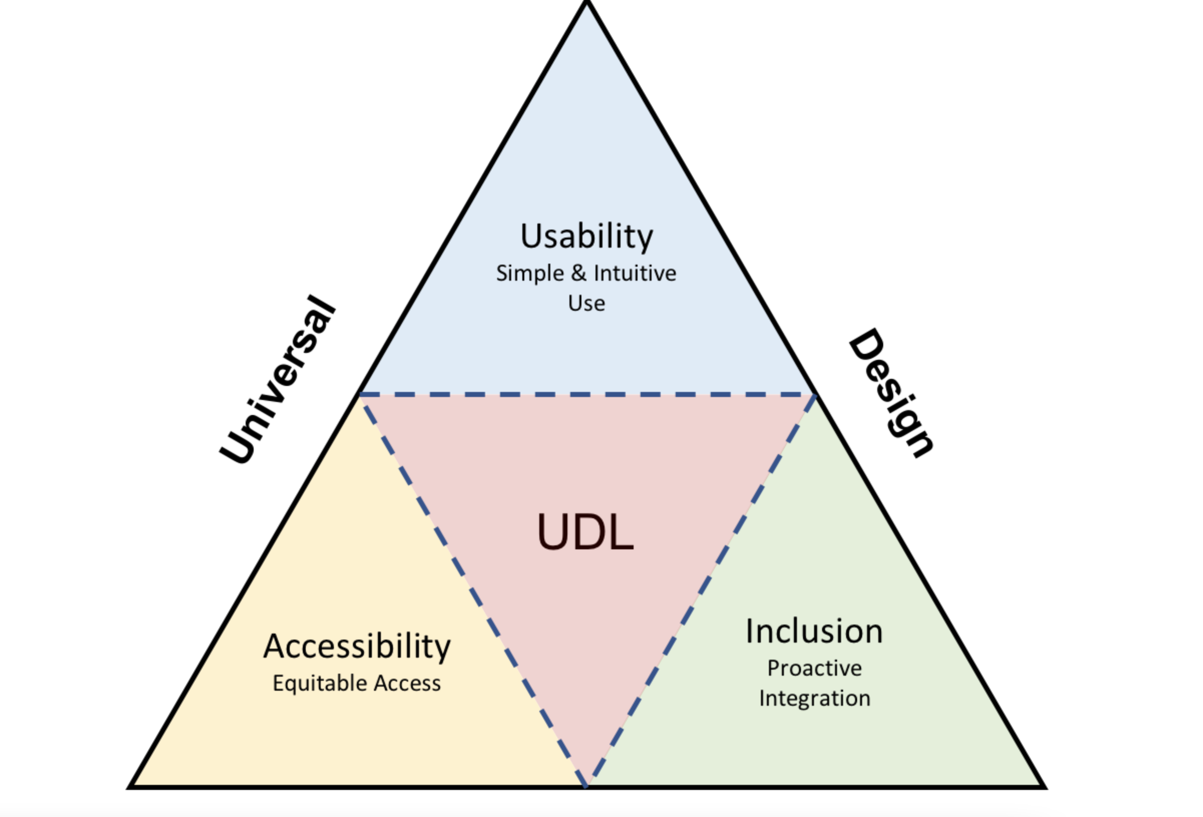

Slide five. Context
- COVID-19 = rapid shift online
- Policy and legislative requirements
- Compounding existing challenges in tertiary education

Slide six. Identified challenges
- Knowing where to get help or accommodations
- Problems with inaccessible technology
- Lack of personal relationships with lecturers
- Difficulty navigating the online learning environment
- Not knowing what to do each week – too unstructured
- Lack of opportunities to get to know classmates
- Feeling like course content lacks purpose or is not pitched at the right level

Slide seven. Online learning has left students dissatisfied
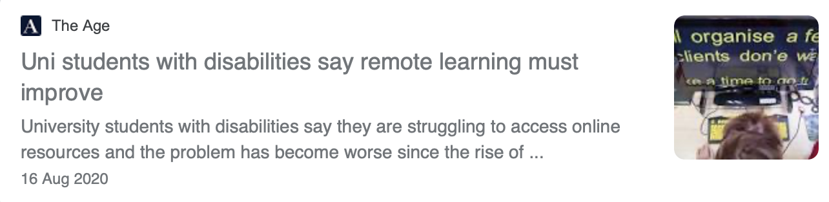

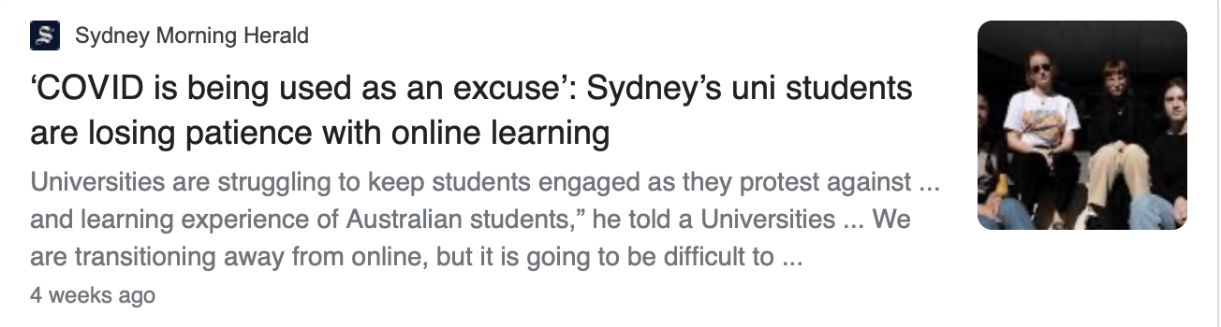

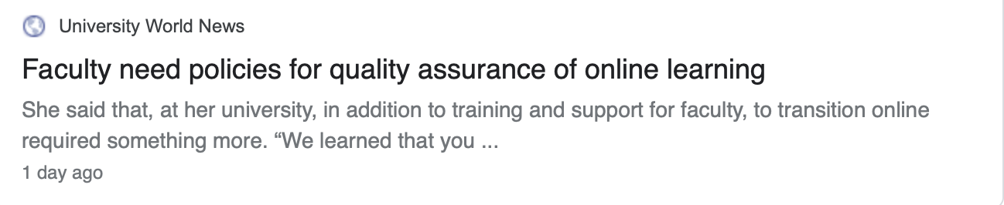

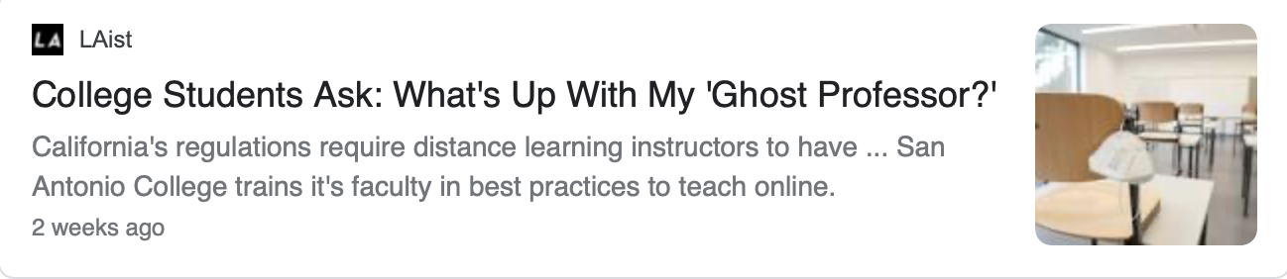

Slide eight. Let's talk about how to overcome these challenges!

Slide nine. Step 1: Create a clear and consistent unit structure
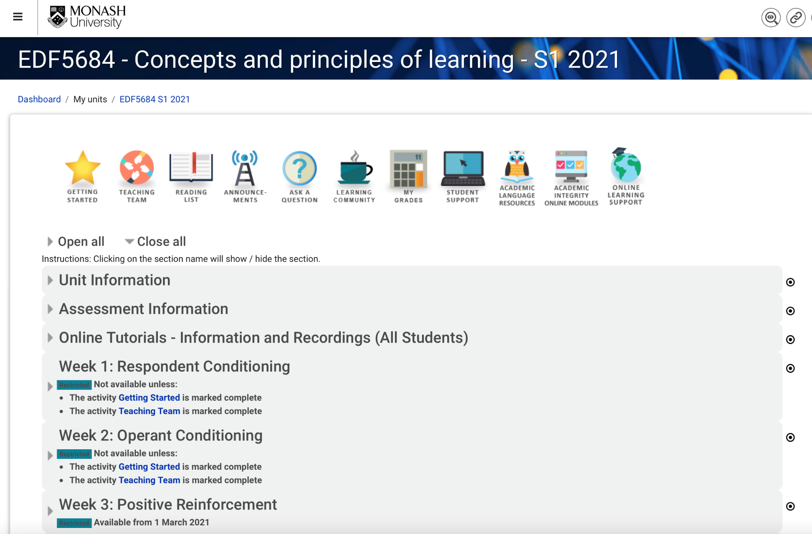

Slide ten. Step 2: Ensure students are welcomed into the unit and are provided with an induction
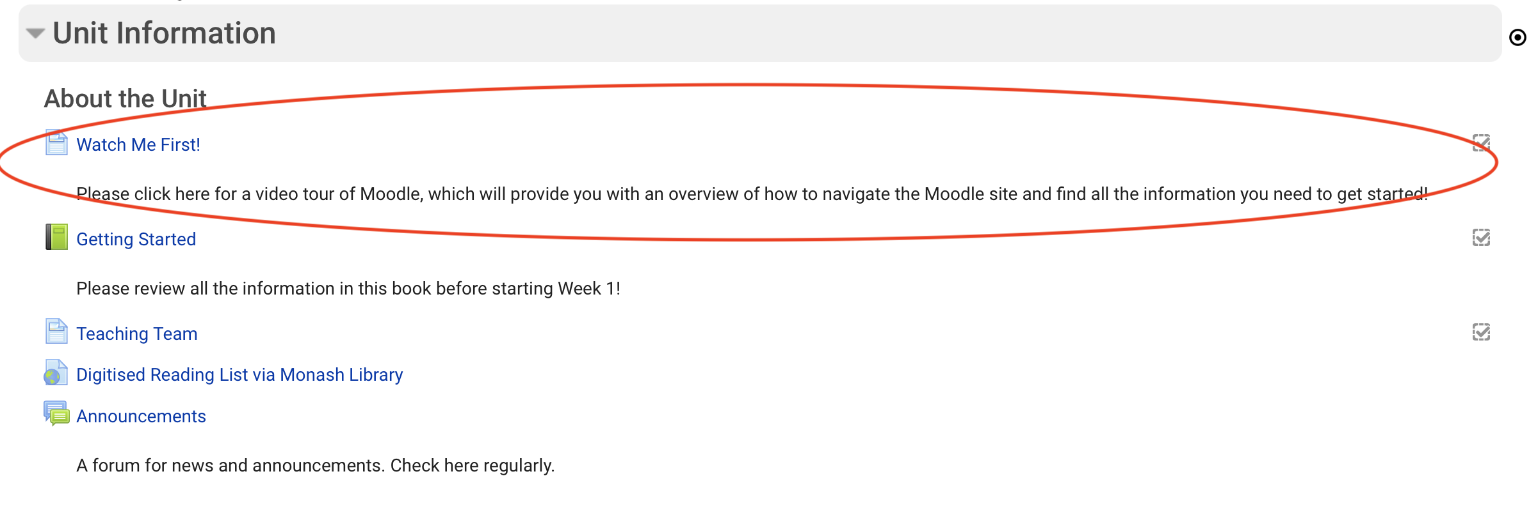
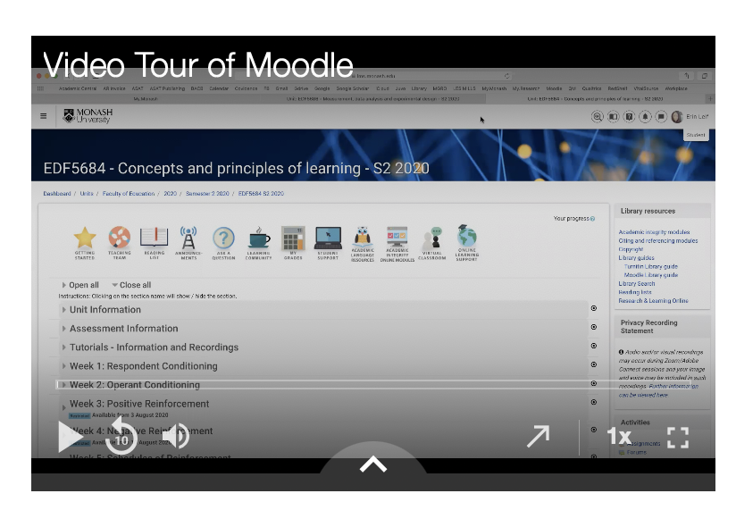

Slide eleven. Example - The Getting Started Book
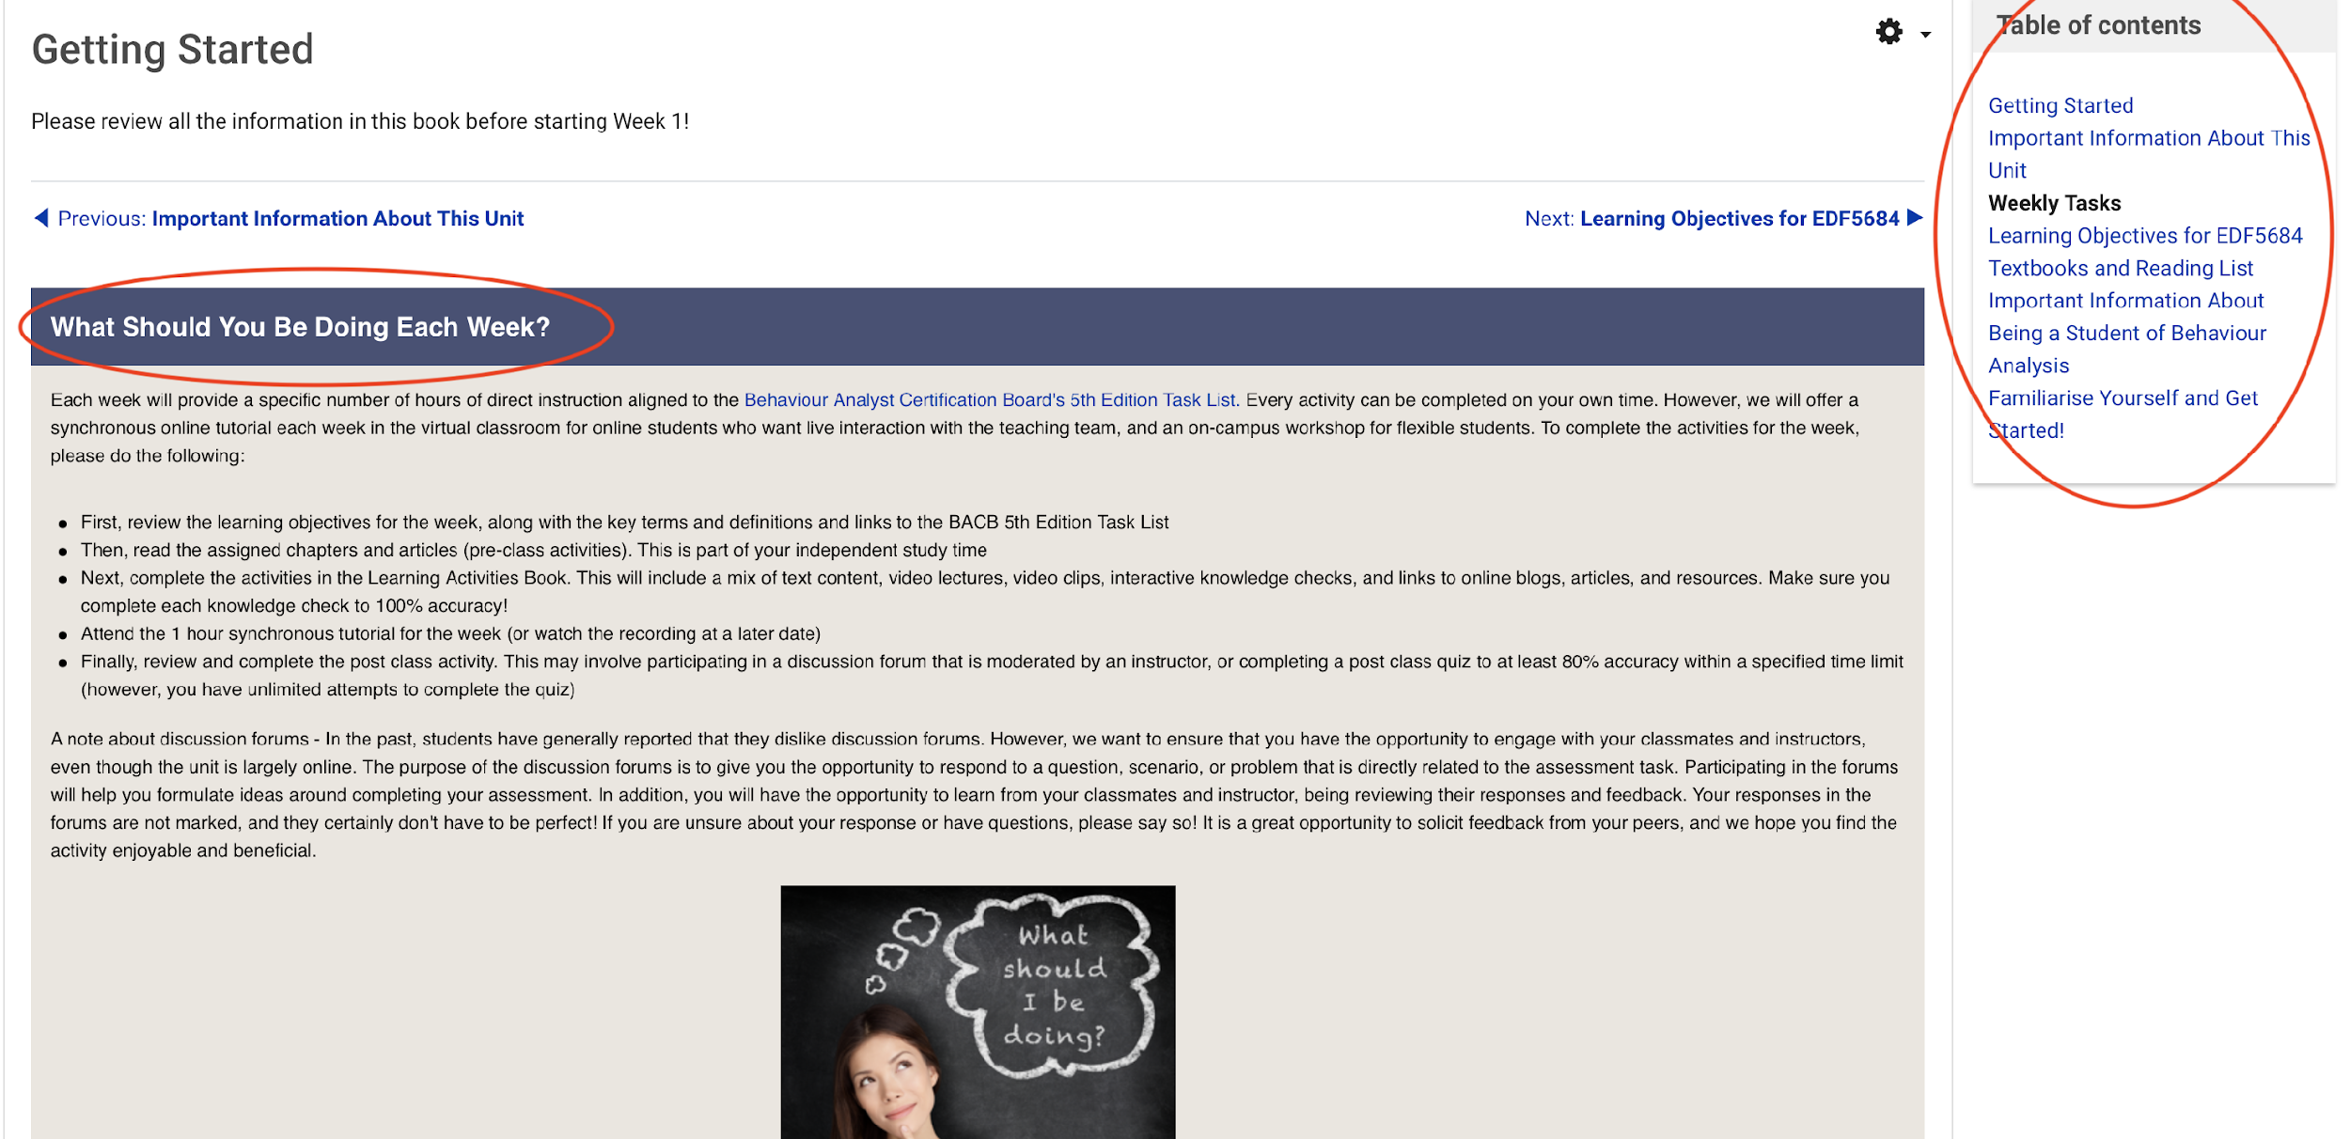

Slide twelve. Example - Unit Level Learning Objectives
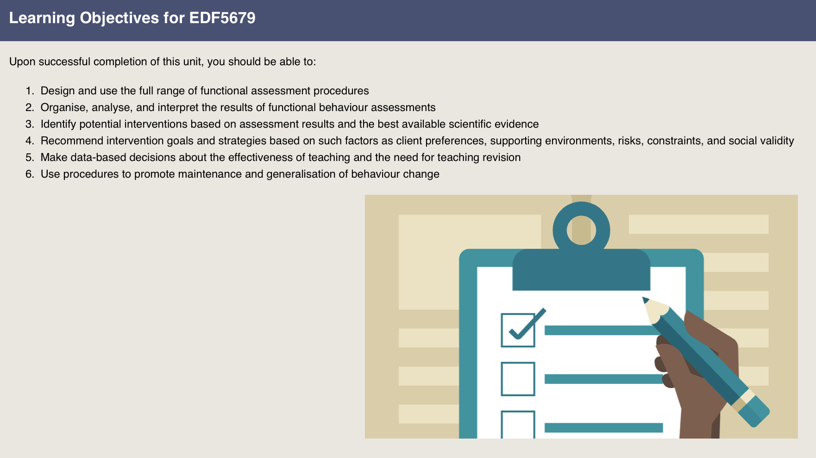

Slide thirteen. Example - Last Page of the Getting Started Book
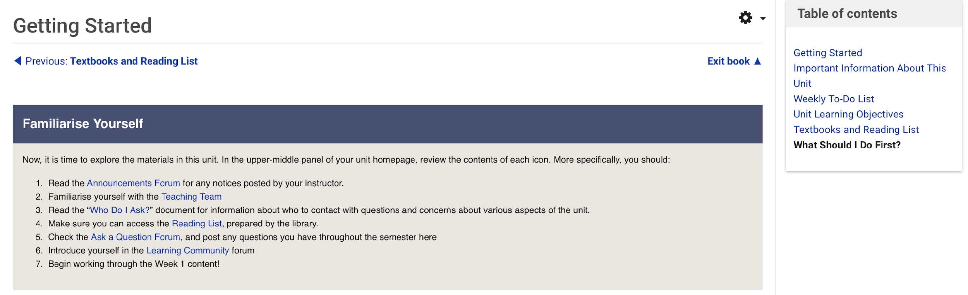

Slide fourteen. Example - The Learning Community Forum
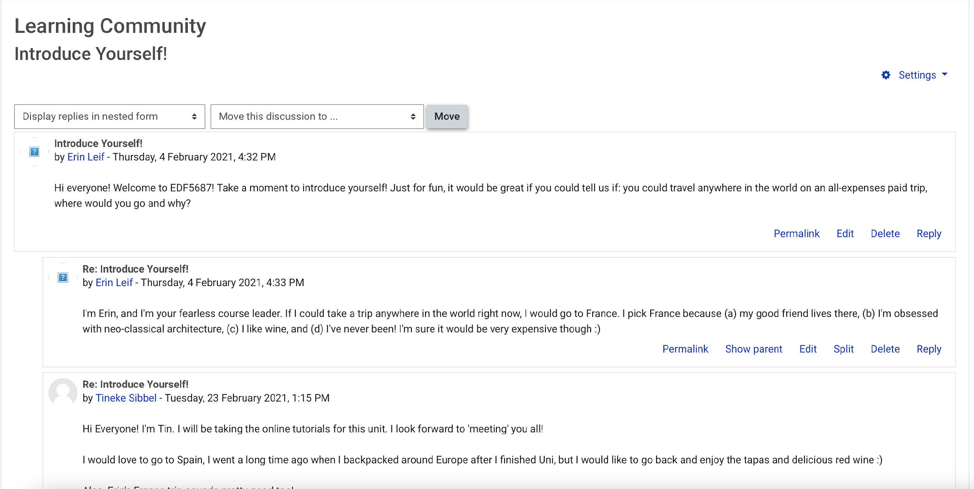

Slide fifteen. Step 3: Set up each week the same way
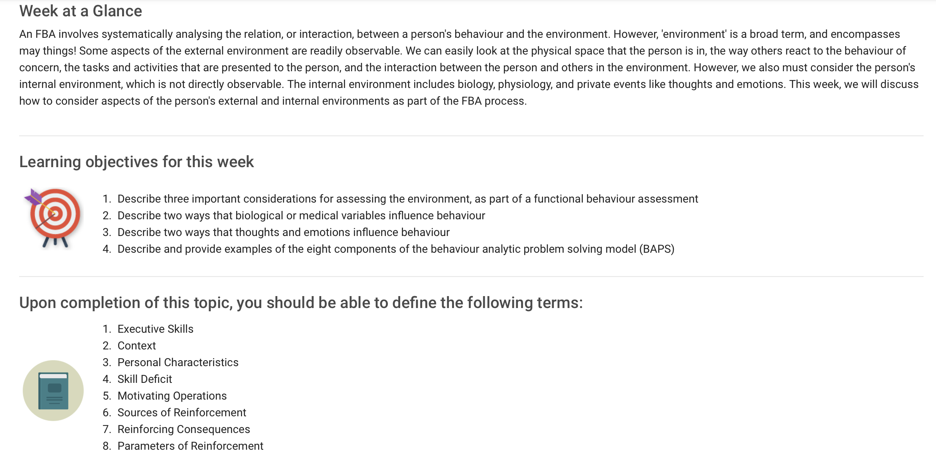

Slide sixteen. Example - List the pre-class activities
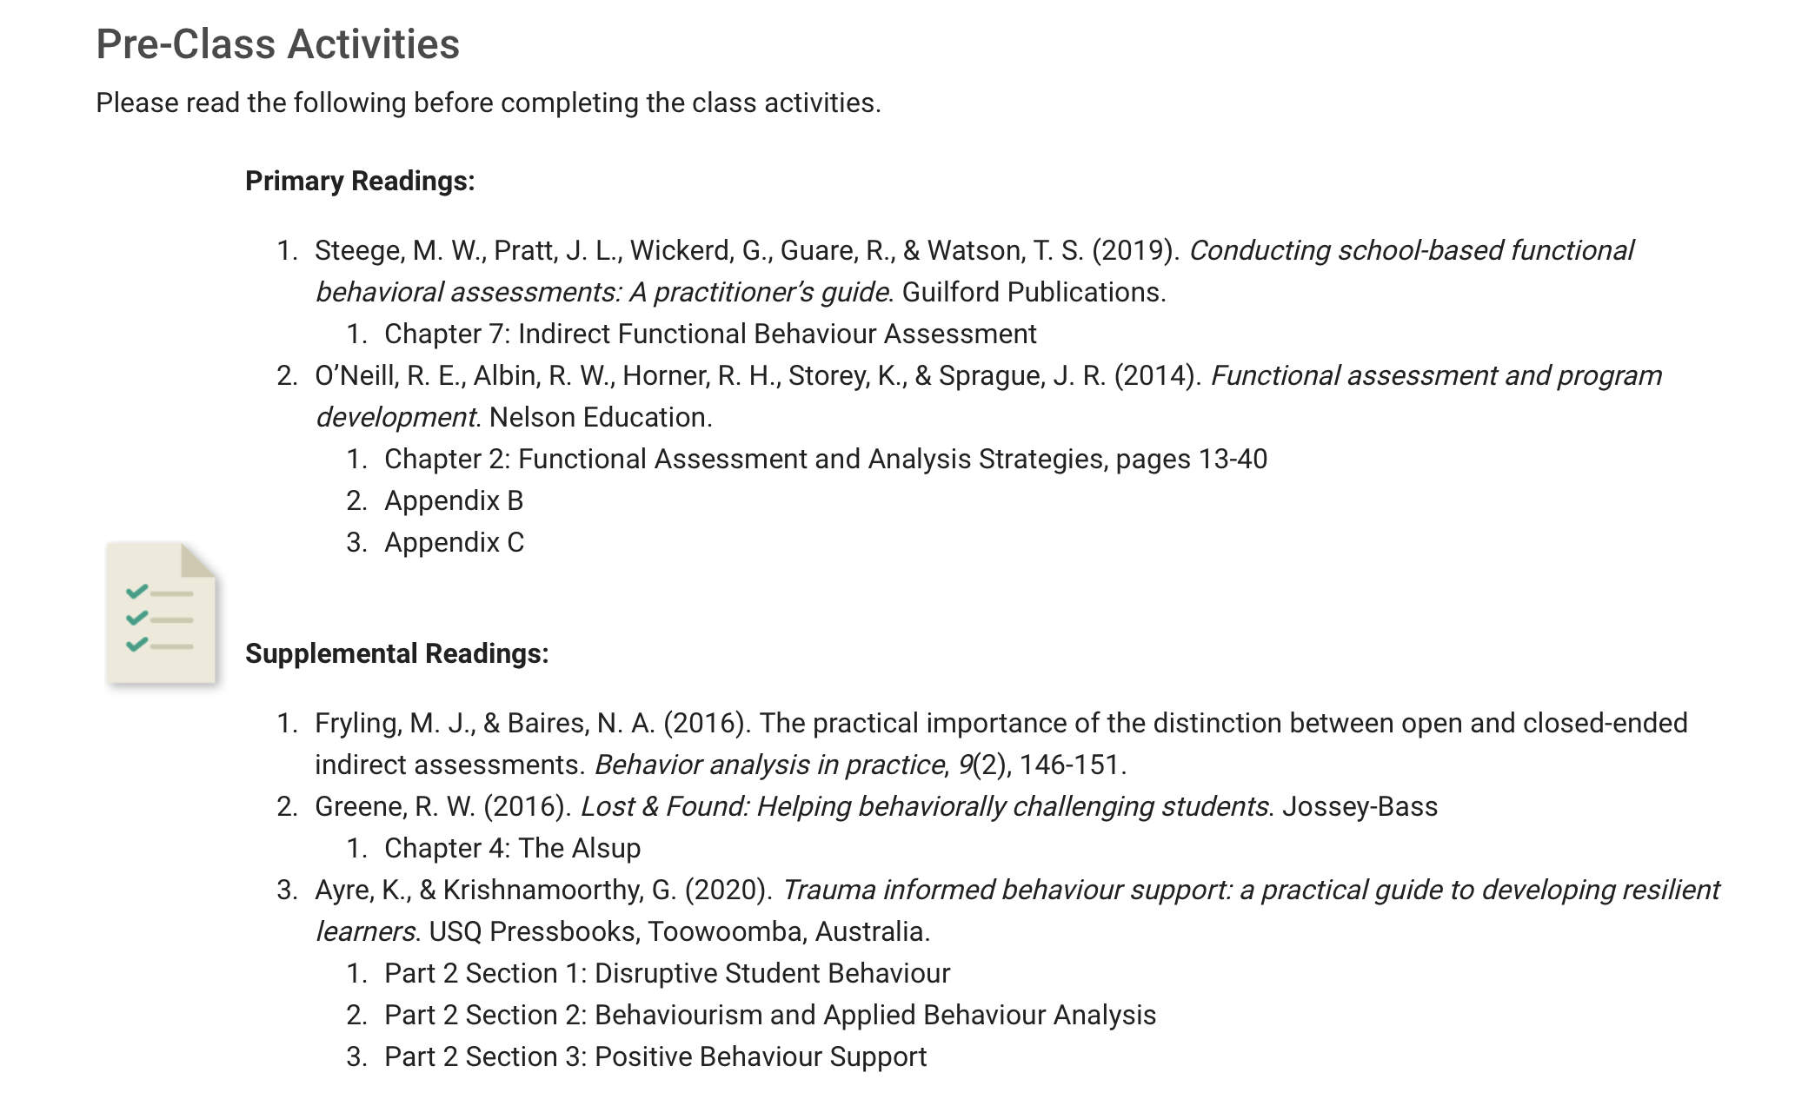

Slide seventeen. Step 4: Align learning objectives to weekly learning activities
- Students are provided with a set of asynchronous online learning activities directly aligned to the weekly learning objectives
- Interactive lessons are meant to replicate the teaching methods that would commonly be delivered in a face-to-face classroom
- Consist of a series of video recorded lectures interspersed with active learning activities, presented to students in ‘Books’ divided into ‘Chapters’

Slide eighteen. Example - Create your online class activities
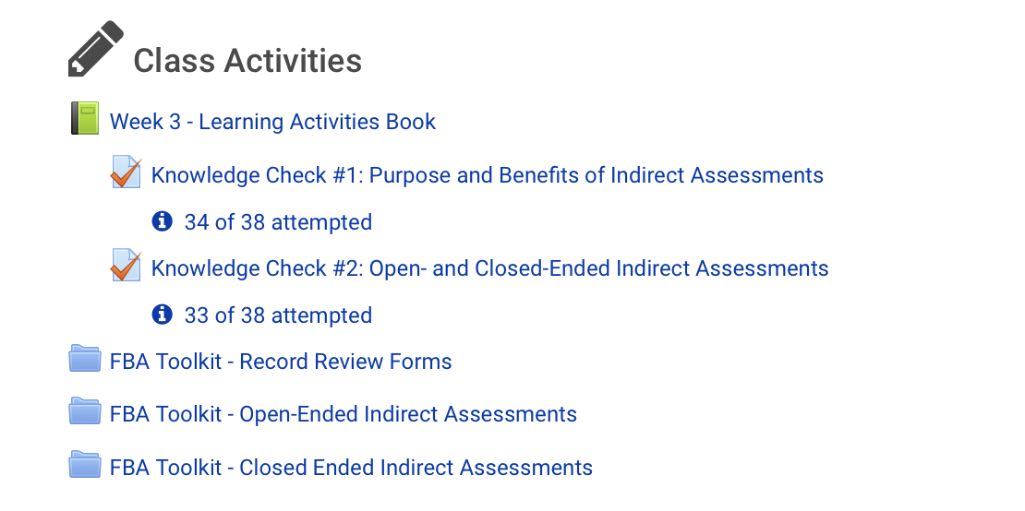

Slide nineteen. Example - The Learning Activities book
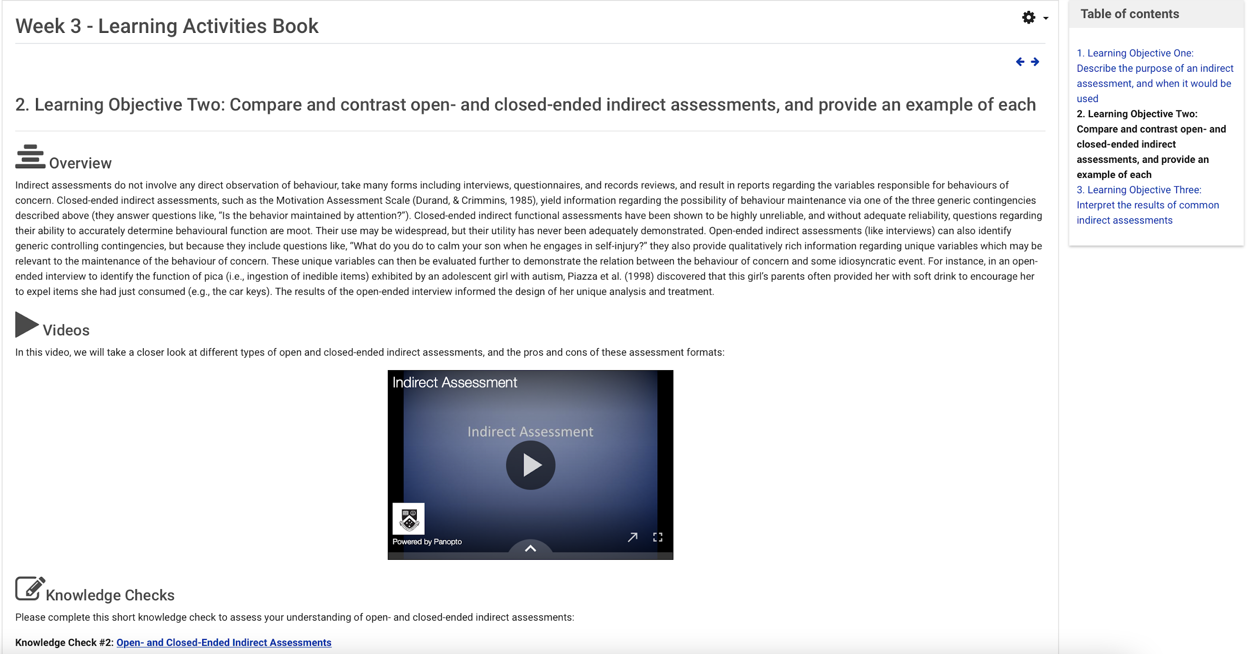

Slide twenty. Example – Chapter titles

Slide twenty-one. Step 5: Create active student learning activities, using the principles of Universal Design for Learning!
- UDL is a way of thinking about teaching and learning that helps give all students an equal opportunity to succeed
- Offers flexibility in the ways students access material, engage with it and show what they know
- Developing Education this way helps all students, but it may be especially helpful for students with learning and thinking differences
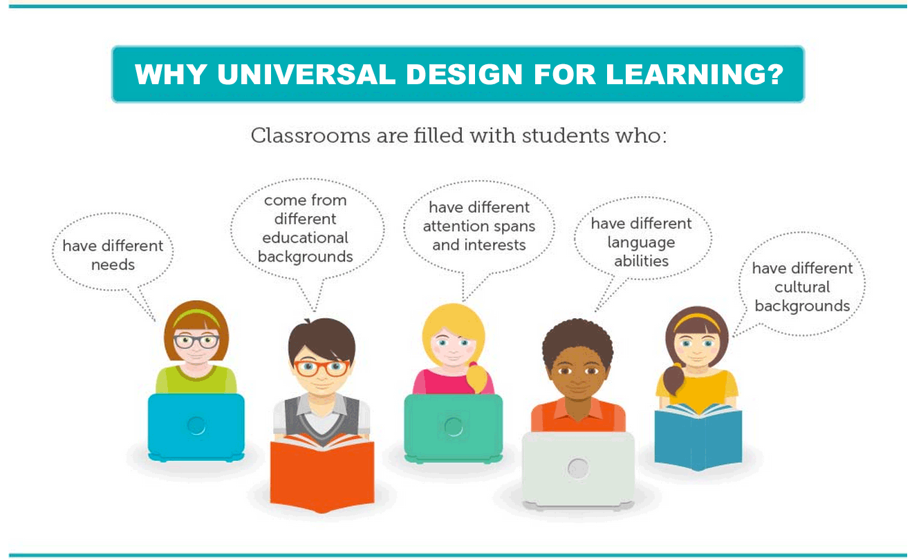

Slide twenty-two. UDL is just an ‘ed’ thing…
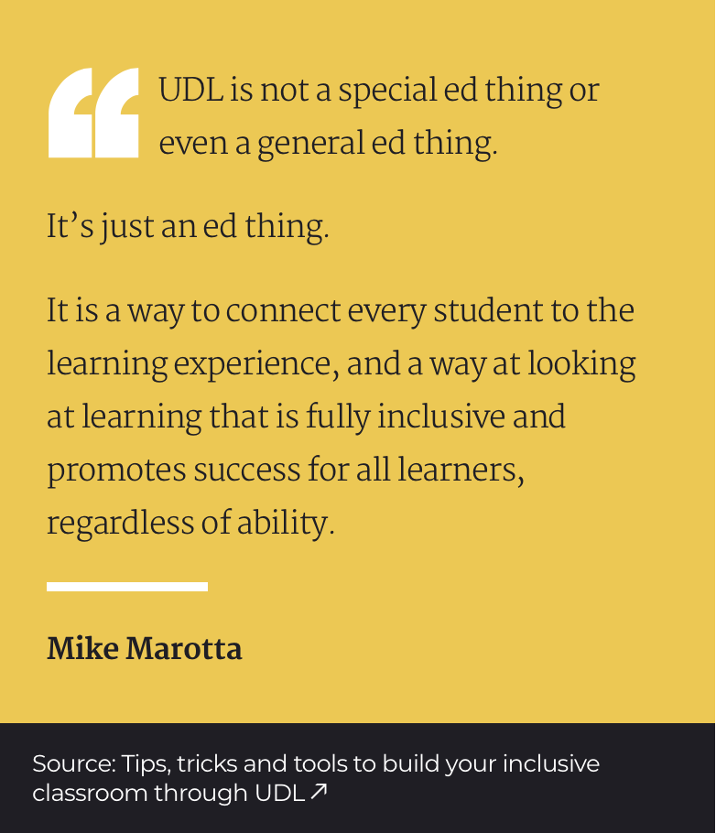

Slide twenty-three. Principle of UDL #1
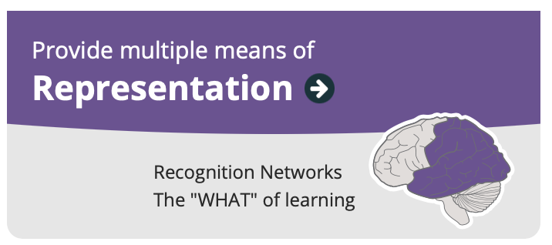
Example:
- A textbook chapter
- A video lecture
- A TED talk
- A blog post
- A graphic
- A link to a website

Slide twenty-four. Principle of UDL #2
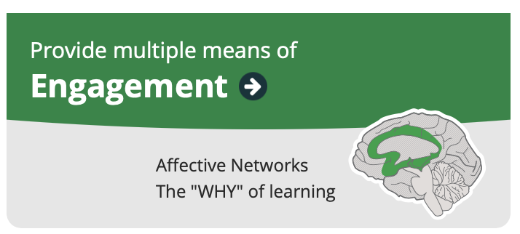
Example:
- A knowledge check
- A quiz
- A discussion forum activity
- A reflection
- A wiki activity
- A group task
- A component of the assessment task

Slide twenty-five. Principle of UDL #3
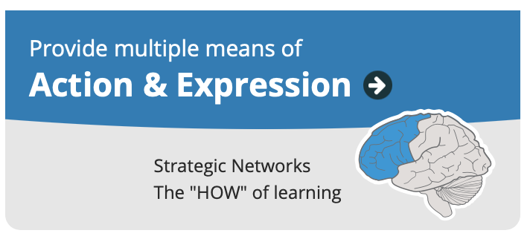
Example:
- Writing
- Talking
- Practicing
- Designing
- Critically analyzing
- Questioning
- Reflecting
- Linking

Slide twenty-six. Example – Constructive Alignment

Slide twenty-seven. Step 6: Engage with your students in multiple ways – synchronous online activities
- Weekly synchronous tutorials
  - We use polling and group discussion to provide students with the opportunity to actively respond and the teaching team with the opportunity to (a) gauge student understanding of the material and (b) present additional Education if needed

Slide twenty-eight. Step 6: Engage with your students in multiple ways – discussion forums
- Post-class discussion forums
  - allow the teaching team to gauge understanding in students who may not have otherwise indicated that they were confused
  - gives students the opportunity to teach material to each other, which requires that they define, synthesise, and relate the material that is being discussed
  - gives students the opportunity to prepare for the assessment tasks

Slide twenty-nine. Step 6: Engage with your students in multiple ways – Moodle progress trackers
- Moodle analytics and completion settings on Moodle
  - We teach students how to use their Moodle ‘progress trackers’ to self-monitor their completion of the online learning activities on Moodle
  - We review the progress trackers at specific points throughout the semester, and check in on students who appear to be falling behind or who are not showing evidence of active engagement with the unit content

Slide thirty. Step 7: Design with accessibility in mind from the start
- A few top tips
  - Ensure the navigation is logical
  - Use clear and descriptive section headers
  - Ensure images have alternative text
  - Ensure videos have captions/transcripts
  - Don’t use text colour to convey meaning
  - Don’t upload scanned documents. Do upload accessible word docs, PPT slide decks, and PDFs

Slide thirty-one. Brickfield Accessibility Toolkit – Now available with Moodle!
- A Moodle plugin, that allows you to:
  - Detect and fix accessibility problems
  - Bulk update alt text, video captions, and missing text for weblinks
  - Provide accessible file formats
  - Fix issues with HTML tags
  - Run reports and gain insights
- https://www.brickfield.ie/brickfield-accessibility-toolkit/

Slide thirty-two. Thank you!
- Erin.Leif@monash.edu
- Laura.Alfrey@monash.edu

