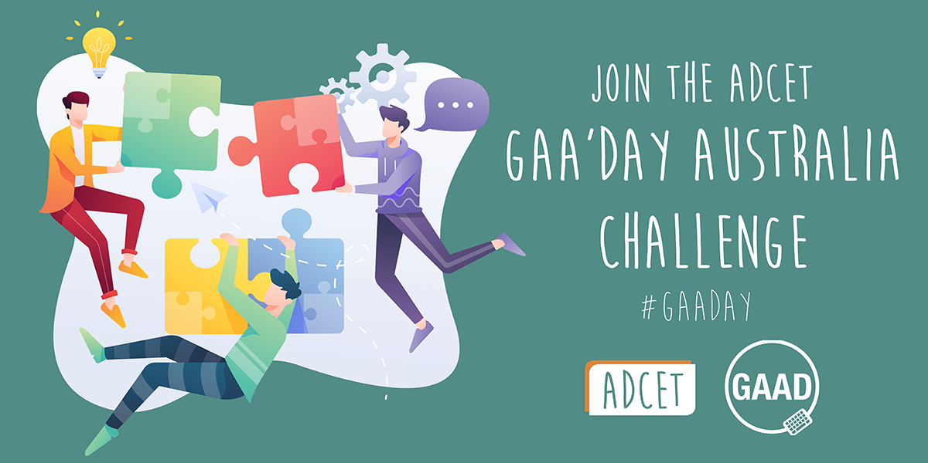

Join the ADCET GAA’Day Australia Challenge.
GAA'day everyone.
The Australian Disability Clearinghouse on Education and Training (ADCET) is throwing down a challenge to the Universities sector and the Vocational Education and Training providers within Australia to experience some accessibility features in their everyday work and life. This coincides with Global Accessibility Awareness Day (GAAD) on Thursday May 20, 2021.
Share your experience with us via email ( admin@adcet.edu.au ) or on our socials using the hashtag #GAADay

Challenge 3: No Peeking, Just Listening (No VIDEO Challenge)
There are some students and staff who may be blind or have vision impairments that cannot see the visual information in an online video. Audio Descriptions help make videos accessible by providing narrated details of what is happening on screen.
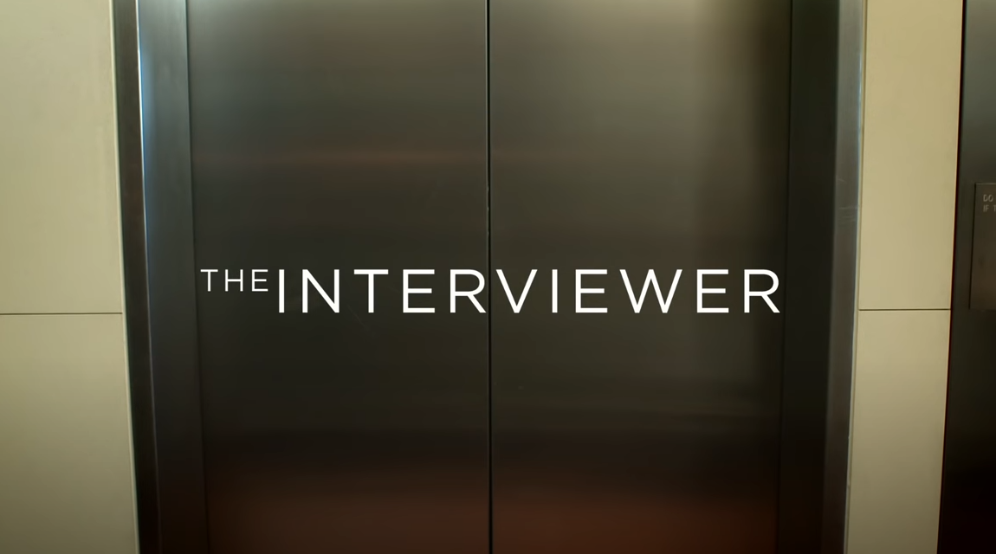
Check out The Interviewer – Captions and Audio Description ( https://www.youtube.com/watch?v=rgRv4bSdLdU ) to experience audio descriptions for yourself.
- Try closing your eyes and listening to the video.
- Does the audio description relay all the relevant information?
The ABC website has an Audio Description Schedule ( https://www.abc.net.au/tv/audiodescription/ ) which highlights upcoming shows across the ABC network that are audio described.
Further information and examples can be found at Audio Description in Australia ( https://audiodescriptionau.com.au/ ).

