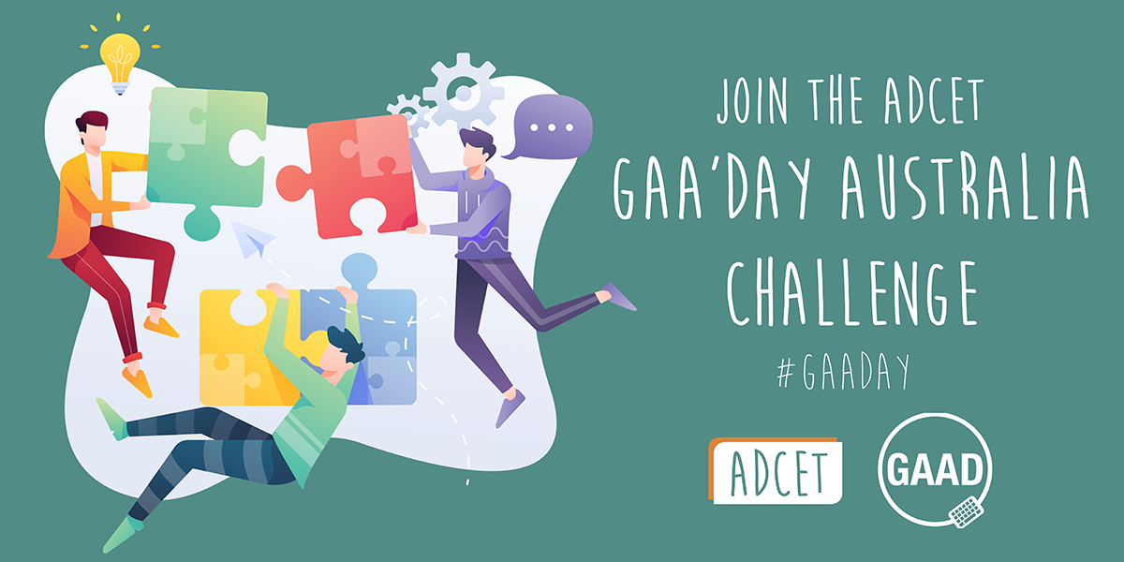

Join the ADCET GAA’Day Australia Challenge.
GAA'day everyone.
The Australian Disability Clearinghouse on Education and Training (ADCET) is throwing down a challenge to the Universities sector and the Vocational Education and Training providers within Australia to experience some accessibility features in their everyday work and life. This coincides with Global Accessibility Awareness Day (GAAD) on Thursday May 20, 2021.
Share your experience with us via email ( admin@adcet.edu.au ) or on our socials using the hashtag #GAADay

Challenge 2: No SOUND TO BE FOUND (No Audio Challenge)
There are some students and staff who may be deaf or find listening to videos/online meetings problematic (unable to clearly hear what is said). For this reason, we challenge you to try watching a video, or attend an online meeting, with the audio turned off or muted and rely on the closed captions or live transcription (if your meeting software and IT area supports it).
You can try this:
- At home, when watching the news, try turning on the subtitles and muting the volume.
- Watch an online video such as https://www.adcet.edu.au/resource/10282/three-essentials-in-the-move-on-line
- Attend an online meeting where everyone relies on the automatic captioning only.
  - For info on how to show captions in Microsoft teams visit Microsoft Teams Meetings Transcription
( https://www.youtube.com/watch?v=9NSYGcz5aA8 )
  - For info on enabling captions in Zoom visit How to Get Closed Captions in Zoom
( https://www.youtube.com/watch?v=4irMTalRQ9k )
Now think about how accurate the captions were. Were they created by humans or by machine?
Technology has come a long way however there are still many cases where automatic captioning can have issues in understanding or interpreting human voices and accents.
While the following video is almost 10 years old, it does highlight how bad automatic captioning can be. Check out https://www.youtube.com/watch?v=23H8IdaS3tk as Link and Rhett take bad captioning to the extreme.

