Working From Home



# Good Practice Guidelines For Tertiary Education Disability Support Leaders, Practitioners and Support Staff

Contents

Background 3

These Good Practice Guidelines 3

Is working from home for me? 4

Encourage informal interactions 5

Trust in Trust 6

Create ‘safe’ spaces 6

Increasing intrinsic motivation 7

Leadership that supports Working-from-Home 8

Our wellbeing 9

Conclusion 10

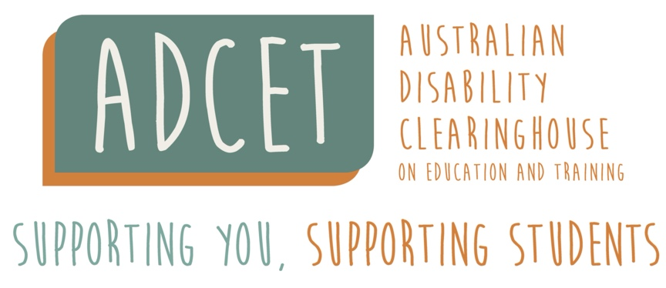

## Background

In July 2020 the Australian Disability Clearinghouse on Education and Training (ADCET) was provided with a grant by the Department of Education, Skills and Employment to respond to the impact of Covid-19 on the participation of students with disability in tertiary education. As part of this grant, we surveyed staff in the sector about the impact on their work during a time when most if not all tertiary providers in Australia were delivering all their courses on-line, and staff were required to work completely from home.

This sudden transition to working from home came with several challenges and pressures for some staff, such as finding an appropriate space to set up a home office, balancing work with looking after children or home schooling, access to a good internet connection, keeping up with changes, or being able to draw a line between work and home. However, overall [we found](https://www.adcet.edu.au/resource/10398/survey-report-beyond-covid-19) that many in our sector found that being able to work from home was one of the silver linings that emerged from the disruptions.

Staff reported that working from home can provide greater flexibility and increased opportunity for a better work and home life balance. Benefits noted were:

* Less commuting time
* Flexibility to choose hours more conducive to contacting students
* Able to better juggle other responsibilities
* Time for more exercise and other positive lifestyle factors
* Using technology to connect better with regional colleagues.

[Studies](https://www.sydney.edu.au/news-opinion/news/2020/09/28/australians-want-to-work-from-home-more-post-covid.html) suggest that as we return to our ‘normal’ routine many of us want to continue working some of our week from home. Likewise, we also found many in our sector hope to be able to have options to blend both on-campus and at home working arrangements in the future. This would enable us to be on campus for those tasks that need us to be there, benefit from having colleagues around us, and building rapport with students while at the same time continue to tap in the advantages of working from home when possible.

No wonder [organisational consultants](https://www.mckinsey.com/business-functions/organization/our-insights/reimagining-the-postpandemic-workforce) are predicting the emergence of new models of working arrangements post the pandemic whereby there is a combination of remote and on-site working in recognition that this can improve flexibility, employee experiences, and productivity.

## These Good Practice Guidelines

These **Working From Home Good Practice Guidelines** do not advocate for or against working from home, not do they explore the practical set up of home offices, but rather they provide some general considerations for ourselves, our leaders, colleagues and teams that can help us decide if a working from home or blended working from home options may be the right fit, and if so how do we maintain our connections with our colleagues, motivation, engagement and wellbeing during the process.

## Is working from home for me?

Here are some steps we can go through to help determine if working from home, either as a total or blended arrangement is for us.

1. It is important to note that each tertiary institution may have different policies, parameters and procedures about work working from home options. Some tertiary providers are keen to get staff and students back on campus to encourage vibrancy, connections and a sense of returning to normal. The first step is to check the options available to us in our workplaces. For example, some tertiary providers offer working from home options for employees with health conditions or who are over a certain age.
2. Secondly, we need to determine how much of our work can be done effectively and efficiently from home. While we may have got by with doing things from home during COVID restrictions this may not necessarily mean that it’s the best way to continue. For example, [we found](https://www.adcet.edu.au/resource/10398/survey-report-beyond-covid-19)  that some aspects of our work such as meeting new students or demonstrating Assistive Technology is better done face-to-face with students. While support staff who have little or no direct face-to-face contact with students it may be possible to do all tasks from home, whereas support staff who provide direct support to students on campus will find it impossible to have work at home options.
3. Consider how our working from home plans might impact on our teams. There are advantages of having our colleagues around us on campus. We’re more likely to ask for help or advice, run an idea past them, or offer to help them out. And it leads to informal interactions that can boost our mood, motivation and performance. This might mean that we coordinate our choice of blended work from home and on-campus days with other team members to provide an optimal coverage that meets both our needs and our team’s needs.
4. Ensure we have adequate space, technology, internet connection, and privacy in our homes. While we might have got away with the side of the kitchen table during COVID restrictions if we’re setting up an office long term we need one that provides an appropriate working space, and also one that allows us to delineate between it and our personal home space.
5. Develop strategies to sustain our connections, motivation, engagement and wellbeing by using these guidelines to guide considerations and actions.

## Encourage informal interactions

Most of us may recall many times when a casual informal chat with a colleague on campus has given us some new information or insight, sparked a new idea, motivated us to follow something up or even just boosted our mood. These not only can help us in our roles, but also can contribute to cohesion, trust and a shared culture. However, when we work from home, we can miss out on those everyday incidental interactions that make things easier for us and build connections and the critical social cohesion our campuses need. Instead, we can risk feeling isolated, disconnected, or left out, all of which can impact on our wellbeing and motivation.

Consider how to foster a sense of belonging, common purpose, and shared norms with co-workers regardless of if they are on-campus, at home or a combination of both. Establish ways to regularly connect with colleagues in both formal and informal ways each working day to build social cohesion and trust. For example, you might want to structure a time for free discussion in staff meetings, use Zoom break out rooms in large meetings so people can have a say, organise some virtual coffee dates or Friday drinks, or send check-in texts.

Consider ways to bring people together face-to-face when possible. No matter how good we get at using online platforms to connect with each other, we still can’t disregard the value of face-to-face interactions. The nuances [can help foster](https://www.mckinsey.com/business-functions/organization/our-insights/reimagining-the-postpandemic-workforce) deeper connections and greater trust, creativity and collaboration.



**Case Study: One team strengthened their connections by setting aside 10 minutes each day for a quick Zoom Check in. The focus was on general chit chat about what was happening in people’s lives, news and current affairs and of course the latest Netflix favourite watch. And at the same time avoiding talk about work. And they took this to the next level with their monthly Friday night virtual social catch-ups where they played online games. Who know virtual scattegories and Pictionary could be so much fun?**

## Trust in Trust

It seems that many are wondering are we really working as hard at home as we did in the office, and even if we have been for the last year can we keep working this hard when there can be so much to distract us when we’re at home. And it’s not easy to put our trust in something that we can’t see for ourselves.

Trust is vital– it’s like the glue that holds everything together and allows our teams to thrive and do our best work. [Fostering communication links](https://hcleadershipessentials.com/blogs/team-development/10-rules-for-building-trust-and-developing-accountability-on-your-virtual-team) that are strong enough to overcome challenges of the isolation and uncertainty of working off campus is important to build trust. Be clear on discussing expectations, team goals, agreed values, and the impact of current issues to created sharing understandings and ground rules for positive behaviours. We can also build trust and accountability in virtual teams when we show we are reliable by getting work done when we say we will have it done.

Consider the [following exercise](https://hcleadershipessentials.com/blogs/team-development/10-rules-for-building-trust-and-developing-accountability-on-your-virtual-team) to build greater trust within teams: Ask everyone to list the behaviours associated with building trust and ones they associate with breaking trust in virtual teams. For example, building trust might include meeting deadlines, acknowledging others work, sharing information, helping others and good listening. Whereas breaking trust might include missing deadlines, taking credit for others work, covering up mistakes and ignoring others. Then determine how you will hold each other accountable for these trust behaviours.

Consider in our leadership roles how we can [ditch our trust issues](https://www.gallup.com/workplace/258197/why-leaders-employees-trust-don.aspx). If we find we don’t trust someone then we need explore how as a leader we enabled this to happen and take some accountability for the part we played. Then look to past performances of the other person to tap into their strengths and intrinsic motivators as a way of engendering more trust.

## Create ‘safe’ spaces

[Research suggests](https://hbr.org/2017/08/high-performing-teams-need-psychological-safety-heres-how-to-create-it) that our highest-performing teams have one thing in common - psychological safety. When we work in teams that are psychological safe we feel we can generate and implement new ideas, take moderate risks, speak our mind, and make mistakes without fear of being punished or shamed in some way. [Simply put psychological safety describes](https://www.michellemcquaid.com/is-your-team-safe/) a team environment where you’re not tied up in knots about the interpersonal risks of looking stupid, negative or intrusive in your colleagues or manager’s eyes.

We [may need to take more care and attention](https://www.mckinsey.com/business-functions/organization/our-insights/reimagining-the-postpandemic-workforce) to create and maintain psychological safety when some people are working on-campus and some are working from home. Unfortunately, we can be [more fearful](https://hbr.org/2020/08/how-to-foster-psychological-safety-in-virtual-meetings) about raising concerns or dissent and taking innovative risks, and less likely to feel that others will come to our defence if we’re working from home.

Consider how to use technology, such as Zoom Breakout Rooms to provide a safe space for team members to discuss issues, raise concerns, learn from mistakes, and ask for help.

Consider how to amplify the psychological safety in your team’s culture by normalising feedback loops and learning from mistakes.

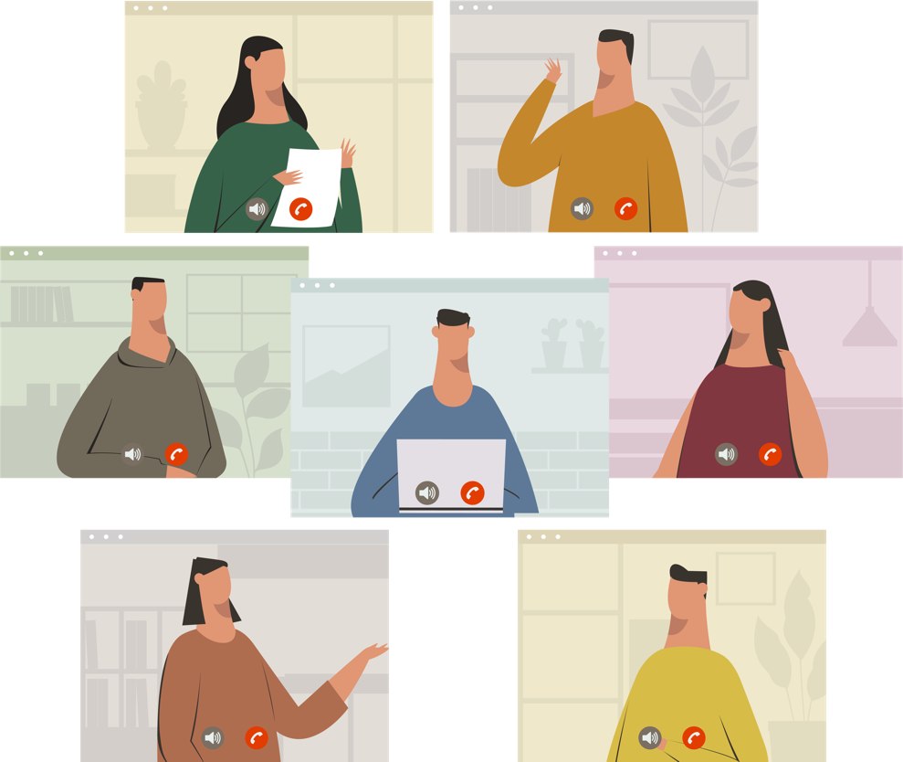

**Case Study: Zoom breakout rooms were used by one team of twenty in their monthly meeting. Staff were randomly allocated to rooms of up to 4 people where they took in turns in answering the question about the last month: What went well? What didn’t go well? What did you learn or do differently? What help might be useful?**

## Increasing intrinsic motivation

Our intrinsic motivation, self-regulation, performance and engagement in our work tasks [is likely to be higher](https://selfdeterminationtheory.org/the-theory/) when it fulfills basic psychological needs for autonomy, competence, purpose and relatedness.

[Research indicates](https://core.ac.uk/download/pdf/154352834.pdf) that working from home can meet our need for autonomy – ability to choose when and how we do our work – and thereby increase our work effort. Our need for competence – our desire to be skilled and acquire new skills, take on challenging tasks, and perform well – [can also be fulfilled](https://www.ncbi.nlm.nih.gov/pmc/articles/PMC4102582/) as we gain new experience and capabilities in blending on-campus and off-campus work requirements. However [we may struggle](https://www.ncbi.nlm.nih.gov/pmc/articles/PMC4102582/) with our need for relatedness – feeling connected to others – when we are working from home.

Consider how the psychological needs may impact on choosing and implementing blended work arrangements for individuals and teams. How might intrinsic motivation and self-regulation be considered in terms of autonomy, competence, purpose and relatedness and included in conversations?



**Case Study: One university staff team started a 'virtual bookclub'. Team members set aside a time each week to access a webinar or podcast of their choice, and take it in turns to share their findings or key messages they gained with others during the regular team meeting. Motivation was high to be involved as staff could choose a topic they felt was relevant and interesting, and they appreciated the opportunity to become more knowledgeable about the area and hone their presentation skills. Other staff also enjoyed growing their skills and knowledge.**

## Leadership that supports Working-from-Home

Studies [indicate](https://www.gallup.com/workplace/317681/remote-work-outcomes-depend-manager.aspx) that mangers play a critical role in how engaged, connected and productive we are as a team that includes staff who work from home. It’s important for managers to be exceptionally clear about expectations, and very intentional about connecting with team members. It also works well when managers rely less on [hierarchical command-and-control structures](https://hbr.org/2012/06/leadership-is-a-conversation) of leadership and more on [conversational, coaching](https://hbr.org/2012/06/leadership-is-a-conversation), and i[nspirational leadership styles](https://www.linkedin.com/pulse/becoming-lessons-from-mckinseys-inspiring-women-leaders-mwangi/), and developing [agile and independent small teams](https://www.mckinsey.com/business-functions/organization/our-insights/unleashing-the-power-of-small-independent-teams). Small independent teams also have the additional benefit of helping break down silos.

[“Physical proximity between leaders and employees isn’t always feasible. But mental or emotional proximity is essential.”](https://hbr.org/2012/06/leadership-is-a-conversation)

Consider the development of [a leadership strategy](https://www.gallup.com/workplace/310988/covid-19-working-from-home-guide.aspx?g_source=link_WWWV9&g_medium=speedbump) that supports autonomy, motivation, trust, psychological safety and wellbeing for people working from home. And includes ways to increase communication and create virtual open-doors within and between teams.

Consider ways to [move away](https://www.mckinsey.com/business-functions/organization/our-insights/unleashing-the-power-of-small-independent-teams) from measuring our work productivity and value by the number of hours spent sitting at desks on campus or home. Instead find ways to define work by the expected outcomes and/or achievements, for example how many Learning Access Plans or student appointments might we expect from our team.

## Our wellbeing

Creating healthy habits can help us care for our physical and mental wellbeing both during our on-campus and our at-home work routines. This can include eating well, sleeping well, regular exercise connecting with others, disconnecting breaks from technology, fostering helpful mindsets, reframing stress, or developing a mindfulness practice. Regardless of what we decide to do, what’s most important is being intentional in some way each day. It’s OK to start small, and as our confidence to make positive change grows so too can our habits and the changes we’ll see.

Consider what areas of wellbeing to focus on. An easy way to do this is to assess our current wellbeing, set some goals of where we might want to be, and track our changes with the free [PERMAH Wellbeing Survey](https://permahsurvey.com/) or [Work on Wellbeing](https://www.workonwellbeing.com/index.php).

Consider any signs of colleagues working from home who seem like they may not be coping or doing OK. Take time to call them for a chat and include in team events. If needed encourage them to ask for help or use employee assistance services.



**Case Study: Despite the restrictions and difficulties of 2020 staff from one university still were able to form teams to actively participate in their annual 10 000 steps Challenge. The steps multiplied quickly up as staff teams competed against each other to be the team with the highest overall and highest average steps per team member. But more importantly it was a catalyst for many staff to recharge their fit bit and re-establish or start a habit of regular exercise that is helpful for our physical and mental wellbeing.**

## Conclusion

In conclusion we hope that these guidelines have been helpful to inform conversations and arrangements for individuals and teams. However, know that you may not get it right at first, and it can be important to be kind to yourself and others as you find the right balance for you, your team, your students, and your education provider.

We welcome any feedback on these guidelines and are keen to hear any case studies or innovative practices. Please share these with us [admin@adcet.edu.au](mailto:admin@adcet.edu.au).

For more resources visit: <https://www.adcet.edu.au/covid-19-faqs/staff-support/working-from-home>.