Australian Disability Clearinghouse on Education and Training
| www.adcet.edu.au
August 2020

Beyond COVID-19
The impact of covid-19 on disability practitioners in the tertiary education sector
Survey Report

Contents
Executive Summary 3
Background 4
Context 4
Our Survey respondents 4
Key Findings 5
Engaging with Students 5
What worked well? 5
Flexible communication modes 6
Proactive Contact 6
Content and Approach 7
Difficulties engaging students 7
Student state - Low Emotional Wellbeing or complex issues 8
Intrinsic Disadvantages 9
Student situation 9
Increased Workloads 9
Supporting Students with Disability during COVID-19 10
Adjustments provided 10
Disability-specific assistance provided 12
Selection of examples 12
Additional challenges faced by students with disability 13
Selection of examples 14
Observations and Insights 16
Students with pre-existing mental health conditions 17
Students on the Autism Spectrum 18
Students with Sensory disability 18
Students with other disability 18
Students with ADHD 19
Systems Issues 19
Emotional and Social Wellbeing Impacts 20
Positive Impacts 20
Working in the Sector – The Impact 21
The overall challenges 21
Working from home 22
Emotional and Social Wellbeing Impacts 22
Budget constraints 23
Student Interactions 23
Additional workloads 23
Communication 24
Positive or neutral impact 24
Overcoming these Challenges 24
Training and/or Shared practices 25
Policy and/or strategies 26
Advocacy and/or training for academic staff 26
Better processes and/or resources 26
The Silver Linings 27
Openness to technological solutions 28
Inclusive teaching and learning 29
Flexible Work Arrangements 30
Connections, Compassion, Creativity and Cohesion 30
ADCET COVID-19 support 31
Helpfulness of COVID-19 supports to sector 31
Additional Feedback 31
Time constraints 32
Future COVID-19 related topics 32
Return to campus 33
Opportunities and Silver Linings 33
Learning from the challenges 33
On-line delivery best practices 33
Universal Design or technology 33
Preference of mode for information 34
Recommendations 34

Executive Summary
This report provides analysis and presents key findings from a scoping survey into the impact of the COVID-19 restrictions on the Disability Practitioner role in Universities and TAFE’s. (Tertiary sector)
The results highlight the commitment and fortitude of staff in the sector. Despite the challenges of: abruptly shifting to working from home; dealing with restructuring and fiscal uncertainties within the sector; increased workloads both in volume and levels of complexity; and multi-layered collaboration this survey indicated that disability practitioners continued to provide students with essential advocacy, adjustments and supports. Often this meant supporting students to navigate around unforeseen obstacles and adapt to change at the same time as they may have been struggling to do the same themselves. As one respondent commented there was an:
“overwhelming feeling of having to support everyone (staff, students and family) but you are operating in the same "never seen before" vacuum of experience as everyone else. Knowing you need to look after your own mental health but not actually having the time or space to do so because you can’t let your team/students/family down in the middle of a global crisis......”
The survey also draws attention to the difficulties many students with disability experienced in adapting and coping with the disruptions. Most prevalent were mental health related, motivation, adapting to change and planning or organising their study. The survey found that students on the autism spectrum, or with pre-existing mental health conditions or ADHD were identified as more likely than others to face challenges with their studies. Students who used Auslan or were lip readers also faced challenges in accessing the on-line material.
However, while students with disability were impacted, the level of impact varied. Many students, including those on the autism spectrum and with mental health conditions not only adjusted well to the changes, they enjoyed them and even flourished in an on-line learning environment.
Respondents reported that proactive contact with students and colleague to check in, and having different communication modes, especially video conferencing technology such as ZOOM enabled engagement with students and staff, and with the increased confidence in usage and benefits it is likely to be an ongoing tool for student and staff engagement.
This survey also found that the flexibility, considerations and supports for students – academic and financial - from institutions were very helpful during this time. One of the biggest silver lining to emerge was the notable shifting of many practices, attitudes and mindsets towards more inclusive teaching and universal design. Necessity seems to have helped quickly break down some long-standing barriers, and there was hope expressed that the progress made will not only be sustained but will be built upon. However, this also created some quandaries about the provision of adjustments in more inclusive practice contexts that will require further discussions.
While some respondents found the range of ADCET resources to support the sector during COVID19 to be helpful, it seems that many people did not assess them due to time limitations, but appreciated knowing that they were there, nonetheless.
This report makes 18 recommendations that includes sustaining and enhancing the silver linings and critical success factors that emerged, progressing the moves towards more universal design, responding to the needs of Deaf and hard of hearing students, providing smaller ‘bite-size’ training and information sessions for staff, addressing the compassion fatigue, and investigating options for further research on the impacts on student retention.

Background

Context
From early 2020 Australian tertiary education institutions and providers first felt the impact that a new strain of coronavirus, when Australia shut its borders to with international students from infected zones. Since then the virus has been named COVID-19, and dramatically disrupted tertiary education with the introduction of physical distancing restrictions. Students and staff were required to be off campus, courses were converted to on-line study, and services, including those provided to students with disability were delivered remotely. Concurrently our social, health and economic systems were going through considerable upheaval and restrictions.
In July, the Australian Department of Education, Skills and Employment provided grant funding to Australian Disability Clearinghouse on Education and Training (ADCET) to facilitate an effective, nationally cohesive response to address the unique challenges of COVID-19 for disability practitioners in tertiary education.
This included surveying the sector regarding the impact of COVID-19 to:
- identify the key issues and needs for disability practitioners and students with disability;
- capture and collate the key learnings and opportunities; and,
- guide the sector nationally post COVID-19 towards improved inclusive practice informed by the principles of Universal Design for Learning (UDL).
As KPMG suggests this could be a moment for transformative change, a catalyst to choose to do things differently to meet the diverse needs and styles of our learners, rather than reverting to old ways post coronavirus restrictions.

Our Survey respondents
An email was sent to over 500 people, who are subscribers of the ADCET newsletter and Aust-ed listserv, inviting them to participate in the survey.
The survey was completed by 110 people, comprising Disability Practitioners (50%) Disability Services Manager (23%), Disability Servicers Support Worker (11%) and other roles (16%). The other roles included NDCO, academic teachers or advisers, librarians, equity officer and careers.
Most of the respondents worked in a university setting (71%), while 17% were from TAFE, 9% from the dual sector, and 3% in other settings. The representation from the different settings, that is university, TAFE, dual and other is aligned with the proportion of ADCET subscribers and Aust-ed list from these respective institutions.

Key Findings

Engaging with Students
The majority of respondents (41%) reported that overall, it was neither easy nor difficult to engage with students during COVID-19. While 8% found it very easy, and 29% found it easy. However, some reported it to be either difficult (21%) or very difficult (1%).
Most respondents felt confident providing support remotely, in particular they felt either extremely confident (15%), very confident (38%), or somewhat confident (43%).
And 5% of respondents did not feel so confident, but no one reported that they were not at all confident.

What worked well?
Ninety-two respondents shared what worked well for them when engaging with students during this time. Some people shared more than one thing that went well. These were categorised in the following areas:
- Flexible communication modes
- Proactive contact
- Content or approach
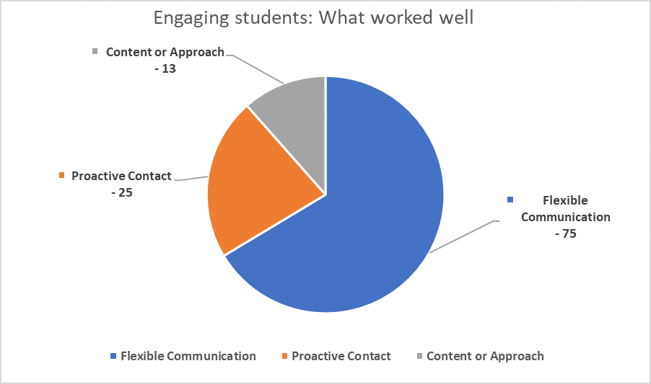
What worked well | Comments
Flexible Communication | 75
Proactive Contact | 25
Content or Approach | 13

Flexible communication modes
There were 75 comments about the benefits of having a flexible range of options for students to choose from – email, phone, and video-conferencing- enabled institutions to continue to deliver services. Preferences were mixed, with most respondents commenting that phone or video conferencing such as Zoom were favourite options.
And while email may have worked for some students it wasn’t always successful as response times were slower, there was a feeling that students have been “bombarded with emails” and having an actual conversations on phone or video conferencing had more impact than sending emails.
“Trying to encourage students to communicate in real time (via Zoom) rather than emails where issues can be misunderstood, or email trails get very long trying to work out what is going on.”
Nearly half of the comments referred to the specific video-conferencing platform Zoom. The benefits included: the ease of use; the share screen options so students could be shown information and given step-by-step advice; and sharing documents.
- “ZOOM has been a lifesaver!”
- “Using ZOOM instead of phone calls whenever possible, so that you can still get a read on student’s non-verbals.”
Comments suggest that many students found the remote appointments easier and preferable to face-to-face appointments. Reasons given were for efficiency, flexibility, convenience and mental health.
- “Students have anxiety about face to face meeting - this helped to overcome this and provide them with reassurance and access to advice and services.”
- “Adjusting the time of appointments to suit students for out of hours appointments, where in the past this did not suit due to working on campus.”
It is also worth noting that some institutions were already offering a range of remote services to their on-line students, so for some staff and students the change was minimal.

Proactive Contact
Twenty-five comments indicated that many tertiary institutions stayed connected with their students with proactive strategies such as:
- Weekly newsletters
- Short regular updates
- Personalised individual emails
- Regular phone check-ins on progress and support needs
- Lots of contacts
- Through already established mentors

- “Checking in with students, rather than waiting to hear of issues. Connecting students to support services like counselling.”

Content and Approach
There were 13 comments regarding the content and/or approach taken when interacting with students. This included:
- Giving practical suggestions and sharing resources such as daily planners and assessment tools
- Spending time asking questions about how they were coping and what assistance they needed
- Demonstrating empathy and understanding that times are difficult, and while some students have enjoyed it, others have not
- Listening, asking questions, giving contact options and being ready to be surprised
- Being very responsive to returning phone calls and emails
- Providing clear messaging
- Being able to interact with them with fewer distractions than in the office environment
It was also felt that students have been reassured by having the same practitioner providing the same types of services during this time.
- “When engaging with students, it is important to listen and understand each student's needs, to allow the student to explain how their disability/medical condition and environment has impacted on their learning and supporting each individual by providing choice to engage with their studies either through on-campus or working/learning from home to achieve their personal learning goals.”

Difficulties engaging students
Ninety respondents provided comments on the difficulties they faced when engaging with students during COVID-19.
These fell under four categories:
- Student state – of emotional wellbeing and/or experiencing complex issues
- Intrinsic disadvantages to remote interaction
- Student situation
- Increased workloads
It is also worth noting that nine respondents noted that they had experienced no concerns with contacting student during this time.
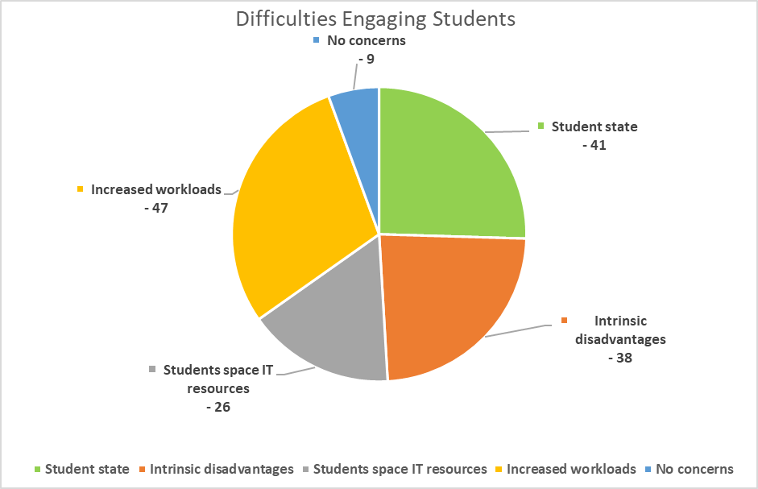
Difficulties Engaging Students | Comments
Student state | 41
Intrinsic disadvantages | 38
Students space IT resources | 26
Increased workloads | 47
No concerns | 9

Student state - Low Emotional Wellbeing or complex issues
Respondents report that it was difficult to contact students who were experiencing low levels of emotional wellbeing, such as struggling to maintain momentum, feeling anxious, feeling disconnected, or were overwhelmed by the changes.
- “The inherent sense of disconnectedness that some students felt as a result of studying online required additional effort when reaching out.”
- “There have been some students with more complex issues, that have found it difficult to engage, if it’s not face-to-face. With these students, no matter what strategy I tried to develop, to connect with them, it seems as it has not been successful.”
- “Students are impacted by more than their disability ie lost jobs, fear of getting COVID-19, family members impacted, homelessness, unable to access specialist appointments etc.”
- “A lot of students were worrying about things outside of their education, so classes/assignments were not on the top of their priority list.”

Intrinsic Disadvantages
There are some intrinsic difficulties in remote communication, in that you just need to be face-to-face for some tasks and for some students and for some of the time. These included:
- Students with complex needs find it difficult to complete and submit paperwork
- Providing physical space appraisals and facilities orientations
- Building rapport with new students for the first time
- Using body language and other visual cues (especially in initial appointments)
- Communication with students with hearing impairments
- Students distracted while on phone appointments
- Demonstrating assistive software and hardware
Additionally, one respondent commented that they found it more difficult to engage students as they were not able to easily access moral support from their colleagues.

Student situation
There were difficulties engaging some students due to IT issues or their living arrangements such as:
- Limited or no access to adequate study spaces
- Limited or no technology
- Requiring Assistive Technology
- Inadequate or no internet connection
- Lack of IT skills or confidence
- Financial concerns

- “Students of Muslim faith had Ramadan fall during this time, which when compounded with other factors made it difficult to attend sessions from a suitable location.”
- “Students had no desk or table in a room where they could participate in learning sessions. This meant they either sat/lay in bed, or were in a room with other family members around. Neither were ideal for maintaining engagement. “

Increased Workloads
Many comments indicated that increases in workload demands and complexities caused difficulties engaging with students. This included:
- Increased number of contacts and enquiries
- Additional time to carry out tasks
- Difficulties accessing staff or resources
- Adapting to new procedures and processes
- Needing capacity to quickly arrange adjustments
- Increased complexity of arrangements, eg Exams
- Increased complexity of student’s situations
- Contacts from students struggling much more than usual
- Dealing with changes and future uncertainties
- Adapting to working from home

- “Even the simplest tasks (eg extension request, exam provisions) have a story attached and it takes more time.”
- “The added layers of trauma students bring to discussions about participation, and having to sort out what is ours to manage and what is the student's”
- “University exams has proved complex with alternative online arrangements not always working for students.”
- “The amount of emails coming through from the wider university has made it difficult to stay updated and ensure student emails aren't missed.”

Supporting Students with Disability during COVID-19

Adjustments provided
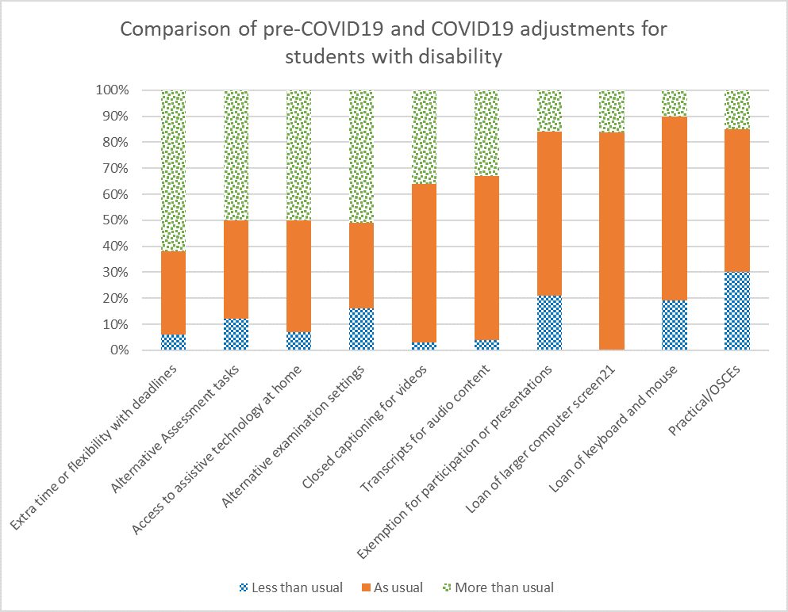

Adjustments provided | Less than usual | As usual | More than usual
Extra time or flexibility with deadlines | 6 | 32 | 62
Alternative Assessment tasks | 12 | 38 | 50
Access to assistive technology at home | 7 | 43 | 50
Alternative examination settings | 16 | 33 | 51
Closed captioning for videos | 3 | 61 | 36
Transcripts for audio content | 4 | 63 | 33
Exemption for participation or presentations | 21 | 63 | 16
Loan of larger computer screen21 | 0 | 67 | 13
Loan of keyboard and mouse | 19 | 71 | 10
Practical/OSCEs | 30 | 55 | 15
As noted in the previous section this survey found that the workload of some in the sector increased due in part to increased enquiries and complexities during this time. This survey found a range of adjustments were arranged at a rate more than usual.
Providing extra time or flexibility with deadlines was the most likely to be arranged (62%) at a rate more than usual during COVID-19 compared to pre-COVID 19.
Around half of the respondents also reported that they arranged more alternative examination settings (51%), alternative assessment tasks (49%) and access to assistive technology at home (49%) compared with pre-COVID19. While around a third of respondents arranged more closed captioning for video content (36%) and transcripts for audio content (33%). Some respondents arranged more than usual exemptions for tutorial participation or presentations (16%), practicals/OSCEs (15%), loan of larger computer screens to counter fatigue or eye strain (13%) and loan of keyboards and mouse for laptops to reduce ergonomic risks (10%).
The adjustments that were most likely to be arranged at the same rate during and pre-COVID19 were loans of keyboards and mouse (71%), loans of larger computer screens (67%), exemptions for tutorial participation or presentations (63%), transcripts for audio content (63%), closed captioning for video content (63%) and practicals (55%).
The notable reports of adjustments provided less frequently during COVID-19, include practicals/OSCEs (30%), exemption for tutorial participation or presentations (21%), loan of larger computer screens (21%) and loan of keyboards (19%), alternative examination settings (16%).
Comments indicated that other differences between COVID and pre-COVID-19 included:
- Increase in the facilitation of access to academics
- Organizational and time management interventions
- Requests for cameras not to be on during class
- Organising real-time note-takers via Zoom for hard of hearing students who would not need this on-campus
- Students who were hard of hearing and/or who lip read and had not reached out for assistance previously
- Considerably more emotional support for students with low motivation or low mental health
Three respondents also raised that while students with disability may have found the greater flexibility for extensions and exams for all students to be helpful this raised some difficult equity dilemmas. For example, when generous additional time for exams or assignments is granted to all students, then should students who need extra time have this in addition? Or is there a need to adopt a universal design approach?

Disability-specific assistance provided
Sixty-one respondents provided examples of how they had assisted a student with disability-specific challenges that impacted on COVID-19 remote learning arrangements. These examples have been categorised in the following areas:
- Adjustments for Deaf or hard of hearing students (12 examples)
- Adjustments for students with vision impairment (3 examples)
- Equipment and Assistive Technology (11 examples)
- Examinations (15 examples)
- Motivational and adapting to change (6 examples)
- Assessment and class participation (17 examples)

Selection of examples
- “Students who have a hearing impairment have found the online format very difficult to participate fully. Closed captioning, close work with tutors, additional exam adjustments and further extensions have all been required.”
- “Providing transcriptions of lectures/tutorials/workshops when previously the students were lip reading.”
- “Student that is normally in class with notetaker and Auslan interpreter. When lectures moved online, organizing with the learning area to give access to the notetaker to sit in on the lecture online and the notetaker to then email the notes to the student after. Access also given to Auslan interpreter to access the lecture online and set up a separate Zoom or 3CX session with the student to sign through.”
- “Vision impaired student who does not have the experience using screen reader for online tests; Provided a participation assistant based rural to assist with reading/writing/invigilation during the examination. Went smoothly. Training for the student for screen reader provided after exam period.”
- “Instead of a face-to-face induction session for our assistive technologies rooms, this has been done via Zoom. There are some issues with this as I am unable to demonstrate some of the hardware available in the room, but I am able to demonstrate some of the software via screenshare.”
- “Provided student via Equity Scholarships with access to a laptop and internet data / sent hard copy exam paper to student home also.”
- “Working with the Office of Teaching and Learning to provide more Universal Design assessments for example a take home exam with a 24-hour completion time.”
- “Due to increased screen time I negotiated alternative exam format as exams were meant to be online and student felt that there would be disadvantage because of this.”
- “I have been able to provide speech to text/text to speech software as an option for online exams for students who may normally have had a scribe/reader for onsite exams. Most students seemed to be happy to have this option, and may prefer to use it as an alternative arrangement for future exams.”
- “Organising an alternative assessment to a student who normally would of had a reader/scribe within an exam centre, negotiated with unit coordinator for a verbal assessment for this student via skype.”
- “During online exams, students had provisions for extra time. This student did not have access to a laptop and had to apply for emergency funds to purchase one.”
- “Arranged study skills tuition sessions, that were previously face to face, by email and phone as this was student's preferred method.”
- “The team have converted on campus mentoring programs to online with initial support. Notetaking services have been offered remotely and likely will continue.”
- “Many students who have not been able to get documentation have put support in place while they wait to get appropriate documentation. Often this was just for extra time for assignments or exams. “
- “A student with PTSD who has requested not to have their video on in any Zoom sessions - ensuring that appropriate advice has been sent to all relevant staff.”
- “Wrote a letter of support for an extension of PhD candidature due to COVID-19 challenges.”
- “Mainly in assisting students to communicate with their academics to find out what might be possible (or not). Given that changes had to be put in place in a hurry, we were not always able to ask the academics to do more than they already were. Where options were not available/suitable, assisting students with understanding Uni policies around withdrawing/ remission of fees/ counselling support/ where to get advice about adjustments to their study plan.”
- “Many students were assessed to be vulnerable to exacerbation of conditions due to isolation. Regular engagements with academics were arranged to promote engagement and communication.”

- “Providing fortnightly 'checkpoint' meetings via zoom to review goals, milestones and problem solving as impact of isolation on student's health and progress was significant. Student had previously failed unit 5 times and is now completed and ready to graduate.”

Additional challenges faced by students with disability
Many students with disability experienced additional challenges during COVID-19 restrictions.
Mental health related challenges were the most prevalent challenge, either noted very often (33%) or often (47%). Students also faced challenges with motivation, noted very often or often by 31% and 42% of respondents respectively. Similarly challenges with adapting to change were noted very often by 24% and often by 43% of respondents. Physical isolation challenges were noted very often by 13% and often by 53% of respondents.
Financial challenges were also noted either very often (18%) or often (43%).
Challenges relating to experiences of domestic violence were the least prevalent, either not being noted at all (36%) or rarely (36%). Other less prevalent challenges observed were limited typing skills, either not noted at all by 13% or rarely noted by 41%, and access to essential course-specific software not noted at all by 17% and rarely noted by 24%.
Additional challenges faced by students with disability | Not at all | Rarely | Sometimes | Often | Very Often
Disability Related | 3 | 7 | 36 | 39 | 16
Motivation | 2 | 3 | 24 | 42 | 30
Course materials | 3 | 17 | 39 | 32 | 9
Course structure | 1 | 9 | 46 | 36 | 8
Physical isolation | 1 | 7 | 25 | 53 | 13
Mental health | 4 | 0 | 16 | 47 | 33
Financial | 5 | 4 | 29 | 43 | 18
Lack of reliable internet | 3 | 5 | 42 | 37 | 13
Access to computer hardware | 4 | 12 | 47 | 28 | 9
Access to essential course specific hardware | 17 | 24 | 39 | 20 | 0
Limited typing skills | 13 | 41 | 37 | 7 | 3
General study environment at home | 3 | 16 | 39 | 34 | 8
Planning and scheduling | 4 | 8 | 33 | 33 | 22
Adapting to change | 0 | 4 | 29 | 43 | 24
Family responsibilities | 1 | 3 | 46 | 39 | 11
Family violence | 36 | 36 | 25 | 4 | 0

Selection of examples
Fifty-six respondents shared examples of how they have helped a student with disability overcome general challenges during COVID-19. Many of these examples highlight the additional depth and breadth of the disability practitioner role during this time. The types of assistance fell under the following categories:
- Motivation, time management and general wellbeing support (16 examples)
- Advocacy to and collaboration within institution (17 examples)
- Linking students with internal counselling services (11 examples)
- Referral to financial supports (13 examples)
- Referral to external agencies (6 examples)
- “Some students have indicated that they have struggled to manage their studies due to motivation, poor time management and prefer face to face. For those students who have expressed this, I have provided generally fortnightly phone calls to monitor their progress to assist them to keep on track.”
- “Continuity of support for a student on the spectrum who has returned overseas. Being able to have Zoom session with him and his family have allowed him to continue his study and has enabled his family to feel fully supported.”
- “Frequent triage of multi layered challenges including lingering impacts on families from bush fires early in 2020. Most often involving step by step breakdown of steps required to address needs.”
- “Being there to listen to their story and providing important information about services and financial assistance that may be available to them.”
- “Providing online tutorials of how to access resources.”
- “A lot more frequent contacts with students throughout the semester to provide whatever support they need, and trying to keep them up to date with information about changes as it is available. More family/other contacts with concerned parents/partners- especially in relation to increased mental health difficulties.”
- “There have been some study spaces available on campus - they were in high demand with long waiting times which were very difficult for some students with disability. We advocated for more spaces to open so that all could be accommodated in a timely way.”
- “Mature aged student did not feel confident about typing her exams online, due to typing speed. She also felt less able to study in the online environment due to childcare issues. I arranged for her to speak with the associate Dean of the School to provide her feedback in person (over the phone) so that she felt her comments were listened to by an actual person.”
- “For one student at risk of isolation and with no technology we did a range of things. We worked with their DES providers and social worker to provide technology. - We worked with the student to find a suitable phone and home internet plan - The DES provider paid for a laptop - The social worker supported them to develop a budget to pay for internet - The social worker paid for installation of internet equipment and set up of computer (through Anglicare, not sure of program) We worked with our on campus supports to reduce the risk of social isolation. - Our counsellor made several calls during the term break to chat - Our library staff supported the student to use a library computer for limited times until the home set up was complete (this was actually a really important part as the library staff also chatted and it meant the student could get out of their house). - We dropped off and posted printed resources and the class pot plants to the student, so they had activities to do at home.”
- “Worked closely with academic staff and students with disability to negotiate reasonable and fair alternative assessments.”
- “Have found the support of teaching staff has been critical. One student experienced issue after issue this semester due to COVID-19 and this has compounded the impact of their condition. The Unit Coordinator went out of their way to provide as much flexibility as was in their power to, and this has made a huge difference.”
- “DA appointments tend to be a forum for some general discussion around many issues so apart from developing LAPs there is often referral to required areas of the university for other student issues. Therefore linking students with student advocates, counselling, student learning, etc all remotely - to assist with specific issues has been helpful.”
- “Arranged academic support worker (sight aide) to assist student(s) with vision impairments to 1) attend classes remotely 2) describe visual content 3) scribe and submit assessments.”
- “Connected a student with our Social Support Advisor as he could not afford to pay for internet, and therefore could not participate. SSA had delivered vouchers by the end of the day to student to pay for internet. I increased time to submit assessments on Access Plan so he had time to catch up.”
- “The student that I helped did not have access to a laptop and I assisted by directing them to apply for emergency funds provided by the university for this purpose.”
- “Support with connecting to their NDIS provider, support with applying for free laptop/internet loan and connections to university supports available remotely.”

Observations and Insights
Seventy-six respondents provided further comments on trends and impacts that they observed during COVID-19. Some of these were in relation to specific cohorts of students and others related to general impacts on students with disability. These observations fell under the following categories:
- Students with pre-existing mental health conditions
- Students on the Autism Spectrum
- Students with sensory disability
- Students with other disability
- Students with ADHD
- Systems issues
- Emotional and social wellbeing impacts
- Positive impacts

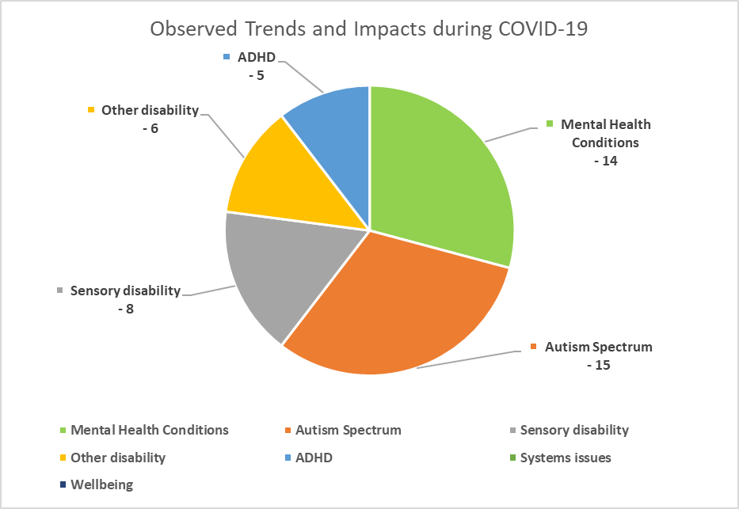
Observed Trends and Impacts during COVID-19 | Comments
Mental Health Conditions | 14
Autism Spectrum | 15
Sensory disability | 8
Other disability | 6
ADHD | 5
Systems issues | 0
Wellbeing | 0
Positive impacts | 0

Students with pre-existing mental health conditions
Comments indicate that the impact on students with pre-existing mental health conditions has been mixed. Some students with anxiety have enjoyed the experience of studying from home and preferred not having to be on campus, especially if they were able to attend on-line classes without the camera on. However other students with anxiety have found it harder to stay motivated and engaged in study, and it exasperated some student’s conditions.
- “I have found working with people with pre-existing mental health conditions to be interesting as lots have thrived during this period as isolation and living with anxiety has been normalised. For others, the transition to study at home has not been successful losing contact with peers, daily routines and social isolation impacting motivation.”
- “Have observed that students with mental health issues have had most difficulty adapting to the changes. A strong pattern of lack of motivation, focus and engagement as well as increased anxiety and depression has emerged.”
- “The situation has provided both challenges but also opportunities for students - some have adapted while others have found online studies do not work for them, I feel anxious students have been impacted the most.”

Students on the Autism Spectrum
Similarly, while there was a noticeable trend for students on the autism spectrum the impact was mixed. Some observed that some students on the spectrum thrived during this time, and once they had re-adjusted became more confident and engaged in their studies. Some students also communicated more than usual both by email and in Zoom classes. However, others in this cohort really struggled. They experienced confusion, stress, feeling overwhelmed and difficulties with staying motivated and managing their studies and withdrew from studies.
- “ASD students - some preferred and became more confident in their engagement with study accessing classes online. While others were very confused and confronted by it. has taken some students a long time to become familiar with not attending face to face classes. These students often had difficulty doing practical follow-up tasks at home. It was difficult to track what study they were completing. Anxiety levels and confusion disengaged some of our ASD students which led to withdrawal form course sadly.”
- “Students on the autism spectrum are variably impacted depending upon their own profile, their home arrangements and the courses they are undertaking hence support needs to be highly individualised. Mentoring has been a very good support, but the university has sometimes not been able to provide a reliable learning context during the pandemic which has increased the stress, anxiety and depression experience by some of these students.”

Students with Sensory disability
This includes students who are Deaf or hard of hearing, or who are Blind or have low vision.
- “The impact on students who are either hard of hearing, deaf or visually impaired have had more challenges in relation to ensuring the supports were in place when studying online. The Blackboard ultra-collaborate was not always accessible or easy to use in particular for the captioning/transcription services.”
- “Assistive technology working in different platforms and automatic captioning for D/deaf students are huge issues at present.”
- “Greatest impact on Auslan users.”
- “Students with low vision really struggled with increased screen time and eye fatigue.”

Students with other disability
These included physical disability, specific learning disability, intellectual disability, medical condition and acquired brain injury.
- “Many students with physical disabilities and medical conditions in particular found studying remotely much less tiring and had more time for their studies. “
- “There are some challenges where students have dyslexia and typing in responses in chat boxes.”
- “Feedback from students (all with Intellectual Disability) about the last 3 months: What was good? Flexibility, not as many distractions as at TAFE, still got work done, got more work done at home, got to know everyone on Zoom, more computer work What was bad? Miss out if you have computer or internet access problems, not seeing friends, some students dropped out, not going out of house walking to TAFE, no classes, computer issues, no face to face contact. “

Students with ADHD
- “Students with conditions such as AD(H)D have often found the lack of routine that physically attending on-campus offers has been challenging.”
- “A lot of students have struggled, particularly students with ADD/ADHD and Autism who can struggle with time management, planning/organisational skills, task orientation and motivation.”
- “Students with ADHD withdrew in droves, except for those students with ADHD in their last semester who used processes like they never hard before! (I think they were desperate to finish).”

Systems Issues
Regardless of the efforts or determination of individuals, some experienced challenges due to environmental and/or systemic factors outside their control. These included the difficulties students had with accessing IT and internet, as well as balancing additional family and work responsibilities. However, the supportive responses from tertiary institutions in providing flexibility around assessments, examinations and grading was seen as a very positive response. Hope was also expressed by some that the systemic changes that occurred during this time, such as less place based models of support and greater inclusive design would continue into the future.
- “High numbers of parents of children with disabilities previously not requiring support. “
- “Access to essential tools for online learning such as reliable internet should be addressed by universities as it has had an enormous impact on those that cannot study because of this.”
- “Some [students] had more time to allocate to studies as they had lost their jobs or had less travel time. A few who were in key work areas had more work such as supermarkets and so had difficulties managing study and work. First years had more difficulties as they had only just commenced and therefore difficulties to create networks and know what the regular 'normal' study life is. Majority of students expressed their gratitude to the university for the flexibility that their course coordinators provided for assessments and how quickly they responded and communicated to students.”
- “For many students, the increased online supports increased the accessibility and flexibility of study and they were less reliant on disability services. The particular challenges of technology, finances, family responsibilities were across the student cohort.”
- “Issues relating to University exams transitioning to online tests will possibly lead to a large reduction in face to face exams in future. I believe this will benefit all students in the long term.”
- “Many students thrive in the online environment - but the external events (job loss, self isolation, fear, concern for family) has had an additional impact.”
- “I have found that for a general cohort of students there has been an overwhelming lack of stress and anxiety as they approached assessment deadlines and end of semester exams as there were embedded reasonable adjustments due to the CVD environment e.g extra working time for exams and ability to apply for an extension without medical evidence as a couple of examples. There was so much more flexibility in the processes and students reported that this gave them a 'sense of control' over there study schedules. It was also interesting to note "the I will give it a go" without the anxiety attached due to the university providing the opportunity for all students to complete a unit however unsuccessful units would not be recorded as an "academic fail" on the student's academic history.”

Emotional and Social Wellbeing Impacts
Not surprisingly comments indicated that studying off campus increased feelings of isolation and disengagement. There also was increases in anxiety among students without a pre-existing mental health condition.
- “Where students have not received clear instructions about how online exams will work, anxiety has really escalated - good lesson for the university going forward to be much clearer around online exam. Students who rely on face to face learning as a big part of their weekly routine, have often become very disengaged this semester.”
- “Anxiety certainly became more prevalent. Some students had not presented previously with anxiety but during COVID-19 and the transition to online learning became extremely anxious.”
- “Some students have absolutely loved working in isolation and prefer this mode of study, whilst others have really struggled as they rely on the energy on campus a plus being around other students to motivate them to complete assessments.”

Positive Impacts
Although it has been previously mentioned that some students enjoyed and/or thrived while studying from home, the comments in this category were just focused on the positive impacts noted and were unrelated to any specific disability group or systemic issues. Additionally, some comments remarked on the capacity of the students to demonstrate adaptability and resilience in the face of abrupt change and challenges.
- “Most students show capacity for adaptability and have adjusted to online delivery of course content and support. Some have even noted a preference for this going forward.”
- “A lot of students have preferred online learning and, in some instances, surprised themselves with how well they adapted to the change.”
- “The situation has provided both challenges but also opportunities for students - some have adapted while others have found online studies do not work for them.”
- “Some students advised of additional struggles which was expected, however was surprised regarding the number of students that found the online delivery format was a better fit for their learning style and removed distractions that being physically being on campus presented, which they had previously been unaware of.”

Working in the Sector – The Impact

The overall challenges
The comments suggest that those working in the sector faced a number of challenges during COVID-19 restrictions. These challenges fell under the following categories:
- Working from Home
- Emotional and social wellbeing
- Additional workloads
- Communication
- Student interactions
- Budget constraints
- Positive or neutral Impact
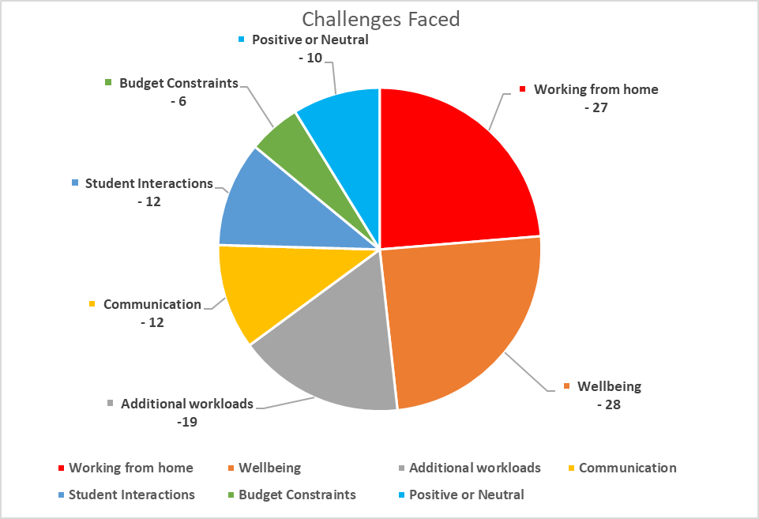
Challenges Faced | Comments
Working from home | 27
Wellbeing | 28
Additional workloads | 19
Communication | 12
Student Interactions | 12
Budget Constraints | 6
Positive or Neutral | 10

Working from home
Challenges included working longer hours, not taking breaks, zoom meeting fatigue, non-ergonomic furniture and equipment, inappropriate space, lack of separation between work and home, family responsibilities, increased stress, and internet or technology issues.
- “Working from home very intense - several back to back Zoom meetings in one day are draining. Tend to keep working and not taking a break.”
- “As I was working from home and all the work was phone or computer based that I was less active and put on weight as a consequence.”
- “Some team members are experiencing stress related to dealing with distressed students in the space of their own home (separating work from home is a challenge) and adds to mental health stresses.”
- “Working from home and home schooling simultaneously. Separating work from home and the discomfort of having to speak to students in my spare room. “

Emotional and Social Wellbeing Impacts
Challenges included compassion fatigue, feeling exhausted, loss of contact and connectedness with colleagues, and trying to simultaneously deal with task changes, uncertainties and restructures.
- “Maintaining motivation has been a challenge for me as well as my students.”
- “Loss of face to face connectedness with colleagues, sense of loneliness, adjusting to no face to face meetings with newly registered students. and the use of technology to augment such interactions.”
- “The biggest challenge was managing my own response to the pandemic at the same time as having to hold a space to support my team and the students we work with. Overlayed with restructure and job losses it has been a very challenging few month. Not having face to face interaction was difficult.”
- “Dealing with uncertainty regarding job losses in our University and across the tertiary education sector, while still trying to deal with anxious and unwell students.”
- “The other factor that I find is the transparency and sharing of information between colleagues as it seems that some people found it difficult to WFH but would not be transparent on this while others seem to have a larger workload during WFH. The disparity in this made it challenging to gauge what the expectations were.”
- “Overwhelming feeling of having to support everyone (staff, students and family) but you are operating in the same "never seen before" vacuum of experience as everyone else. Knowing you need to look after your own MH but not actually having the time or space to do so because you can’t let your team/students/family down in the middle of global crisis......”

Budget constraints
- “Budget constraints to be creative and innovative to engage students during this time but no adequate funds to be able to perform my role effectively. I had to make home deliveries of gifts to allow for connection with students from my own time and resources. Management support in recognising that it may cost more to engage students, but the benefits outweigh the costs would have [been] beneficial for me.”

Student Interactions
- “I would have many face to face appointments or students dropping by my office. Although moving to phone appointments only has been an easy transition, there potentially could be students not accessing the service because of this.”
- “Potential impact on relationships if continues.”

Additional workloads
As discussed in the previous Supporting Students section of this report staff within the sector experienced substantial increases in their workloads, both in terms of volume and complexity. Comments in this section included communicating across relevant staff and stakeholders, engaging students, learning and using new technology, examination arrangements, additional captioning requirements, increased problem-solving and advocacy.
- “Ensuring that all the university relevant stakeholders were communicating with each other and with students in a timely manner. Trying to connect all the parts was challenging. Having central examinations relay the adjustments to each Faculty and then having the Learning Designers have to assist the unit coordinators with Blackboard for the online exams was also difficult at times.”
- “Getting to iron out some alternative course delivery and teaching methods, with lecturers, by letting them understand the concept of equity and the challenges students with disability face and manage every step of their lives, as compared to students without disability.”
- “Increased volume of work and contact from students needing different types of support than they had previously. “
- “Problem-solving remote service delivery and impact on students when you have no actual control over any of the decision-making at a senior level and no discretionary funding to ensure students are not further excluded.”
- “Working with over-worked and stressed academics when trying to negotiate extensions on top of extensions for students. “

Communication
Some expressed frustration at the lack of communication flow and/or approach from management. However, others found trying to keep up-to-date with information about frequent changes to be overwhelming and stressful in itself, and particularly so for part time workers.
- “Accessing overview information on the changes occurring in delivery models and new initiatives as pace for change was rapid and there did not appear to be anyone who was tracking this for the organisation.”
- “Difficult to get clear communication from and throughout the college about path forward, many learning areas did not know how they were moving forward so student enquires could not be answered.”
- “The most unnecessary challenge for me was stress related to constant changing parameters and messaging from executive management, which indicated they had little understanding of how people learn. I could manage the redesign of the program on the fly and the engagement of the students, but their s#!$ was out of my control and extremely counter productive.”
- “Information overload (endless communications and changes in information), whilst trying to manage increased workloads with distressed students, and transitioning/learning new systems (which don't always work) to be able to work from home. I understand students feelings of being overwhelmed, as I have also experienced this. Even though I have seen a lot of Covid-19 support information/ webinars/ Zoom meetings being offered to assist staff/ disability practitioners, I have not had the time to engage with this (and have felt that more information would not be helpful whilst already feeling overwhelmed by information), so I have avoided these. I have probably missed some good information, because of the timing of this being offered.”

Positive or neutral impact
- “I have generally found working from home less stressful and have been able to complete work loads without the continual interruptions of a busy office environment. This has equated to providing a very responsive service to the student's needs. I have found it easier to access academic staff via zoom and telephone / emails during this time.”
- “I have been able to perform most of my duties with no issues working from home.”
- “My work with students was not affected and I do not feel the level of service provided was compromised.”

Overcoming these Challenges
Fifty-nine respondents provided suggestions for what would be helpful in overcoming these challenges. These fell under the following categories:
- Training and/or shared practices
- Policies and/or strategies
- Advocacy and/or training for academic staff
- Processes and/or resources
- Other
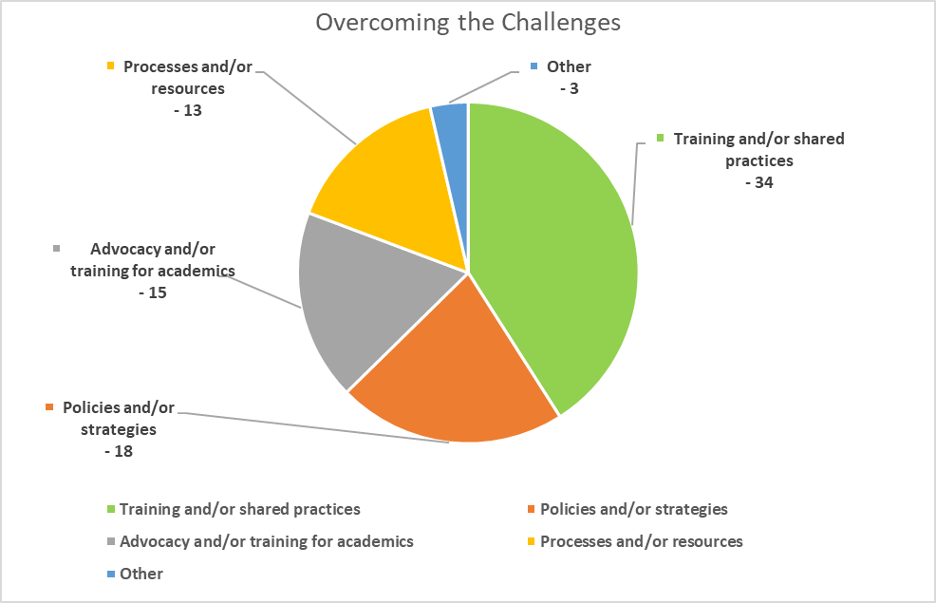
Overcoming the Challenges | Comments
Training and/or shared practices | 34
Policies and/or strategies | 18
Advocacy and/or training for academics | 15
Processes and/or resources | 13
Other | 3
Training and/or Shared practices
These included sharing good working from home practices, managing wellbeing, the changing nature of the role, on-line study and technology. Some respondents also noted the value and helpfulness for training provided and shared practices opportunities through ADCET. Aust-ed and EPHEA during this time.
- “Would love to have a 'weekly' or 'monthly' offering for staff. Maybe this could be something that we contribute to across the sector and brand or use ourselves. Our Library has a lovey subscription ' digital literacy bytes' - something you can do, something you can try, something you can read - or something you can explore, play with etc). More of what we currently have through Austed and ADCET- maybe an improved Austed subject search or platform so that we use it more.”
- “Shared practices - the collegiality and support within the sector itself (through AUSTED and EPHEA) is outstanding and has definitely helped me to cope over the past couple of months.”
- “The NDCOs organised several Covid related webinars - these were quite early in the pandemic and I think they could certainly be repeated or with different but related topics.”
- “Opportunity to articulate "feelings" both individually and as part of the team.”
- “Training offered by ADCET has been great. Some sharing of practices would be helpful, especially related to our changing role in this new on-line and more flexible study environment.”
- “Clear examples of what technology has worked, become beneficial and why. We're not all techsavvy and it's great to hear how something actually works in a given context.”
- “More information/professional learning about facilitating learning/engagement tasks online that ensure everyone is participating meaningfully.”

Policy and/or strategies
This included policy and strategies that addressed the ASSD funding model, flexibility around assessment extensions, inclusive teaching and learning, and working from home practices.
- “If would be a valuable tool if ADCET were able to collate and draft any guidelines re adjustments in the online environment, advise re mandatory attendance on campus for students as we transition back onto campus etc. Any sharing of practices and policy would support any advocacy at the individual university level.”
- “Broader policy around students who need to continue to stay away from campus.”
- “Adoption of more flexible Working from home practices - not just useful in a crisis!”
- “A policy reform that sees managers in education institutions having good knowledge about working with groups of diverse students and understanding how people learn.”

Advocacy and/or training for academic staff
This included an awareness campaign on the impact and challenges faced by students, the need for consideration of diverse learners during rapid responses and universal design learning.
- “Other teams recognising impact of change on students with disability - training, case studies, awareness raising would be good so 'inclusion' is not an add on but embedded into decision making.”
- “strategic advocacy will be needed as we know the first people/funding to suffer in any economic downturn are our most vulnerable groups.”
- “Mindset shift of academics that they are part of the responsibility to support/create inclusive education practices and support students also. “
Better processes and/or resources
This included better resources to enable services to proactively provide support to students, more IT support, better internet, and better communication flow. Also some commented that regular team meetings and check-ins were very helpful in supporting each other and keeping informed.
- “A well-resourced sector would help. Services to actively check in with all students and reach out to them to offer support instead of waiting for students to contact. Disability staff are already stretched so support for this within the rest of the university would be good.”
- “More personalised IT support.”
- “Multiple modalities for assessing knowledge.”
- “Short, clear information provided from one main source, in easy to navigate formats. Sometimes I need some information specifically but trying to find it in the endless amount of information going around has been impossible.”
- “Daily check-in by team has been beneficial.”

Other
These included:
- “I think the circumstances were so extraordinary I'm not sure anything would have helped much.”
- “The challenges are largely circumstantial and coincided with the crisis however opportunities are emerging for conversation and reconsideration of academic practice and its impact on students with disability which is very encouraging.”

The Silver Linings
Sixty-two respondents shared examples of positive practices and strategies that emerged during restrictions that would be valuable to continue post-COVID-19. These fell under the following categories:
- Openness to technological solutions
- Inclusive teaching and learning
- Flexible work arrangements
- Connections, compassion, creativity and cohesion
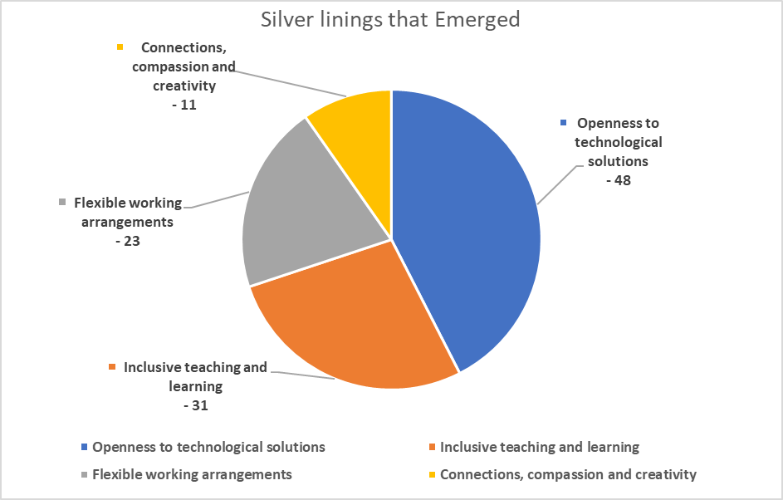
Silver linings that Emerged | Comments
Openness to technological solutions | 48
Inclusive teaching and learning | 31
Flexible working arrangements | 23
Connections, compassion and creativity | 11

Openness to technological solutions
This included a newfound expectation that functions, and tasks can be done on-line, increasing confidence in users, technology to support accessibility, more flexible course delivery, and universal design. For work teams this has created more efficiencies, and increased connections and collaborations for staff across dispersed locations.
- “The biggest positive may be the recognition of the value of online conferencing tools. This applies to staff to staff, staff to student and student to student communication.”
- “Using technology for team meetings as a standard has been great -saves inter campus travel. Also no commuting has allowed for more admin to be done daily.”
- “Daily team catch ups have been terrific to bring people together across different campuses.”
- “Highlighting to academics that alternative ways of learning can work really well, and hopefully this will carry forward so future negotiations may be more readily accommodated.”
- “The university community have been forced to adapt to remote teaching, learning and support. For some students remote learning is preferred and work at home arrangements for some staff is also preferred. Perhaps working and studying arrangements can be delivered more flexibly on an ongoing basis? It is hoped Universities can sustain more blended learning units where both face to face and remote learning options for students are available.”
- “improved team connections as our geographically dispersed team meet several times a week for a virtual cup of tea. Introduction of new initiatives such as an online appointment booking system, becoming familiar with Office 365 and making the most of its functionality.”
- “Considering alternatives to how support is usually provided to students has opened a range of possibilities, given impetus to adopt inclusive practices for all students' benefit, e.g. captions, transcription, software built in learning tools.”
- “This legacy of this experience is that we have to be more innovative in terms of how technology can add value to our existing practices. However, it is important to remember that technology cannot replace the value of the human interaction, it can facilitate it.”
- “Students understanding that they can now do units via distance whereas before, they lacked confidence in doing this, A greater acceptance of video teaching and meetings - far less time in travel that is not necessary.”
- “My team is scattered statewide and the shift to zoom meant that we were all on an equal footing. Our intrastate teammates really appreciated the sudden equality and felt they could for the first time participate on an equal basis in team discussions. Added pressure has contributed to a flow of ideas about ways we can enhance practice and an enthusiasm to action these ideas is evident.”
- “Many students have benefited from the flexible/mixed modes of delivery and now understand what works better for them.”

Inclusive teaching and learning
This included flexibility for addressing accessibility issues, alternative assessments, improvements in online learning, and more interest in universal design.
- “A sudden realisation, that accessibility is an important aspect in the delivery of online education ... and finding some solutions, though hurriedly!”
- “Some learning areas have adapted quickly and found that teaching can be done multiple ways, lecturers were more willingly to be flexible than they normally are, accessibility issues were highlighted and are now being addressed.”
- “More flexible approach to alternative assessments instead of end of semester invigilated exams.”
- “Some changes to practices and mindset of other parts of the university who are now taking a more active role in inclusivity and support of students with disability (exams and academics.”
- “Considering alternatives to how support is usually provided to students has opened up a range of possibilities, given impetus to adopt inclusive practices for all students' benefit, e.g. captions, transcription, software built in learning tools.”
- “We have so much evidence now to show how adjustments can be implemented without compromising academic integrity - there's no excuses anymore !!”

Flexible Work Arrangements
These positives included the flexibility around working from home that gave opportunities for some staff to maintain a better work/home life balance. Many respondents expressed hopes for future blended arrangement of working from home and on campus.
- “Mix of work from home with some on-campus when required/needed would be optimal. “
- “Knowledge that I am able to work from home successfully and somehow implementing this into the work week for work/life balance.”
- “It has been informative to see how much can be done from home using an online platform to conduct business. However, it is still important to have the option of physical face-to-face contact so that unfettered conversations and a deeper understanding of each other can occur. Flexibility in terms of work arrangements with the university should be on offer after the pandemic.”
- “Professional staff should have the option to WFH with less bureaucracy, it should be outcomes driven and not "people in the office" approach as we have already demonstrated that it can be done.”

Connections, Compassion, Creativity and Cohesion
This included academics more willing to engage with and support students, greater collaboration from across institutions and the sector, more open conversations about not coping and needing more support, and new and innovative ways to connect with colleagues. The situation also highlighted the ongoing resilience, creativity and adaptability of disability practitioners to continually work for the best possible solutions for the students they work with.
- “Overall academics having compassion as baseline for decision making and needing to support students to succeed to end of term.”
- “Support from ADCET and colleagues around Australia has been fantastic. “
- “Greater collaboration among new areas to get things done - need to hold on to and foster these relationships. “
- “We have started a 'bookclub' with the team where we have set aside time to for all to access webinar or podcast or 2 of their choice, and will be sharing our findings next week. This will continue. Daily team catch ups have been terrific to bring people together across different campuses.”
- “Disability services staff have shown (again) their remarkable resilience & creativity in making things work for students which I think should be acknowledged & celebrated. “

ADCET COVID-19 support

Helpfulness of COVID-19 supports to sector
Respondents rated the usefulness of the resources, webinars and online discussions that ADCET provided in partnership with the NDCO program to support the sector during COVID-19.
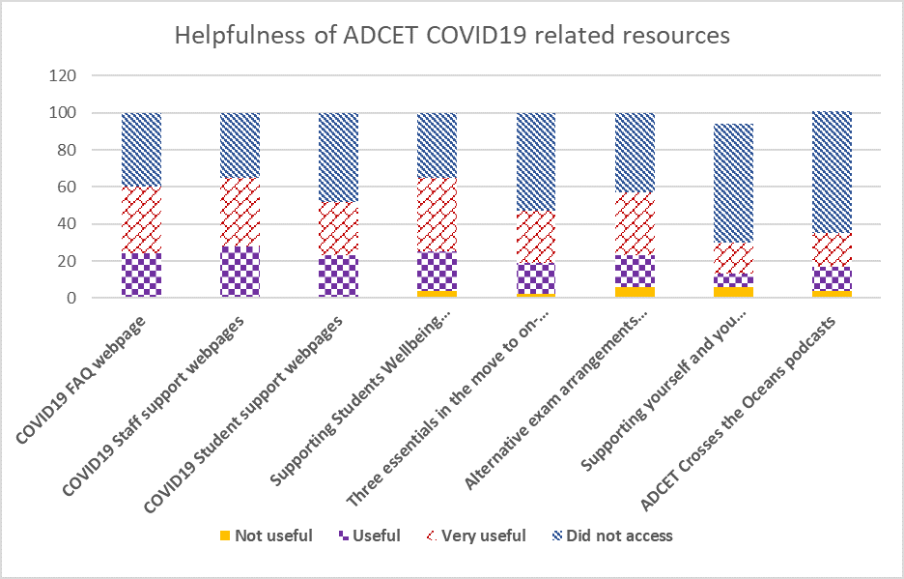
Helpfulness of ADCET COVID-19 related resources | Not useful | Useful | Very useful | Did not access
COVID-19 FAQ webpage | 0 | 24 | 36 | 40
COVID-19 Staff support webpages | 0 | 28 | 37 | 35
COVID-19 Student support webpages | 0 | 23 | 29 | 48
Supporting Students Wellbeing webinar | 4 | 21 | 40 | 35
Three essentials in the move to on-line webinar | 2 | 17 | 28 | 53
Alternative exam arrangements online discussion | 6 | 17 | 34 | 43
Supporting yourself and you support others online discussion | 6 | 7 | 17 | 64
ADCET Crosses the Oceans podcasts | 4 | 13 | 18 | 66

Additional Feedback
Forty two respondents provided additional feedback and comments on the resources and sessions provided. These fell under the categories of:
- Very helpful
- Time constraints limited engagement
- Other
- Helpfulness
Comments indicate that people found the resources helpful and practical, and appreciated the support from ADCET and colleagues.
- “Thank you for organizing so much PD - it's been great. “
- “I access the ADCET website at least weekly - great, up-to-date resources and connection with others via webinars etc.”
- “The webinars have been an invaluable way to pull the Sector together. Knowing so much info is available on ADCET when needed is very comforting!”
- “It is wonderful to have an online community to support each other during these very difficult times.”
- “I valued the emails that came out via AustEd mail list. I didn't read them all, but it's always good to "see" colleagues in action when working at home alone.”

Time constraints
Due to increased level of demands in the role and coping with the changes many were not able to engage in the sessions. However, even if people were not able to access the resources, it seems that it was beneficial to know that they were there and could be accessed at a later date.
- “Did not have time to access due to service demand but experienced sense of response from ADCET to assist during this critical time and intend to refer to some of these resources when things calm down a little!”
- “Unfortunately, I was not able to access as we were so busy with student contact and wellbeing phone calls I was not able to find the time to attend. But appreciated them being available and was engaged with the email conversations around them.”
- “Whilst this information was probably very good, there was just way too much going on when we were already overloaded with increased work and communications.”

Other
A couple of respondents commented that they were disappointed not all sessions were recorded. Another indicated they had other ways to access the same information, and another wanted information and ideas on very specific adjustment adaptations to all be in one place.

Future COVID-19 related topics
Sixty-five respondents provided comments on other COVID-19 related topics that they would like further information about. The other comments were distributed under the categories of:
- None or unsure (46 comments)
- Return to Campus (4 comments)
- Opportunities and Silver Linings (5 comments)
- Learning from Challenges (2comments)
- On-line Learning Best Practices (6 comments)
- Universal Design or Technology (4 comments)
- Other (4 comments)
Perhaps the large proportion of respondents who indicated that there was nothing else needed or that they were unsure reflects the additional workload demands and feelings of being overwhelmed by information.

Return to campus
- “How to support students to overcome fears and transition back to campus and face-to-face learning.”

Opportunities and Silver Linings
- “A discussion around opportunities to come out of this and aspects that have arisen during COVID that would be helpful to maintain.”
- “Adaptations to services in the TAFE sector during COVID and changes that will be kept as improvements to service.”
- “How to convince manager that flexible working arrangements are for the benefit of team and service long term.”

Learning from the challenges
- “I'm keen to explore data associated with (1) new registrations with tertiary disability services, (2) withdrawal rates and (3) student feedback on accessing external support services and if/how it impacted studies.”
- “Compassion fatigue.”

On-line delivery best practices
- “The very aspect of online delivery of education needs to be looked into through the lens of accessibility. There is a patchwork approach, currently. What is needed is planning it all with accessibility in the core alongside other core considerations.”
- “The future of online delivery during and post COVID. What it will continue to mean for accessibility and how we build on the wins and minimise the losses.”
- “Increasing engagement and participation in the online learning environment.”

Universal Design or technology
- “Other Universities experience of proctored exams. “
- “More info about Zoom, Colloborate, Teams, captioning, real-time transcription.”
- “Universal Design and reasonable adjustments - where do we draw the lines between them?”

Other
- “Little has been said about the post-viral syndrome and would be interesting to consider how we can support these students who have recovered from infection yet retain many medial symptoms.”
- “Study to Work Transition Webinars by alumni who have graduated and taken up graduate employment positions.”
- “Design thinking.”

Preference of mode for information
Respondents ranked their preferences to receiving information.
Webinars were the most popular mode (ranked first by 28%) followed by webpages (25%) and good practice guidelines (15%). The less preferred option were podcasts.
The preference rank was:
- Webinar
- Webpage
- Good practice guides
- Online forums/discussions
- Facts sheets
- Case studies
- Community of practice
- Podcasts.

Recommendations
- Host a participative forum to design ways of how to build upon and embed the silver linings that emerged during COVID-19 into ongoing practice and processes, including work practices, universal design, proactive supports and collaborations.
- Further explore the critical success factors that enabled some students to thrive through the disruptions and in on-line learning environments. Determine which of these factors are teachable traits that could be taught to other students, and investigate the availability or options for developing appropriate resources.
- Develop resources on best practice in supporting students in on-line learning environments, including issues that address motivation and engagement.
- Develop a fact sheet, including case studies on the issues around the emerging dilemma around adjustment-based support within more inclusive practices/universal design contexts.
- Develop and deliver a series of small ‘bite-sized’ training or information sessions that are less than 30 minutes duration for the sector on relevant topics.
- Continue to provide supports to the sector in a variety of formats including webinars, fact sheets, webpages, good practice guides, case studies, communities of practice, and podcasts. Develop information on the benefits and efficiencies of podcasts to inform the sector.
- Develop fact sheets on good practices in using video conferencing platforms such as ZOOM.
- Identify and promote professional development options for trauma-informed and/or psychological flexibility approaches to responding to the provision of student and staff wellbeing.
- Identify and promote sector relevant professional development options for compassion fatigue and proactive wellbeing and resilience strategies.
- Compare the holistic models of support currently used in sector.
- Develop web-based resources that include ‘how-to advice’ and case studies on the increased collaboration across whole institutions.
- Continue to promote the newly developed Guidelines: Responding to the needs of staff and students with disability in COVID-19 Return to Campus Planning for Australia’s Tertiary Institutions.
- Develop good practice guidelines that includes case studies and the productivity benefits of working from home or a blend of working from home and on campus.
- Host discussion or community of practice on universities experience of on-line proctored exams.
- Host webinar and develop web resource on supporting students who are Deaf or hard of hearing in on-line learning environments.
- Host a study to work webinar on the changing context of graduate employment opportunities.
- Be alert to the on-going effects of the post-viral syndrome on students and the potential necessity to provide information to the sector regarding this.
- Investigate options for external research that generates data on (1) new registrations with tertiary disability services, (2) withdrawal rates and (3) student feedback on accessing external support services and if/how it impacted studies during COVID-19 remote learning.

KPMG, COVID19: How the coronavirus could transform higher education, 8th April 2020. Accessed at https://home.kpmg/au/en/home/insights/2020/04/coronavirus-covid-19-education-sector-transformation.html

