Accessibility Features
built into iPhone and iPad

Introduction
The release of the iPhone 3GS in 2009 saw the beginning of a major accessibility revolution. When the original iPhone was released in 2007, many, including this scribe, assumed that its reliance on a touch screen precluded the possibility of a screen reader. Inclusion of VoiceOver, Apple's screen reader, on the iPhone 3GS was therefore a surprising and welcome development. Not only had it been demonstrated that a screen reader could be used with a touch screen, but one was included, rather than having to be purchased separately.

Since then, accessibility features for people who have a broad range of needs have been added. This document summarises the accessibility features available on iPhone, iPad and iPod. Future references will be to the iPhone, but include the other products using iOS. Importantly, these features can often be used in conjunction with free or paid apps to further improve accessibility.

Finding accessibility features
From the Home screen tap:
- Settings
- General
- Accessibility
Facilities are divided into four sections:
- Vision
- Interaction
- Hearing
- Learning

Vision

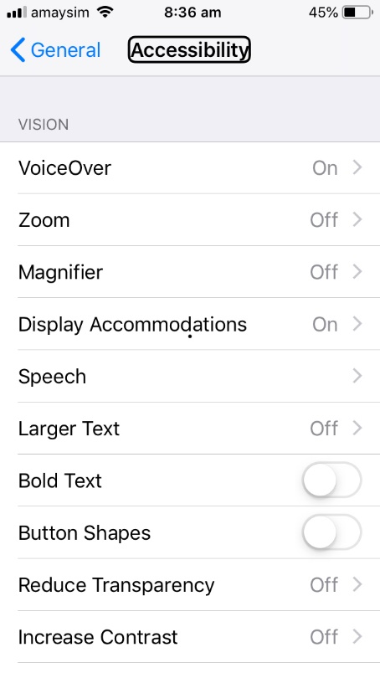
VoiceOver
As mentioned above, VoiceOver is Apple's screen reader. It is provided with Macintosh computers, iPhone, iPad, iPod and Apple TV. As a word of warning: When VoiceOver is active on the iPhone etc, an entirely different set of gestures are required. If not familiar with those gestures, operating the device is challenging. If all else fails, one method of turning VoiceOver off is to ask Siri to turn it off.
VoiceOver features and options will not be discussed in detail here. Suffice to say that it can be tailored to individual needs and preferences by tapping the VoiceOver Button. In brief:
- Speech settings including language, speed, verbosity and pronunciation can be adjusted.
- Keyboard options include several methods of selecting letters, an onscreen Braille keyboard and full VoiceOver control via an external keyboard.
- An external electronic Braille display can be used with or instead of synthetic speech output.

Zoom
Zoom magnifies the entire screen. This is a very brief summary of features. Gestures are available to control it, including moving around the screen and magnification level. A maximum zoom level of 15 x can be chosen.

Magnifier
Magnifier uses the phone's camera to project the image of surrounding objects onto the screen. Magnification level can be set from 1 to 15 x. The torch can be turned on and various filter settings are available. A freeze frame facility is also provided.

Display Accommodations
There are four settings for adjusting the display to meet ones needs. The following is a brief summary of their facilities:
- Invert colours (off by default).
- Colour Filters (off by default) for people who are colour blind or have trouble reading the display. Many filters are offered.
- Auto-Brightness (on by default).
- Reduce White Point (off by default) reduces intensity of bright colours.

Speech
- Speak Selection (off by default) reveals a Speak Button when text is selected.
- Speak Screen (off by default) speaks the contents of the screen when swiping down from the top of the screen with two fingers.
- Typing Feedback button reveals various options for getting spoken feedback as text is entered.
- Voices button provides a choice of numerous voices in different languages. The voice chosen here is independent of that used in VoiceOver.
- Speaking Rate provides a slider to set the rate to one's liking.
- Pronunciation provides a dictionary so that words mispronounced by the synthetiser can be corrected.

Miscellaneous
- Larger text (off by default).
- Bold Text (off by default).
- Button Shapes (off by default).
- Reduce Transparency (off by default).
- Increase contrast (off by default).
- Reduced Motion (off by default).
- On/Off Labels (off by default).

Interaction

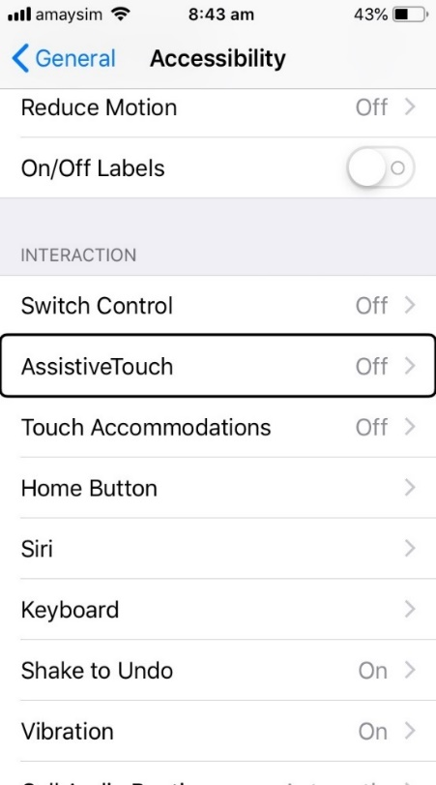
Switch Control
The iPhone can be controlled with a connected switch (a switch may be used by people who have very limited physical movement). Many parameters can be adjusted to meet individual needs. Recipes (multiple actions combined into one) can be created so as to speed up the interaction which, by its nature, is very slow.

Assistive Touch
This can be used by people who have difficulty touching the screen or who use an adaptive accessory. Just some options include:
- Customise Top Level Menu allows default actions of various icons to be changed.
- Customised Actions allow interaction with the Custom Actions Icon without having to open the menu.
- Custom gestures can be created.

Touch Accommodations

Hold Duration (off by default)
This allows adjustment of the length of time the screen is touched before the touch is recognised. That can be helpful in preventing accidental activations.

Ignore Repeat (off by default)
This allows adjustment of duration between two touches being treated as one touch. This is also helpful if the user has reduced fine motor control.

Tap Assistance (off by default)
This allows any single finger gesture to perform a tap. It is necessary to record the gesture to be used.

Home Button
- Duration between presses of the Home Button can be adjusted for double and triple presses. This is helpful for people who require extra time to perform multiple presses.
- Press and Hold to Speak is set by default to speak to Siri. This can be turned off.
- Rest Finger to Open (off by default) allows devices that still have a Home Button to be opened by resting a finger on it without pressing the button (Touch ID must be enabled).

Siri
- Type to Siri (off by default).

Voice Feedback
Siri will provide voice feedback:
- Always on (default);
- Control with Ring Switch (no voice feedback when on silent);
- Hands-Free Only.

Keyboards

Software keyboards
- Show lowercase keys (on by default). This affects keyboards that use the shift key to switch between upper and lowercase letters.

Keyboards (continued)

Hardware keyboards
- Key repeat (on by default).
- Sticky Keys (off by default). When turned on, keys such as shift, control, Option and Command can be pressed before pressing another key rather than having to press keys simultaneously. Pressing the shift key twice allows a word to be written in uppercase.
- Slow Keys (off by default). When turned on, the duration of a key press can be extended. This can help to avoid accidental key presses.

Shake to undo
- On by default.

Vibration
- On by default.

Call audio routing
- Automatic by default. Other options are:
  - Bluetooth headset;
  - Speaker.
- Auto answer calls (off by default).

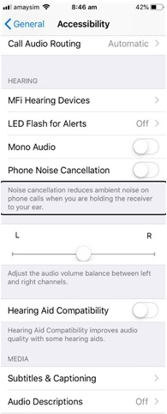
Hearing
- MFi Hearing Devices will be searched for when the button is pressed (other hearing aids are paired under Bluetooth Devices).
- LED flash for alerts (off by default).
- Mono audio (off by default).
- Phone noise cancellation (off by default) reduces ambient noise when phone is held to the ear.
- Left-right stereo balance (centred by default).
- Hearing aid compatibility (off by default) improves hearing aid quality with some hearing aids.

Media
- Subtitles and captioning (off by default).
- Audio descriptions (off by default).

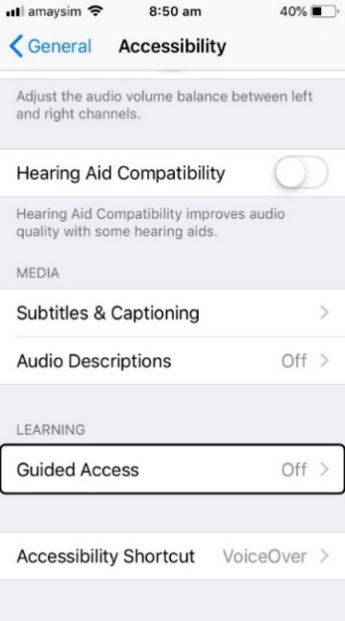
Learning

Guided Access
- When turned on, Guided Access will keep the device in a single app and allows control of which features to make available.

Accessibility shortcut
- A triple click of the Home Button can be used to toggle on and off one of several accessibility features such as VoiceOver, various colour settings or switch access.

Written by: Andrew Downie (August 2019)

