Supporting students with Autism Spectrum Disorder in higher education

Slide 1
A Power Point presentation by Dr Ceridwen Owen (University of Tasmania) included in the ADCET (Australian Disability Clearing House)
webinar “Supporting Students with Disabilities – Individualised and Institution-level Approaches in Practice”, April 7, 2016.

This project was funded by the National Centre for Student Equity in Higher Education (NCSEHE) of Curtin University

Slide 2

Investigators:
Ceridwen Owen (Lead, School of Architecture & Design)
Damhnat McCann (School of Health Sciences)
Christopher Rayner (Presenter, School of Education)
Carol Devereaux and Fiona Sheehan (Disability Services)
Lyndsay Quarmby (Centre for Rural Health)

Research Assistants:
Debbie Hindle, Wendy Roberts, Belinda Jarman, Cathryn Kerr

Advisors:
Darlene McLennan (Manager, Australian Disability Clearinghouse on Education & Training)
Mary Brake (Autism Consultant, Department of Education, Tasmania)

Slide 3

Outline:
- Context
- Disability and pedagogy – literature and survey
- Built environment – literature and student experiences
- Conclusions
- Limitations and future research

Slide 4

1. Context: ASD

What is Autism Spectrum Disorder (ASD)?
A lifelong neurodevelopmental disorder characterised by difficulties in:
- social communication and interaction; and
- restricted or repetitive patterns of behaviour and interests.

Slide 5

Context: challenges
What challenges are reported for students with ASD in higher education?
- Managing everyday life and independent study
- Social engagement and socially mediated learning experiences
- Disclosing and seeking assistance

Slide 6

Context: scope and methods

What did this project involve?
- Literature reviews
- Online Survey
- Self-directed photography (‘photovoice’) and interviews

Slide 7

2. Disability and pedagogy: literature
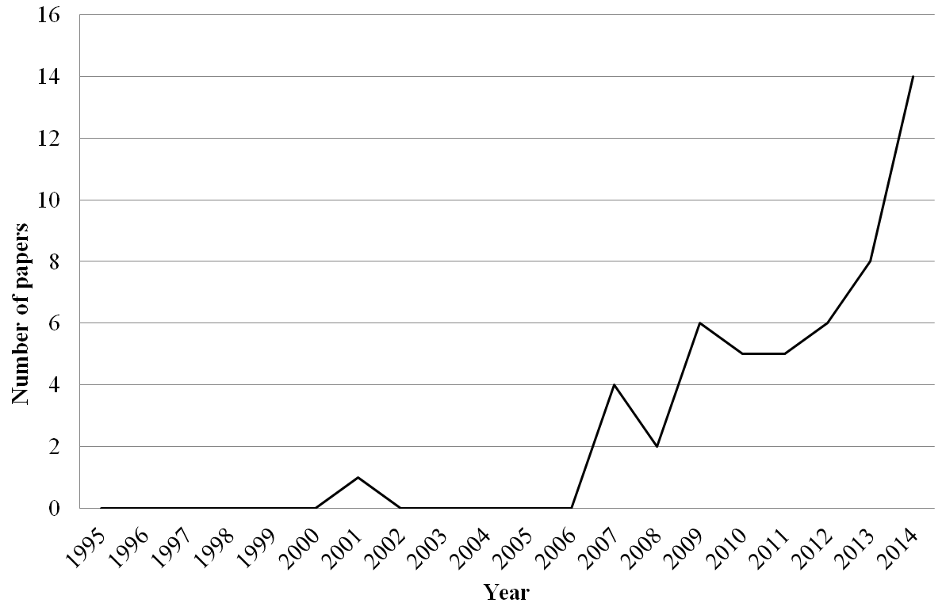

Slide 8

Pedagogy and disability supports:
Papers included: descriptive studies (41%), discussion papers (30%), program evaluations (21%), and literature reviews (8%)
Themes included:
- Supporting effective transitions and orientation
- Collaborative and multidisciplinary approaches
- (Peer) Mentoring and participation support
- Developing students’ social, communication, self-advocacy, and university-specific academic skills
- Creating awareness of sensory processing characteristics
- Professional learning for staff in relation to ASD and inclusive teaching practices

Slide 9

Disability + pedagogy: existing supports

AUST-ED Survey findings:
A strong emphasis on the provision of individualised assessment and support to reflect the specific needs of each particular student.
Types of support included transition support, the development of study and organisations skills, facilitating social and/or personal development, and the implementation of specific strategies to address ASD challenges.
Methods of support included ASD specific mentoring, education of staff and case management, LAP process, external liaison.

Slide 10

3. Built environment: literature
- Key issues – sensory sensitivities + disorientation (navigation and wayfinding), spatial variation and ‘safe spaces’.
- Lack of research literature and policy development in relation to built environment, particularly in higher education.
- Disparity in research between student and staff perspectives (particularly in relation to sensory sensitivities).

Slide 11

3. Built environment: student experiences
- Site: University of Tasmania
- Sample: Six students with ASD
- Methods: Self-directed photography (‘photovoice’) and interviews

Slide 12

3.Built environment: student experiences – sensory
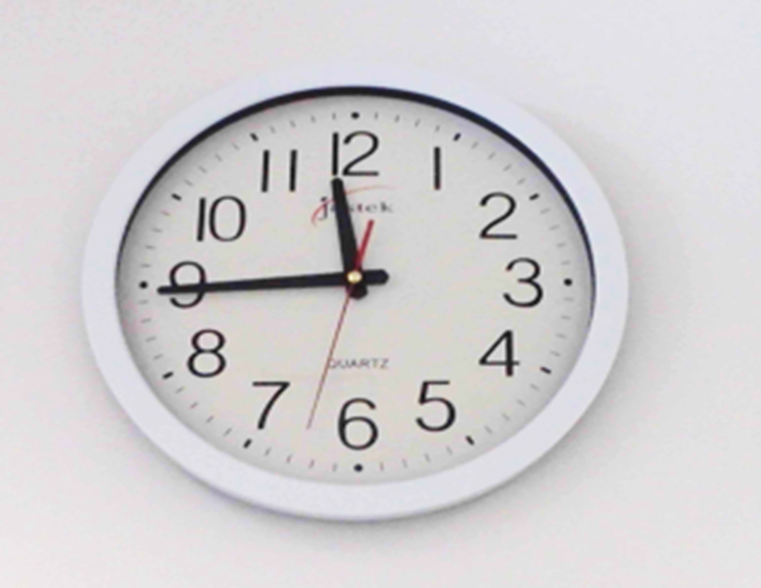

“Please find an alternative for these.” (Participant 3 diary)

Slide 13
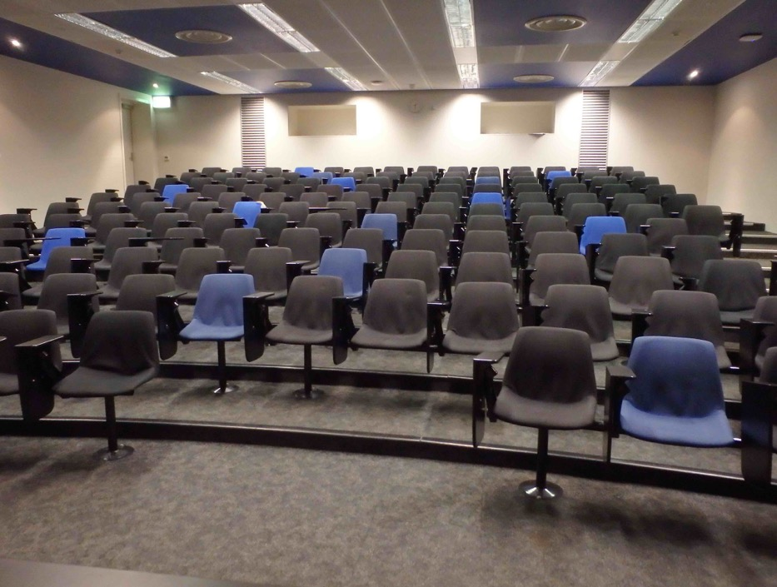
“I can cope with this unless I am tired or stressed.” (Participant 3 diary)

Slide 14
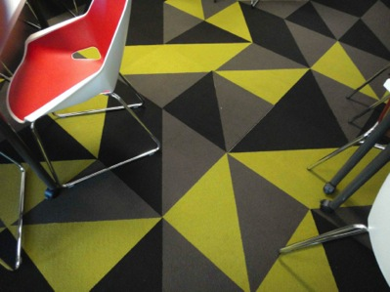
When I was taking this photo I felt “nauseous.”
Extra information about this photo for the researchers: “This carpet is new. I liked the old, plain one.”
(Participant 6 diary)

Slide 15

“You lose the ability to think or process … you're essentially stupider in these environments.” (Participant 4 interview)
- Experience of headaches and nausea
- Effects can last hours or even days

Slide 16
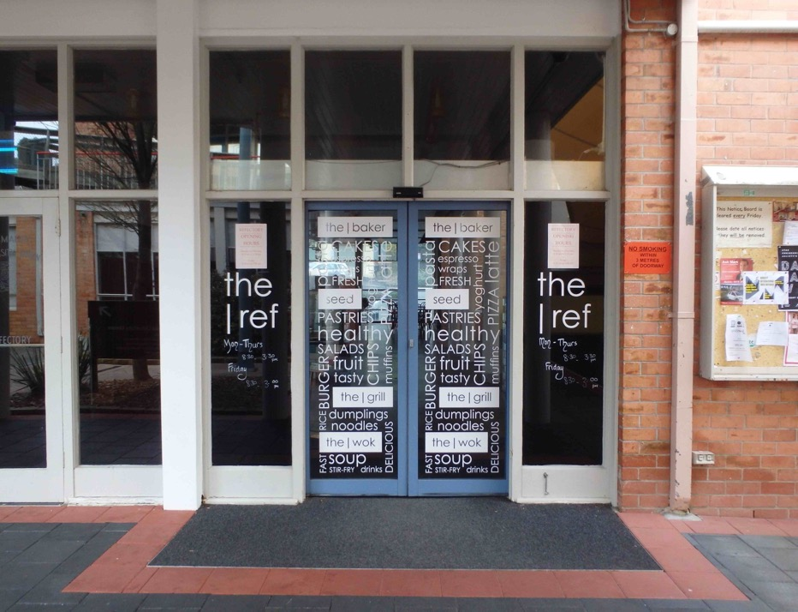
“I could not go inside, even to take a picture.” (Participant 3 diary, referring to the cafeteria

Slide 17

3.Built environment: student experiences – social
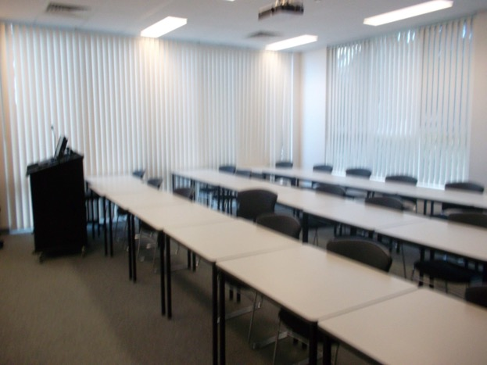
First photo)
When I was taking this photo I felt “Angry, trapped, hate. Get out of my way.”
(Participant 4 Diary)
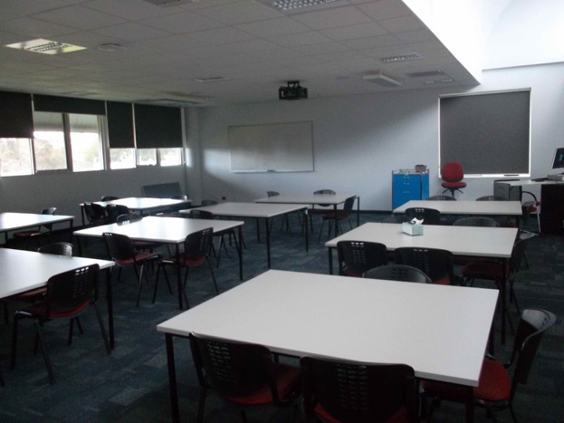

(Second photo)
When I was taking this photo I felt “Relaxed, collaborative, engaged.”
(Participant 4 Diary)

Slide 18

“I had made a conscious decision some time ago now that I had to build myself up as much as I possibly can to all of that to get by in life otherwise I'd just be in my little cocoon all the time at home and that's not healthy.”
(Participant 6 interview)
Slide 19

3.Built environment: student experiences – cognitive
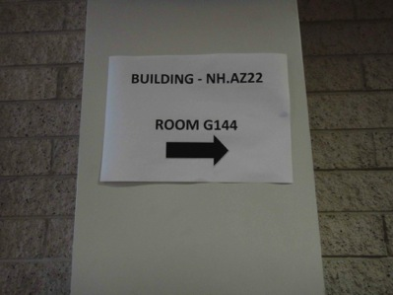
“I don’t understand why there are so many numbers/codes for the same room. I have often got lost. I don’t understand the campus map either as that is a coded mess.”(Participant 6 diary)

Slide 20
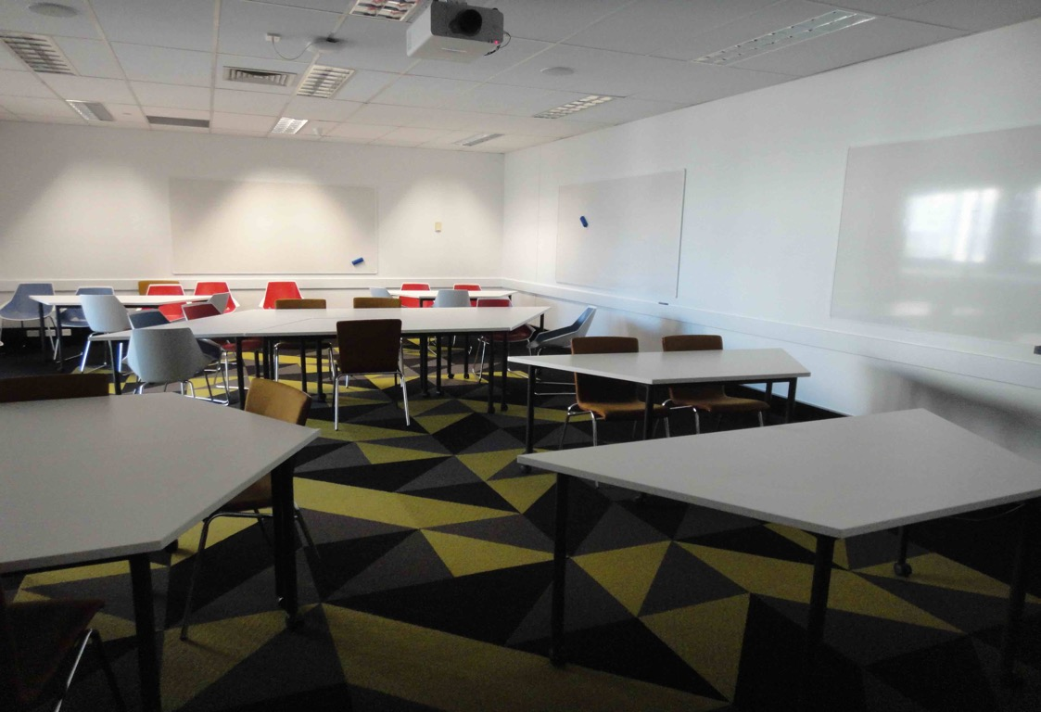
“This photo makes me think about how I spent a lot of the lesson trying to work out which way to sit…. There are whiteboards almost the whole way around the room. This added to my confusion.”
(Participant 6 diary)

Slide 21
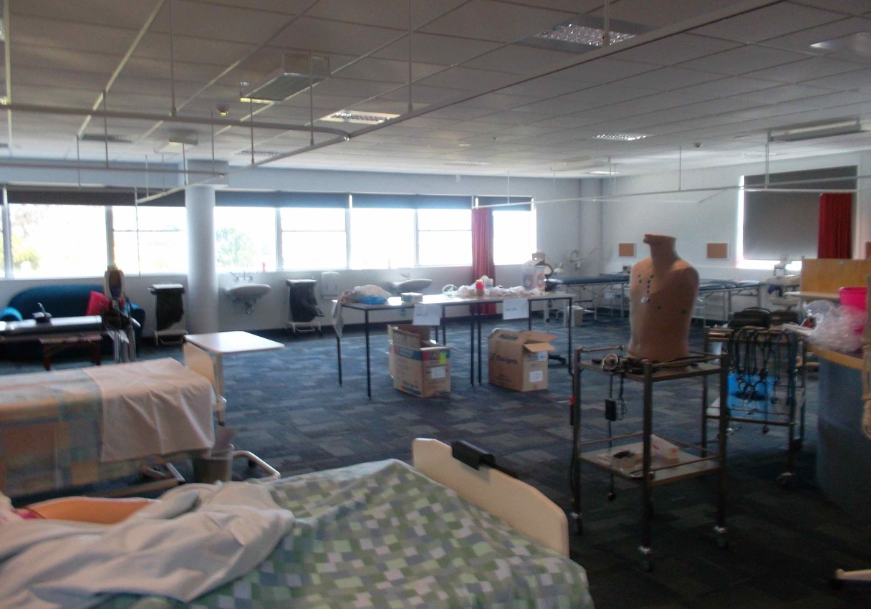
“It makes learning a lot more casual and self-directed ... the whole atmosphere changes a bit. You can kind of realise that you're allowed to do that, there aren't really rules in place. It's more something that just flows.”
(Participant 4 interview)

Slide 22

3. Built environment: student experiences – supports

- Student access study centre
- Online and distance education support
- Learning Access Plans
- Staff awareness and support

“… if it wasn't for her [lecturer] I would have pulled the pin. I wouldn't actually be there now, at all. I would have thought, ‘No, this is just too hard, I just feel like an idiot.’”
(Participant 5 interview)

Slide 23
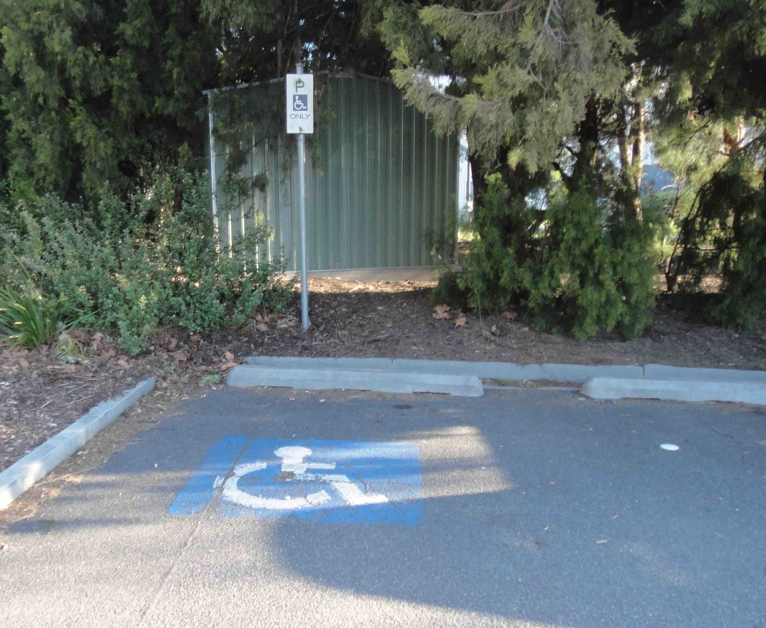
“I felt a bit sad that [the logo] is highlighting difference, and the stereotype that someone with a challenge therefore must be in a wheelchair…. This photo makes me think about wanting to re-design the concept of dis-ABILITY.”
(Participant 6 diary)

Slide 24

3. Built environment: student experiences – (informal) supports
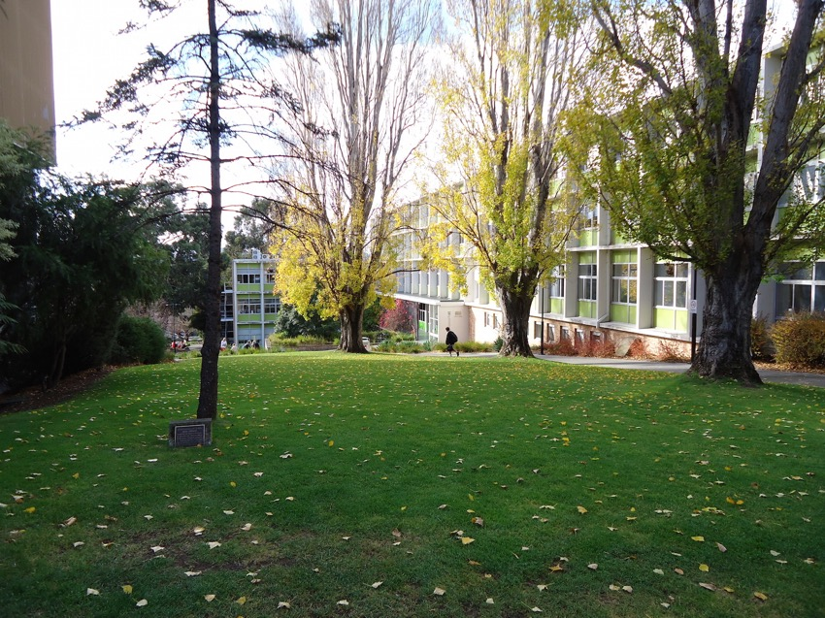
“… what they all have in common is kind of open space, easy to navigate, not too busy, not too quiet, but open. It's open and outdoors but at the same time it's closed and contained.”
(Participant 4 interview)

Slide 25
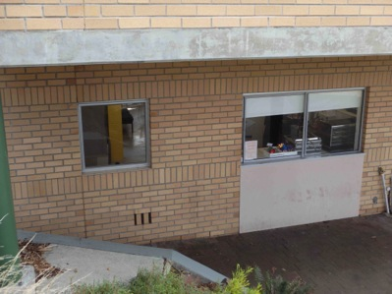
This photo makes me think about “the lady used to save me a sandwich each day. It was much safer here than the other places that sold food. She probably never knew how much she helped me that first year.” (Participant 3 diary)

Slide 26
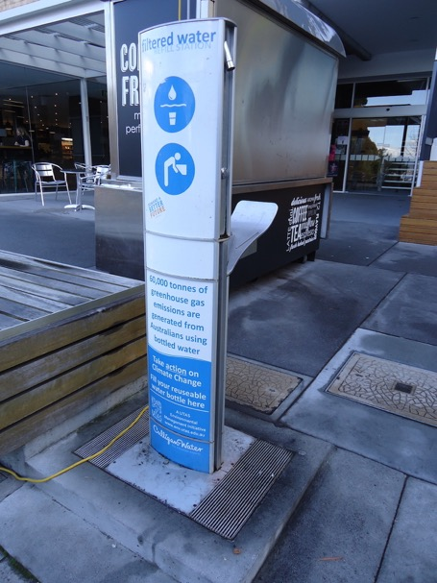
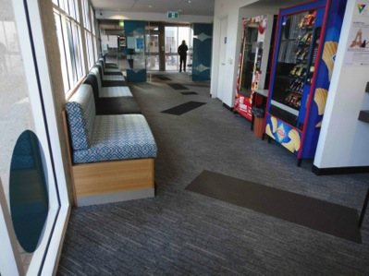

Slide 27

Built environment: student experiences – escape
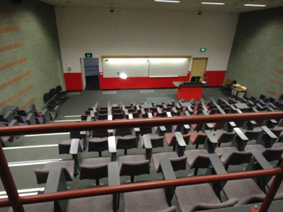
“I tend to pick a spot all the time. Even in the lecture room I pick a chair, that’s my chair.”
(Participant 6 interview)

Slide 28
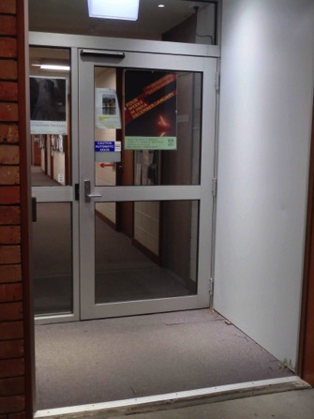
“This is a picture of the scary self-opening door…. It is hard to remember to stop when I am in a rush to get to the safety of the SASC.”
(Participant 3 diary)

Slide 29

4. Conclusions
“…you have to be assertive to be autistic and the world doesn’t owe me anything and I don't like to play the victim. Where I just put it out there and say, look I'm autistic, I just need your assistance.”
(Participant 5 interview)

Slide 30

Recommendations for disability supports:
- Individualised assistance and effective implementation of Learning Access Plans (LAPs)
- Addressing social and self-management/advocacy skills
- The development of further (peer) mentoring programs

Slide 31

Pedagogical recommendations:
- The use of inclusive practices, such as those informed by Universal Design for Learning (UDL) principles
- Promoting greater awareness and understanding of ASD, particularly among teaching staff
- Enabling students to exercise agency and manage their own learning journey

Slide 32

Inclusive design (built environment) solutions:
- Campus spaces need to be considered holistically
- Spaces need to facilitate navigation and engagement, as well as provide opportunities for withdrawal
- Low cost adjustments (clocks, lighting) can make big differences
- Recent design trends towards hyper-stimulating learning spaces should be balanced with access to quiet environments with natural features
- Development of relevant policy and design guidelines is encouraged

Slide 33

Possibilities for the National Disability Insurance Scheme (NDIS):
- Broadening of the peer mentor role to specifically meet the needs of a student with ASD, and continuing the support traditionally offered for ‘transitioning’ at the beginning of an individual’s study
- Clarification of the type of support available under the NDIS that takes into account the unique (but less visible) disability-related needs of this population
Such initiatives have the potential to assist these students to complete their higher education study, and increase the likelihood of their future employment and economic independence.

Slide 34

5. Limitations and future directions
Limitations: small and specific sample of students
Future directions: examine retention rates for students with ASD and include the experiences of a broader range of participants including:
- individuals with ASD who have failed to access higher education despite academic competency and interest; and
- individuals who have entered higher education but failed to graduate.

Slide 35

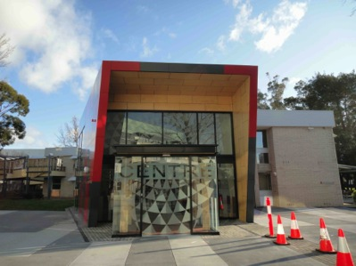
I took this photo because “I keep on wanting to fix the skewed building.”
When I was taking this photo I felt “a bit agitated.”
This photo makes me think about “why people design buildings this way/why they build them incorrectly.”
(Participant 6 diary)

