Tips for parents/carers to support the educational and career journeys of students with disability
Research with students with disability, stakeholders and parents/carers into how to best support the career development learning (CDL) of students with disability led to the development of a set of Best Practice Principles.
This document for parents and carers highlights the top tips for supporting high educational and career outcomes for students with disability. It features the voices of parents/carers of students with disability.
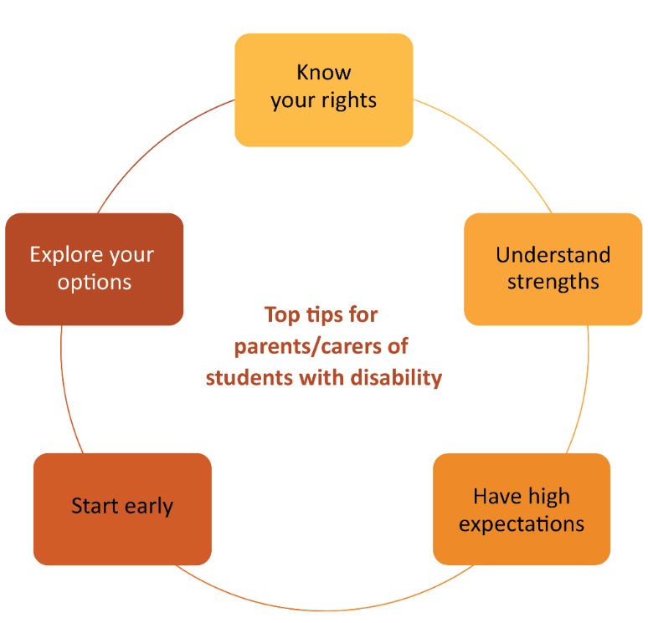

Know your rights
Find out what is required by educational institutions and workplaces when it comes to receiving equitable access to educational opportunities like work placement.
The experience of some parents or carers of students with disability is that educational institutions may need to be reminded about what diversity and inclusion means in practice. This should not be the responsibility of the student or family, so you may want to seek support from advocacy organisations such as Family Advocacy, Children and Young People with Disability Australia (CYDA), Youth Disability Advocacy Service (YDAS) and others.
Parents/carers have observed conscious and unconscious ableism in schools and the broader community with their students with disability not being given the opportunity to show what they can do in the workplace.
[A barrier for him is] employers not being willing to give him a chance.
Male carer of an 18-year-old student with autism
Part-time work has been problematic and there has been mistreatment and bullying at times by junior level managers. They would say that there is a lot of conscious and unconscious ableism out there in schools and in the wider community.
Mother of 17-year-old student with autism spectrum disorder (autism), Tourette syndrome, developmental coordination disorder (DCD), attention deficit hyperactivity disorder (ADHD) and generalised anxiety disorder

Reflective questions
- Do you understand the responsibilities of the educational institution to provide your student with adjustments and support to access work experiences?
- Who can you speak to or where can you find more information and advice?
Top Tip!
Read about student rights and responsibilities in higher education here.
Read about employment rights here.

Understand your student’s strengths
Observe and foster your student’s strengths and interests. Focus on those and what the student can contribute to a workplace independently and with supports or adjustments.
There are online tools that can support the exploration of strengths and interests. The Australian Governments’ YourCareer and the combined state governments’ myfuture websites are excellent sources of information on industries, occupations and qualifications. Both have quizzes that your student can use to clarify interests and strengths.
Top Tips!
Take a quiz to find a list of occupations that might suit.
Explore other activities to help you think about post-school study and employment.

His disability allows him to complete work to a very high standard and his attitude would make him a great employee.
Male carer of an 18-year-old student with autism

Reflective questions
- What is my student good at and interested in?
- How could my student add value to a workplace through their strengths?
Top Tip!
Hear/read/view stories about people with disability in the workforce.

Have high expectations of your student
Aspire, and help your student aspire to, educational and employment outcomes that match their desires, interests and strengths.
Some people (including some educators) have low expectations of students with disability, which might influence what they and you think is possible for your student. Try not to close off opportunities. Instead, encourage dreams and aspirations.
Support your student to continually define what success means for them in relation to their career goals and ambitions. Exploring success stories and examples of people with similar disability who have achieved personal and employment or career goals can help nurture high expectations for your student.
Top Tip!
Read about the real experiences of higher education of students with disabilities here

Seeing people with the same disability as her having jobs and seeing what sorts of things they are doing in their careers is really useful … and this shapes my understanding of what might be possible for my daughter.
Mother of 8-year-old daughter with Down syndrome

Reflective questions
- What type of work would the student find rewarding?
- What might the student be capable of, given the right conditions?
- What have others with a similar disability achieved, and what supports did they receive to achieve that?

Start exploring careers early
Seek out and get involved in career activities for your family member early on in their education – don’t wait until Year 9! This will assist you to guide your family member as they develop their goals and ambitions for the future. Source information from support services specialising in different disabilities, speak to teachers and support staff in schools and utilise the expertise of career advisors.
Top Tip!
Read more here and here about why you should start exploring careers
early with your child.

Even though my daughter is only 8, I feel I need to focus on her future work and career options now – to make sure that she has some! ... I don't think parents whose kids don't have disabilities need to think about that aspect of the future. They have the privilege of knowing their kids will have access to employment …
Mother of 8-year-old daughter with Down syndrome

Reflective questions
- Who can I have conversations with to help explore career options that might be suitable for my student?
- What services or outreach programs are available at the school, and how do I ensure that my student can access these?

Explore different options for education, training and work experience
Seek information about the pathways through education into employment, including different providers and courses on offer. Work with your family member to plan ahead with consideration of subject selection, pacing of subjects and courses.
Top Tip!
Have a look at your local university (or university of choice) and ask whether they offer enabling or foundation courses – these programs might offer alternatives to the traditional school-to-university pathway.
Some parents/carers of students with disability have experienced long and difficult journeys to find the right educational environments – environments where their student is valued and cared for, and where people will have high expectations of them. “Shopping around” and investigating different providers has been one approach that parents/carers have taken. Alternative providers like TAFE (Technical and Further Education) instead of secondary schools for the senior school years might be more suitable for some students. Private educational providers might offer more flexibility or study options to better suit individual student needs.
Assess the suitability of education providers prior to enrolment by, for example, arranging to meet with school leaders and support teams to discuss the learning environment, school culture and supports available; seeking advice from trusted advisors such as early childhood educators that the family are confident with (for transition to primary), primary school educators for transition to secondary school and so on; and attending open days or parent information sessions, perhaps taking a support person for additional perspective.
I was able to find a private educational provider that offered round-the-clock phone support. They offered options like instead of class practicums students can do 1–1 practicums… [and] a full 12 months to complete (it’s a 1-term course for most).
Mother of 18-year-old with ASD, ADHD and learning difficulties
Work experience is invaluable for career development. Explore work experience options including supported and virtual options.
Parents/carers of students with disability have experienced their student missing out on work experiences in secondary school because of a lack of workplaces to support them. Such students are completing secondary school without those rich opportunities, and this has an impact on their aspirations, skill development and employability.
Top Tip!
Read guides to good practice in work placements and work integrated learning for students with disability (see CDL Hub)

Reflective questions
- What other pathways exist for my student to acquire the skills or qualifications they desire?
- What do local TAFE colleges, other registered training organisations (including private training providers) or Adult and Community Education (ACE) providers offer?
- What options are there for work placements for my student?
Examples: Ticket to Work, Australian Network on Disability (AND), Disability Employment Services (DES), internships, school workplace learning programs, Work Inspiration programs, National Disability Insurance Scheme (NDIS), School Leaver Employment Supports (SLES), customised employment providers and volunteering organisations.
Top tips for parents/carers of students with disability:
1. Know your rights
2. Understand strengths
3. Have high expectations
4. Start exploring careers early
5. Explore your options

Source: O’Shea et al. National Career Development Learning Hub for students with disability. National Careers Institute Partnership grant (2021–2023). The research involved interviews and surveys with students, parents/carers and stakeholders and analysis of existing data sets. Total participant responses = 774.

