Instructions: This checklist is to assist tertiary education providers to consider strategies to improve inclusion for people with disability. Below are some considerations for tertiary education providers in relation to building an organisation which embraces people with disability in education and employment. Check the box if you need to consider how to address these items in your institution.

Disability inclusion framework
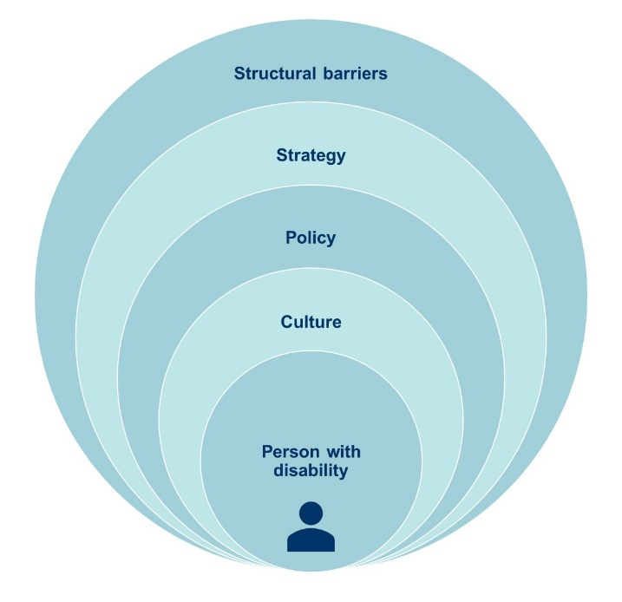

Person with disability
☐ What processes/supports/strategies do you have in place for students with disability at all stages of the student lifecycle e.g., recruitment/widening participation, admissions/enrolment, orientation, teaching and learning, accessibility, student support, co-curricular, WIL, graduate employment, graduation?
☐ What processes/processes/strategies do you have in place for staff with disability at all stages of the employment lifecycle e.g., recruitment, onboarding, health and safety support, flexible work arrangements, accessibility?
☐ Where are the student and staff with disability voices in your collaborations, decisions-making and feedback mechanisms?
☐ What processes/supports/strategies do you have in place for people with disability (public, future students and staff) who visit your university e.g. events, wayfinding, physical access, welcoming culture, inclusive imagery/language, accessibility web information, access to the campus/es etc?
Actions to consider: e.g., Check out the ADCET website for resources
Click or tap here to enter text.

Strategy
☐ Does your university strategic plan specifically mention disability or equity?
☐ Do you have senior leaders championing disability inclusion?
☐ Does your university have a current Disability Inclusion Action Plan (DIAP)?
☐ Is your DIAP publicly available? Is it accessible?
☐ Does your DIAP cover inclusion across learning, digital and physical/built environments?
☐ Do you have an advisory committee? Does it include people with disability?
☐ Is your DIAP registered with the Australian Human Rights Commission?
☐ How are you monitoring, reporting and evaluating strategy, interventions and activities, including collecting and analysing data?
Actions to consider:
Click or tap here to enter text.

Policy
☐ Does your university have a specific disability or equity policy which covers people with disability?
☐ Does your university have policies/processes/procedures which reflect the Disability Discrimination Act (DDA) and the Disability Standards for Education (DSE)?​
☐ Does your university have reference to eliminating discrimination in student and staff code of conduct?
☐ Does your university have policies/processes/procedures which cover reasonable adjustments (for students and staff), accessibility (digital/technology, physical, learning), inherent requirements, applying standards?
☐ How do staff understand their legislative obligations?​
☐ Is there a complaints process for people with disability in relation to discrimination, harassment or victimisation?
☐ Do you track the number of complaints of disability discrimination at your institution?
Actions to consider:
Click or tap here to enter text.

Structural barriers
☐ Do you know your pain points for accessibility (digital, physical, teaching, staffing)?​
☐ How do you recruit, retain and support students and staff with disability?​
☐ What is your university’s approach to Universal Design for Learning?​
☐ What is digital accessibility like across all platforms?​ Do you have a policy on ICT procurement? Does your university comply with WCAG?
☐ What challenges are there on your physical campuses?​
☐ Are your approaches evidence-based and consultative?
Actions to consider:
Click or tap here to enter text.

Culture
☐ Do you have disability awareness training for all staff?​ Is it recommended or mandatory?
☐ Do you have disability awareness training for students e.g., mentors or ambassadors, embedded in graduate capabilities framework, extra-curricular?
☐ Do you have professional development opportunities for staff in relation to digital accessibility?
☐ Do you have professional development opportunities for staff in relation to Universal Design for Learning and/or inclusive teaching strategies?
☐ What professional development opportunities are available around disability and inclusion where there are specific barriers such as employment e.g., recruiting people with disability equitably, supporting students with disability in WIL and graduate employment?​
☐ What active inclusion strategies are in place e.g., events, days of observance, inclusive events?
☐ Do you have a policy/process/guidelines in relation to inclusive imagery and language?
☐ Do your feedback mechanisms allow for commentary on inclusion for people with disability?
Actions to consider:
Click or tap here to enter text.

